1 The expression is equivalent to
1)
2)
3)
4)

2 The legs of an isosceles right triangle each measure 10 inches. What is the length of the hypotenuse of this triangle, to the nearest tenth of an inch?
1) | 6.3
2) | 7.1
3) | 14.1
4) | 17.1

3 The expression 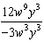 is equivalent to
1)
2)
3)
4)

4 The spinner shown in the diagram below is divided into six equal sections.

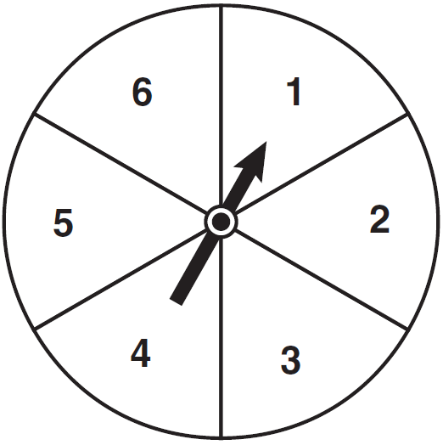

Which outcome is least likely to occur on a single spin?
1) | an odd number
2) | a prime number
3) | a perfect square
4) | a number divisible by 2

5 What are the factors of the expression ?
1)
2)
3)
4)

6 What is expressed in simplest radical form?
1)
2)
3)
4)

7 A survey is being conducted to determine which school board candidate would best serve the Yonkers community. Which group, when randomly surveyed, would likely produce the most bias?
1) | 15 employees of the Yonkers school district
2) | 25 people driving past Yonkers High School
3) | 75 people who enter a Yonkers grocery store
4) | 100 people who visit the local Yonkers shopping mall

8 An 8-foot rope is tied from the top of a pole to a stake in the ground, as shown in the diagram below.

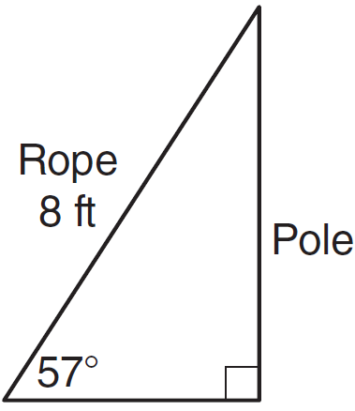

If the rope forms a 57° angle with the ground, what is the height of the pole, to the nearest tenth of a foot?
1) | 4.4
2) | 6.7
3) | 9.5
4) | 12.3

9 How many different ways can five books be arranged on a shelf?
1) | 5
2) | 15
3) | 25
4) | 120

10 What is the slope of the line passing through the points and ?
1)
2)
3)
4)

11 Which type of function is represented by the graph shown below?

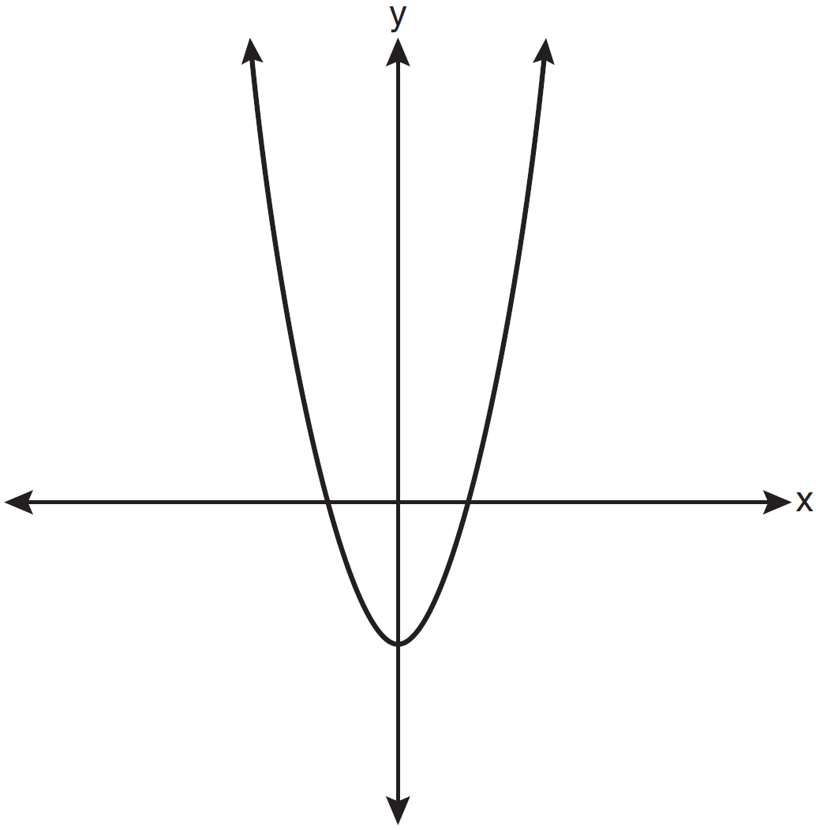
1) | absolute value
2) | exponential
3) | linear
4) | quadratic

12 Which equation represents a line parallel to the y-axis?
1)
2)
3)
4)

13 Melissa graphed the equation and Dave graphed the equation on the same coordinate grid. What is the relationship between the graphs that Melissa and Dave drew?
1) | Dave's graph is wider and opens in the opposite direction from Melissa's graph.
2) | Dave's graph is narrower and opens in the opposite direction from Melissa's graph.
3) | Dave's graph is wider and is three units below Melissa's graph.
4) | Dave's graph is narrower and is three units to the left of Melissa's graph.

14 In right triangle ABC shown below, and .

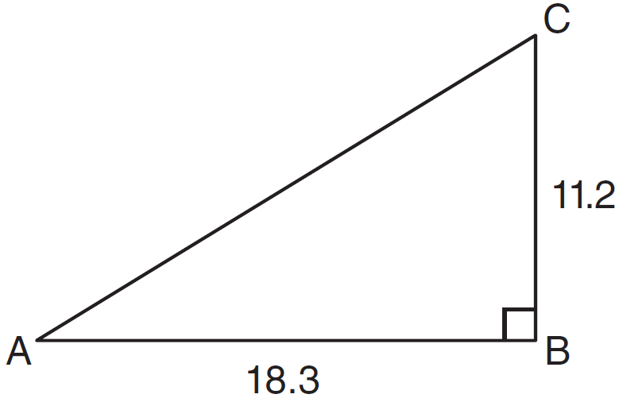

What is the measure of , to the nearest tenth of a degree?
1) | 31.5
2) | 37.7
3) | 52.3
4) | 58.5

15 The maximum height and speed of various roller coasters in North America are shown in the table below.

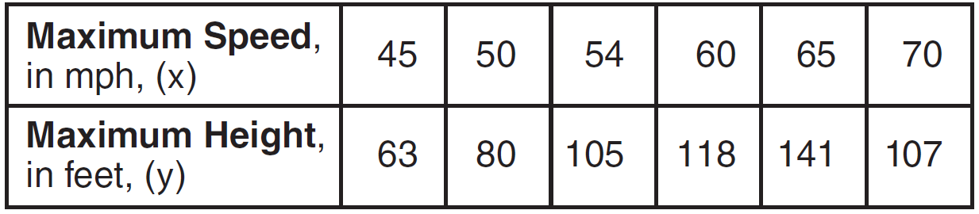

Which graph represents a correct scatter plot of the data?
1) | 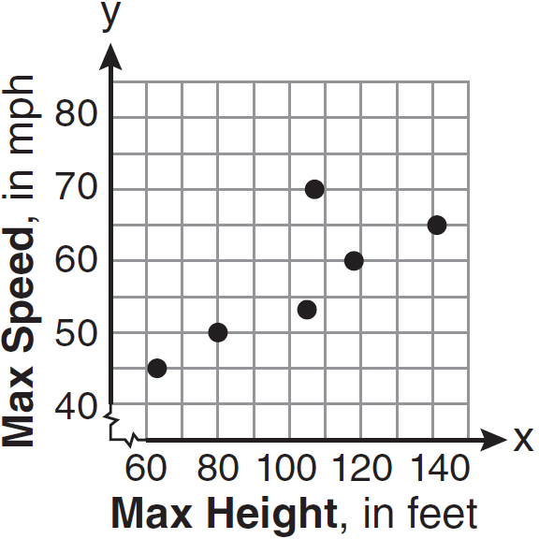
2) | 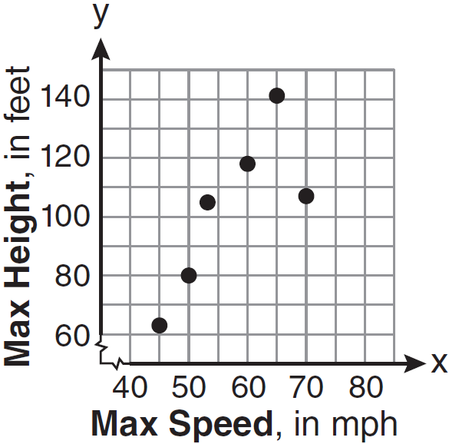
3) | 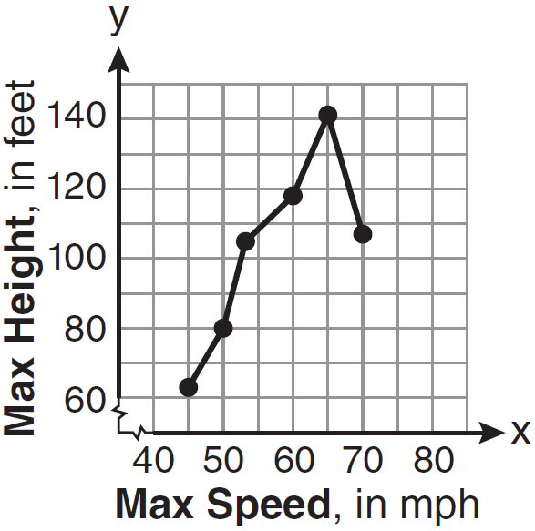
4) | 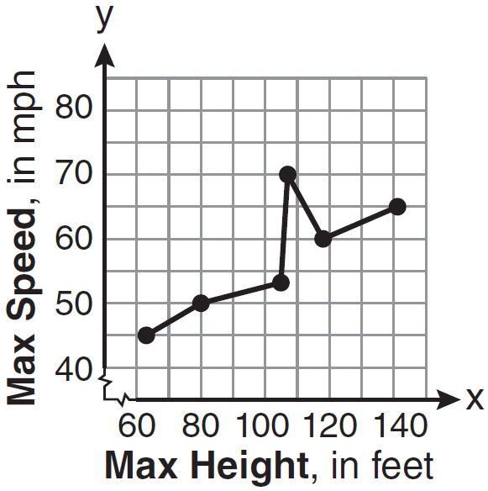

16 Which set of ordered pairs represents a function?
1)
2)
3)
4)

17 A hiker walked 12.8 miles from 9:00 a.m. to noon. He walked an additional 17.2 miles from 1:00 p.m. to 6:00 p.m. What is his average rate for the entire walk, in miles per hour?
1) | 3.75
2) | 3.86
3) | 4.27
4) | 7.71

18 Which ordered pair is a solution to the system of equations and ?
1)
2)
3)
4)

19 Which verbal expression can be represented by ?
1) | 5 less than 2 times x
2) | 2 multiplied by x less than 5
3) | twice the difference of x and 5
4) | the product of 2 and x, decreased by 5

20 The dimensions of a rectangle are measured to be 12.2 inches by 11.8 inches. The actual dimensions are 12.3 inches by 11.9 inches. What is the relative error, to the nearest ten-thousandth, in calculating the area of the rectangle?
1) | 0.0168
2) | 0.0167
3) | 0.0165
4) | 0.0164

21 An example of an algebraic expression is
1)
2)
3)
4)

22 A study showed that a decrease in the cost of carrots led to an increase in the number of carrots sold. Which statement best describes this relationship?
1) | positive correlation and a causal relationship
2) | negative correlation and a causal relationship
3) | positive correlation and not a causal relationship
4) | negative correlation and not a causal relationship

23 Given: 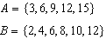
What is the union of sets A and B?
1)
2)
3)
4)

24 The value of a car purchased for $20,000 decreases at a rate of 12% per year. What will be the value of the car after 3 years?
1) | $12,800.00
2) | $13,629.44
3) | $17,600.00
4) | $28,098.56

25 For which set of values of x is the algebraic expression 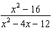 undefined?
1)
2)
3)
4)

26 Michael is 25 years younger than his father. The sum of their ages is 53. What is Michael’s age?
1) | 14
2) | 25
3) | 28
4) | 39

27 What is the product of , , and expressed in scientific notation?
1)
2)
3)
4)

28 Which notation describes ?
1)
2)
3)
4)

29 What is 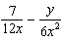 expressed in simplest form?
1) | 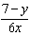
2) | 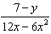
3) | 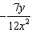
4) | 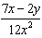

30 When is subtracted from , the difference is
1) | 0
2)
3)
4)

31 The area of a rectangle is represented by . If the width of the rectangle is represented by , express the length of the rectangle as a binomial.

32 A method for solving is shown below. Identify the property used to obtain each of the two indicated steps.

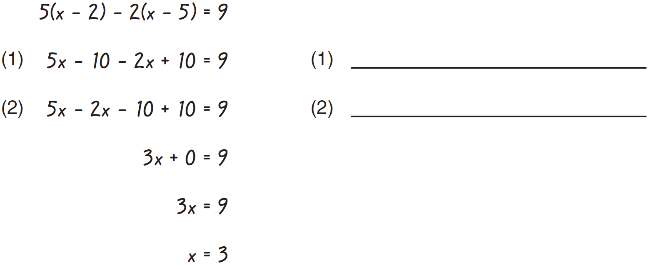

33 State the equation of the axis of symmetry and the coordinates of the vertex of the parabola graphed below.

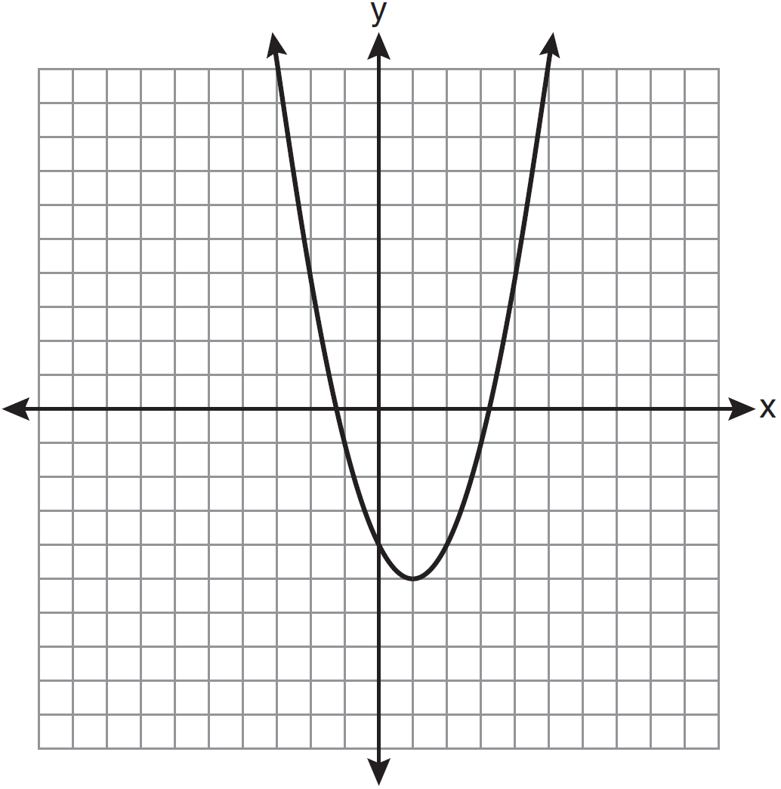

34 Given the following list of students' scores on a quiz:
5, 12, 7, 15, 20, 14, 7
Determine the median of these scores. Determine the mode of these scores. The teacher decides to adjust these scores by adding three points to each score. Explain the effect, if any, that this will have on the median and mode of these scores.

35 Chelsea has $45 to spend at the fair. She spends $20 on admission and $15 on snacks. She wants to play a game that costs $0.65 per game. Write an inequality to find the maximum number of times, x, Chelsea can play the game. Using this inequality, determine the maximum number of times she can play the game.

36 A plastic storage box in the shape of a rectangular prism has a length of , a width of , and a height of 5. Represent the surface area of the box as a trinomial in terms of x.

37 Solve algebraically for x: 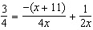

38 An outfit Jennifer wears to school consists of a top, a bottom, and shoes. Possible choices are listed below.
Tops: T-shirt, blouse, sweater
Bottoms: jeans, skirt, capris
Shoes: flip-flops, sneakers
List the sample space or draw a tree diagram to represent all possible outfits consisting of one type of top, one type of bottom, and one pair of shoes. Determine how many different outfits contain jeans and flip-flops. Determine how many different outfits do not include a sweater.

39 Solve the following system of inequalities graphically on the set of axes below.
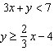
State the coordinates of a point in the solution set.

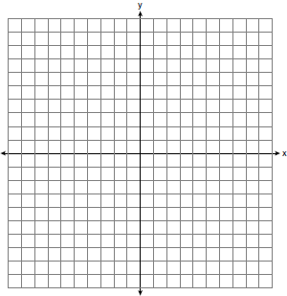
1 ANS: 3 PTS: 2 REF: 061101ia STA: A.A.19
TOP: Factoring the Difference of Perfect Squares

2 ANS: 3
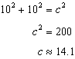

PTS: 2 REF: 061102ia STA: A.A.45 TOP: Pythagorean Theorem

3 ANS: 1 PTS: 2 REF: 061103ia STA: A.A.12
TOP: Division of Powers

4 ANS: 3
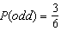, 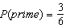, 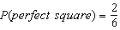, 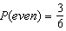

PTS: 2 REF: 061104ia STA: A.S.22 TOP: Geometric Probability

5 ANS: 2 PTS: 2 REF: 061105ia STA: A.A.20
TOP: Factoring Polynomials

6 ANS: 3

PTS: 2 REF: 061106ia STA: A.N.2 TOP: Simplifying Radicals

7 ANS: 1
Asking school district employees about a school board candidate produces the most bias.

PTS: 2 REF: 061107ia STA: A.S.3 TOP: Analysis of Data

8 ANS: 2
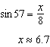

PTS: 2 REF: 061108ia STA: A.A.44 TOP: Using Trigonometry to Find a Side

9 ANS: 4

PTS: 2 REF: 061109ia STA: A.N.8 TOP: Permutations

10 ANS: 3
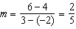

PTS: 2 REF: 061110ia STA: A.A.33 TOP: Slope

11 ANS: 4 PTS: 2 REF: 061111ia STA: A.G.4
TOP: Families of Functions

12 ANS: 4 PTS: 2 REF: 061112ia STA: A.A.36
TOP: Parallel and Perpendicular Lines

13 ANS: 2 PTS: 2 REF: 061113ia STA: A.G.5
TOP: Graphing Quadratic Functions

14 ANS: 1 PTS: 2 REF: 061114ia STA: A.A.43
TOP: Using Trigonometry to Find an Angle

15 ANS: 2 PTS: 2 REF: 061115ia STA: A.S.7
TOP: Scatter Plots

16 ANS: 2
In (2), each element in the domain corresponds to a unique element in the range.

PTS: 2 REF: 061116ia STA: A.G.3 TOP: Defining Functions

17 ANS: 1
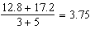

PTS: 2 REF: 061117ia STA: A.M.1 TOP: Speed

18 ANS: 2
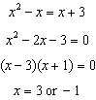. Since , the solutions are and . 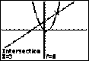

PTS: 2 REF: 061118ia STA: A.A.11 TOP: Quadratic-Linear Systems

19 ANS: 3 PTS: 2 REF: 061119ia STA: A.A.2
TOP: Expressions

20 ANS: 3
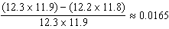

PTS: 2 REF: 061120ia STA: A.M.3 TOP: Error
KEY: area

21 ANS: 2 PTS: 2 REF: 061121ia STA: A.A.3
TOP: Expressions

22 ANS: 2 PTS: 2 REF: 061122ia STA: A.S.14
TOP: Analysis of Data

23 ANS: 4 PTS: 2 REF: 061123ia STA: A.A.31
TOP: Set Theory

24 ANS: 2

PTS: 2 REF: 061124ia STA: A.A.9 TOP: Exponential Functions

25 ANS: 4
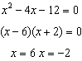

PTS: 2 REF: 061125ia STA: A.A.15 TOP: Undefined Rationals

26 ANS: 1
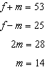

PTS: 2 REF: 061126ia STA: A.A.7 TOP: Writing Linear Systems

27 ANS: 2 PTS: 2 REF: 061127ia STA: A.N.4
TOP: Operations with Scientific Notation

28 ANS: 2 PTS: 2 REF: 061128ia STA: A.A.29
TOP: Set Theory

29 ANS: 4
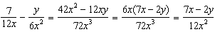

PTS: 2 REF: 061129ia STA: A.A.17 TOP: Addition and Subtraction of Rationals

30 ANS: 4 PTS: 2 REF: 061130ia STA: A.A.13
TOP: Addition and Subtraction of Polynomials KEY: subtraction

31 ANS:
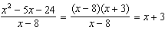

PTS: 2 REF: 061131ia STA: A.A.14 TOP: Division of Polynomials

32 ANS:
(1) Distributive; (2) Commutative

PTS: 2 REF: 061132ia STA: A.N.1 TOP: Identifying Properties

33 ANS:

PTS: 2 REF: 061133ia STA: A.G.10
TOP: Identifying the Vertex of a Quadratic Given Graph

34 ANS:
12, 7. Both the median and the mode will increase.

PTS: 3 REF: 061134ia STA: A.S.16 TOP: Central Tendency

35 ANS:
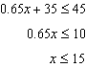

PTS: 3 REF: 061135ia STA: A.A.6 TOP: Modeling Inequalities

36 ANS:
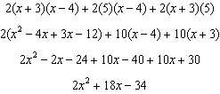

PTS: 3 REF: 061136ia STA: A.G.2 TOP: Surface Area

37 ANS:
. 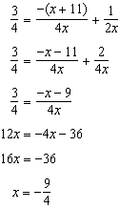

PTS: 4 REF: 061137ia STA: A.A.26 TOP: Solving Rationals

38 ANS:
(T,J,F), (T,J,N), (T,K,F), (T,K,N), (T,C,F), (T,C,N), (B,J,F), (B,J,N), (B,K,F), (B,K,N), (B,C,F), (B,C,N), (S,J,F), (S,J,N), (S,K,F), (S,K,N), (S,C,F), (S,C,N). 3, 12.

PTS: 4 REF: 061138ia STA: A.S.19 TOP: Sample Space

39 ANS:
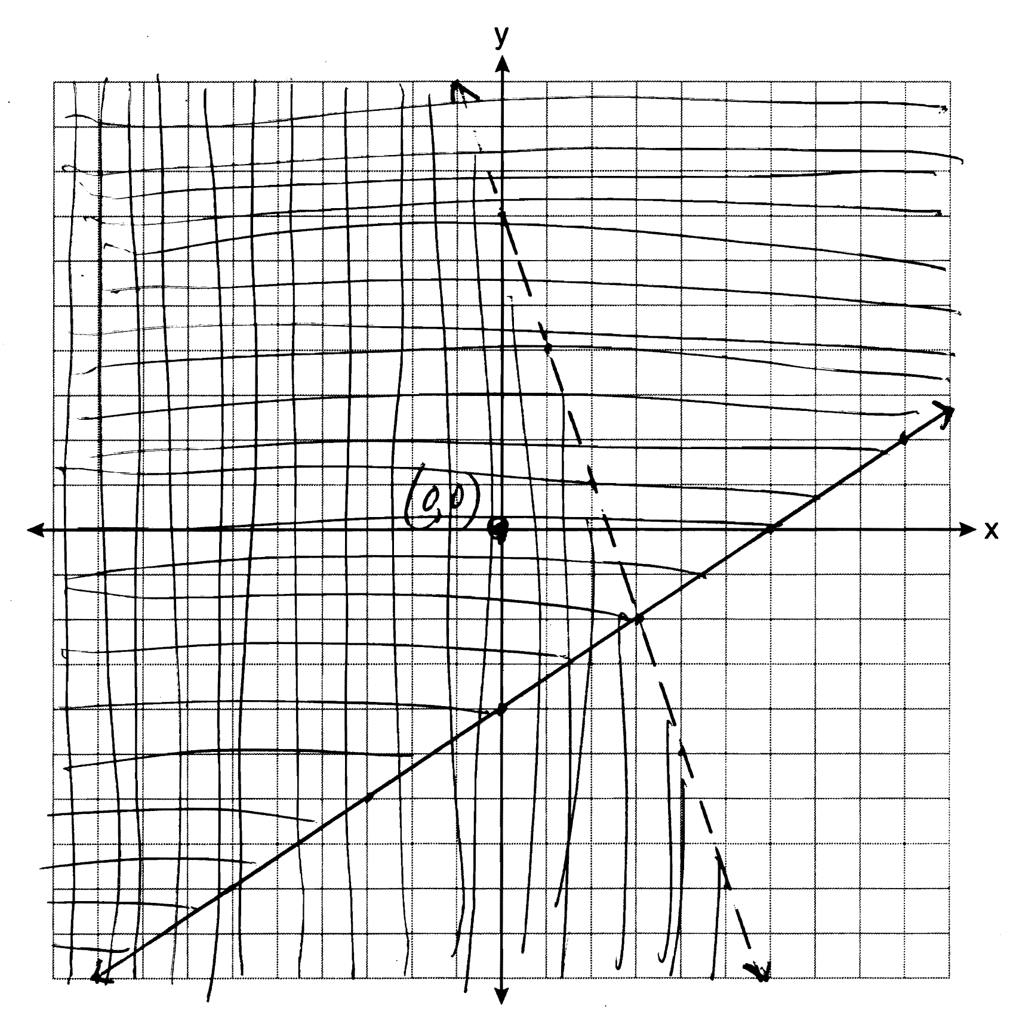

PTS: 4 REF: 061139ia STA: A.G.7 TOP: Systems of Linear Inequalities

