**D – Rate, Lesson 3, Speed (r. 2018)**

RATE

Speed

|  |  |
| --- | --- |
| **Common Core Standard**  **A-CED.A.2** Create equations in two or more variables to represent relationships between quantities; ~~graph equations on coordinate axes with labels and scales~~. | **Next Generation Standard**  **AI-A.CED.2** Create equations and linear inequalities in two variables to represent a **real-world context**.  Notes:  • This is strictly the development of the model (equation/inequality).  • Limit equations to linear, quadratic, and exponentials of the form *f(x) = a(b)x* where *a* > 0 and *b* > 0 (*b* ≠ 1). |

**LEARNING OBJECTIVES**

Students will be able to:

1) Solve problems involving the speed formula: 

**Overview of Lesson**

|  |  |
| --- | --- |
| **Teacher Centered Introduction**  **Overview of Lesson**  **- activate students’ prior knowledge**  **- vocabulary**  **- learning objective(s)**  **- big ideas: direct instruction**  **- modeling** | **Student Centered Activities**  **guided practice ⬅Teacher: anticipates, monitors, selects, sequences, and connects student work**  **- developing essential skills**  **- Regents exam questions**  **- formative assessment assignment (exit slip, explain the math, or journal entry)** |

**VOCABULARY**

distance

speed

time

**BIG IDEAS**

 

**DEVELOPING ESSENTIAL SKILLS**

|  |  |
| --- | --- |
| **Questions** | **Answers** |
| An airplane travels 700 miles in two hours. What is its average speed? |  |
| A train travel 400 miles in 8 hours.  What is its average speed? |  |
| A car’s average speed is 60 miles per hour.  How far has it travelled after 6 hours? |  |
| A car averages 55 miles per hour.  How long will it take to travel 300 miles, to the hour and *nearest minute*? |  |

**REGENTS EXAM QUESTIONS**

A.CED.A.2: Speed

91) An airplane leaves New York City and heads toward Los Angeles. As it climbs, the plane gradually increases its speed until it reaches cruising altitude, at which time it maintains a constant speed for several hours as long as it stays at cruising altitude. After flying for 32 minutes, the plane reaches cruising altitude and has flown 192 miles. After flying for a total of 92 minutes, the plane has flown a total of 762 miles. Determine the speed of the plane, at cruising altitude, in miles per minute. Write an equation to represent the number of miles the plane has flown, *y*, during *x* minutes at cruising altitude, only. Assuming that the plane maintains its speed at cruising altitude, determine the total number of miles the plane has flown 2 hours into the flight.

92) Loretta and her family are going on vacation. Their destination is 610 miles from their home. Loretta is going to share some of the driving with her dad. Her average speed while driving is 55 mph and her dad's average speed while driving is 65 mph. The plan is for Loretta to drive for the first 4 hours of the trip and her dad to drive for the remainder of the trip. Determine the number of hours it will take her family to reach their destination. After Loretta has been driving for 2 hours, she gets tired and asks her dad to take over. Determine, to the *nearest tenth of an hour*, how much time the family will save by having Loretta's dad drive for the remainder of the trip.

**SOLUTIONS**

91) ANS:

Strategy: Draw a picture to model the problem.

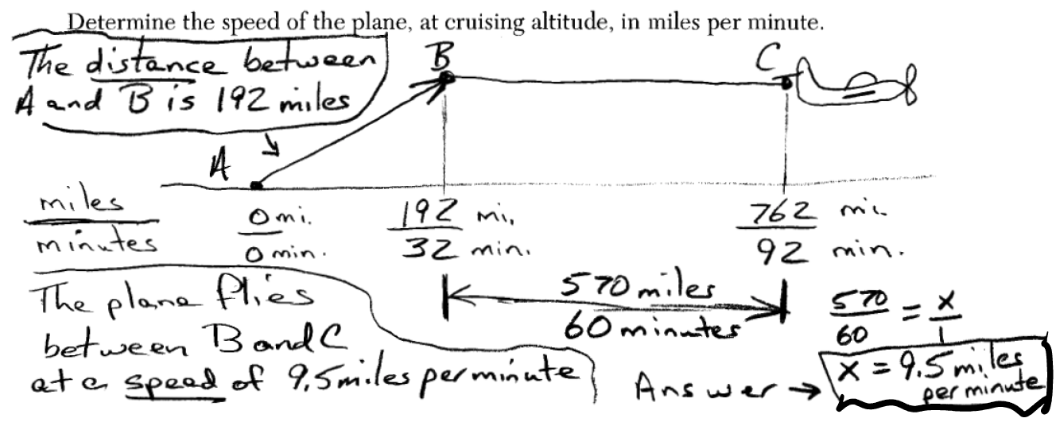

At cruising altitude, the plane is flying at the speed of 9.5 miles per minute.

Write an equation to represent the number of miles the plane has flown, *y*, during *x* minutes at cruising altitude, only. (NOTE: This is line segment  in the above picture.



Assuming that the plane maintains its speed at cruising altitude, determine the total number of miles the plane has flown 2 hours into the flight.

Let *M* represent the total miles flown. Let *t* represent the number of minutes flown.

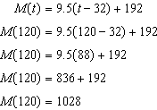

2 hours into the flight, the plane has flown 1,028 miles.

PTS: 4 NAT: A.CED.A.2 TOP: Speed

92) ANS:

10 hours and .3 hours.

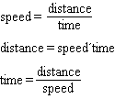

If Loretta drives at an average speed of 55 miles per hour for the first 4 hours of the trip, she will drive  miles. Since the total distance is 610 miles, this leaves  miles for her dad to drive. If her dad drives at an average speed of 65 miles per hour, it will take him  hours to drive 390 miles. If Loretta drives 4 hours and her dad drives 6 hours, the total trip will take 10 hours.

If Loretta gets tired after two hours of driving at an average speed of 55 miles per hour, she will have driven  miles, leaving  miles for her dad to drive. At an average speed of 65 m iles per hour, it will take her dad  hours to drive 500 miles. The family will save approximately  hours by having Loretta’s dad drive for the remainder of the trip.

PTS: 4 NAT: A.CED.A.2 TOP: Speed