**K – Polynomials, Lesson 1, Identifying Solutions (r. 2018)**

POLYNOMIALS

Identifying Solutions

|  |  |
| --- | --- |
| **Common Core Standard**  **A-REI.10** Understand that the graph of an equation in two variables is the set of all its solutions plotted in the coordinate plane, ~~often forming a curve (which could be a line)~~. | **Next Generation Standard**  **AI-A.REI.10** Understand that the graph of an equation in two variables is the set of all its solutions plotted in the coordinate plane.  **Note: Graphing linear equations is a fluency recommendation for Algebra I. Students become fluent in solving characteristic problems involving the analytic geometry of lines, such as writing down the equation of a line given a point and a slope. Such fluency can support them in solving less routine mathematical problems involving linearity; as well as modeling linear phenomena.** |

**LEARNING OBJECTIVES**

Students will be able to:

1)

**Overview of Lesson**

|  |  |
| --- | --- |
| **Teacher Centered Introduction**  **Overview of Lesson**  **- activate students’ prior knowledge**  **- vocabulary**  **- learning objective(s)**  **- big ideas: direct instruction**  **- modeling** | **Student Centered Activities**  **guided practice ⬅Teacher: anticipates, monitors, selects, sequences, and connects student work**  **- developing essential skills**  **- Regents exam questions**  **- formative assessment assignment (exit slip, explain the math, or journal entry)** |

**VOCABULARY**

balanced equation

graph

ordered pair

solutions

table of values

true statement

**BIG IDEAS**

A solution to an equation is a value or values that satisfy the equation.

* In equations, solutions are those values that make the left expression equal to the right expression. When both the left and right expressions are equal in value, the equation is said to be balanced and the equation becomes a true statement.
* In tables of values, solutions appear in the form of ordered pairs that, when substituted into the equation, will make the equation balance.
* In a graph, solutions appear as points on the line. The graph of an equation represents the set of all points that satisfy the equation (make the equation balance). Each and every point on the graph of an equation represents a ordered pair that can be substituted into the equation to make the equation true. Thus, if a point is on the graph of the equation, the point is a solution to the equation.

**MODELING ESSENTIAL SKILLS**

|  |  |  |  |
| --- | --- | --- | --- |
| ?Solution?  and Equation | Balanced  Equation | Table  of Values | Graph |
| 1. Is (2,3) a solution of | No, the equation does not balance. | No, the table of values shows: when , the values of y is 2.3333. | No, the point (2,3) is not on the graph of the line |
| 1. Is (4,-1) a solution of | Yes. The equation balances. | Yes. The table of values shows that when x = 4, the value of y is  -1. | Yes. The point (4,-1) is on the graph of the line |

**DEVELOPING ESSENTIAL SKILLS**

Determine if the given ordered pair is a solution to the given equation using three different methods for identifying solutions.

|  |  |  |  |
| --- | --- | --- | --- |
| ?Solution?  and Equation | Balanced  Equation | Table  of Values | Graph |
| 1. Is (4,5) a solution of ? | No. The equation does not balance. | No. The table of values shows that when x = 4, the value of y is also 4. | No, the point (4,5) is not on the graph of the line |
| 1. Is (5,1) a solution of ? | No. The equation does not balance. | No. The table of values shows that when x=5, the value of y is 24. | No, the point (5,1) is not on the line. |
| Is (4,-10) a solution of ? | Yes. The equation balances. | Yes. The table of values shows that when x=4, the value of y is -10. | Yes. The point (4, -10) is on the line. |

**REGENTS EXAM QUESTIONS (through June 2018)**

**A.REI.10: Identifying Solutions**

325) On the set of axes below, draw the graph of the equation .

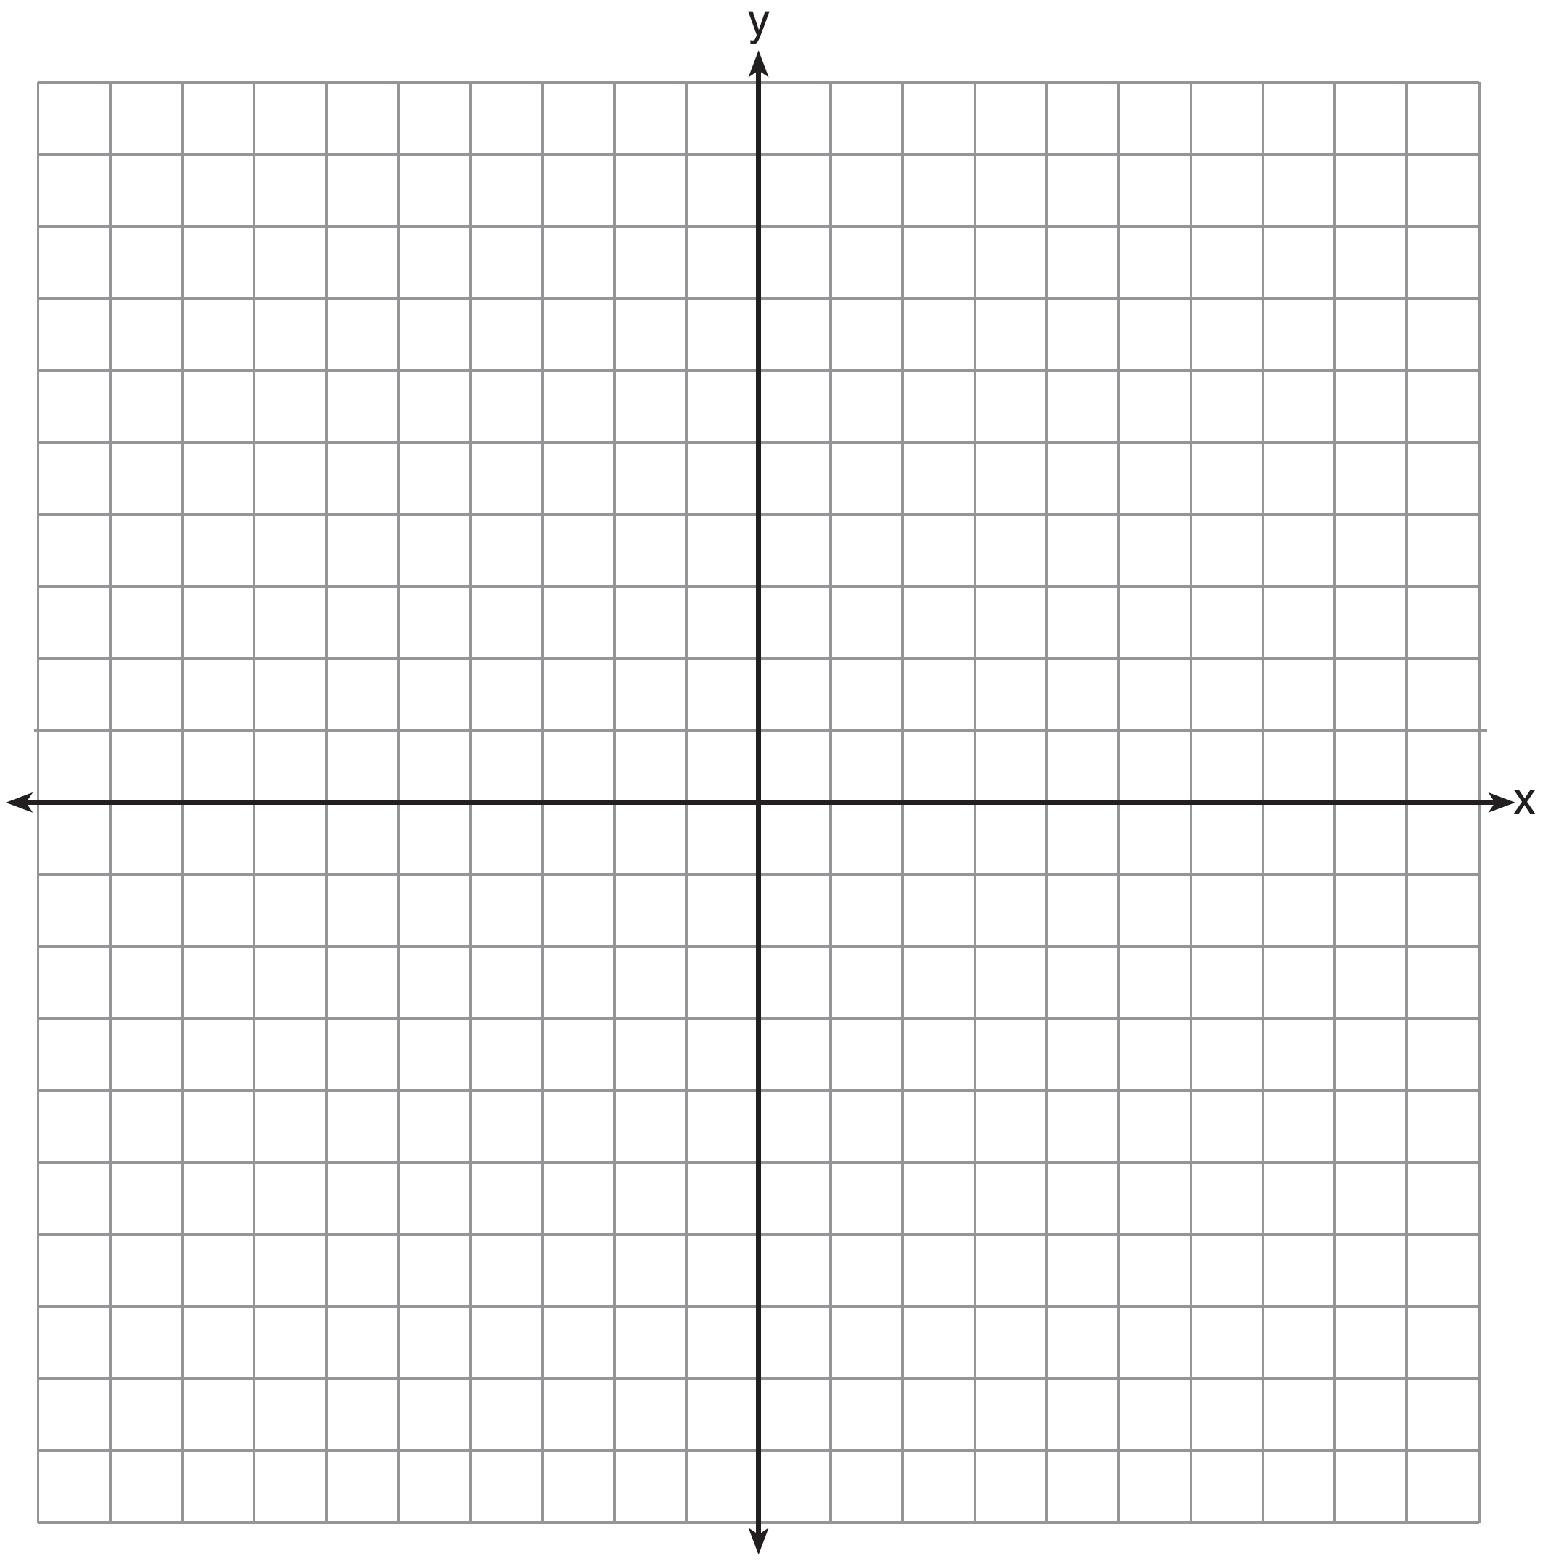

Is the point  a solution to the equation? Explain your answer based on the graph drawn.

326) Which point is *not* on the graph represented by ?

|  |  |  |  |
| --- | --- | --- | --- |
| 1) |  | 3) |  |
| 2) |  | 4) |  |

327) The solution of an equation with two variables, *x* and *y*, is

|  |  |  |  |
| --- | --- | --- | --- |
| 1) | the set of all x values that make *y = 0.* | 3) | the set of all ordered pairs , that makes the equation true. |
| 2) | the set of all y values that make x *= 0.* | 4) | the set of all ordered pairs , where the graph of the equation crosses the *y*-axis |

328) Which ordered pair would *not* be a solution to ?

|  |  |
| --- | --- |
| 1) |  |
| 2) |  |
| 3) |  |
| 4) |  |

329) Which ordered pair below is *not* a solution to ?

|  |  |
| --- | --- |
| 1) |  |
| 2) |  |
| 3) |  |
| 4) |  |

**SOLUTIONS**

325) ANS:

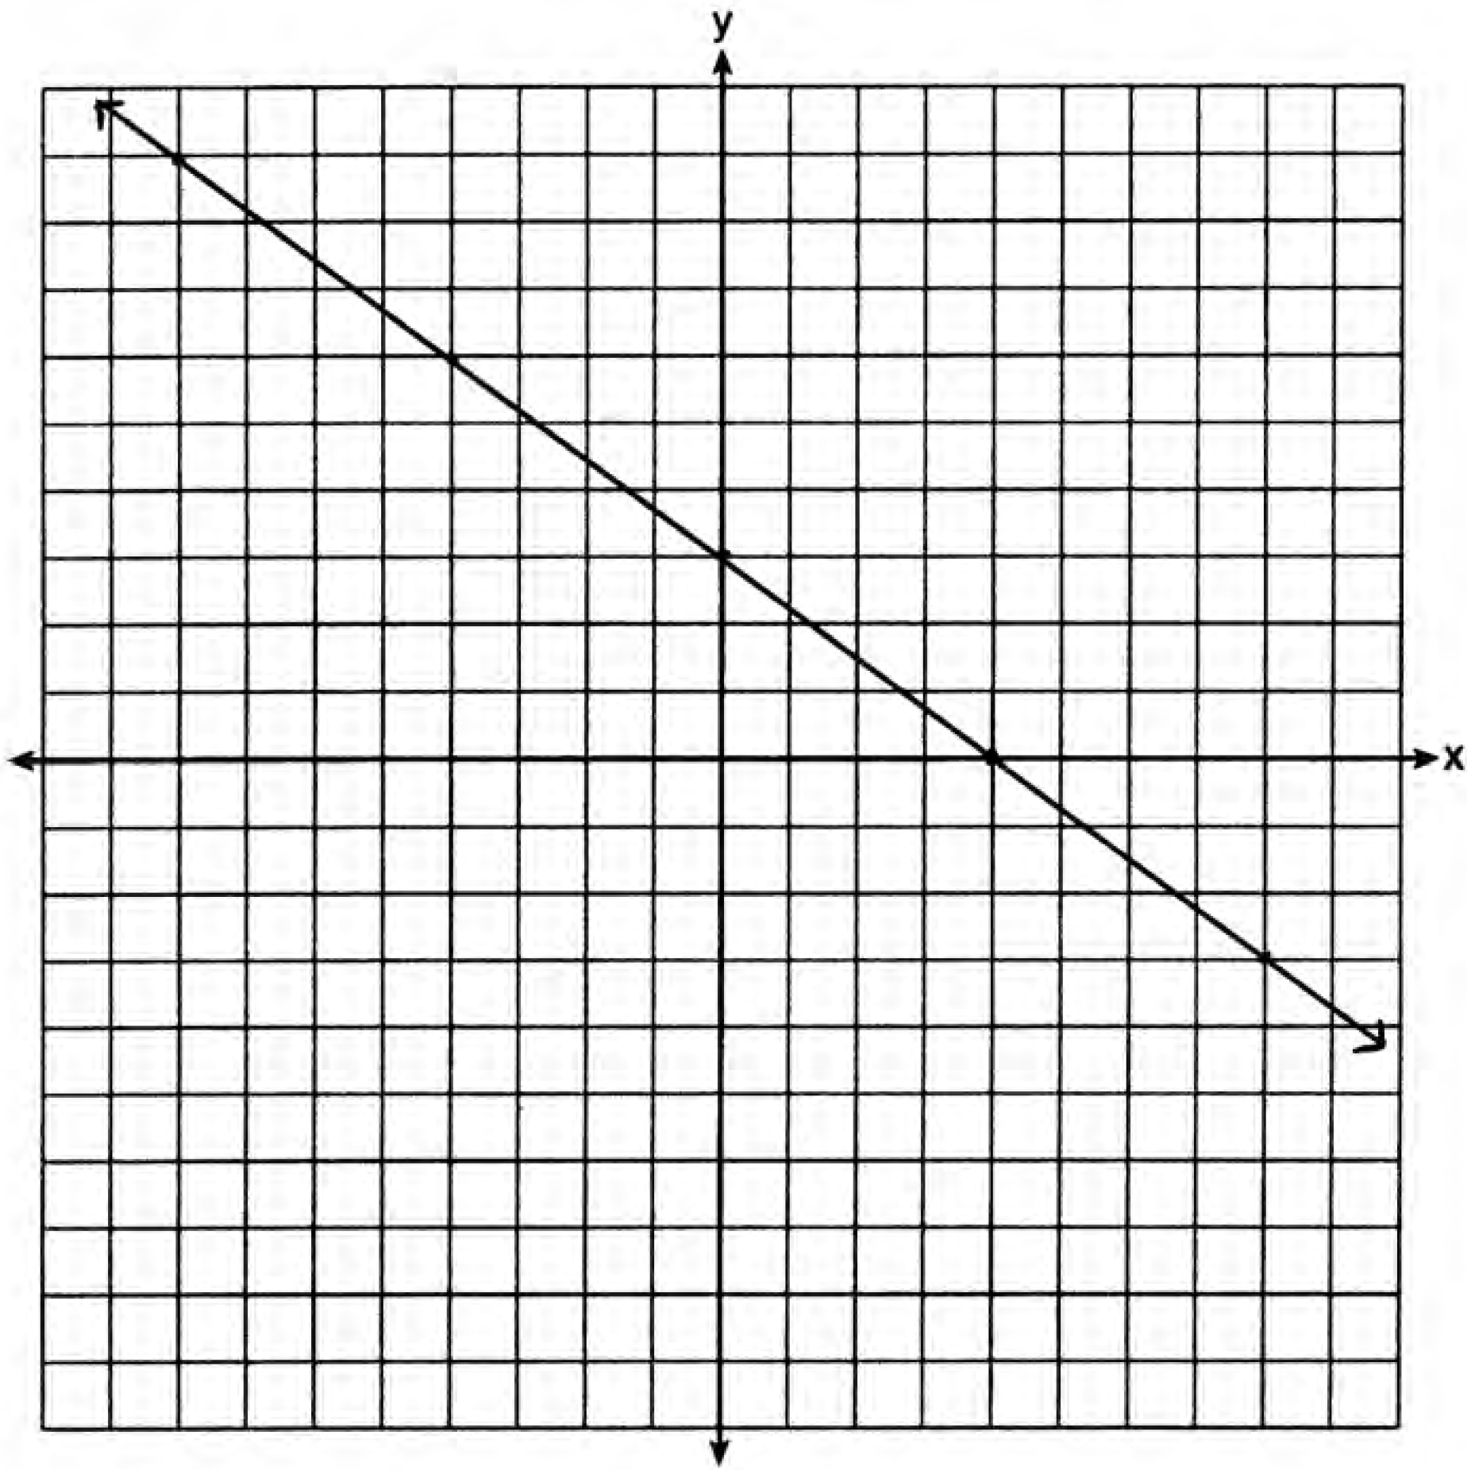

No, because  is not on the graph.

Strategy #1. Use the y-intercept and the slope to plot the graph of the line, then determine if the point  is on the graph.

STEP 1. Plot the y-intercept.

Plot . The given equation is in the slope intercept form of a line, , where b is the y-intercpet. The value of b is 3, so the graph of the equation crosses the y axis at .

STEP 2. Use the slope of the line to find and plot a second point on the line. The given equation is in the slope intercept form of a line, , where m is the slopet. The value of m is , so the graph of the equation has a negative slope that goes down three units and across four units. Starting at the y-intercept, , if you go down 3 and over 4, the graph of the line will pass through the point .

STEP 3. Use a straightedge to draw a line that passes through the points  and .

STEP 4. Inspect the graph to determine if the point  is on the line. It is not.

Strategy #2. Input the equation of the line into a graphing calculator, then use the table of values to plot the graph of the line and to determine if the point  is on the line.

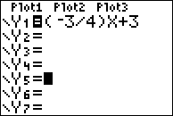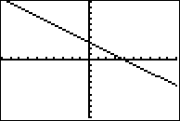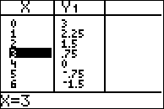

Be sure to explain your answer in terms of the graph and not in terms of the table of values or the function rule.

PTS: 2 NAT: A.REI.10 TOP: Graphing Linear Functions

326) ANS: 4

Straegy: Input the equation in a graphing calculator, then use the table of values to eliminate wrong answers.

STEP 1. Input the equation and look at the table view of the function.

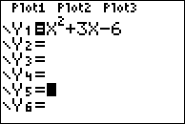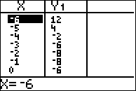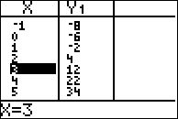

STEP 2. Eliminate answers that are *on* the graph.

The point (-6, 12) is on the graph, so eliminate answer choice a.

The point (-4, -2) is on the graph, so eliminate answer choice b.

The point (2, 4) is on the graph, so eliminate answer choice c.

The point (3, -6) is *not* on the graph, so answer choice d is the correct answer.

PTS: 2 NAT: A.REI.D.10 TOP: Graphing Quadratic Functions

327) ANS: 3

1. Understanding: The problem is asking for the definition of solution as it relates to to equations with two variables.

2. Strategy: Examine each answer choice and eliminate wrong answers.

3. Execution of Strategy:

a) the set of all x-values that make  is used to find the x-intercepts of an equation.

b) the set of all y-values that make  is used to find the y-intercepts of an equation.

c) the set of all ordered pairs, (x,y) that makes the equation true is the best answer choice.

d) the set of all ordered pirs, (x,y) where the graph of the equation crosses the y-axis is too limiting.

4. Does it Make Sense? Yes. An equation is true if the left expression equals the right expression. If the equation has two variables, then the solution to the equation must have values for each variable.

PTS: 2 NAT: A.REI.D.11

328) ANS: 4

Strategy #1: Input the equation into a graphing calculator and inspect the table of values to see which answer choices are solutions to the equation.

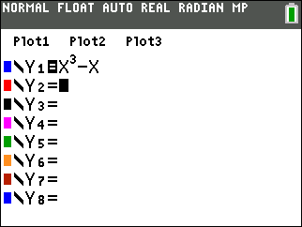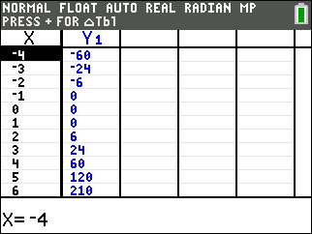

Note that , , and  appear in the table and are, therefore, solutions to the equation . The ordered pair  does not appear in the table and is, therefore, not a solution to the equation .

Strategy #2

Substitute each ordered pair into the equation  and see if the equation balances.

|  |  |
| --- | --- |
| Equation balances. | Equation balances. |
| Equation balances. | Equation does not balance. |

PTS: 2 NAT: A.REI.D.10 TOP: Identifying Solutions

329) ANS: 4

Strategy: Use the table of values view in a graphing calculator to find the ordered pair that does not satisfy the function.

STEP 1. Input  into a graphing calculator

STEP 2. Set table view to increase by half integers.

STEP 3. Inspect table and eliminate any answer choice that appears in the table.

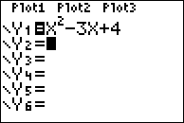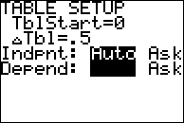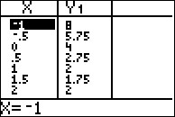

STEP 4. Select the ordered pair that does not appear in the table of values.

STEP 5. Check: The ordered pair (-1,6) does not appear in the table of values and will not satisfy the function rule .

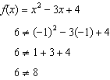

PTS: 2 NAT: A.REI.D.10 TOP: Identifying Solutions