**I – Systems, Lesson 7, Other Systems (r. 2018)**

SYSTEMS

Other Systems

|  |  |
| --- | --- |
| **Common Core Standard**  **A-REI.D.11** Explain why the x-coordinates of the points where the graphs of the equations *y=f(x)* and *y=g(x)* intersect are the solutions of the equation *f(x)=g(x)*; find the solutions approximately, e.g., using technology to graph the functions, make tables of values, ~~or find successive approximations~~. Include cases where *f(x)* and/or *g(x)* are linear, polynomial, rational, absolute value, exponential~~, and logarithmic functions~~.  ~~PARCC: Tasks that assess conceptual understanding of the indicated concept may involve any of the function types mentioned in the standard except exponential and logarithmic functions. Finding the solutions approximately is limited to cases where f(x) and g(x) are polynomial functions.~~ | **Next Generation Standard**  **AI-A.REI.11** Given the equations *y = f(x)* and *y = g(x)*:  i) **recognize** that each x-coordinate of the intersection(s) is the solution to the equation *f(x) = g(x)*;  ii)find the solutions approximately using technology to graph the functions or make tables of values; and  iii) **interpret the solution in context**.  (Shared standard with Algebra II)  **Notes: Algebra I tasks are limited to cases where *f(x)* and *g(x)* are linear, polynomial, absolute value, and exponential functions of the form  where *a* > 0 and *b* > 0 (*b* ≠ 1).**  **Students should be taught to find the solutions approximately by using technology to graph the functions *and* by making tables of values. When solving any problem, students can choose either strategy.** |

**LEARNING OBJECTIVES**

Students will be able to:

1) use technology to create tables and graphs to find solutions of systems of equations involving linear and non-linear functions.

**Overview of Lesson**

|  |  |
| --- | --- |
| **Teacher Centered Introduction**  **Overview of Lesson**  **- activate students’ prior knowledge**  **- vocabulary**  **- learning objective(s)**  **- big ideas: direct instruction**  **- modeling** | **Student Centered Activities**  **guided practice ⬅Teacher: anticipates, monitors, selects, sequences, and connects student work**  **- developing essential skills**  **- Regents exam questions**  **- formative assessment assignment (exit slip, explain the math, or journal entry)** |

**VOCABULARY**

absolute value equation

exponential equation

families of functions

linear equation

piecewise equation

quadratic equations

slope intercept form

solution of a system

**BIG IDEAS**

A **solution of a system** of equations makes each equation in the system true. This rule can be applied to systems involving different families of functions. Typically, graphing is the easiest way to solve systems of equations involving different families of functions. Algebraic solutions may also be used.

**DEVELOPING ESSENTIAL SKILLS**

Use technology to create a table of value and graph for each system, then state the solution(s) for each system.

|  |  |  |  |  |
| --- | --- | --- | --- | --- |
| 1.  absolute  linear | 2.  absolute  quadratic | 3.  quadratic  piecewise | 4.  quadratic  quadratic | 5.  absolute  quadratic |

Answers

|  |  |  |  |
| --- | --- | --- | --- |
| Solutions | Calculator Input | Table | Graph |
| 1.    (-1,1) |  |  |  |
| 2.    (-2,0) and (2,0) |  |  |  |
| 3.    (-2,0) and (2,0) |  |  |  |
| 4.    (-4,1) and (-1,1) |  |  |  |
| 5.    (-1,1) and (1,1) |  |  |  |

**REGENTS EXAM QUESTIONS (through June 2018)**

A.REI.D.11: Other Systems

294) Two functions,  and , are graphed on the same set of axes. Which statement is true about the solution to the system of equations?

|  |  |  |  |
| --- | --- | --- | --- |
| 1) | is the solution to the system because it satisfies the equation . | 3) | is the solution to the system because it satisfies both equations. |
| 2) | is the solution to the system because it satisfies the equation . | 4) | , , and  are the solutions to the system of equations because they all satisfy at least one of the equations. |

295) On the set of axes below, graph

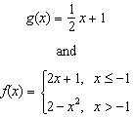



How many values of *x* satisfy the equation ? Explain your answer, using evidence from your graphs.

296) Given the functions  and , which value of *x* makes ?

|  |  |  |  |
| --- | --- | --- | --- |
| 1) |  | 3) | 3 |
| 2) | 2 | 4) |  |

297) The graphs of the functions  and  are drawn. Which statement about these functions is true?

|  |  |  |  |
| --- | --- | --- | --- |
| 1) | The solution to  is 3. | 3) | The graphs intersect when . |
| 2) | The solution to  is 1. | 4) | The graphs intersect when . |

298) The graph below shows two functions, *f(x)* and *g(x)*. State the values of *x* for which .

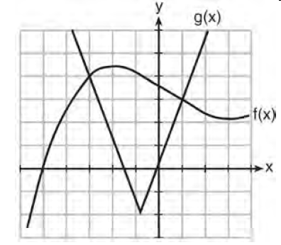

299) Which value of *x* results in equal outputs for  and ?

|  |  |  |  |
| --- | --- | --- | --- |
| 1) |  | 3) |  |
| 2) | 2 | 4) | 4 |

300) Graph  and  on the grid below. Does ? Use your graph to explain why or why not.



**SOLUTIONS**

294) ANS: 3

Strategy: Input both functions in a graphing calculator, then use the table and graph views of the function to select the correct answer.

STEP 1. Transpose the second function for input into a graphing calculator.

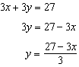

STEP 2. Input both functions in a graphing calculator.

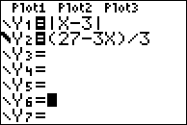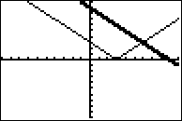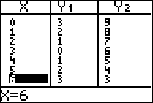

When , the value of y in both equations is 3. (6, 3) is the solution to this system.

PTS: 2 NAT: A.REI.D.11 TOP: Nonlinear Systems

295) ANS:

Step 1. Plot 

Step 2. Plot  over the interval 

Step 3. Plot  over the interval 

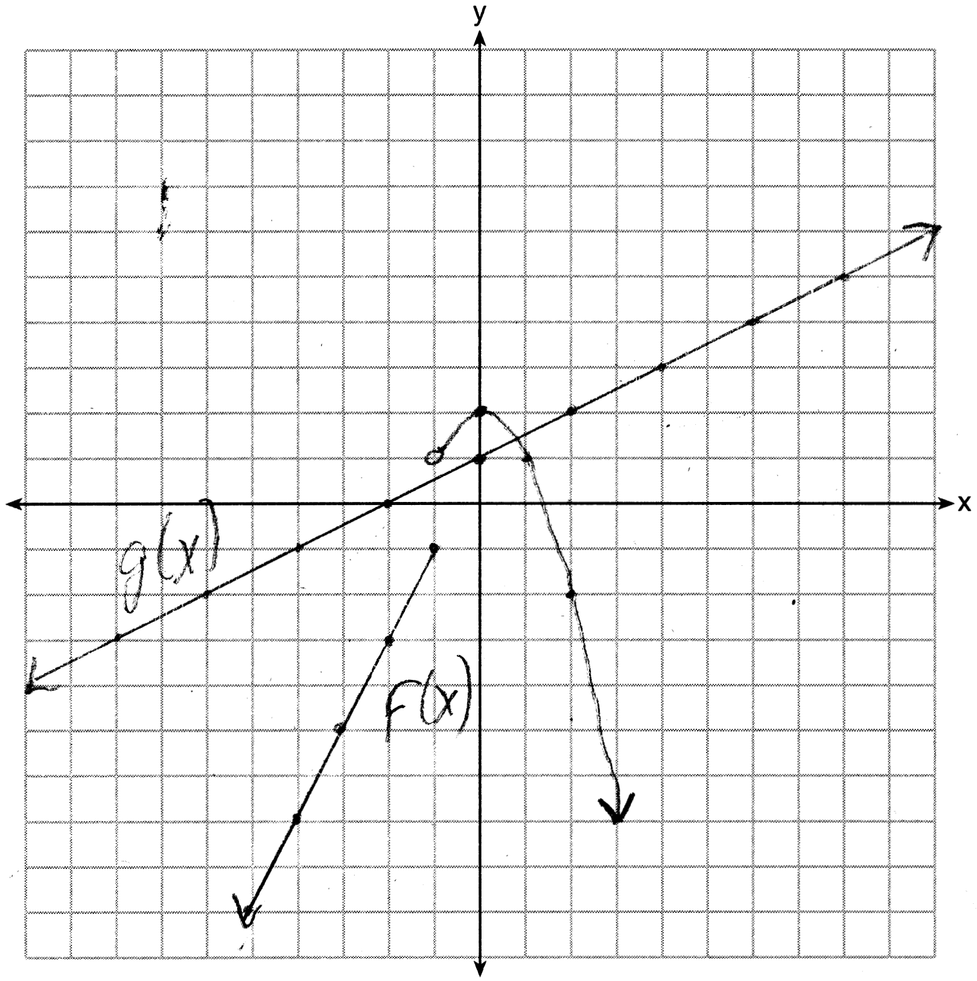

Only 1 value of *x* satisfies the equation , because the graphs only intersect once.

PTS: 4 NAT: F.IF.C.7 TOP: Other Systems

296) ANS: 1

Strategy #1: Input both function rules in a graphing calculator.

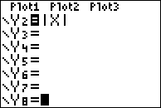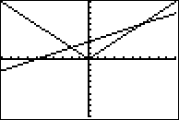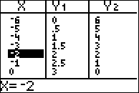

Strategy #2: Set the right expressions of both functions equal to one another. Then solve for the positive and negative values of .



|  |  |
| --- | --- |
|  |  |

Check:

|  |  |
| --- | --- |
|  |  |

PTS: 2 NAT: A.REI.D.11 TOP: Other Systems

297) ANS: 2

Step 1. Understand that only of the answer choices is true.

Step 2. Strategy. Input both functions in a graphing calculator and explore the truth of each answer choice.

Step 3. Execution of Strategy.

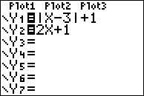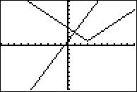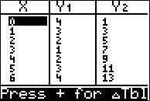

The graph and table show that the solution for this system of equations is (1,3). This means that  and . Accordingly, when x is 1, . The correct answer is choice b).

Step 4. Does is make sense? Yes. All of the other answer choices can be eliminated as wrong. The problem can be checked algebraically as follows:

Given:  and , find 

|  |  |
| --- | --- |
| This is an extraneous solution. | This solution checks. |

PTS: 2 NAT: A.REI.D.11 TOP: Other Systems

298) ANS:

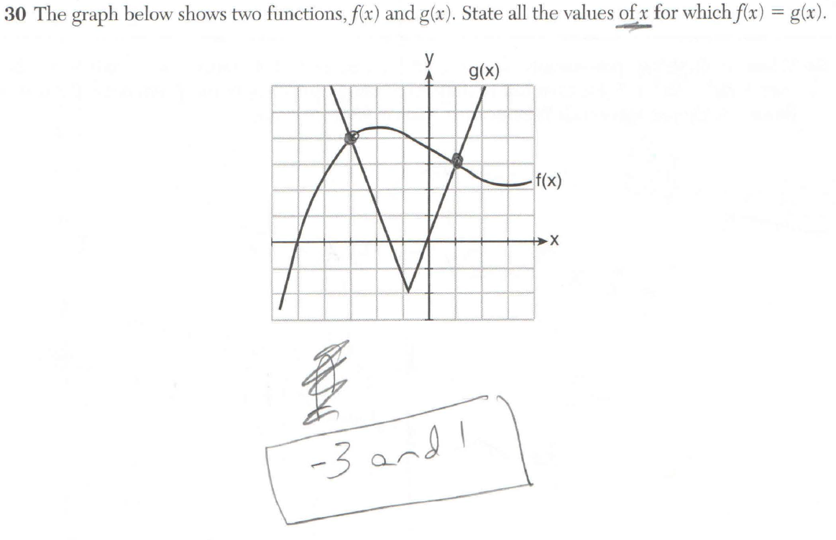

PTS: 2 NAT: A.REI.D.11

299) ANS: 2

When , .

|  |  |
| --- | --- |
|  |  |

PTS: 2 NAT: A.REI.D.11 TOP: Other Systems

KEY: AI

300) ANS:

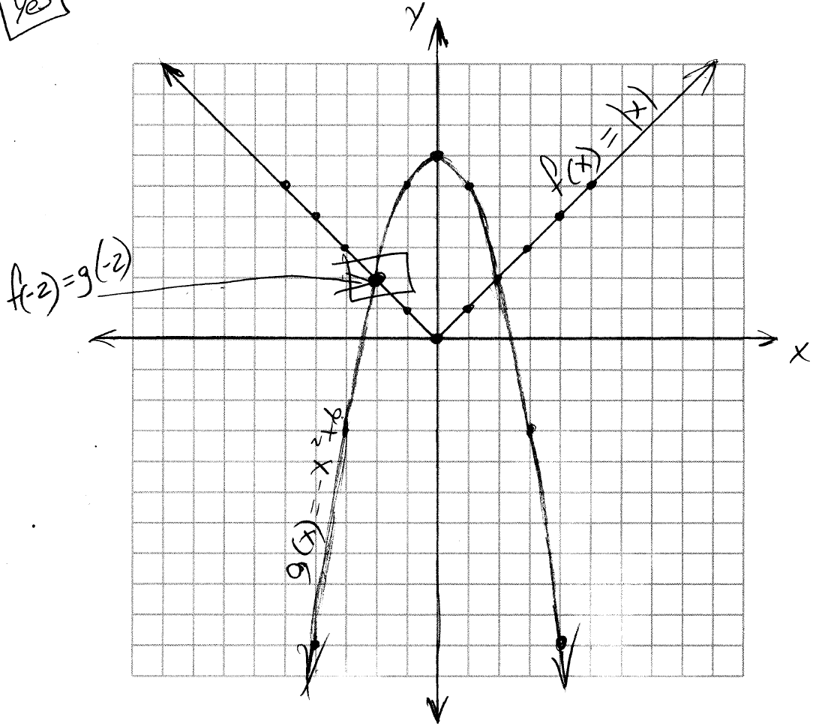

Yes, because the graph of  intersects the graph of  at .

PTS: 4 NAT: A.REI.D.11 TOP: Other Systems

KEY: AI