**F – Inequalities, Lesson 4, Graphing Linear Inequalities (r. 2018)**

INEQUALITIES

Graphing Linear Inequalities

|  |  |
| --- | --- |
| **Common Core Standard**  **A-REI.12** Graph the solutions to a linear inequality in two variables as a half-plane (excluding the boundary in the case of a strict inequality), and graph the solution set to a system of linear inequalities in two variables as the intersection of the corresponding half-planes. | **Next Generation Standard**  **AI-A.REI.12** Graph the solutions to a linear inequality in two variables as a half-plane (excluding the boundary in the case of a strict inequality), and graph the solution set to a system of linear inequalities in two variables as the intersection of the corresponding half-planes.  **Note: Graphing linear equations is a fluency recommendation for Algebra I. Students become fluent in solving characteristic problems involving the analytic geometry of lines, such as writing down the equation of a line given a point and a slope. Such fluency can support them in solving less routine mathematical problems involving linearity; as well as modeling linear phenomena (including modeling using systems of linear inequalities in two variables).** |

**LEARNING OBJECTIVES**

Students will be able to:

1. Graph a single inequality involving two variables on a coordinate plane.
   1. Determine if the boundary line is a solid line or a dashed line.
   2. Determine if the solution set is shaded above or below the boundary line.

**Overview of Lesson**

|  |  |
| --- | --- |
| **Teacher Centered Introduction**  **Overview of Lesson**  **- activate students’ prior knowledge**  **- vocabulary**  **- learning objective(s)**  **- big ideas: direct instruction**  **- modeling** | **Student Centered Activities**  **guided practice ⬅Teacher: anticipates, monitors, selects, sequences, and connects student work**  **- developing essential skills**  **- Regents exam questions**  **- formative assessment assignment (exit slip, explain the math, or journal entry)** |

**VOCABULARY**

boundary line

dashed line

linear inequality

shading

solid line

solution set

testing a solution

**BIG IDEAS**

**A linear inequality** describes a region of the coordinate plane that has a **boundary line**. Every point in the region is a **solution of the inequality**.

The **solution set** of a linear inequality includes all ordered pairs that make the inequality true. The graph of an inequality represents the solution set.

**Graphing a Linear Inequality**

**Step One.** Change the inequality sign to an equal sign and graph the boundary line in the same manner that you would graph a linear equation.

▪ When the inequality sign **contains** an equality bar beneath it, use a solid line for the boundary. Any point (ordered pair) on the boundary line is part of the solution set.

▪ When the inequality sign **does not contain** an equality bar beneath it, use a dashed line for the boundary. Any point (ordered pair) on the boundary line is *not* part of the solution set.

**Step Two**. Restore the inequality sign and test a point to see which side of the boundary line the solution is on. The point (0,0) is a good point to test since it simplifies any multiplication. However, if the boundary line passes through the point (0,0), another point not on the boundary line must be selected for testing.

▪ If the test point makes the inequality true, shade the side of the boundary line that includes the test point.

▪ If the test point makes the inequality not true, shade the side of the boundary line does not include the test point.

NOTE: If the dependent variable is isolated in the left expression of the inequality, a simplified way to determine which side of the line to shade is as follows:

* If the inequality sign contains >, shade *above* the boundary line.
  + Examples:  and  are shaded *above* the boundary line.
* If the inequality sign contains <, shade *below* the boundary line.
  + Examples:  and  are shaded *below* the boundary line.

**Example** Graph 

**First**, change the inequality sign an equal sign and graph the line: . This is the boundary line of the solution. Since there is no equality line beneath the inequality symbol, use a dashed line for the boundary.

NOTE: A graphing calculator can be used if the inequality has the dependent variable isolated as the in the left expression of the inequality



**Next**, **test a point** to see which side of the boundary line the solution is on. Try (0,0), since it makes the multiplication easy, but remember that any point will do.



Note: Most graphing calculators do not have the ability to distinguish between solid and dashed lines on a graph of an inequality.

**DEVELOPING ESSENTIAL SKILLS**

Graph the inequalityand determine if point with coordinates (3,8) is in the solution set.

STEP 1. Isolate the dependent variable in the left expression of the inequality.



STEP 2. Input the transformed inequality in a graphing computer and use the table and graph views to plot the boundary line.

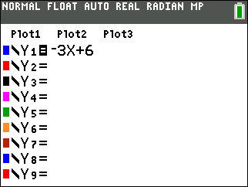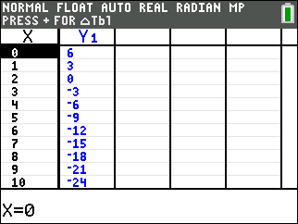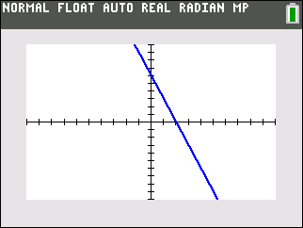

Since the inequality  sign contains an equal bar, the boundary line is a solid line and any points on the boundary line are included in the solution set.

STEP 3. Since the dependent variable is isolated in the left expression, and the inequality sign includes <, shade the area *below* the boundary line. (NOTE: The graphing calculator can be set to show < or > inequalities.)

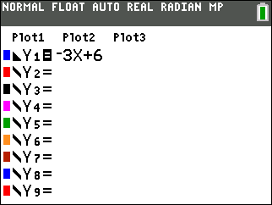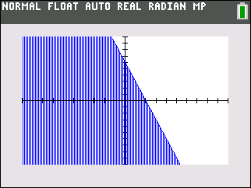

STEP 4. Inspect the graph to determine if the point (3,8) is included in the solution set. It is not.

STEP 5. Do a check to see if the point (3,8) makes the original inequality true.



Since the inequality is not true for the point (3,8), the point is not in the solution set.

**REGENTS EXAM QUESTIONS (through June 2018)**

A.REI.D.12: Graphing Linear Inequalities

157) Which inequality is represented in the graph below?

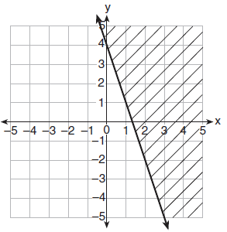

|  |  |  |  |
| --- | --- | --- | --- |
| 1) |  | 3) |  |
| 2) |  | 4) |  |

158) On the set of axes below, graph the inequality .

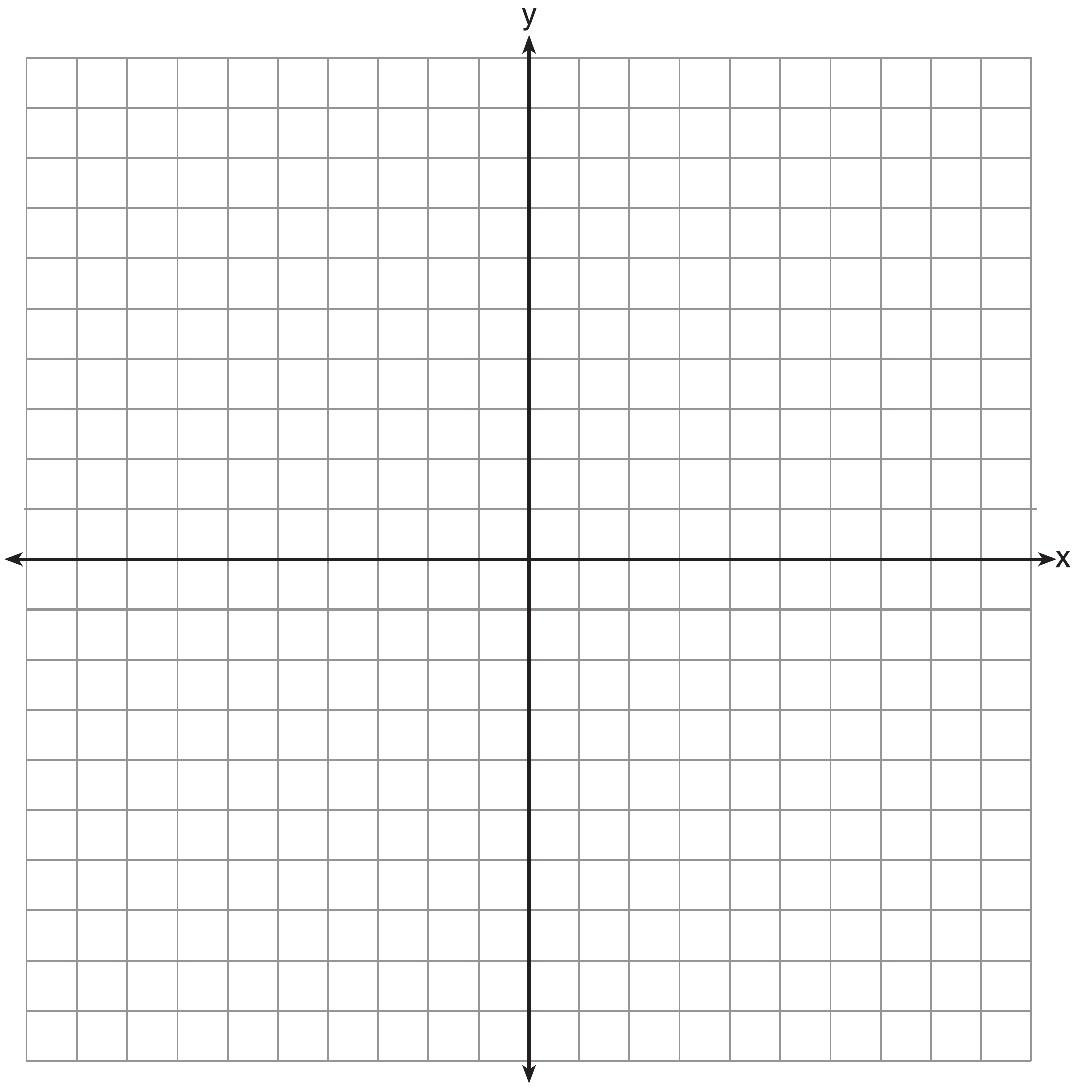

159) Which inequality is represented by the graph below?

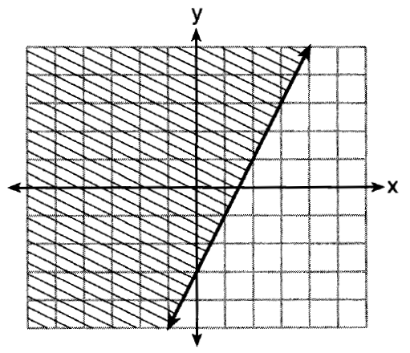

|  |  |  |  |
| --- | --- | --- | --- |
| 1) |  | 3) |  |
| 2) |  | 4) |  |

160) Shawn incorrectly graphed the inequality  as shown below:

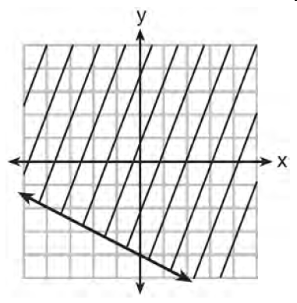

Explain Shawn’s mistake.

Graph the inequality correctly on the set of axis below.

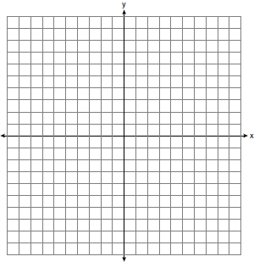

161) Graph the inequality  on the set of axes below. State the coordinates of a point in its solution.



162) Graph the inequality  on the set of axes below.



**SOLUTIONS**

157) ANS: 1

Strategy: Use the slope intercept form of a line, , to construct the inequality from the graph.

The line passes though points (0,4) and (1,1), so the slope is . The y-intercept is 4.

The equation of the boundary line is , so eliminate choices *c* and *d.*

The shading is above the line, so eliminate choice *b.*

The inequality is , so answer choice *a* is correct.

PTS: 2 NAT: A.REI.D.12 TOP: Linear Inequalities

158) ANS:

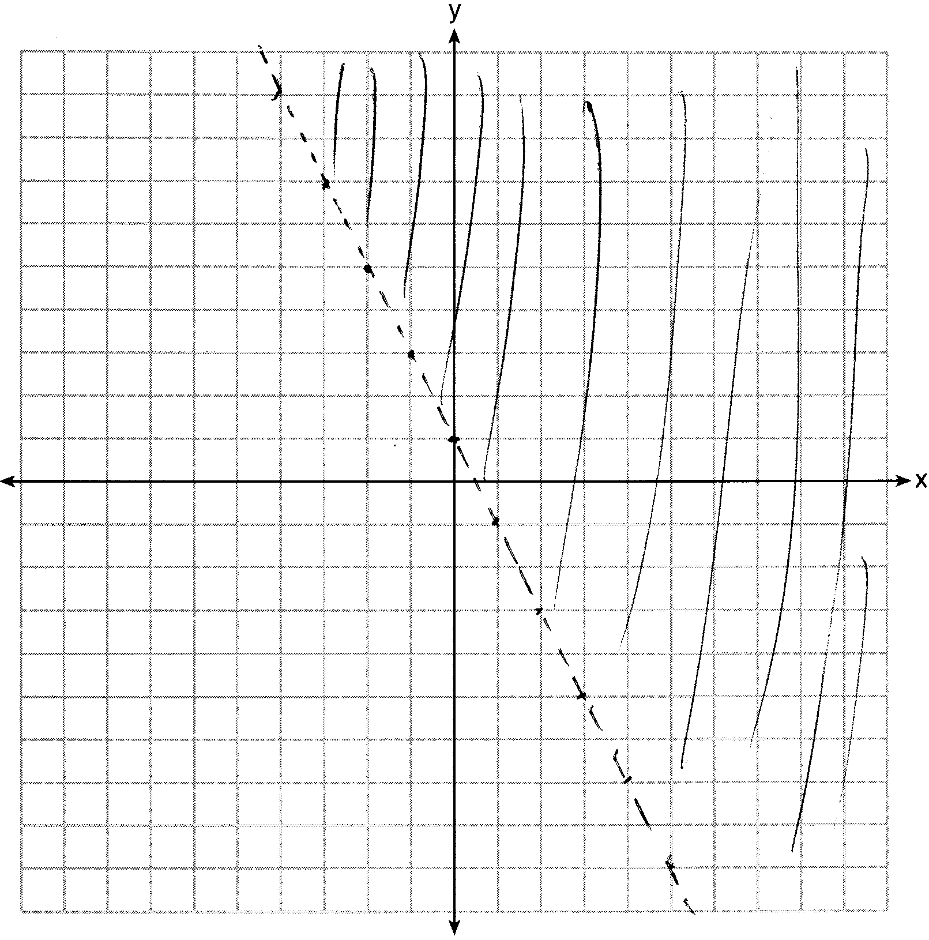

Strategy: Transpose the inequality, put it in a graphing calculator, then use the table and graph views to create the graph on paper.

STEP 1. Transpose the inequality for input into a graphing calculator.



STEP 2. Inpout the inequality into a graphing calculator.

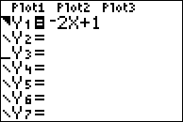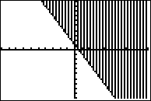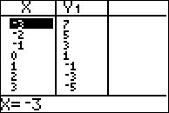

STEP 3. Use information from the graph and table views to create the graph on paper. Be sure to make the line dotted.

PTS: 2 NAT: A.REI.D.12 TOP: Graphing Linear Inequalities

159) ANS: 2 PTS: 2 NAT: A.REI.D.12 TOP: Graphing Linear Inequalities

160) ANS:

Shawn’s mistake was he shaded the wrong side of the boundary line.

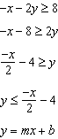

Shawn’s y-intercept is correct. 

Shawn’s slope is correct. 

Shawn correctly graphed a solid boundary line. 

Shawn’s mistake was he shaded the wrong side of the boundary line.

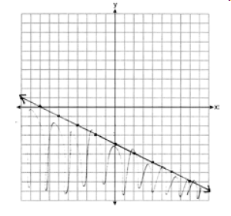

PTS: 4 NAT: A.REI.D.12

161) ANS:

Strategy: Use the slope intercept form of the inequality to plot the y-intercept at -5, then use the slope of  to find another point on the boundary line. Plot the boundary line as a dashed. Shade the area above the boundary line. Select any number in the shaded area.

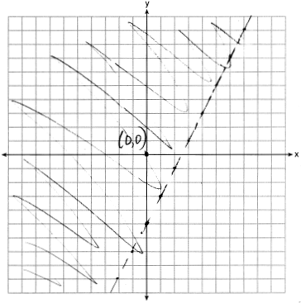

Check (0,0) in the inequality as follows:

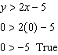

PTS: 2 NAT: A.REI.D.12 TOP: Graphing Linear Inequalities

162) ANS:

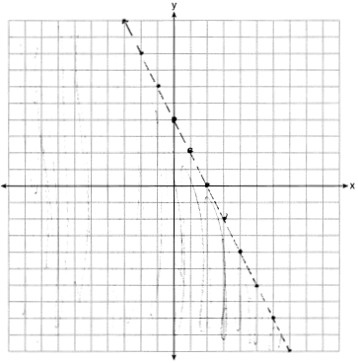



PTS: 2 NAT: A.REI.D.12 TOP: Graphing Linear Inequalities