**I – Systems, Lesson 5, Graphing Systems of Linear Inequalities (r. 2018)**

SYSTEMS

Graphing Systems of Linear Inequalities

|  |  |
| --- | --- |
| **Common Core Standard**  **A-REI.12** Graph the solutions to a linear inequality in two variables as a half-plane (excluding the boundary in the case of a strict inequality), and graph the solution set to a system of linear inequalities in two variables as the intersection of the corresponding half-planes. | **Next Generation Standard**  **AI-A.REI.12** Graph the solutions to a linear inequality in two variables as a half-plane (excluding the boundary in the case of a strict inequality), and graph the solution set to a system of linear inequalities in two variables as the intersection of the corresponding half-planes.  **Note: Graphing linear equations is a fluency recommendation for Algebra I. Students become fluent in solving characteristic problems involving the analytic geometry of lines, such as writing down the equation of a line given a point and a slope. Such fluency can support them in solving less routine mathematical problems involving linearity; as well as modeling linear phenomena (including modeling using systems of linear inequalities in two variables).** |

**LEARNING OBJECTIVES**

Students will be able to:

1) Graph the solution set of a system of linear inequalities.

**Overview of Lesson**

|  |  |
| --- | --- |
| **Teacher Centered Introduction**  **Overview of Lesson**  **- activate students’ prior knowledge**  **- vocabulary**  **- learning objective(s)**  **- big ideas: direct instruction**  **- modeling** | **Student Centered Activities**  **guided practice ⬅Teacher: anticipates, monitors, selects, sequences, and connects student work**  **- developing essential skills**  **- Regents exam questions**  **- formative assessment assignment (exit slip, explain the math, or journal entry)** |

**VOCABULARY**

boundary line

dashed line

shading

solid line

solution set

testing a point

**BIG IDEAS**

**A linear inequality** describes a region of the coordinate plane that has a **boundary line**. Every point in the region is a **solution of the inequality**.

Two or more linear inequalities together form a **system of linear inequalities**. Note that there are two or more boundary lines in a system of linear inequalities.

A **solution of a system of linear inequalities** makes each inequality in the system true. The graph of a system shows all of its solutions.

**Graphing a Linear Inequality**

**Step One.** Change the inequality sign to an equal sign and graph the boundary line in the same manner that you would graph a linear equation.

▪ When the inequality sign **contains** an equality bar beneath it, use a solid line for the boundary.

▪ When the inequality sign **does not contain** an equality bar beneath it, use a dashed or dotted line for the boundary

**Step Two**. Restore the inequality sign and test a point to see which side of the boundary line the solution is on. The point (0,0) is a good point to test since it simplifies any multiplication. However, if the boundary line passes through the point (0,0), another point not on the boundary line must be selected for testing.

▪ If the test point makes the inequality true, shade the side of the boundary line that includes the test point.

▪ If the test point makes the inequality not true, shade the side of the boundary line does not include the test point.

**Example** Graph 

**First**, change the inequality sign an equal sign and graph the line: . This is the boundary line of the solution. Since there is no equality line beneath the inequality symbol, use a dashed line for the boundary.



**Next**, **test a point** to see which side of the boundary line the solution is on. Try (0,0), since it makes the multiplication easy, but remember that any point will do.



Note: The TI-83+ graphing calculator does not have the ability to distinguish between solid and dashed lines on a graph of an inequality. The less than and greater than symbols are input using the far-left column of symbols that can be accessed through the feature.

**Graphing a System of Linear Inequalities**. Systems of linear inequalities are graphed in the same manner as systems of equations are graphed. The solution of the system of inequalities is the region of the coordinate plane that is shaded by both inequalities.

**Example**: Graph the system: 

**First**, convert both inequalities to slope-intercept form and graph.

|  |  |
| --- | --- |
|  |  |



**Next**, test a point in each inequality and shade appropriately.

▪ Since point (0,0) is on the boundary line of , select another point, such as (0,1).



▪ Since (0,0) is not on the boundary line of , we can use (0,0) as our test point, as follows:



Note that the system of inequalities divides the coordinate plane into four sections. The solution set for the system of inequalities is the area where the two shaded regions overlap.

**DEVELOPING ESSENTIAL SKILLS**

Graph the solution sets of the following systems of inequalities. State if the origin (0,0) *is* or *is not* in the solution set.

|  |  |  |  |  |
| --- | --- | --- | --- | --- |
| 1. | 2. | 3. | 4. | 5. |

Answers

1. The origin is *in* the solution set.

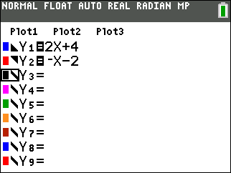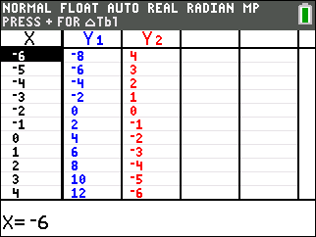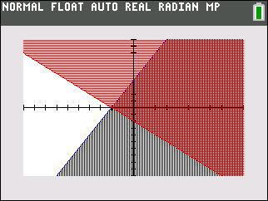

1. The origin is *not in* the solution set.

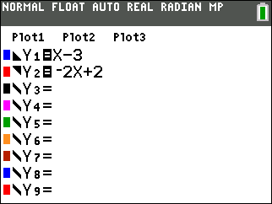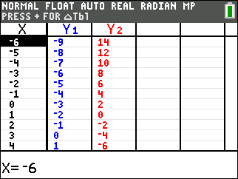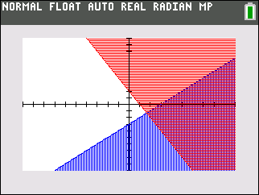

1. The origin is *not in* the solution set.

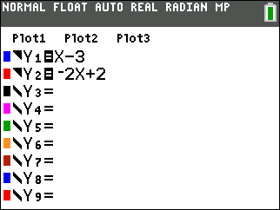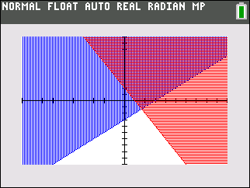

1. The origin is *not in* the solution set.

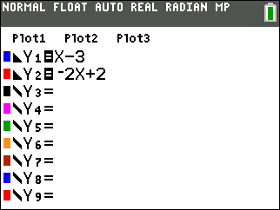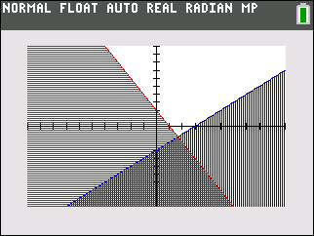

1. The origin is *in* the solution set.

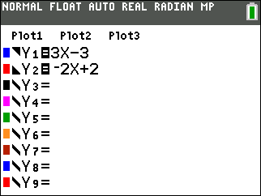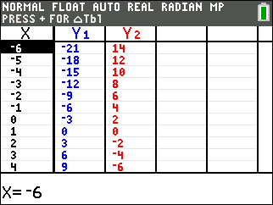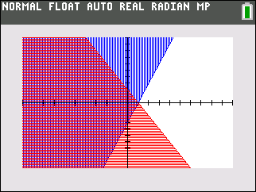

**REGENTS EXAM QUESTIONS**

A.REI.D.12: Graphing Systems of Linear Inequalities

273) Which ordered pair is *not* in the solution set of ** and ?

|  |  |  |  |
| --- | --- | --- | --- |
| 1) |  | 3) |  |
| 2) |  | 4) |  |

274) Given: 

Which graph shows the solution of the given set of inequalities?

|  |  |  |  |
| --- | --- | --- | --- |
| 1) |  | 3) |  |
| 2) |  | 4) |  |

275) Which point is a solution to the system below?



|  |  |  |  |
| --- | --- | --- | --- |
| 1) |  | 3) |  |
| 2) |  | 4) |  |

276) What is one point that lies in the solution set of the system of inequalities graphed below?

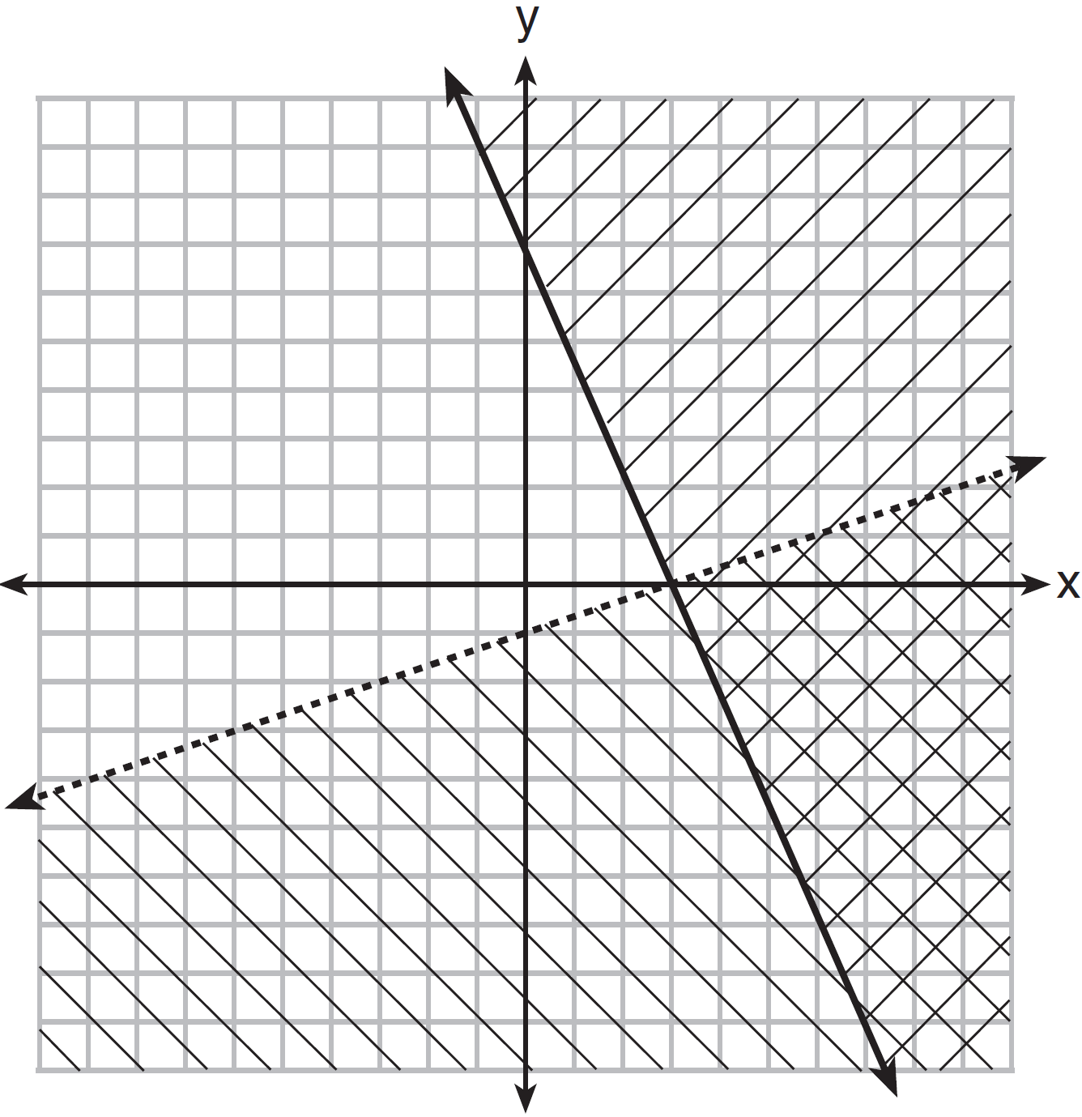

|  |  |  |  |
| --- | --- | --- | --- |
| 1) |  | 3) |  |
| 2) |  | 4) |  |

277) First consider the system of equations  and . Then consider the system of inequalities  and . When comparing the number of solutions in each of these systems, which statement is true?

|  |  |  |  |
| --- | --- | --- | --- |
| 1) | Both systems have an infinite number of solutions. | 3) | The system of inequalities has more solutions. |
| 2) | The system of equations has more solutions. | 4) | Both systems have only one solution. |

278) The Reel Good Cinema is conducting a mathematical study. In its theater, there are 200 seats. Adult tickets cost $12.50 and child tickets cost $6.25. The cinema's goal is to sell at least $1500 worth of tickets for the theater.

Write a system of linear inequalities that can be used to find the possible combinations of adult tickets, *x*, and child tickets, *y*, that would satisfy the cinema's goal.

Graph the solution to this system of inequalities on the set of axes below. Label the solution with an *S*.

Marta claims that selling 30 adult tickets and 80 child tickets will result in meeting the cinema's goal. Explain whether she is correct or incorrect, based on the graph drawn.

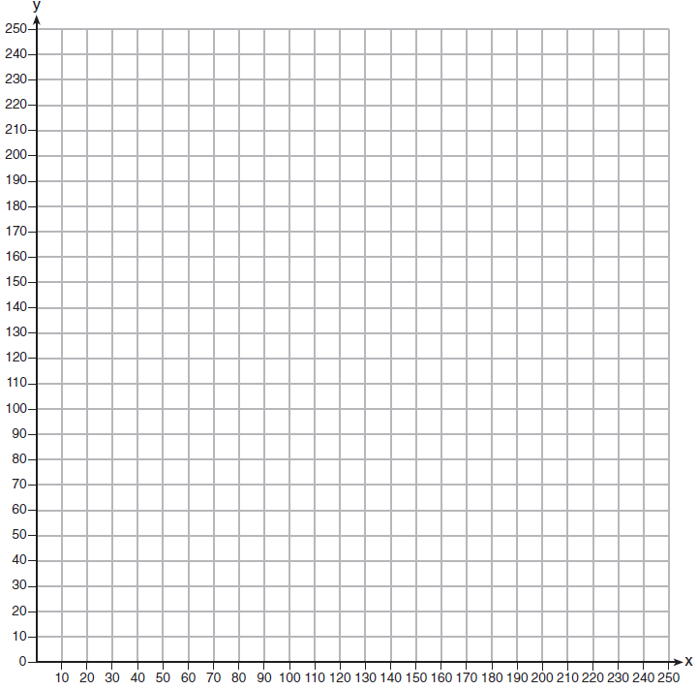

279) Which graph represents the solution of  and ?

|  |  |  |  |
| --- | --- | --- | --- |
| 1) |  | 3) |  |
| 2) |  | 4) |  |

280) The graph of an inequality is shown below.

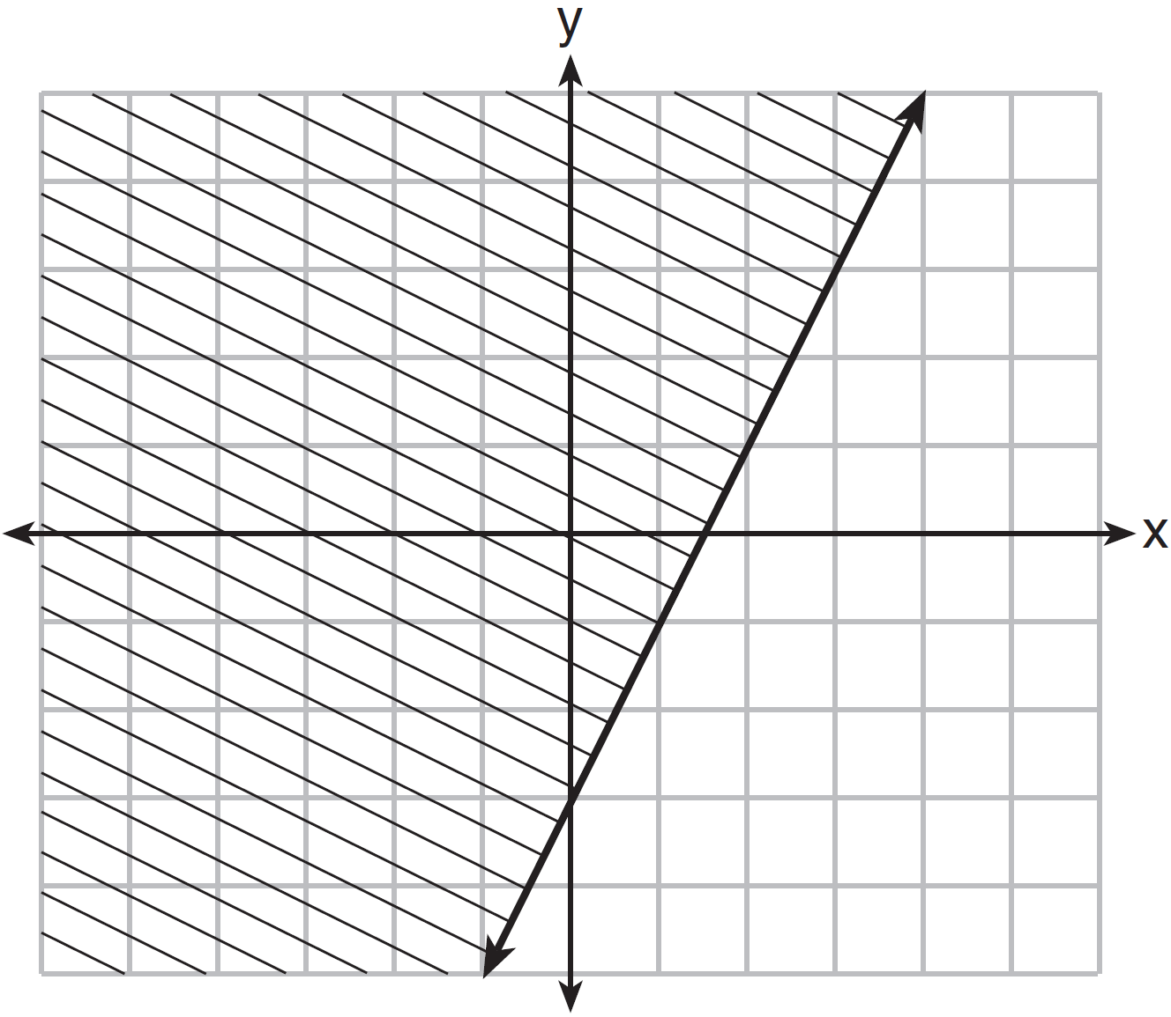

a) Write the inequality represented by the graph.

b) On the same set of axes, graph the inequality .

c) The two inequalities graphed on the set of axes form a system. Oscar thinks that the point  is in the solution set for this system of inequalities. Determine and state whether you agree with Oscar. Explain your reasoning.

281) Determine if the point  is a solution to the system of inequalities graphed below. Justify your answer.

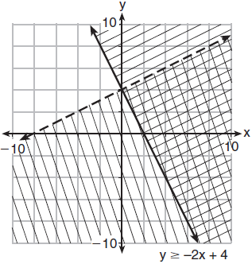

282) The sum of two numbers, *x* and *y*, is more than 8. When you double *x* and add it to *y*, the sum is less than 14. Graph the inequalities that represent this scenario on the set of axes below.

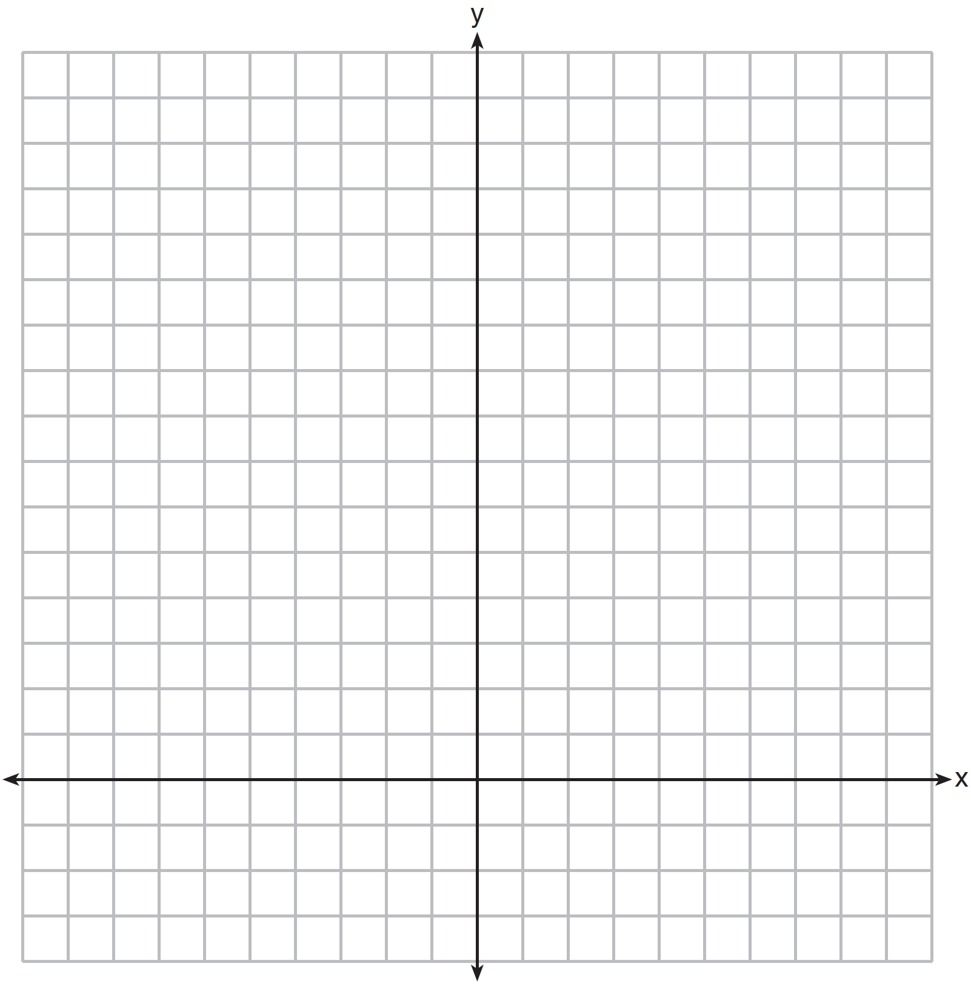

Kai says that the point  is a solution to this system. Determine if he is correct and explain your reasoning.

283) Solve the following system of inequalities graphically on the grid below and label the solution *S*.





Is the point  in the solution set? Explain your answer.

284) On the set of axes below, graph the following system of inequalities:



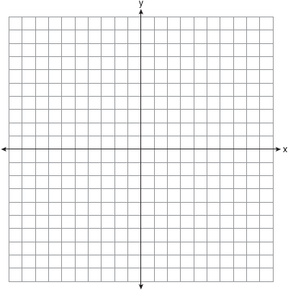

Determine if the point  is in the solution set. Explain your answer.

285) Edith babysits for *x* hours a week after school at a job that pays $4 an hour. She has accepted a job that pays $8 an hour as a library assistant working *y* hours a week. She will work both jobs. She is able to work no more than 15 hours a week, due to school commitments. Edith wants to earn at least $80 a week, working a combination of both jobs. Write a system of inequalities that can be used to represent the situation. Graph these inequalities on the set of axes below.

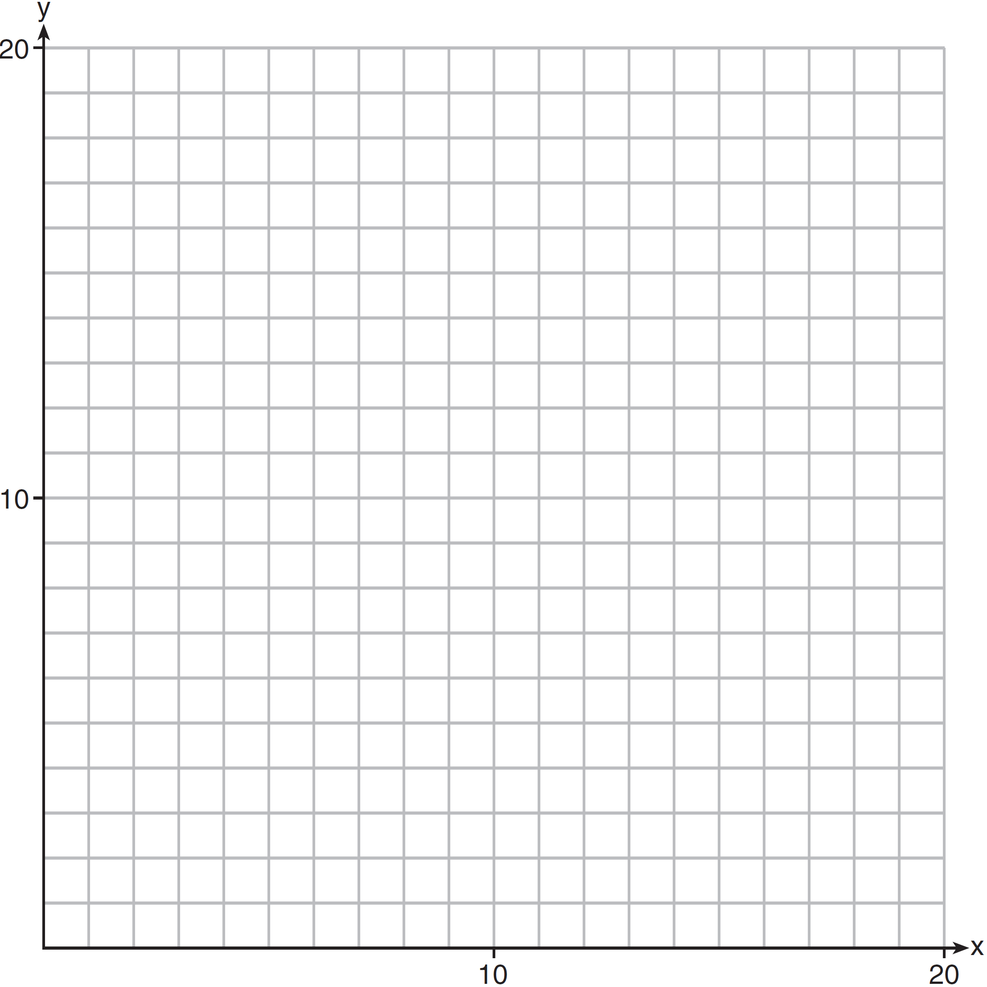

Determine and state one combination of hours that will allow Edith to earn *at least* $80 per week while working *no more than* 15 hours.

286) An on-line electronics store must sell at least $2500 worth of printers and computers per day. Each printer costs $50 and each computer costs $500. The store can ship a maximum of 15 items per day. On the set of axes below, graph a system of inequalities that models these constraints.

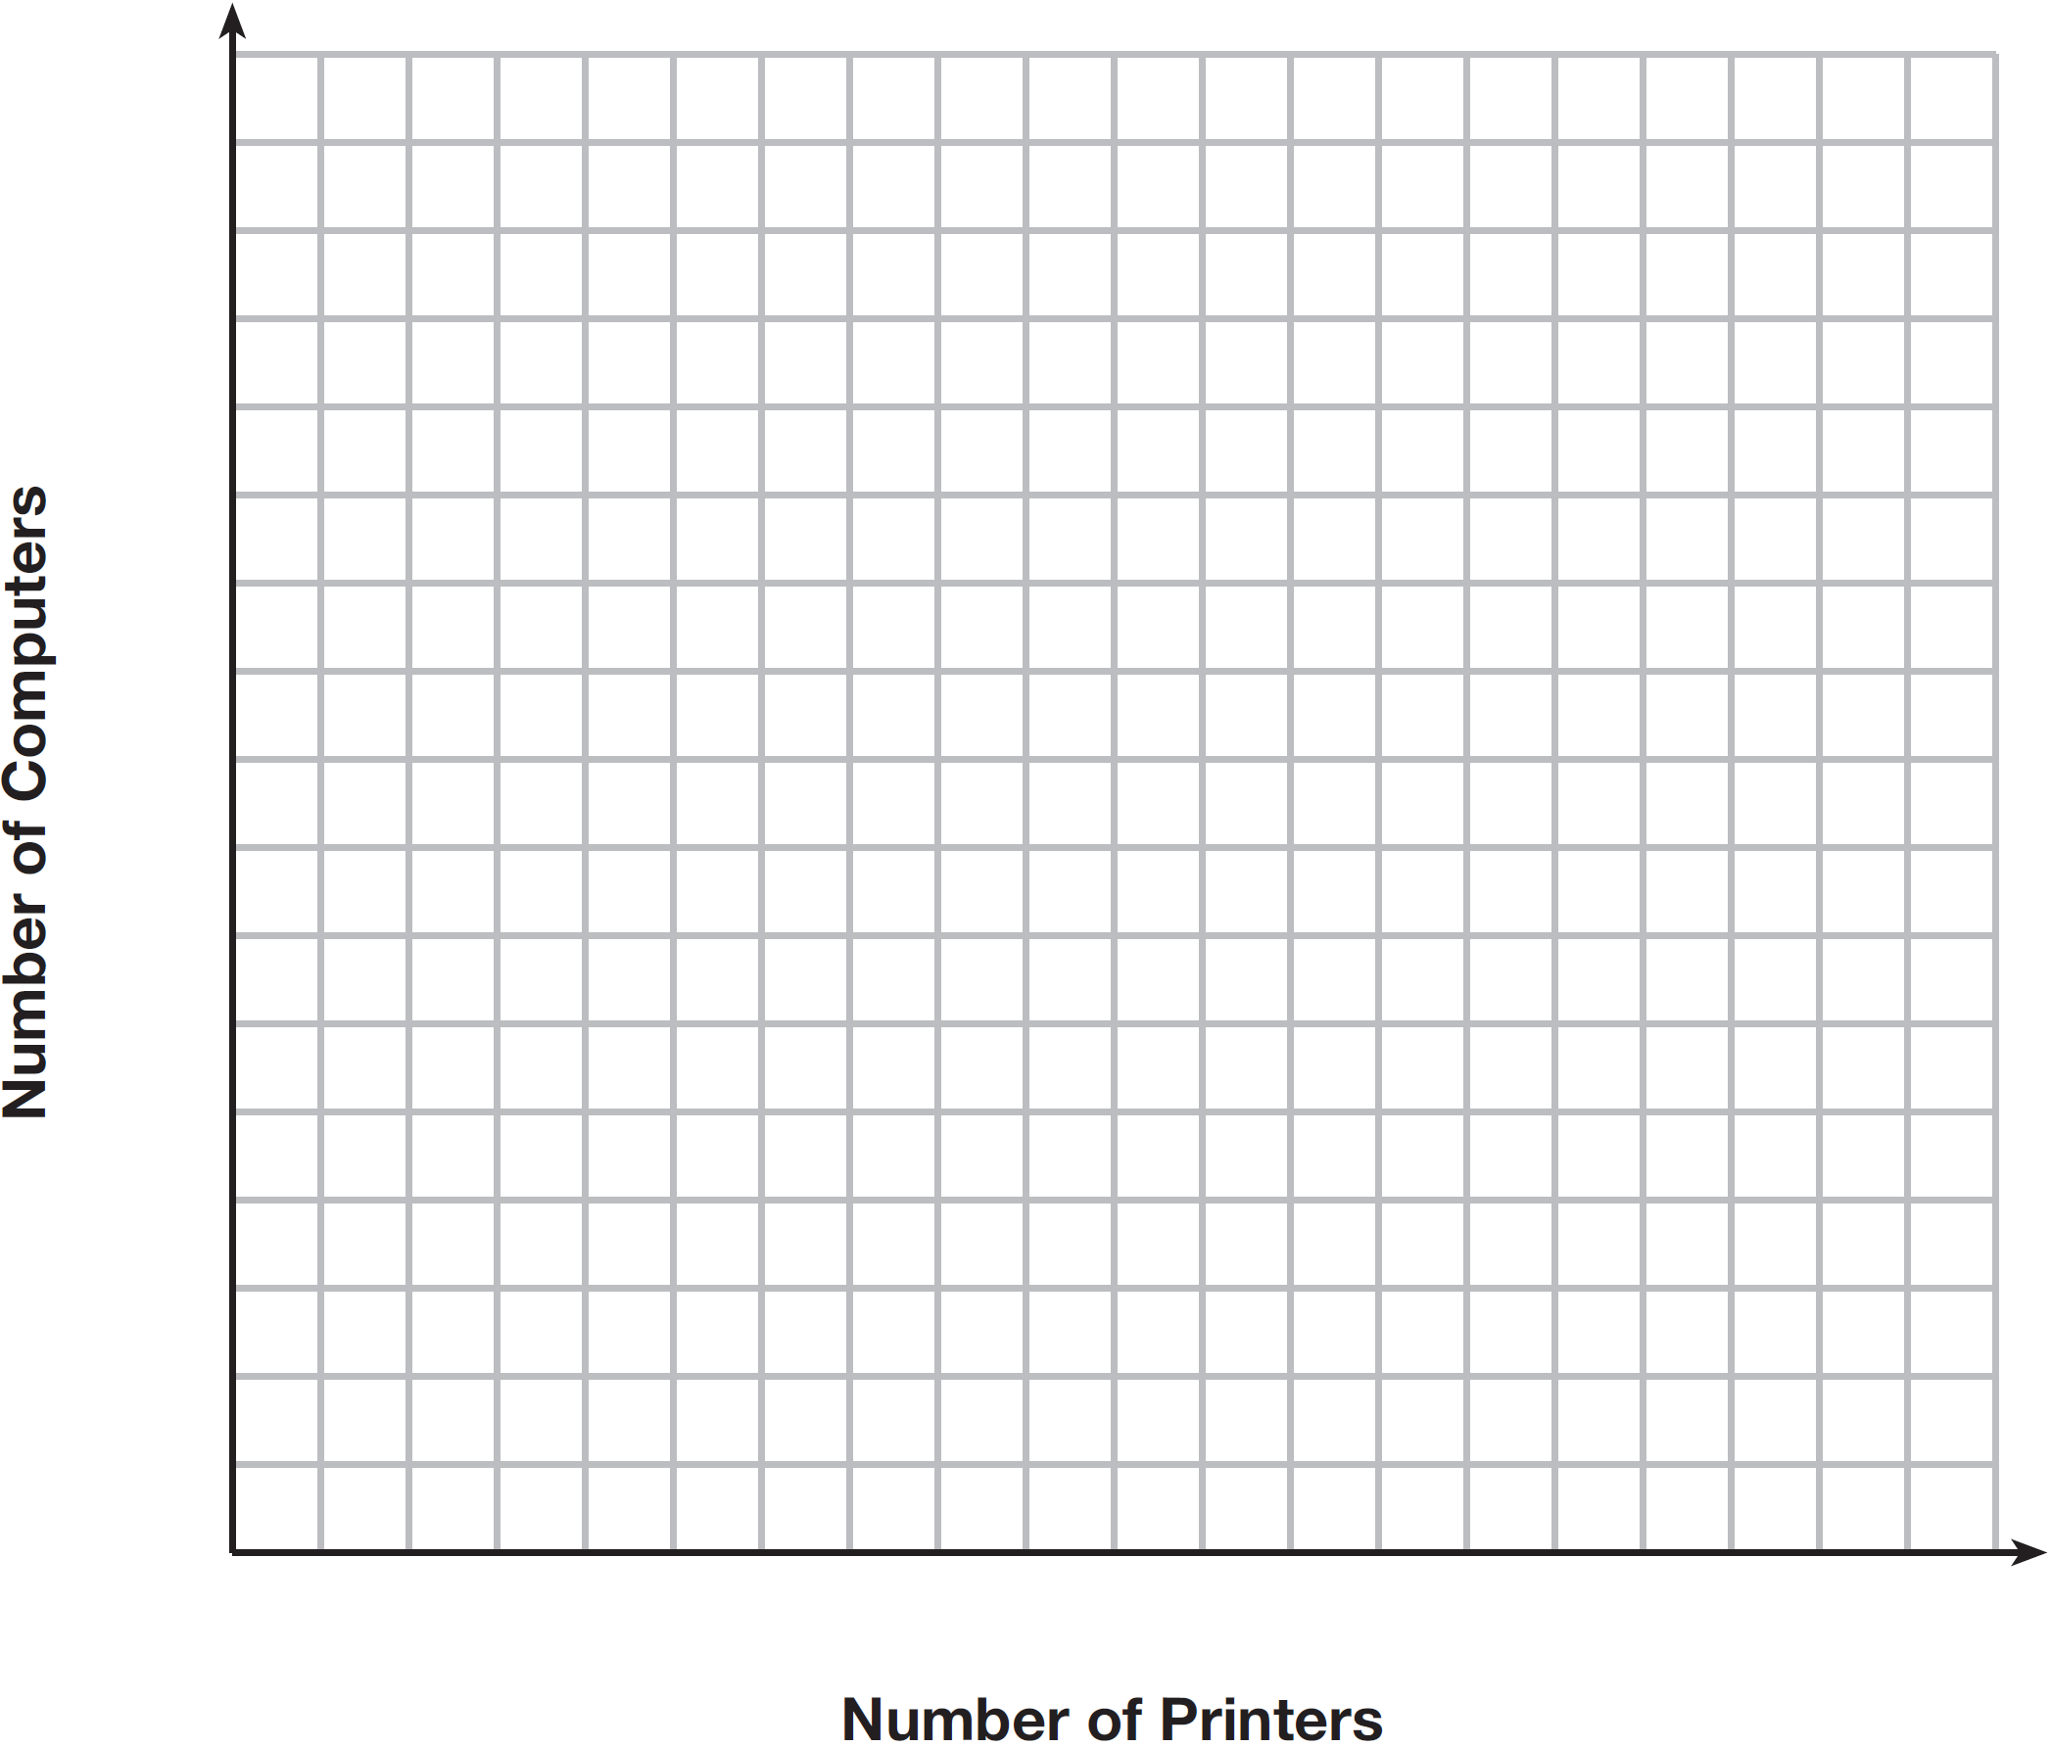

Determine a combination of printers and computers that would allow the electronics store to meet all of the constraints. Explain how you obtained your answer.

**SOLUTIONS**

273) Which ordered pair is *not* in the solution set of ** and ?

|  |  |  |  |
| --- | --- | --- | --- |
| 1) |  | 3) |  |
| 2) |  | 4) |  |

274) Given: 

Which graph shows the solution of the given set of inequalities?

|  |  |  |  |
| --- | --- | --- | --- |
| 1) |  | 3) |  |
| 2) |  | 4) |  |

275) Which point is a solution to the system below?



|  |  |  |  |
| --- | --- | --- | --- |
| 1) |  | 3) |  |
| 2) |  | 4) |  |

276) What is one point that lies in the solution set of the system of inequalities graphed below?



|  |  |  |  |
| --- | --- | --- | --- |
| 1) |  | 3) |  |
| 2) |  | 4) |  |

277) First consider the system of equations  and . Then consider the system of inequalities  and . When comparing the number of solutions in each of these systems, which statement is true?

|  |  |  |  |
| --- | --- | --- | --- |
| 1) | Both systems have an infinite number of solutions. | 3) | The system of inequalities has more solutions. |
| 2) | The system of equations has more solutions. | 4) | Both systems have only one solution. |

278) The Reel Good Cinema is conducting a mathematical study. In its theater, there are 200 seats. Adult tickets cost $12.50 and child tickets cost $6.25. The cinema's goal is to sell at least $1500 worth of tickets for the theater.

Write a system of linear inequalities that can be used to find the possible combinations of adult tickets, *x*, and child tickets, *y*, that would satisfy the cinema's goal.

Graph the solution to this system of inequalities on the set of axes below. Label the solution with an *S*.

Marta claims that selling 30 adult tickets and 80 child tickets will result in meeting the cinema's goal. Explain whether she is correct or incorrect, based on the graph drawn.



279) Which graph represents the solution of  and ?

|  |  |  |  |
| --- | --- | --- | --- |
| 1) |  | 3) |  |
| 2) |  | 4) |  |

280) The graph of an inequality is shown below.



a) Write the inequality represented by the graph.

b) On the same set of axes, graph the inequality .

c) The two inequalities graphed on the set of axes form a system. Oscar thinks that the point  is in the solution set for this system of inequalities. Determine and state whether you agree with Oscar. Explain your reasoning.

281) Determine if the point  is a solution to the system of inequalities graphed below. Justify your answer.



282) The sum of two numbers, *x* and *y*, is more than 8. When you double *x* and add it to *y*, the sum is less than 14. Graph the inequalities that represent this scenario on the set of axes below.



Kai says that the point  is a solution to this system. Determine if he is correct and explain your reasoning.

283) Solve the following system of inequalities graphically on the grid below and label the solution *S*.





Is the point  in the solution set? Explain your answer.

284) On the set of axes below, graph the following system of inequalities:





Determine if the point  is in the solution set. Explain your answer.

285) Edith babysits for *x* hours a week after school at a job that pays $4 an hour. She has accepted a job that pays $8 an hour as a library assistant working *y* hours a week. She will work both jobs. She is able to work no more than 15 hours a week, due to school commitments. Edith wants to earn at least $80 a week, working a combination of both jobs. Write a system of inequalities that can be used to represent the situation. Graph these inequalities on the set of axes below.



Determine and state one combination of hours that will allow Edith to earn *at least* $80 per week while working *no more than* 15 hours.

286) An on-line electronics store must sell at least $2500 worth of printers and computers per day. Each printer costs $50 and each computer costs $500. The store can ship a maximum of 15 items per day. On the set of axes below, graph a system of inequalities that models these constraints.



Determine a combination of printers and computers that would allow the electronics store to meet all of the constraints. Explain how you obtained your answer.