**H – Quadratics, Lesson 1, Solving Quadratics (r. 2018)**

QUADRATICS

Solving Quadratics

|  |  |
| --- | --- |
| **Common Core Standards**  **A-SSE.B.3** Choose and produce an equivalent form of an expression to reveal and explain properties of the quantity represented by the expression.  **A-REI.B.4a** Solve quadratic equations in one variable.  NYSED: Solutions may include simplifying radicals. | **Next Generation Standards**  **AI-A.SSE.3** Choose and produce an equivalent form of an expression to reveal and explain properties of the quantity represented by the expression.  (Shared standard with Algebra II)  **AI-A.REI.4** Solve quadratic equations in one variable.  Note: Solutions may include simplifying radicals. |

NOTE: This lesson is in four parts and typically requires four or more days to complete.

**LEARNING OBJECTIVES**

Students will be able to:

1. Transform a quadratic equation into standard form and identify the values of a, b, and c.
2. Convert factors of quadratics to solutions.
3. Convert solutions of quadratics to factors.
4. Solve quadratics using the quadratic formula.
5. Solve quadratics using the completing the square method.
6. Solve quadratics using the factoring by grouping method.

**Overview of Lesson**

|  |  |
| --- | --- |
| **Teacher Centered Introduction**  **Overview of Lesson**  **- activate students’ prior knowledge**  **- vocabulary**  **- learning objective(s)**  **- big ideas: direct instruction**  **- modeling** | **Student Centered Activities**  **guided practice ⬅Teacher: anticipates, monitors, selects, sequences, and connects student work**  **- developing essential skills**  **- Regents exam questions**  **- formative assessment assignment (exit slip, explain the math, or journal entry)** |

**VOCABULARY**

box method of factoring

completing the square

constant

factoring by grouping

factors

forms of a quadratic

linear term

multiplication property of zero

quadratic equation

quadratic formula

quadratic term

roots

solutions

standard form of a quadratic

x-axis intercepts

zeros

Part 1 – Overview of Quadratics

**BIG IDEAS**

The **standard form** of a quadratic is: .

*  is the quadratic term
*  is the linear term
* *c* is the constant term

Note: If the quadratic terms is removed, the remaining terms are a linear equation.

The definition of a **quadratic equation** is: an equation of the second degree.

Examples of quadratics in different **forms**:

|  |  |
| --- | --- |
| Forms | Examples |
| standard form |  |
| without the *bx* term (the linear term) |  |
| without the *c* term (the constant term ) |  |
| factored forms |  |
| other forms |  |

(Source: your dictionary.com)

**Multiplication Property of Zero**: The **multiplication property of zero** says that if the product of two numbers or expressions is zero, then one or both of the numbers or expressions must equal zero. More simply, if , then either  or , or, both x and y equal zero.

Example: The quadratic equation has two factors: . The multiplication property of zero says that one or both of these factors must equal zero, because the product of these two factors is zero. Therefore, write two equations, as follows:

Eq #1  Therefore, 

Eq #2  Therefore, 

By the multiplication property of zero, .

**Zeros:** A **zero** of a quadratic equation is a **solution** or **root** of the equation. The words **zero**, **solution**, and **root** all mean the same thing. The zeros of a quadratic equation are the value(s) of *x*  when . A quadratic equation can have one, two, or no zeros. There are four general strategies for finding the zeros of a quadratic equation:

1. Solve the quadratic equation using the quadratic formula.
2. Solve the quadratic equation using the completing the square method.
3. Solve the quadratic equation using the factoring by grouping method.
4. Input the quadratic equation into a graphing calculator and find the x-axis intercepts.

**x-axis intercepts**: The zeros of a quadratic can be found by inspecting the graph view of the equation. In graph form, the zeros of a quadratic equation are the x-values of the coordinates of the **x-axis intercepts** of the graph of the equation. The graph of a quadratic equation is called a parabola and can intercept the x-axis in one, two, or no places.

Example: Find the x-axis intercepts of the quadratic equation  by inspecting the x-axis intercepts of its graph.

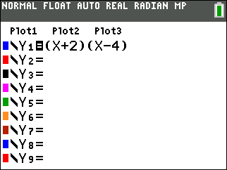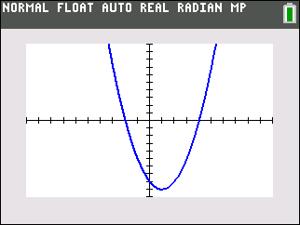

The coordinates of the x-axis intercepts are are . These x-axis intercepts show that the values of x when y=0 are -2 and 4, so the solutions of the quadratic equation are .

**The Difference Between Zeros and Factors**

**Factor**: A **facto**r is:

1) a whole number that is a **divisor** of another number, or

2) an algebraic expression that is a **divisor** of another algebraic expression.

Examples:

o 1, 2, 3, 4, 6, and 12 all divide the number 12,

so 1, 2, 3, 4, 6, and 12 are all factors of 12.

o  will divide the trinomial expression ,

so are both factors of the .

**Start with Factors and Find Zeros**

Remember that the **factors** of an expression are *related to* the **zeros** of the expression by the **multiplication property of zero**. Thus, if you know the **factors**, it is easy to find the **zeros**.

Example: If the factors of the quadratic equation  are  and , then by the multiplication property of zero: either , or , or both equal zero. Solving each equation for *x* results in the zeros of the equation, as follows:

 

**Start with Zeros and Find Factors**

If you know the **zeros** of an expression, you can work backwards using the **multiplication property of zero** to find the **factors** of the expression. For example, if you inspect the graph of an equation and find that it has **x-intercepts** at  and , then you know that the solutions are  and  . You can use these two equations to find the factors of the quadratic expression, as follows:



The factors of a quadratic equation with zeros of 3 and -2 are .

With practice, you can probably move back and forth between the **zeros** of an expression and the **factors** of an expression with ease.

Part 1 – Overview of Quadratics

**DEVELOPING ESSENTIAL SKILLS**

Convert the following quadratic equations to standard form and identify the values of a, b, and c:

** **

Find the zeros of the following quadratic equations:

 

Part 2 – The Quadratic Formula

The **quadratic formula** is: 

[Quadratic Formula Song](https://www.youtube.com/watch?v=VOXYMRcWbF8)

**SOLVING QUADRATIC EQUATIONS STRATEGY #1: Use the Quadratic Formula**

|  |  |
| --- | --- |
| Start with any quadratic equation in the form of | The right expression *must* be zero. |
| Identify the values of a, b, and c. | , , and |
| Substitute the values of a, b, and c into the quadratic formula, which is |  |
| Solve for x |  |

The quadratic formula can be used to solve any quadratic equation.

Part 2 – The Quadratic Formula

**DEVELOPING ESSENTIAL SKILLS**

Solve the following quadratic equations using the quadratic formula. Leave answers in simplest radical form.

|  |  |
| --- | --- |
|  |  |
|  |  |
|  |  |
|  |  |
|  |  |

Part 3 – The Box Method of Factoring

|  |  |
| --- | --- |
|  | The Box Method  for  Factoring a Trinomial |

|  |  |
| --- | --- |
| INSTRUCTIONS | EXAMPLE |
| STEP 1 Start with a factorable quadratic in standard form:  and a 2-row by 2-column table. | Solve by factoring: |
| STEP 2 Copy the quadratic term into the upper left box and the constant term into the lower right box. |  |
| STEP 3 Multiply the quadratic term by the constant term and write the product to the right of the table. |  |
| STEP 4 Factor the product from STEP 3 until you obtain two factors that *sum* to the linear term (*bx*). |  |
| STEP 5 Write one of the two factors found in STEP 4 in the upper right box and the other in the lower left box. Order does not matter. |  |
| STEP 6 Find the greatest common factor of each row and each column and record these factors to the left of each row and above each column. Give each factor the same plus or minus value as the nearest term in a box.  NOTE: If all four of the greatest common factors share a common factor, reduce each factor by the common factor and add the common factor as a third factor. Eg. |  |
| STEP 7 Write the expressions above and beside the box as binomial factors of the original trinomial. |  |
| STEP 8 Check to see that the factored quadratic is the same as the original quadratic. |  |
| STEP 9 Convert the factors to zeros. |  |

Part 3 – The Box Method of Factoring

**DEVELOPING ESSENTIAL SKILLS**

Solve each quadratic by factoring.

|  |  |
| --- | --- |
|  |  |
|  |  |
|  |  |
|  |  |
|  |  |

Part 4 – Completing the Square

**SOLVING QUADRATIC EQUATIONS STRATEGY #3: Completing the Square**

|  |
| --- |
| **completing the square algorithm**  A process used to change an expression of the form ax2 +bx +c into a perfect square binomial by adding a suitable constant. |

Source: NYSED Mathematics Glossary

|  |  |
| --- | --- |
| **PROCEDURE TO FIND THE ZEROS AND EXTREMES OF A QUADRATIC** | |
| **Start with any quadratic equation of the general form** | |
| **STEP 1**  **Isolate all terms with and *x* on one side of the equation. If , divide every term in the equation by *a* to get one expression in the form of** | |
| **STEP 2**  **Complete the Square by adding  to both sides of the equation.** | |
| **STEP 3**  **Factor the side containing  into a binomial expression of the form** | |
| **STEP 4a**  **(solving for roots and zeros only)**  **Take the square root of both sides of the equation and simplify,** | **STEP 4b**  **(solving for maxima and minima only)**  **Multiply both sides of the equation by *a*.**  **Move all terms to left side of equation.**  **Solve the factor in parenthesis for axis of symmety and x-value of the vertex..**  **The number not in parentheses is the y-value of the vertes.** |

|  |  |  |
| --- | --- | --- |
| **STEPS:** | **EXAMPLE A** | **EXAMPLE B** |
| **Start with any quadratic equation of the general form** |  |  |
| **STEP 1)**  **Isolate all terms with and *x* on one side of the equation.**  **If , divide every term in the equation by *a* to get one expression in the form of** |  |  |
| **STEP 2)**  **Complete the Square by adding  to both sides of the equation.** |  |  |
| **STEP 3)**  **Factor the side containing  into a binomial expression of the form** |  |  |
| **STEP 4a)**  **Take the square roots of both sides of the equation and simplify.** |  |  |
| **STEP 4b**  **Multiply both sides of the equation by *a*.**  **Move all terms to left side of equation.**  **Solve the factor in parenthesis for axis of symmety and x-value of the vertex.**  **The number not in parentheses is the y-value of the vertes.** |  |  |

Part 4 – Completing the Square

**DEVELOPING ESSENTIAL SKILLS**

Solve the following quadratic equations by completing the square.

|  |  |
| --- | --- |
|  |  |
|  |  |
|  |  |
|  |  |
|  |  |

**REGENTS EXAM QUESTIONS (through June 2018)**

A.APR.B.3, A.REI.B.4: Solving Quadratics

169) Solve  for *m* by factoring.

170) Keith determines the zeros of the function  to be  and 5. What could be Keith's function?

|  |  |  |  |
| --- | --- | --- | --- |
| 1) |  | 3) |  |
| 2) |  | 4) |  |

171) In the equation , *b* is an integer. Find algebraically *all* possible values of *b*.

172) Which equation has the same solutions as 

|  |  |  |  |
| --- | --- | --- | --- |
| 1) |  | 3) |  |
| 2) |  | 4) |  |

173) The zeros of the function  are

|  |  |  |  |
| --- | --- | --- | --- |
| 1) | and | 3) | 1 and 2 |
| 2) | 1 and | 4) | and 2 |

174) The zeros of the function  are

|  |  |  |  |
| --- | --- | --- | --- |
| 1) | 3 and | 3) | and 1 |
| 2) | 3 and 1 | 4) | and |

175) Janice is asked to solve . She begins the problem by writing the following steps:

Line 1 

Line 2 

Line 3 

Use Janice’s procedure to solve the equation for x.

Explain the method Janice used to solve the quadratic equation.

176) What is the solution set of the equation ?

|  |  |  |  |
| --- | --- | --- | --- |
| 1) | -2 and *a* | 3) | 2 and *a* |
| 2) | -2 and -*a* | 4) | 2 and -*a* |

177) The function  is defined by the expression . Use factoring to determine the zeros of . Explain what the zeros represent on the graph of .

178) If the quadratic formula is used to find the roots of the equation , the correct roots are

|  |  |  |  |
| --- | --- | --- | --- |
| 1) |  | 3) |  |
| 2) |  | 4) |  |

179) Which equation has the same solution as ?

|  |  |  |  |
| --- | --- | --- | --- |
| 1) |  | 3) |  |
| 2) |  | 4) |  |

180) What are the roots of the equation ?

|  |  |  |  |
| --- | --- | --- | --- |
| 1) |  | 3) |  |
| 2) |  | 4) |  |

181) Write an equation that defines  as a trinomial where . Solve for *x* when .

182) If , the roots of the equation are

|  |  |  |  |
| --- | --- | --- | --- |
| 1) | and 25 | 3) | and 5 |
| 2) | , only | 4) | , only |

183) Ryker is given the graph of the function . He wants to find the zeros of the function, but is unable to read them exactly from the graph.

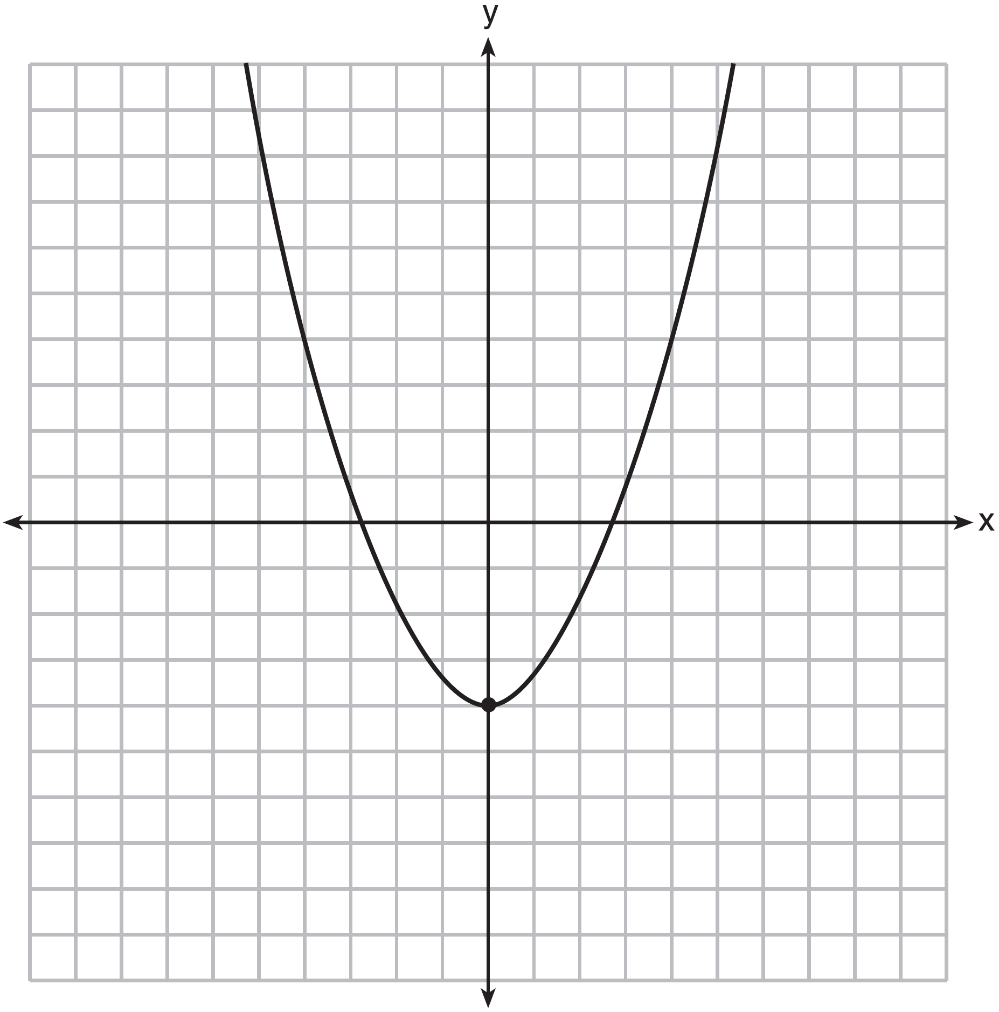

Find the zeros in simplest radical form.

184) A student was given the equation  to solve by completing the square. The first step that was written is shown below.



The next step in the student’s process was . State the value of *c* that creates a perfect square trinomial. Explain how the value of *c* is determined.

185) Which equation has the same solutions as ?

|  |  |  |  |
| --- | --- | --- | --- |
| 1) |  | 3) |  |
| 2) |  | 4) |  |

186) Solve the equation  algebraically for *x.*

187) When directed to solve a quadratic equation by completing the square, Sam arrived at the equation . Which equation could have been the original equation given to Sam?

|  |  |  |  |
| --- | --- | --- | --- |
| 1) |  | 3) |  |
| 2) |  | 4) |  |

188) A student is asked to solve the equation . The student's solution to the problem starts as 

A correct next step in the solution of the problem is

|  |  |  |  |
| --- | --- | --- | --- |
| 1) |  | 3) |  |
| 2) |  | 4) |  |

189) What are the solutions to the equation ?

|  |  |  |  |
| --- | --- | --- | --- |
| 1) |  | 3) |  |
| 2) |  | 4) |  |

190) The solution of the equation  is

|  |  |  |  |
| --- | --- | --- | --- |
| 1) |  | 3) |  |
| 2) |  | 4) |  |

191) When solving the equation  by completing the square, which equation is a step in the process?

|  |  |  |  |
| --- | --- | --- | --- |
| 1) |  | 3) |  |
| 2) |  | 4) |  |

192) Solve the equation for *y*: 

193) Fred's teacher gave the class the quadratic function .

a) State two different methods Fred could use to solve the equation .

b) Using one of the methods stated in part *a,* solve  for *x,* to the *nearest tenth.*

194) What is the solution of the equation ?

|  |  |  |  |
| --- | --- | --- | --- |
| 1) | 6, only | 3) | 2 and |
| 2) | 2, only | 4) | 6 and |

195) Amy solved the equation . She stated that the solutions to the equation were  and . Do you agree with Amy's solutions? Explain why or why not.

196) The height, *H*, in feet, of an object dropped from the top of a building after *t* seconds is given by . How many feet did the object fall between one and two seconds after it was dropped? Determine, algebraically, how many seconds it will take for the object to reach the ground.

197) What are the solutions to the equation ?

|  |  |  |  |
| --- | --- | --- | --- |
| 1) | and | 3) | and |
| 2) | and | 4) | and |

198) Find the zeros of , algebraically.

199) Which value of *x* is a solution to the equation ?

|  |  |  |  |
| --- | --- | --- | --- |
| 1) |  | 3) |  |
| 2) |  | 4) |  |

200) The method of completing the square was used to solve the equation . Which equation is a correct step when using this method?

|  |  |  |  |
| --- | --- | --- | --- |
| 1) |  | 3) |  |
| 2) |  | 4) |  |

201) What are the solutions to the equation ?

|  |  |  |  |
| --- | --- | --- | --- |
| 1) |  | 3) |  |
| 2) |  | 4) |  |

202) Solve the equation  by completing the square.

203) What are the solutions to the equation ?

|  |  |  |  |
| --- | --- | --- | --- |
| 1) | 1 and 7 | 3) |  |
| 2) | and | 4) |  |

204) The quadratic equation  is rewritten in the form , where *q* is a constant. What is the value of *p*?

|  |  |  |  |
| --- | --- | --- | --- |
| 1) |  | 3) |  |
| 2) |  | 4) | 9 |

205) Solve for *x* to the *nearest tenth*: .

**SOLUTIONS**

169) ANS:

 and 

Strategy: Factor by grouping.

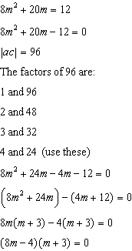

Use the multiplication property of zero to solve for m.

|  |  |
| --- | --- |
|  |  |

PTS: 2 NAT: A.SSE.B.3 TOP: Solving Quadratics

170) ANS: 3

Strategy: Convert the zeros to factors.

If the zeros of  are  and 5, then the factors of  are  and .

Therefore, the function can be written as .

The correct answer choice is *c*.

PTS: 2 NAT: A.SSE.B.3 TOP: Solving Quadratics

171) ANS:

6 and 4

Strategy: Factor the trinomial  into two binomials.

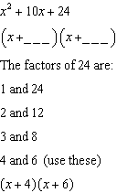

Possible values for *a* and *c* are 4 and 6.

PTS: 2 NAT: A.SSE.B.3 TOP: Solving Quadratics

172) ANS: 4

Strategy 1: Factor by grouping.

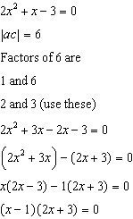

Answer choice *d* is correct

Strategy 2: Work backwards by using the disrtibutive property to expand all answer choices and match the expanded trinomials to the function .

|  |  |
| --- | --- |
| a. | c. |
| b. | d. |

PTS: 2 NAT: A.SSE.B.3 TOP: Solving Quadratics

173) ANS: 4

Strategy 1. Factor, then use the multiplication property of zero to find zeros.

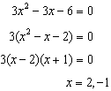

Strategy 2. Use the quadratic formula.

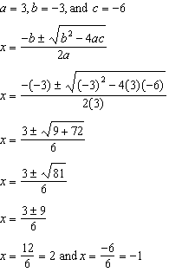

Strategy 3. Input into graphing calculator and inspect table and graph.

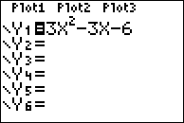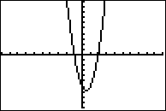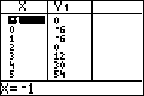

PTS: 2 NAT: A.SSE.B.3 TOP: Solving Quadratics

174) ANS: 1

Strategy #1: Solve by factoring:

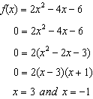

Strategy #2: Solve by inputing equation into graphing calculator, the use the graph and table views to identify the zeros of the function.

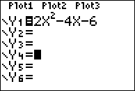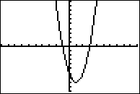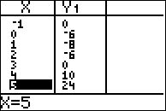

The graph and table views show the zeros to be at -1 and 3.

PTS: 2 NAT: A.SSE.B.3 TOP: Solving Quadratics

KEY: zeros of polynomials

175) ANS:

Use Janice’s procedure to solve for X.

Line 4  and 

Line 5 Therefore:

 and 

Explain the method Janice used to solve the quadratic formula.

Janice made the problem easier by substituting B for *8x*, then solving for B. After solving for B, she reversed her substitution and solved for *x*.

Check:

|  |  |
| --- | --- |
|  |  |

PTS: 4 NAT: A.SSE.B.3a

176) ANS: 3

The solution set of a quadratic equation includes all values of x when y equals zero. In the equation , the value of y is zero and  and  are factors whose product is zero.

The multiplication property of zero says, if the product of two factors is zero, then one or both of the factors must be zero.

Therefore, we can write:  and .

PTS: 2 NAT: A.SSE.B.3 TOP: Solving Quadratics

177) ANS:



Factor  as follows:



Then, use the multiplication property of zero to find the zeros, as follows:

 and 

The zeros of a function are the *x*-values when . On a graph, the zeros are the values of *x* at the *x*-axis intercepts.

PTS: 4 NAT: A.SSE.B.3 TOP: Solving Quadratics

178) ANS: 1

Strategy: Use the quadratic equation to solve , where , , and .

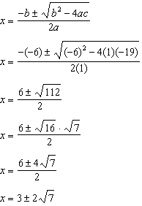

Answer choice *a* is correct.

PTS: 2 NAT: A.REI.B.4 TOP: Solving Quadratics

KEY: quadratic formula

179) ANS: 2

Strategy: Use the distributive property to expand each answer choice, the compare the expanded trinomial to the given equation . Equivalent equations expressed in different terms will have the same solutions.

|  |  |
| --- | --- |
| a. | c. |
| b. | d. |

PTS: 2 NAT: A.REI.B.4 TOP: Solving Quadratics

KEY: completing the square

180) ANS: 2

Strategy 1: Use the quadratic equation to solve , where , , and .

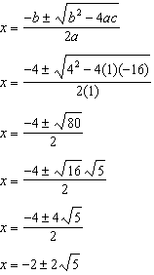

Answer choice *b* is correct.

Strategy 2: Solve by completing the square:

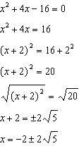

Answer choice *b* is correct.

PTS: 2 NAT: A.REI.B.4 TOP: Solving Quadratics

KEY: quadratic formula

181) ANS:

 and 

Strategy: Transform the expression  to a trinomial, then set the expression equal to 0 and solve it.

STEP 1. Transform  into a trinomial.

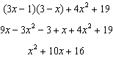

STEP 2. Set the trinomial expression equal to 0 and solve.

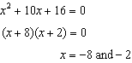

PTS: 4 NAT: A.REI.B.4 TOP: Solving Quadratics

KEY: factoring

182) ANS: 3

Strategy: Solve using root operations.

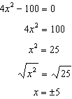

Answer choice *c* is correct.

PTS: 2 NAT: A.REI.B.4 TOP: Solving Quadratics

KEY: taking square roots

183) ANS:



Strategy: Use root operations to solve for x in the equeation .

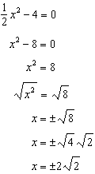

PTS: 2 NAT: A.REI.B.4 TOP: Solving Quadratics

KEY: taking square roots

184) ANS:

The value of c that creates a perfect square trinomial is , which is equal to 9.

The value of c is determined by taking half the value of *b*, when , and squaring it. In this problem, , so .

PTS: 2 NAT: A.REI.B.4 TOP: Solving Quadratics

KEY: completing the square

185) ANS: 4

Strategy: Use the distributive property to expand each answer choice, the compare the expanded trinomial to the given equation . Equivalent equations expressed in different terms will have the same solutions.

|  |  |
| --- | --- |
| a. | c. |
| b. | d. |

PTS: 2 NAT: A.REI.B.4 TOP: Solving Quadratics

KEY: completing the square

186) ANS:

Strategy 1: Solve using factoring by grouping.

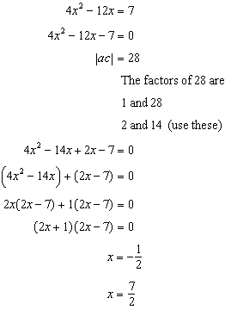

Strategy 2: Solve by completing the square.

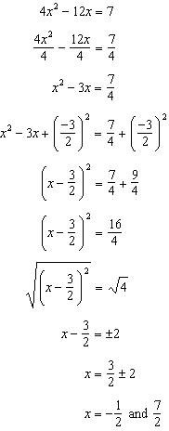

Strategy 3. Solve using the quadratic formula, where , , and .

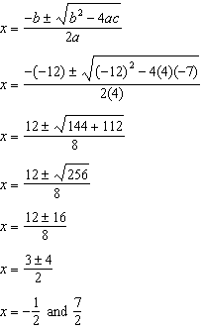

PTS: 2 NAT: A.REI.B.4 TOP: Solving Quadratics

KEY: factoring

187) ANS: 4

Strategy: Assume that Sam’s equation is correct, then expand the square in his equation and simplify.

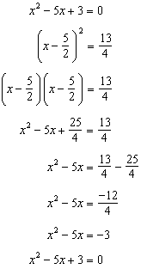

PTS: 2 NAT: A.REI.B.4 TOP: Solving Quadratics

KEY: completing the square

188) ANS: 1

Strategy: The next step should be to take the square roots of both expressions.

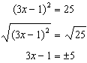

The correct answer choice is *a*.

PTS: 2 NAT: A.REI.B.4 TOP: Solving Quadratics

KEY: completing the square

189) ANS: 2

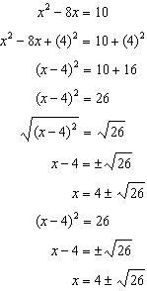

PTS: 2 NAT: A.REI.B.4 TOP: Solving Quadratics

KEY: completing the square

190) ANS: 3

Strategy 1: Solve using root operations.

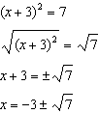

Strategy 2. Solve using the quadratic equation.

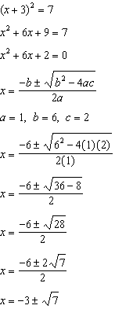

PTS: 2 NAT: A.REI.B.4 TOP: Solving Quadratics

KEY: completing the square

191) ANS: 2

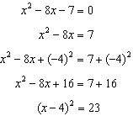

PTS: 2 NAT: A.REI.B.4 TOP: Solving Quadratics

KEY: completing the square

192) ANS:

The solutions are  and .

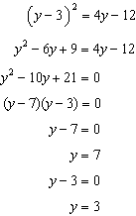

PTS: 2 NAT: A.REI.B.4 TOP: Solving Quadratics

KEY: factoring

193) ANS:

a) Quadratic formula and completing the square.

b) -0.7 and -3.3

|  |  |
| --- | --- |
| Complete the Square Method | Quadratic Formula Method    a=4, b=16, c=9 |

PTS: 1 NAT: A.REI.A.1

194) ANS: 3

Step 1. Understand that solving the equation means isolating the value of x.

Step 2. Strategy. Isolate x.

Step 3. Execution of strategy.

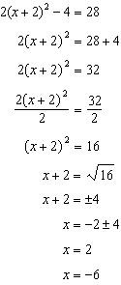

Step 4. Does it make sense? Yes. The values 2 and -6 satisfy the equation .

|  |  |
| --- | --- |
| x=2 | x=-6 |

PTS: 2 NAT: A.REI.B.4 TOP: Solving Quadratics

KEY: taking square roots

195) ANS:

Yes. I agree with Amy’s solution. I get the same solutions by using the quadratic formula.

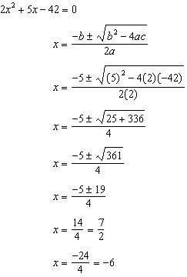

NOTE: Acceptable explanations could also be made by: 1) substituting Amy’s solutions into the original equation and showing that both solutions make the equation balance; 2) solving the quadratic by completing the square and getting Amy’s solutions; or 3) solving the quadratic by factoring and getting Amy’s solutions.

PTS: 2 NAT: A.REI.B.4 TOP: Solving Quadratics

KEY: factoring NOT: NYSED classifies this as A.REI.A

196) ANS:

How many feet did the object fall between one and two seconds after it was dropped?

Strategy: Input the function in a graphing calculator.

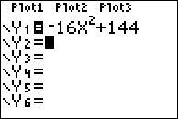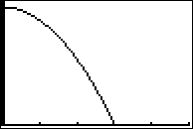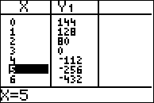

After one second, the object is 128 feet above the ground.

After two seconds, the object is 80 feet above the ground.

The object fell  feet between one and two seconds after it was dropped.

Determine algebraically how many seonds it will take for the object to reach the ground.

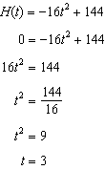

The object will hit the ground after 3 seconds.

PTS: 4 NAT: A.SSE.B.3 TOP: Solving Quadratics

197) ANS: 1

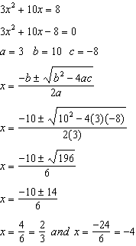

PTS: 2 NAT: A.REI.B.4

198) ANS:



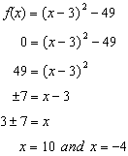

PTS: 2 NAT: A.REI.B.4

199) ANS: 4

|  |  |  |  |
| --- | --- | --- | --- |
| Given |  | = |  |
| Add (12) | +12 | = | +12 |
| Simplify |  | = | 0 |
| Add () |  | = |  |
| Simplify | 25 | = |  |
| Divide (36) |  | = |  |
| Simplify |  | = | x2 |
| Square Root |  | = | x |

The only correct answer choice is .

PTS: 2 NAT: A.REI.B.4 TOP: Solving Quadratics

KEY: taking square roots

200) ANS: 1

|  |  |  |  |
| --- | --- | --- | --- |
| Given |  | = | 0 |
| Divide by 2 |  | = |  |
| Simplify |  | = | 0 |
| Subtract 3 | -3 | = | -3 |
| Simplify |  | = | -3 |
| Complete the Square |  | = |  |
| Simplify |  | = |  |
| Factor and Simplify |  | = | -3 + 9 |
| Simplify |  | = | 6 |

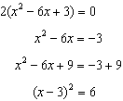

PTS: 2 NAT: A.REI.B.4 TOP: Solving Quadratics

KEY: completing the square

201) ANS: 1

Strategy 1: Use the quadratic equation to solve , where , , and .

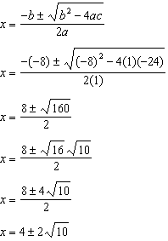

Answer choice *a* is correct.

Strategy 2. Solve by completing the square.

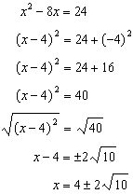

Answer choice *a* is correct.

PTS: 2 NAT: A.REI.B.4 TOP: Solving Quadratics

KEY: completing the square

202) ANS:

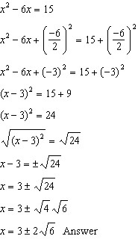

PTS: 2 NAT: A.REI.B.4 TOP: Solving Quadratics

KEY: completing the square

203) ANS: 1

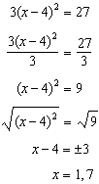

PTS: 2 NAT: A.REI.B.4 TOP: Solving Quadratics

KEY: taking square roots

204) ANS: 3

Strategy: Rewrite  in the form of  and find the value of p.

|  |  |  |  |
| --- | --- | --- | --- |
| Notes | Left Epression | Sign | Right Expression |
| Given |  | = | 12 |
| Complete the Square |  | = |  |
| Exponents and Parentheses |  | = |  |
| Factor left expression and simplify right expression |  | = | 21 |
| Compare to form given in the question. |  | = | q |



PTS: 2 NAT: A.REI.B.4 TOP: Solving Quadratics

KEY: completing the square

205) ANS:

Answer: -2.8, 1.8

Strategy: Use the quadratic formula

STEP 1. Identify the values of a, b, and c in .



STEP 2. Substitute these values in the quadratic formula and solve.

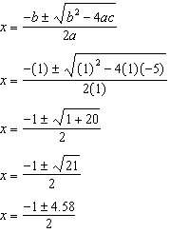

|  |  |
| --- | --- |
|  |  |

PTS: 2 NAT: A.REI.B.4 TOP: Solving Quadratics

KEY: quadratic formula