K – Polynomials, Lesson 6, Graphing Polynomial Functions (r. 2018)

POLYNOMIALS
Graphing Polynomial Functions
Common Core Standard  F-BF.3 Identify the effect on the graph of replacing f(x) by f(x) + k, k f(x), f(kx), and f(x + k) for specific values of k (both positive and negative); find the value of k given the graphs. Experiment with cases and illustrate an explanation of the effects on the graph using technology. Include recognizing even and odd functions from their graphs and algebraic expressions for them.  PARCC: Identifying the effect on the graph of replacing f(x) by f(x) +k, kf(x), and f(x+k) for specific values of k (both positive and negative) is limited to linear and quadratic functions. Experimenting with cases and illustrating an explanation of the effects on the graph using technology is limited to linear functions, quadratic functions, square root functions, cube root functions, piecewise-defined functions (including step functions and absolute value functions), and exponential functions with domains in the integers. Tasks do not involve recognizing even and odd functions. | Next Generation Standard  AI-F.BF.3a Using f(x) + k, k f(x), and f(x + k):  i) identify the effect on the graph when replacing f(x) by f(x) + k,  k f(x), and f(x + k) for specific values of k (both positive and negative);  ii) find the value of k given the graphs;  iii) write a new function using the value of k; and  iv) use technology to experiment with cases and explore the effects on the graph.  (Shared standard with Algebra II)  Note: Tasks are limited to linear, quadratic, square root, and absolute value functions; and exponential functions of the form where a > 0 and b > 0 (b ≠ 1).

LEARNING OBJECTIVES
Students will be able to:
- Use a constant k in the equation of the parabola to move the graph of parabolas up, down, left, and/or right.
- Use a constant k in the equation of the parabola to make the parabola open upward or downward.
- Use a constant k in the equation of the parabola to make the parabola narrower or wider.

Overview of Lesson
Teacher Centered Introduction  Overview of Lesson  - activate students’ prior knowledge  - vocabulary  - learning objective(s)  - big ideas: direct instruction  - modeling | Student Centered Activities  guided practice ⬅Teacher: anticipates, monitors, selects, sequences, and connects student work  - developing essential skills  - Regents exam questions  - formative assessment assignment (exit slip, explain the math, or journal entry)

VOCABULARY

constant
narrower
scalar
translation
vertex
wider

BIG IDEAS

The graph of a function is changed when either or x is multiplied by a scalar, or when a constant is added to or subtracted from either or x. A graphing calculator can be used to explore the translations of graph views of functions.

Up and Down

The addition or subtraction of a constant outside the parentheses moves the graph up or down by the value of the constant.

Examples:
Replace f(x) by f(x) + k
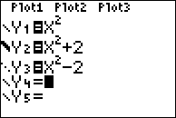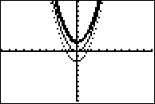

Left and Right
The addition or subtraction of a constant inside the parentheses moves the graph left or right by the value of the constant.

Replace f(x) by f(x + k)
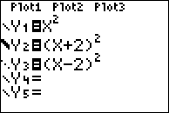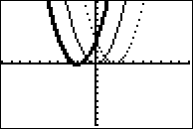

Width and Direction of a Parabola
Changing the value of a in a quadratic affects the width and direction of a parabola. The bigger the absolute value of a, the narrower the parabola.

Examples:
Replace f(x) by f(kx)
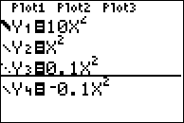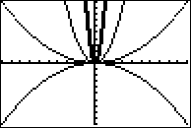

DEVELOPING ESSENTIAL SKILLS
1. Consider the graph of the equation , when . If a is multiplied by 3, what is true of the graph of the resulting parabola?
a. | The vertex is 3 units above the vertex of the original parabola.
b. | The new parabola is 3 units to the right of the original parabola.
c. | The new parabola is wider than the original parabola.
d. | The new parabola is narrower than the original parabola.

2. Melissa graphed the equation and Dave graphed the equation on the same coordinate grid. What is the relationship between the graphs that Melissa and Dave drew?
a. | Dave's graph is wider and opens in the opposite direction from Melissa's graph.
b. | Dave's graph is narrower and opens in the opposite direction from Melissa's graph.
c. | Dave's graph is wider and is three units below Melissa's graph.
d. | Dave's graph is narrower and is three units to the left of Melissa's graph.

3. The graph of a parabola is represented by the equation where a is a positive integer. If a is multiplied by 2, the new parabola will become
a. | narrower and open downward
b. | narrower and open upward
c. | wider and open downward
d. | wider and open upward

4. How is the graph of affected when the coefficient of is changed to a smaller positive number?
a. | The graph becomes wider, and the y-intercept changes.
b. | The graph becomes wider, and the y-intercept stays the same.
c. | The graph becomes narrower, and the y-intercept changes.
d. | The graph becomes narrower, and the y-intercept stays the same.

5. Which is the equation of a parabola that has the same vertex as the parabola represented by , but is wider?
a. |  | c.
b. |  | d. | 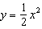

6. The graph of the equation is shown below.

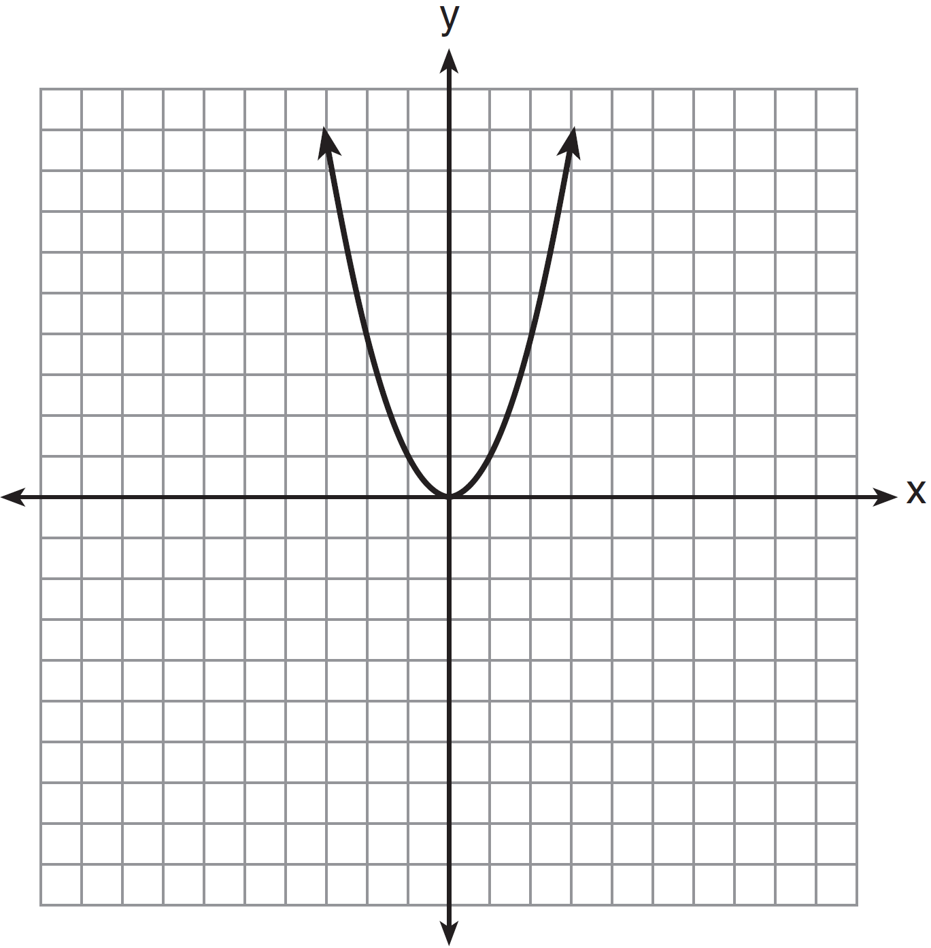

Which statement best describes the change in this graph when the coefficient of is multiplied by 4?
a. | The parabola becomes wider.
b. | The parabola becomes narrower.
c. | The parabola will shift up four units.
d. | The parabola will shift right four units.

7. The graph of is shown below.

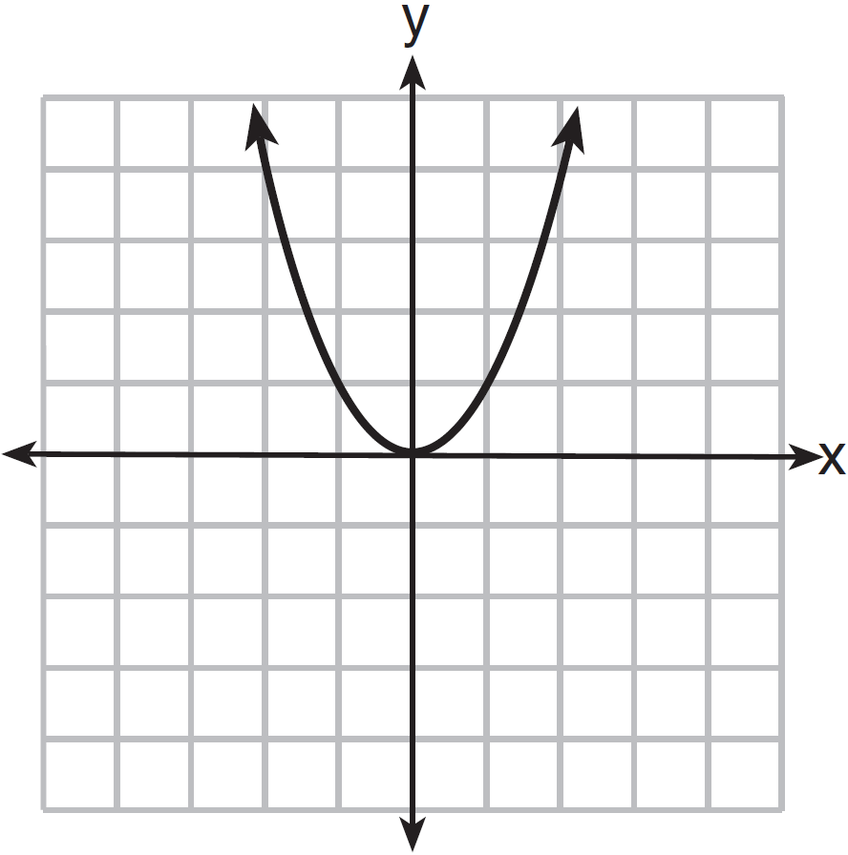

Which graph represents ?
a. | 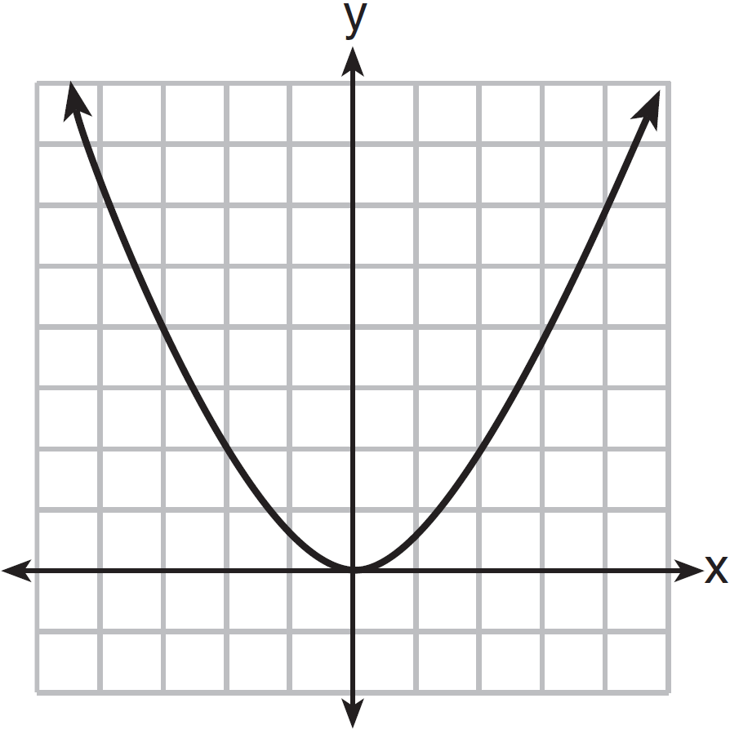 | c. | 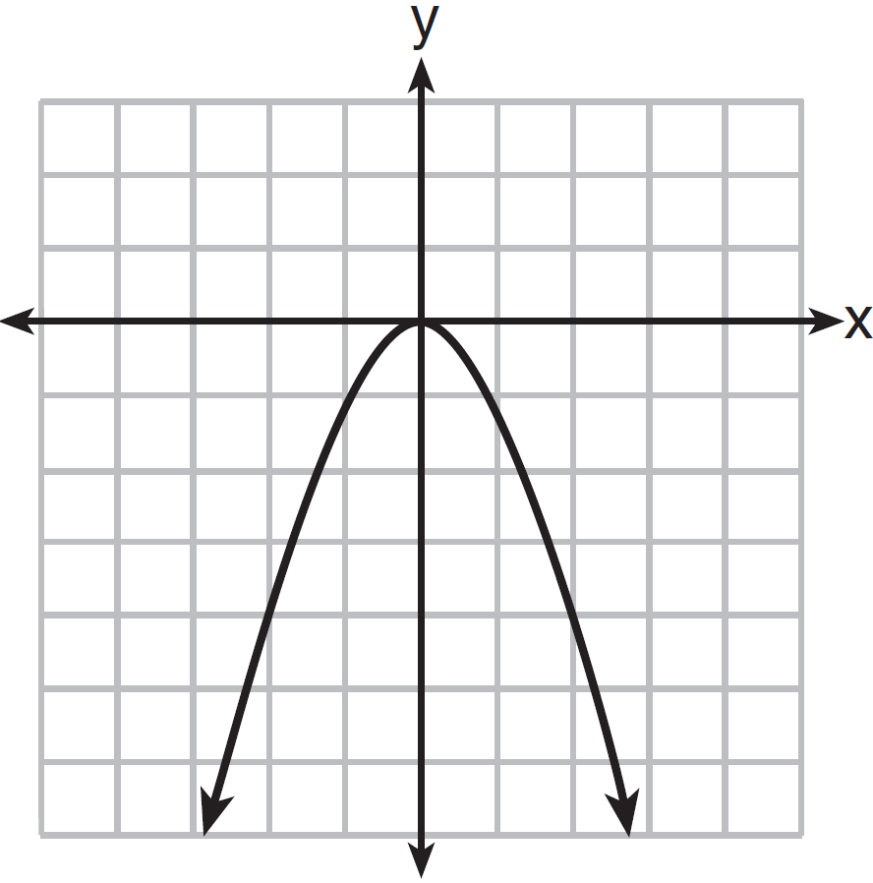
b. | 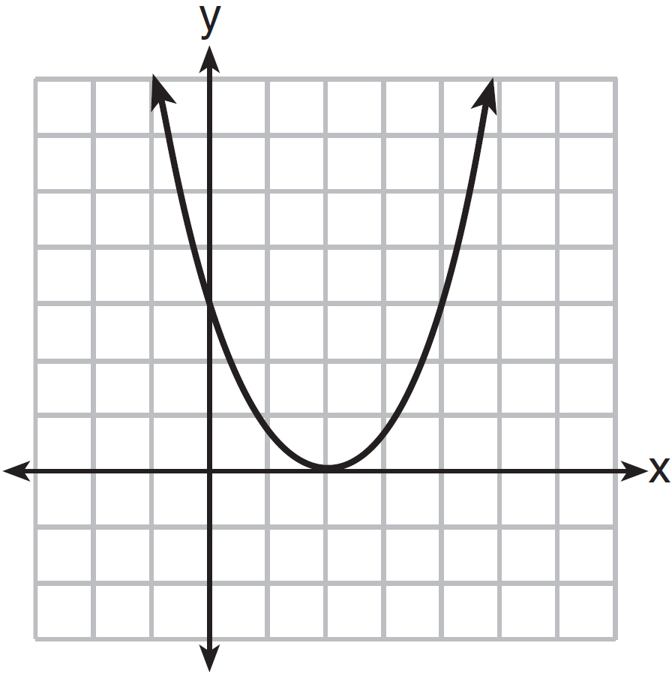 | d. | 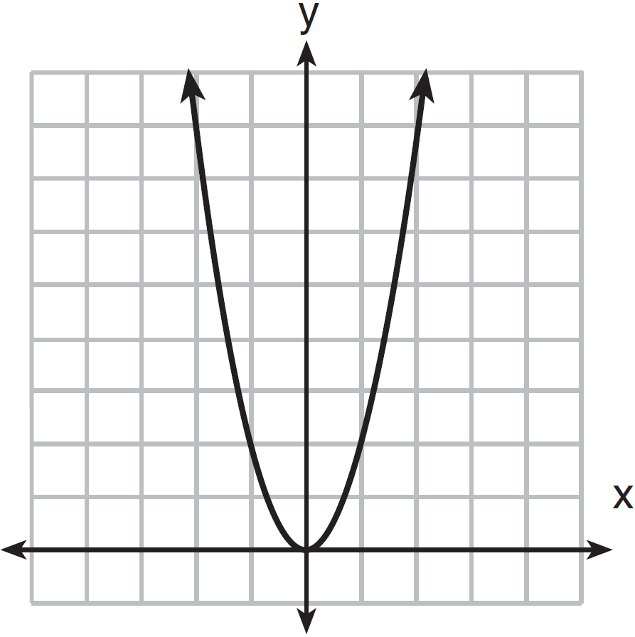

ANSWERS

1. ANS: D

2. ANS: B

3. ANS: B

4. ANS: B

5. ANS: D

6. ANS: B

7. ANS: D

REGENTS EXAM QUESTIONS (through June 2018)
F.BF.B.3: Graphing Polynomial Functions

372) The graph of the equation is shown below.

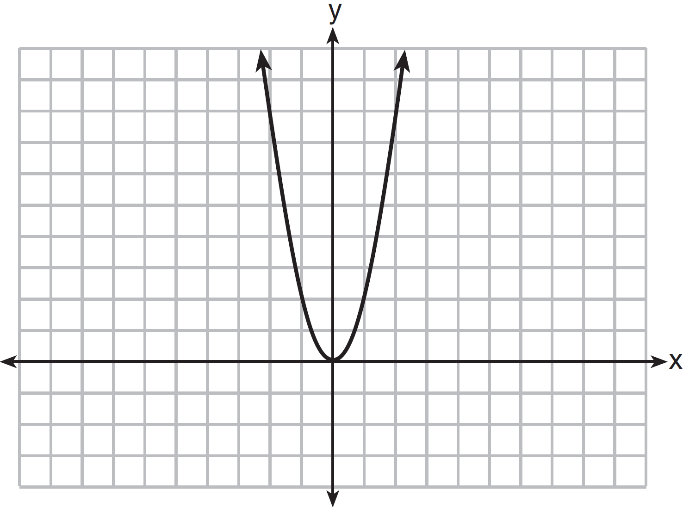

If a is multiplied by , the graph of the new equation is
1) | wider and opens downward | 3) | narrower and opens downward
2) | wider and opens upward | 4) | narrower and opens upward

373) How does the graph of compare to the graph of ?
1) | The graph of is wider than the graph of , and its vertex is moved to the left 2 units and up 1 unit. | 3) | The graph of is narrower than the graph of , and its vertex is moved to the left 2 units and up 1 unit.
2) | The graph of is narrower than the graph of , and its vertex is moved to the right 2 units and up 1 unit. | 4) | The graph of is wider than the graph of , and its vertex is moved to the right 2 units and up 1 unit.

374) The vertex of the parabola represented by has coordinates . Find the coordinates of the vertex of the parabola defined by . Explain how you arrived at your answer. [The use of the set of axes below is optional.]

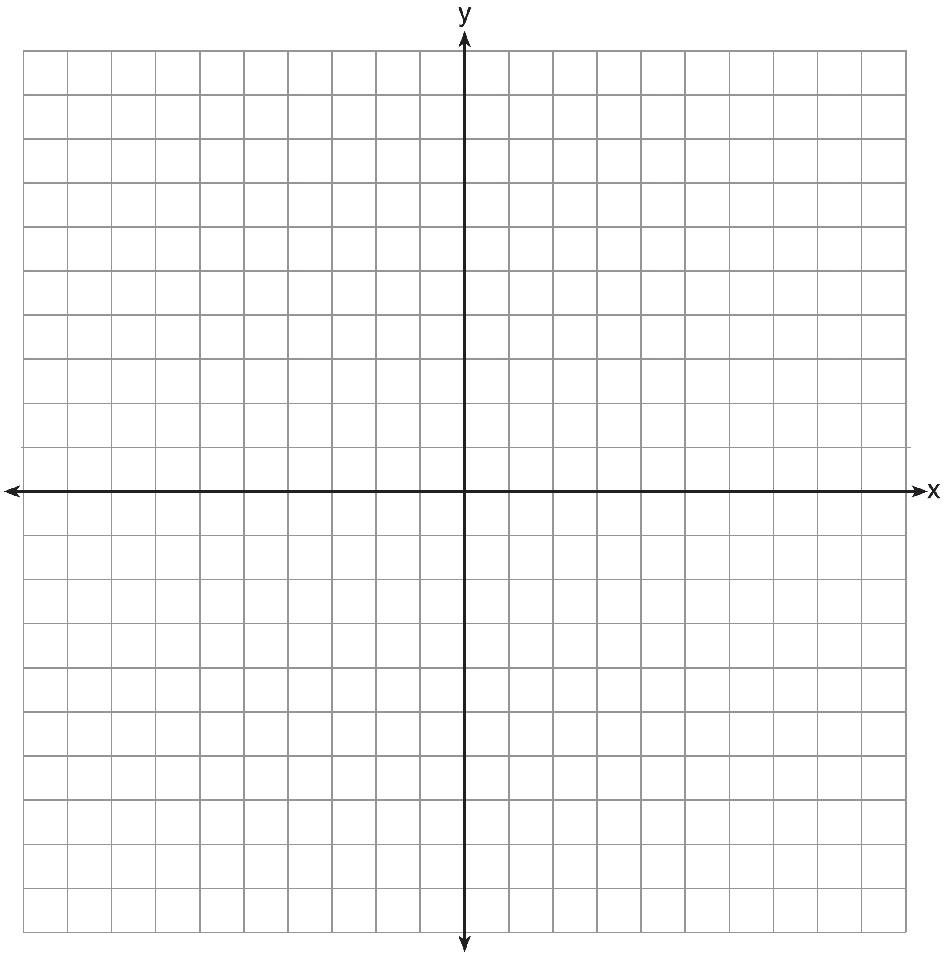

375) Given the graph of the line represented by the equation , if b is increased by 4 units, the graph of the new line would be shifted 4 units
1) | right | 3) | left
2) | up | 4) | down

376) When the function is multiplied by the value a, where , the graph of the new function,
1) | opens upward and is wider
2) | opens upward and is narrower
3) | opens downward and is wider
4) | opens downward and is narrower

377) In the diagram below, is graphed. Also graphed is , the result of a translation of .

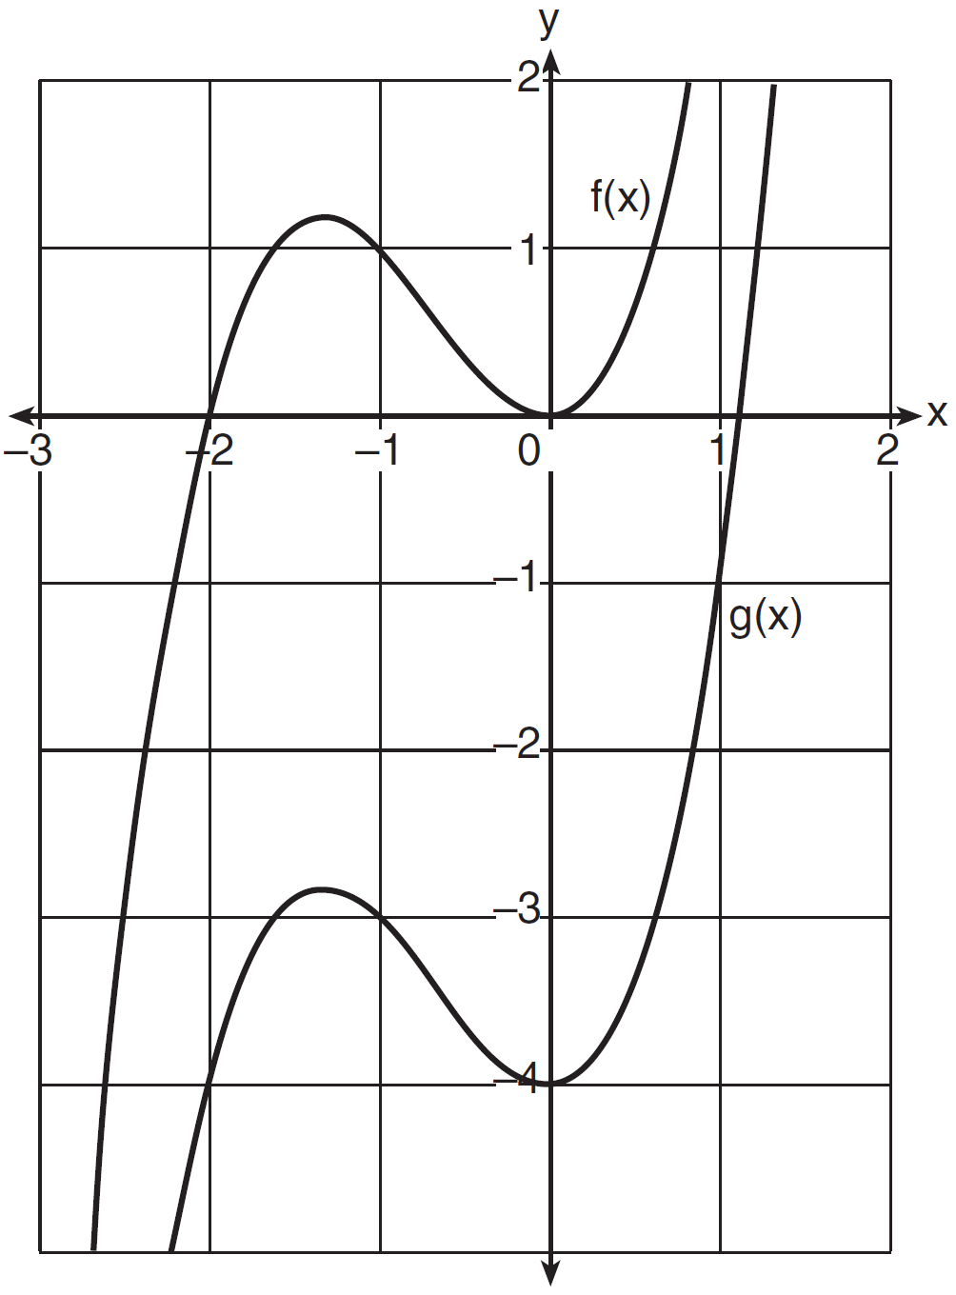

Determine an equation of . Explain your reasoning.

378) In the functions and , k is a positive integer. If k is replaced by , which statement about these new functions is true?
1) | The graphs of both and become wider. | 3) | The graphs of both and shift vertically.
2) | The graph of becomes narrower and the graph of shifts left. | 4) | The graph of shifts left and the graph of becomes wider.

379) If the original function is shifted to the left 3 units to make the function , which expression would represent ?
1) |  | 3)
2) |  | 4)

380) The graph of the function is represented below. On the same set of axes, sketch the function .
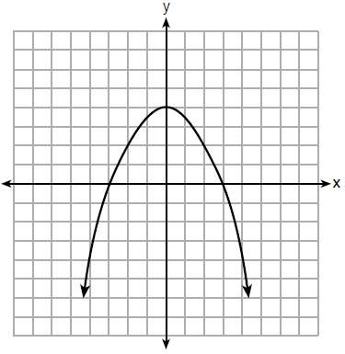

SOLUTIONS

372) ANS: 1
Strategy: Use the following general rules for quadratics, then check with a graphiong calculator.
As the value of a approaches 0, the parabola gets wider.
A positive value of a opens upward.
A negative value of a opens downward.

Check with graphing calculator:
Assume , then
If a is multiplied by , then 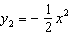.
Input both equations in a graphing calculator, as follows:

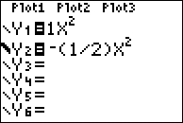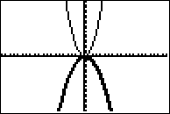

PTS: 2 NAT: F.BF.B.3 TOP: Transformations with Functions and Relations

373) ANS: 2
Strategy: Input both functions in a graphing calculator and compare them.

Let the graph of be the graph of
Let the graph of be the graph of
Input both functions in a graphing calculator.
g(x) is the thick line and f(x) is the thin line.
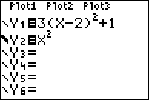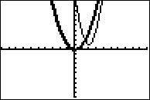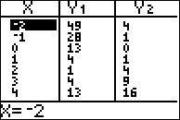

PTS: 2 NAT: F.BF.B.3 TOP: Transformations with Functions and Relations

374) ANS:
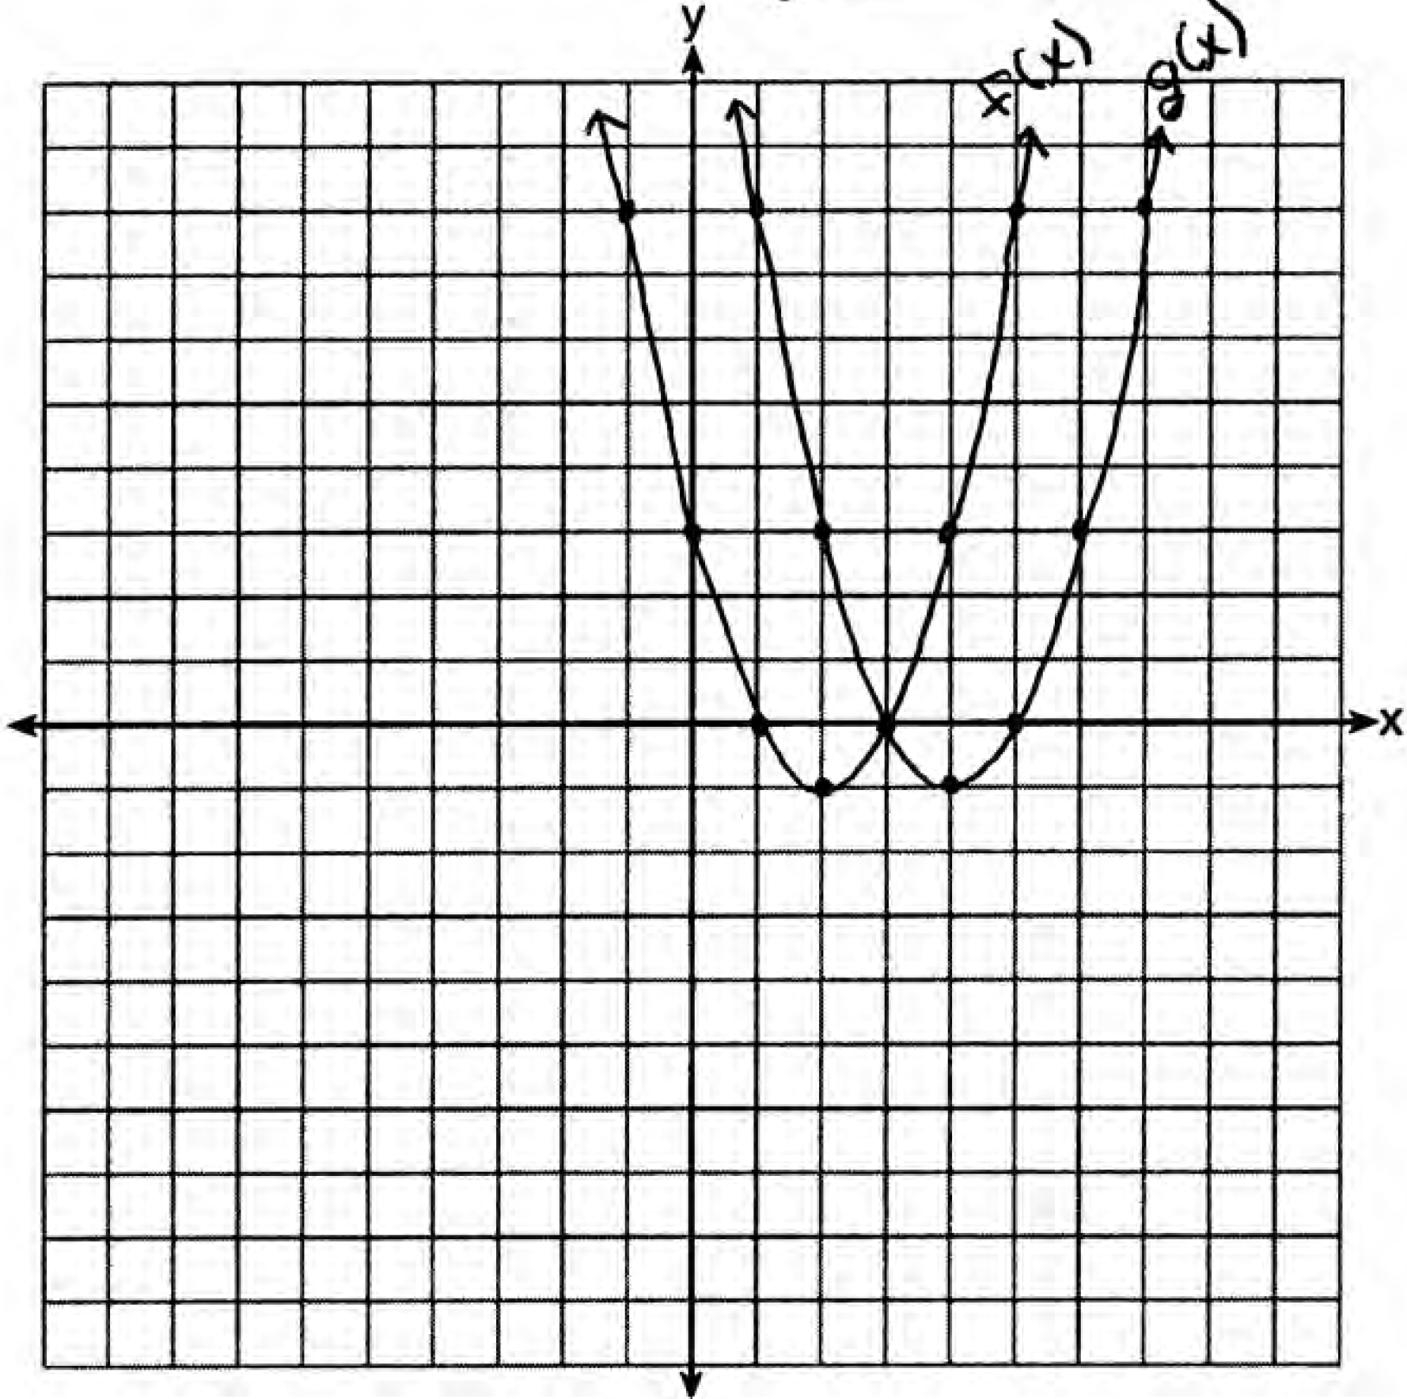
. is a horizontal shift two units to the right

Strategy 1: Compose a new function, find the axis of symmetry, solve for g(x) at axis of symmetry, as follows:
and  Therefore: 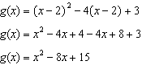 | 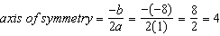  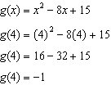
The coordinates of the vertex of g(x) are (4,-1)

Strategy #2. Input the new function in a graphing calculator and identify the vertex.
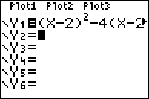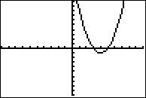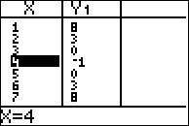

PTS: 2 NAT: F.BF.B.3 TOP: Transformations with Functions and Relations

375) ANS: 2
Strategy: Use the characteristics of the slope intercept form of a line, which is , where y is the dependent variable, m is the slope, x is the dependent variable, and b is the y-inctercept.

If b (the y-intercept) is increased by four, the slope remains the same and the new line is shifted up 4 units.

Check using a graphing calculator.
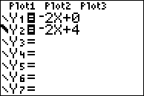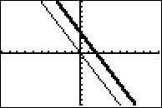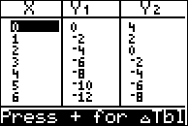

PTS: 2 NAT: F.BF.B.3 TOP: Transformations with Functions and Relations

376) ANS: 2
Strategy: Eliminate wrong answers.
Step 1. Since , a must be positive and the graph of must open upward. Eliminate any choice that opens downward.
Step 2. Determine if the graph gets wider or narrower by selecting a number larger than 1 for a, then input both functions in a graphing calculator and compare their graphs. The graph gets narrower, so eliminate any answer that indicates wider.
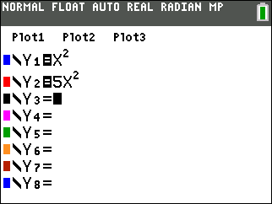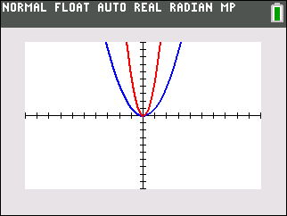
a) opens upward and is wider
b) opens upward and is narrower
c) opens downward and is wider
d) opens downward and is narrower

PTS: 2 NAT: F.BF.B.3 STA: A.G.5 TOP: Graphing Polynomial Functions

377) ANS:

f(x) has a y-intercept of 0.
g(x) has a y-intercept of -4.
Every point on f(x) is a translation down 4 units to create g(x).

PTS: 2 NAT: F.BF.B.3 TOP: Graphing Polynomial Functions

378) ANS: 1
Since k is a positive integer, the lowest possible value for k is 1. If k is replaced by , the graphs of both and will become wider.
Let k = 1 | Let be replaced by 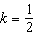
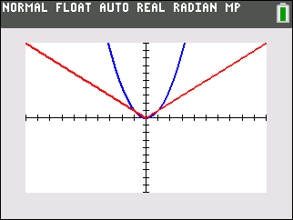 | 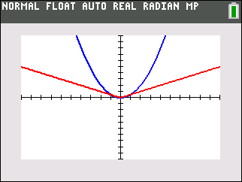

PTS: 2 NAT: F.BF.B.3 TOP: Graphing Polynomial Functions

379) ANS: 2
Strategy: Input the orginal function and the four answer choices in a graphing calculator. Then, select the function rule for the graph that is shifted 3 units to the left.
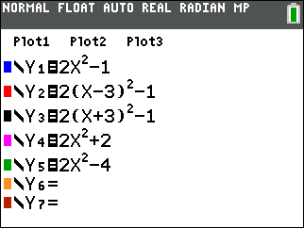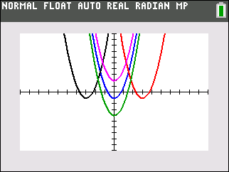

PTS: 2 NAT: F.BF.B.3 TOP: Graphing Polynomial Functions

380) ANS:
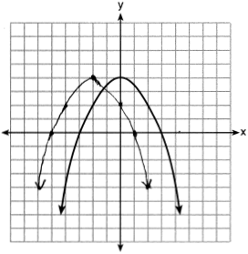
Strategy: Solve a simpler problem - pick a simple quadratic function, such as and see what happens to the graph when the function is changed to .
STEP 1. Input both in functions in a graphing calcualor.
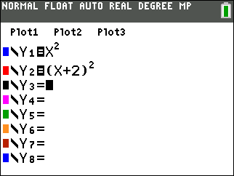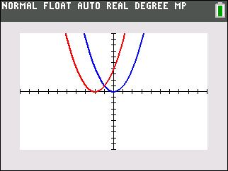
STEP 2. Observe that the graph moves two units to the left.
STEP 3. Move every point of the original function two units to the left.

PTS: 2 NAT: F.BF.B.3 TOP: Graphing Polynomial Functions

