**M – Functions, Lesson 8, Relating Graphs to Events (r. 2018)**

FUNCTIONS

Relating Graphs to Events

|  |  |
| --- | --- |
| **CC Standard**  **F-IF.4** For a function that models a relationship between two quantities, interpret key features of graphs and tables in terms of the quantities, and sketch graphs showing key features given a verbal description of the relationship. *Key features include: intercepts; intervals where the function is increasing, decreasing, positive, or negative; relative maximums and minimums; symmetries; ~~end behavior~~; ~~and periodicity~~.*  PARCC: Tasks have a real-world context. Tasks are limited to linear functions, quadratic functions, square root functions, cube root functions, piece-wise defined functions (including step functions and absolute value functions) and exponential functions with domains in the integers. | **NG Standard**  **AI-F.IF.4** For a function that models a relationship between two quantities:  i) interpret key features of graphs and tables in terms of the quantities; and  ii) sketch graphs showing key features given a verbal description of the relationship.  (Shared standard with Algebra II)  Notes:  • Algebra I key features include the following: intercepts, **zeros**; intervals where the function is increasing, decreasing, positive, or negative; maxima, minima; and symmetries.  • Tasks have a real-world context and are limited to the following functions: linear, quadratic, square root, piece-wise defined (including step and absolute value), and exponential functions of the formwhere *a* > 0 and *b* > 0 (*b*≠1). |

**LEARNING OBJECTIVES**

Students will be able to:

1. relate graphs to real-world contexts, and
2. relate real-world contexts to graphs.

**Overview of Lesson**

|  |  |
| --- | --- |
| **Teacher Centered Introduction**  **Overview of Lesson**  **- activate students’ prior knowledge**  **- vocabulary**  **- learning objective(s)**  **- big ideas: direct instruction**  **- modeling** | **Student Centered Activities**  **guided practice ⬅Teacher: anticipates, monitors, selects, sequences, and connects student work**  **- developing essential skills**  **- Regents exam questions**  **- formative assessment assignment (exit slip, explain the math, or journal entry)** |

**VOCABULARY**

speed

rate of change

increasing

decreasing

interval

**BIG IDEAS**

**Increasing or Decreasing Intervals and Slope**

|  |  |
| --- | --- |
| **A Function is Increasing Over an Interval that has Positive Slope** | **A Function is Decreasing Over an Interval that has Negative Slope**. |
| **Example:**  **The function at right is**  • **increasing over the interval 0 < x < 2.5**  • **decreasing over the interval 2.5 < x < 5.5** |  |

NOTE: Graphs involving time and distance variables are about speed.



**DEVELOPING ESSENTIAL SKILLS**

1. The accompanying graph shows Marie’s distance from home (*A*) to work (*F*) at various times during her drive.

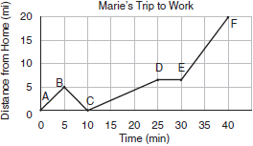

Marie left her briefcase at home and had to return to get it. State which point represents when she turned back around to go home and explain how you arrived at that conclusion. Marie also had to wait at the railroad tracks for a train to pass. How long did she wait?

2. John left his home and walked 3 blocks to his school, as shown in the accompanying graph.

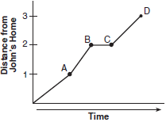

What is one possible interpretation of the section of the graph from point *B* to point *C*?

|  |  |  |  |
| --- | --- | --- | --- |
| a. | John arrived at school and stayed throughout the day. | c. | John returned home to get his mathematics homework. |
| b. | John waited before crossing a busy street. | d. | John reached the top of a hill and began walking on level ground. |

3. The accompanying graph show the amount of water left in Rover’s water dish over a period of time.

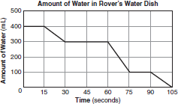

How long did Rover wait from the end of his first drink to the start of his second drink of water?

|  |  |  |  |
| --- | --- | --- | --- |
| a. | 10 sec | c. | 60 sec |
| b. | 30 sec | d. | 75 sec |

4. A bug travels up a tree, from the ground, over a 30-second interval. It travels fast at first and then slows down. It stops for 10 seconds, then proceeds slowly, speeding up as it goes. Which sketch best illustrates the bug’s distance (*d*) from the ground over the 30-second interval (*t*)?

|  |  |  |  |
| --- | --- | --- | --- |
| a. |  | c. |  |
| b. |  | d. |  |

**ANSWERS**

1. ANS:

B, 5 minutes. At point B, Mary’s distance from home begins to decrease, representing the point where she turned back around to go home. The interval between points D and E is the only portion of the graph where Mary’s distance from home remains constant. It lasts for 5 mins.

2. ANS: B

Between points *B* and *C*, John’s distance from home remains constant. (2) represents an interpretation in which John’s distance remains constant, waiting before crossing a busy street. (1) also represents an interpretation in which John’s distance remains constant, but at points *B* and *C*, John had not yet arrived at school. In both (3) and (4), John’s distance from school is changing.

3. ANS: B

When Rover is drinking, the amount of water in his dish decreases over time. The first decrease ends at 30 seconds and the second decrease begins at 60 seconds. The difference between these points is 30 seconds.

4. ANS: C

In this sketch, the bug’s speed is decreasing during the first third of time, equals 0 during the second third of time and is increasing the last third of time. In (4), the bug is traveling down the tree. In (1) and (2), the bug’s speed remains constant.

**REGENTS EXAM QUESTIONS (through June 2018)**

F.IF.B.4: Relating Graphs to Events

474) To keep track of his profits, the owner of a carnival booth decided to model his ticket sales on a graph. He found that his profits only declined when he sold between 10 and 40 tickets. Which graph could represent his profits?

|  |  |  |  |
| --- | --- | --- | --- |
| 1) |  | 3) | Profits in this graph decline between 10 and 40 tickets, so |
| 2) | The slope in this graph is always positive, so the profit never declines. | 4) |  |

475) During a snowstorm, a meteorologist tracks the amount of accumulating snow. For the first three hours of the storm, the snow fell at a constant rate of one inch per hour. The storm then stopped for two hours and then started again at a constant rate of one-half inch per hour for the next four hours.

a) On the grid below, draw and label a graph that models the accumulation of snow over time using the data the meteorologist collected.



b) If the snowstorm started at 6 p.m., how much snow had accumulated by midnight?

476) The graph below models Craig's trip to visit his friend in another state. In the course of his travels, he encountered both highway and city driving.

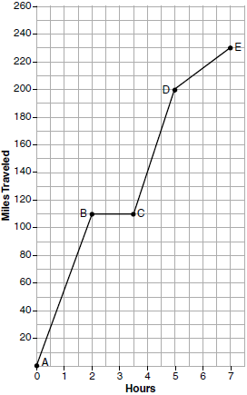

Based on the graph, during which interval did Craig most likely drive in the city? Explain your reasoning. Explain what might have happened in the interval between *B* and *C*. Determine Craig's average speed, to the *nearest tenth of a mile per hour*, for his entire trip.

477) The graph below represents a jogger's speed during her 20-minute jog around her neighborhood.

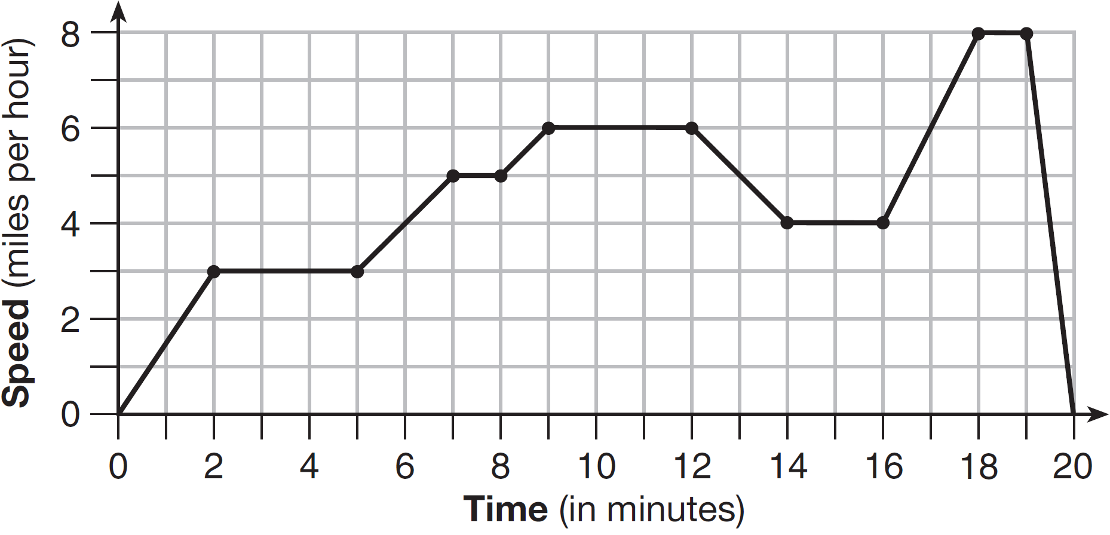

Which statement best describes what the jogger was doing during the  minute interval of her jog?

|  |  |  |  |
| --- | --- | --- | --- |
| 1) | She was standing still. | 3) | She was decreasing her speed |
| 2) | She was increasing her speed. | 4) | She was jogging at a constant rate. |

478) A driver leaves home for a business trip and drives at a constant speed of 60 miles per hour for 2 hours. Her car gets a flat tire, and she spends 30 minutes changing the tire. She resumes driving and drives at 30 miles per hour for the remaining one hour until she reaches her destination. On the set of axes below, draw a graph that models the driver’s distance from home.

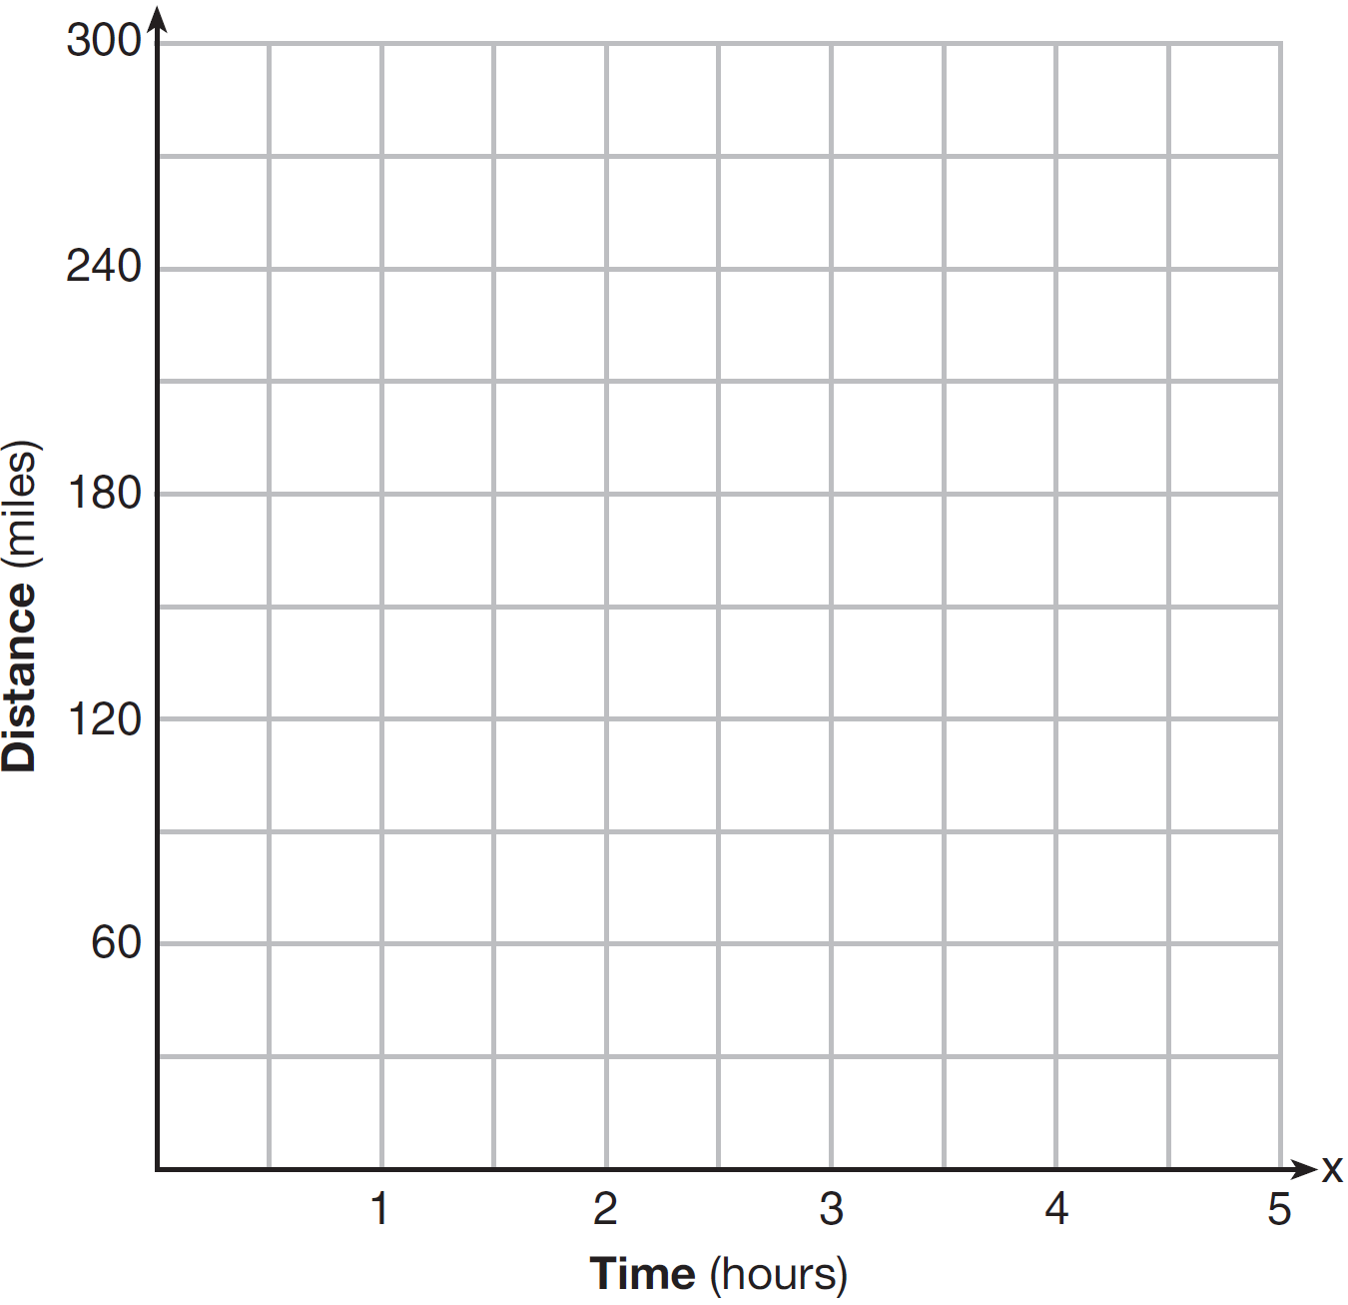

**SOLUTIONS**

474) ANS: 3

Declining profits over the interval 10 to 40 tickets sold will be shown as a negative slope.

|  |  |
| --- | --- |
| a)  Over the interval between 10 and 40 tickets sold, there is no negative slope, so this is a wrong choice. | c)  Over the interval between 10 and 40 tickets sold, the slope is negative, so this is the correct choice. |
| b)  Over the interval between 10 and 40 tickets sold, the slope is always positive, so this is a wrong choice. | d)  Over the interval between 10 and 40 tickets sold, there is first a positive slope and then a negative, so this is a wrong choice. |

PTS: 2 NAT: F.IF.B.4 TOP: Relating Graphs to Events

475) ANS:

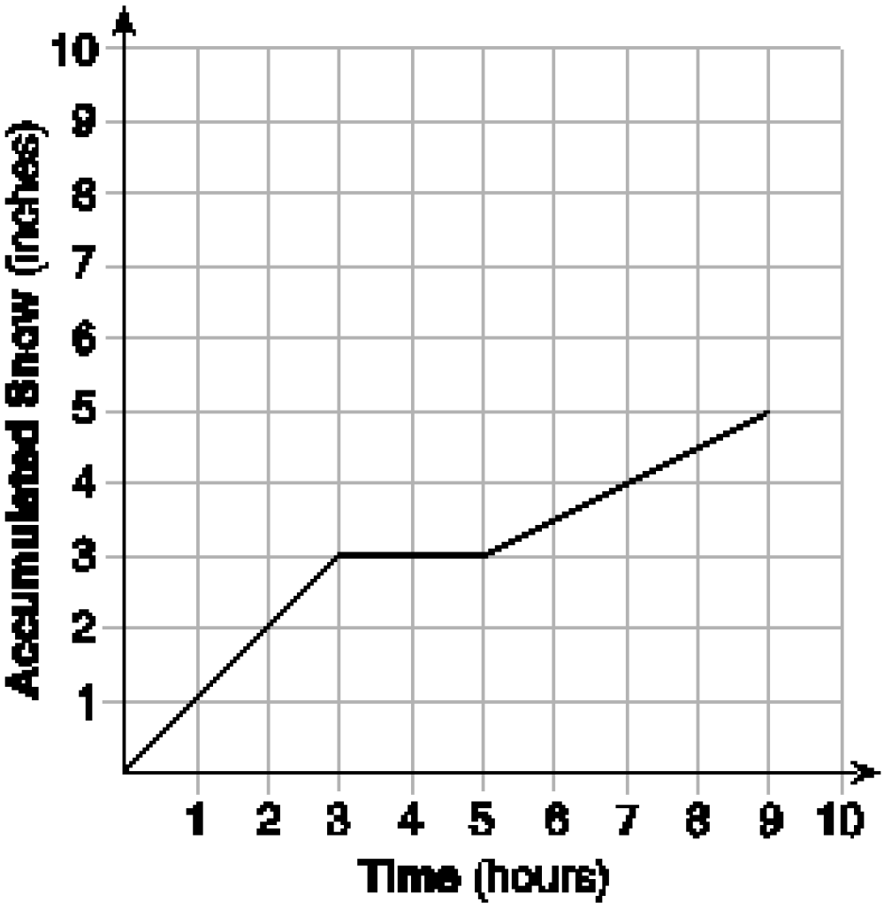 At midnight, 6 hours after the storm began,  inches of snow have fallen.

Strategy - Part a). Label the x and y axes and the corresponding intervals, then use the rates of change from the problem to complete the graph.

STEP 1. Plot the rate of change for the first three hours of the storm. The rate of change during this time is 1 inch per 1 hour.

STEP 2. Plot no change in accumulation for the two hours when the storm is stopped.

STEP 3. Plot the rate of change for the next four hours. During this interval, the rate of change is  inch per 1 hour.

Strategy: Part b). Determine which point on the graph corresponds to midnight.

Midnight it six hours after 6 p.m., so the coordinate  can be used to determine the amount of accumulation at midnight. The amount of snow accumulation at midnight is  inches.

PTS: 4 NAT: F.IF.B.4 TOP: Relating Graphs to Events

476) ANS:

Craig most likely was driving in the city during the interval *.* The slope of ** is less steep than the slopes of  and , indicating a lower speed. Speed limits are usually lower in the city than on the highway.

During the interval , Craig stopped.

Craig’s average speed for the entire trip was 32.9 miles per hour.



**

PTS: 4 NAT: F.IF.B.4 TOP: Relating Graphs to Events

477) ANS: 4

Strategy: Pay close attention to the labels on the x-axis and the y-axis, then eliminate wrong answers. NOTE: A horizontal line (no slope) means that speed is not changing.

Answer a can be eliminated because she would have a speed of 0 if she were standing still. She was only standing still at the start and end of her jog.

Answer b can be eliminated because the speed does not change during the  minute interval of her jog.

Answer c can be eliminated because the speed does not change during the  minute interval of her jog.

Answer d is the correct choice because a horizontal line (no slope) means that speed is not changing.

PTS: 2 NAT: F.IF.B.4 TOP: Relating Graphs to Events

478) ANS:

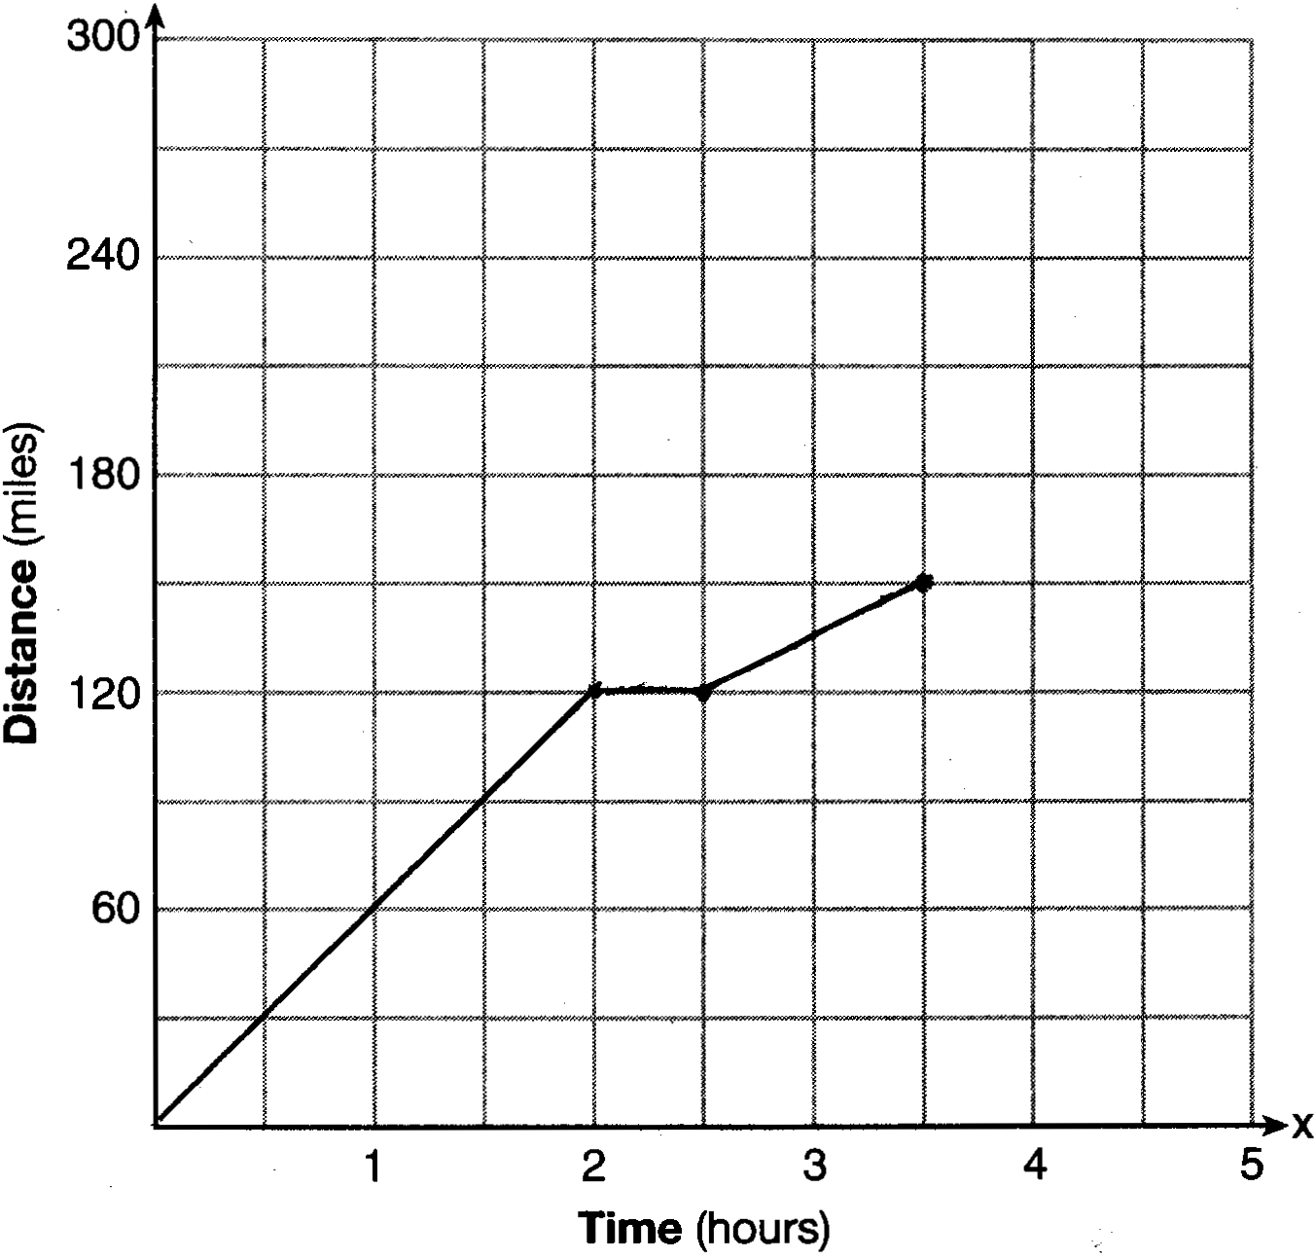

Strategy - Use the speed of the car as the rate of change to complete the graph.

STEP 1. Plot 2 hours at 60 miles per hour slope, based on the language “... a constant speed of 60 miles per hour for 2 hours.”

STEP 2. Plot  hour at 0 slope based on the language “...she spends 30 minutes changing the tire.”

STEP 3. Plot 1 hour at 30 miles per hour slope based on the language “...drives at 30 miles per hour for the remaining one hour...”

PTS: 2 NAT: F.IF.B.4 TOP: Relating Graphs to Events