D – Rate, Lesson 4, Rate of Change (r. 2018)

RATE
Rate of Change
Common Core Standard  F-IF.B.6 Calculate and interpret the average rate of change of a function (presented symbolically or as a table) over a specified interval. Estimate the rate of change from a graph.  PARCC: Tasks have a real-world context. Tasks are limited to linear functions, quadratic functions, square root functions, cube root functions, piece-wise defined functions (including step functions and absolute value functions) and exponential functions with domains in the integers. | Next Generation Standard  AI-F.IF.6 Calculate and interpret the average rate of change of a function over a specified interval.  (Shared standard with Algebra II)  Notes:  • Functions may be presented by function notation, a table of values, or graphically.  • Algebra I tasks have a real-world context and are limited to the following functions: linear, quadratic, square root, piece-wise defined (including step and absolute value), and exponential functions of the form where a > 0 and b > 0, (b ≠ 1).

LEARNING OBJECTIVES
Students will be able to:
1) Calculate and interpret the average rate of change of a function over a specified interval.

Overview of Lesson
Teacher Centered Introduction  Overview of Lesson  - activate students’ prior knowledge  - vocabulary  - learning objective(s)  - big ideas: direct instruction  - modeling | Student Centered Activities  guided practice ⬅Teacher: anticipates, monitors, selects, sequences, and connects student work  - developing essential skills  - Regents exam questions  - formative assessment assignment (exit slip, explain the math, or journal entry)

VOCABULARY

average rate of change
coordinate pair
interval
rate of change
slope
slope formula
steepness

BIG IDEAS

Rate of Change is a measure of how two variables are related to one another. Rate of change can be expressed in many ways:
Rate of change can also be found by inspecting a table or graph of a function.
Table | Graph
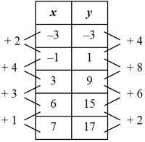  By finding the change in y and the change in x between each coordinate pair in a table, you can see if the rate of change is constant or variable. This table shows a linear function because the rate of change is constant. | 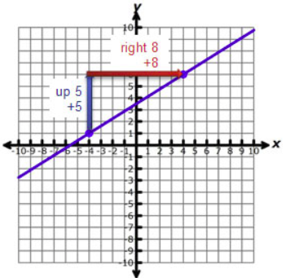  By picking two known points on the graph of a line, you can build a right triangle to find the change in y and the change in x. The rate of change for this linear function is . Always read from left to right when using this method.

- The rate of change in a linear function is constant between any two points anywhere on the straight line.
- The rate of change in a non-linear function varies.
- The rate of change can be either positive or negative.
  - A positive rate of change indicates that both variables are either increasing together or decreasing together, though not necessarily at the same rate.
  - A negative rate of change indicates that one variable increases while the other variable decreases.
- The rate of change in a function can be estimated by the steepness of a graph.

Average Rate of Change is used primarily with non-linear functions, since all linear functions have a constant rate of change. Average rate of change can be defined as the slope of the straight line that connects the end points of the interval over which the average rate of change is measured.

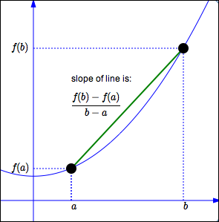

Example: The graph below records the number of hours and the distance travelled by a family on a trip. The graph is non-linear, so the rate of change is not constant.
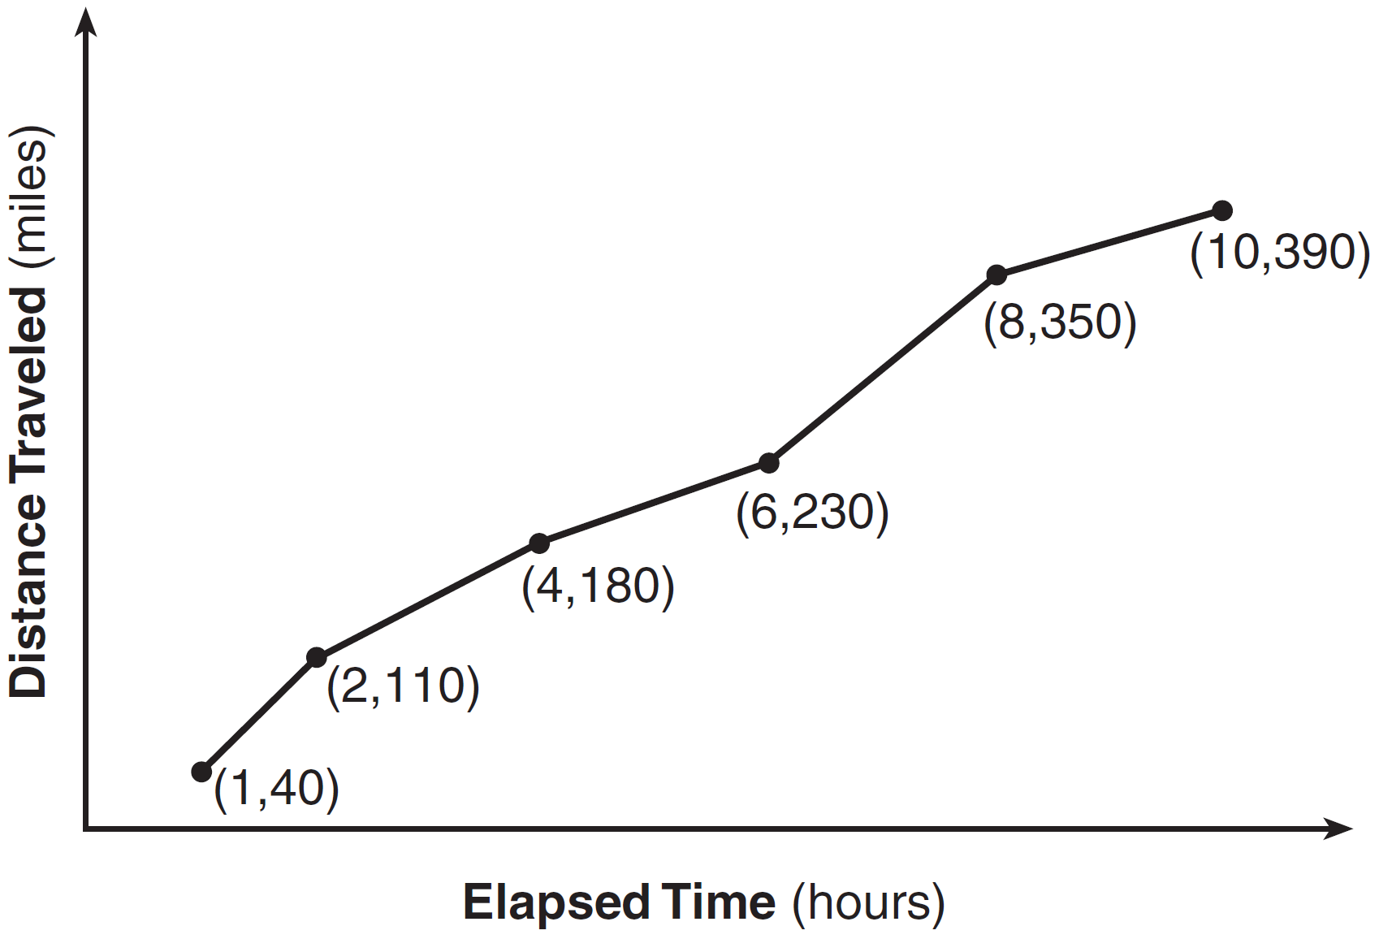
To compute the average rate of change for the entire trip, use the end points of the intervals of the graph. Include the origin (0,0) as their starting point. Ten hours later, they had travelled 390 miles (10,390). Their average rate of change for the entire trip is the slope of the line connecting points (0, 0) and (10, 390), which can be calculated as follows:
In this example, the average rate of change measures speed, the relationship between distance and time. Notice from the graph that their speed was not constant. Sometimes they went faster than 39 mph and sometimes slower than 39 mph, but their average speed over the entire trip was 39 mph.

DEVELOPING ESSENTIAL SKILLS
- Find the average rate of change between the first and fifth 5 hours.
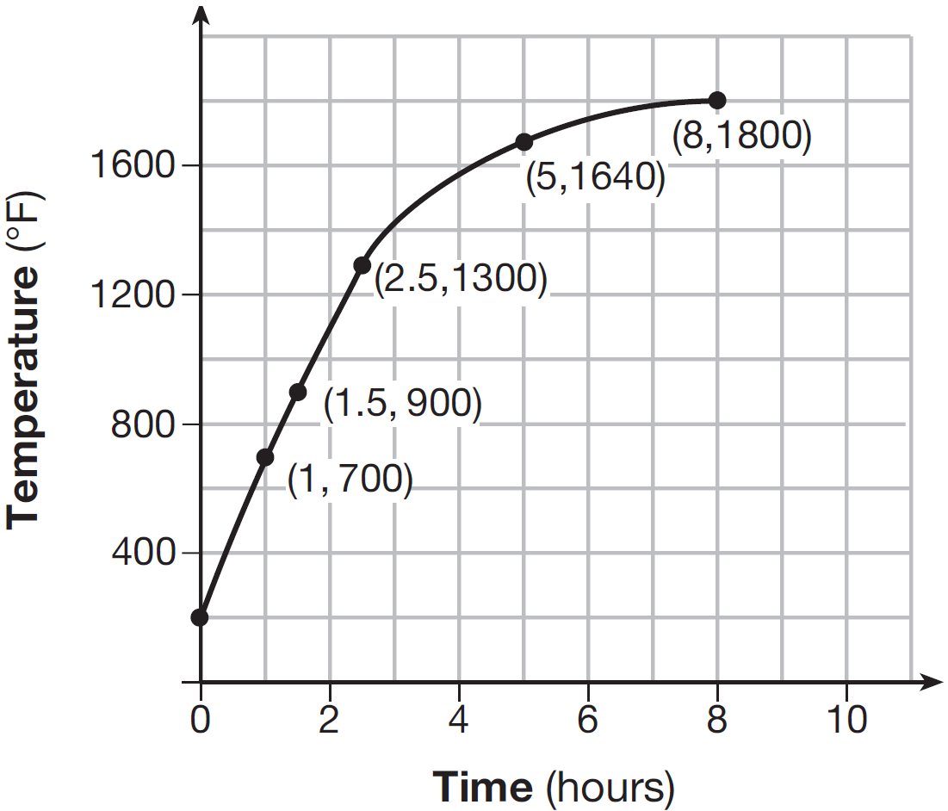
- Use rate of change to determine if the table below represents a linear or a non-linear function. Explain your answer.
Table of Values
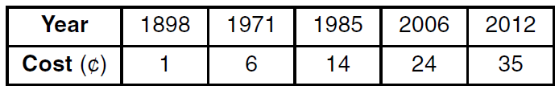
Interval
Rate of change between 1898 and 1971 | 73 | 5
Rate of change between 1971 and 1985 | 14 | 8
The table is non-linear because the rate of change is not constant.
REGENTS EXAM QUESTIONS (through June 2018)
F.IF.B.6: Rate of Change

93) Given the functions , , and shown below:

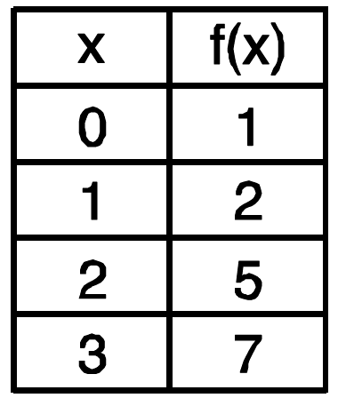

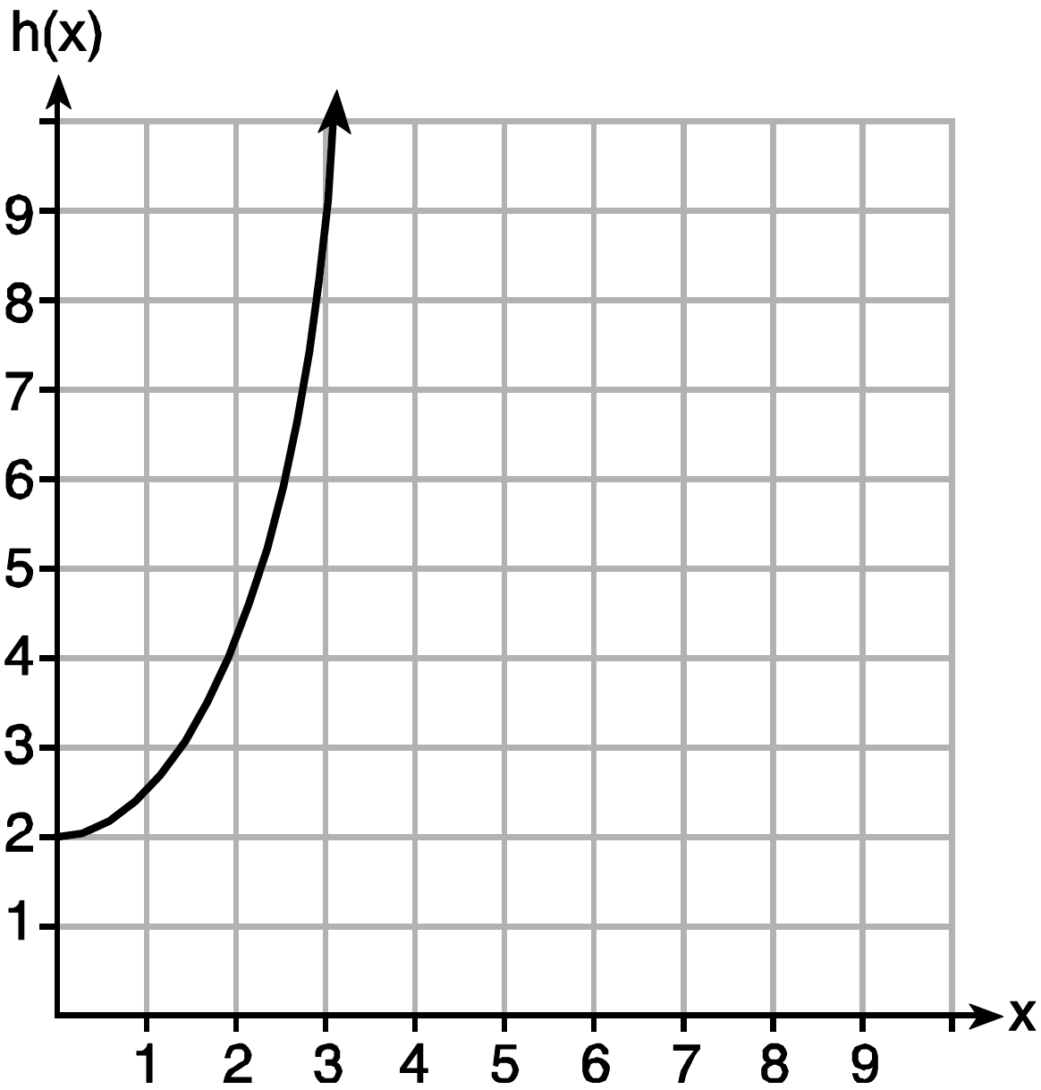

The correct list of functions ordered from greatest to least by average rate of change over the interval is
1) | , , | 3) | , ,
2) | , , | 4) | , ,

94) An astronaut drops a rock off the edge of a cliff on the Moon. The distance, , in meters, the rock travels after t seconds can be modeled by the function . What is the average speed, in meters per second, of the rock between 5 and 10 seconds after it was dropped?
1) | 12 | 3) | 60
2) | 20 | 4) | 80

95) The graph below shows the distance in miles, m, hiked from a camp in h hours.

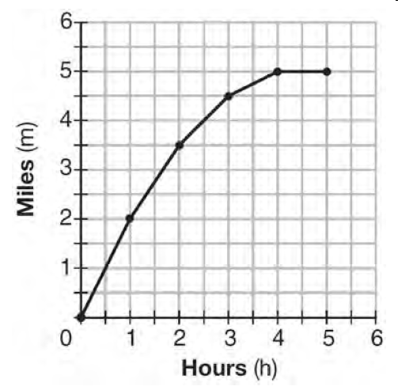
Which hourly interval had the greatest rate of change?

1) | hour 0 to hour 1 | 3) | hour 2 to hour 3
2) | hour 1 to hour 2 | 4) | hour 3 to hour 4

96) The Jamison family kept a log of the distance they traveled during a trip, as represented by the graph below.

During which interval was their average speed the greatest?
1) | the first hour to the second hour | 3) | the sixth hour to the eighth hour
2) | the second hour to the fourth hour | 4) | the eighth hour to the tenth hour

97) The table below shows the average diameter of a pupil in a person’s eye as he or she grows older.

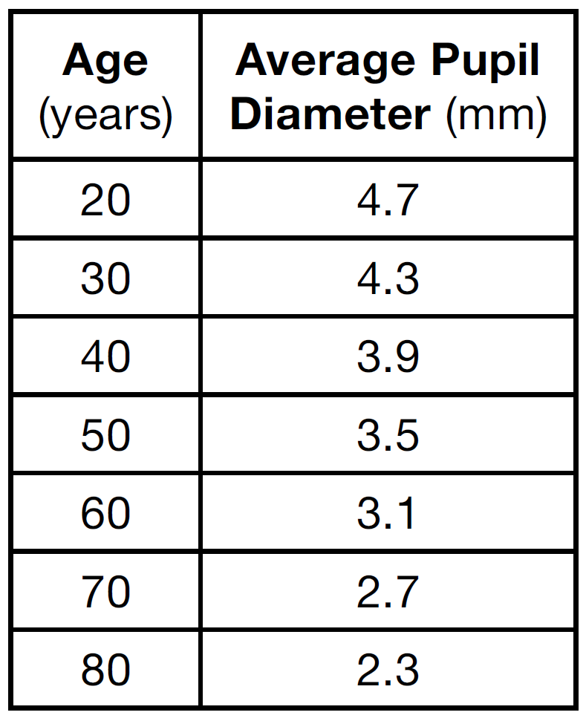

What is the average rate of change, in millimeters per year, of a person’s pupil diameter from age 20 to age 80?
1) | 2.4 | 3)
2) | 0.04 | 4)

98) Joey enlarged a 3-inch by 5-inch photograph on a copy machine. He enlarged it four times. The table below shows the area of the photograph after each enlargement.

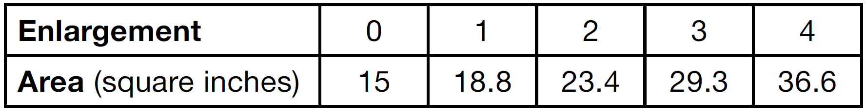

What is the average rate of change of the area from the original photograph to the fourth enlargement, to the nearest tenth?
1) | 4.3 | 3) | 5.4
2) | 4.5 | 4) | 6.0

99) Firing a piece of pottery in a kiln takes place at different temperatures for different amounts of time. The graph below shows the temperatures in a kiln while firing a piece of pottery after the kiln is preheated to 200ºF.

During which time interval did the temperature in the kiln show the greatest average rate of change?
1) | 0 to 1 hour | 3) | 2.5 hours to 5 hours
2) | 1 hour to 1.5 hours | 4) | 5 hours to 8 hours

100) The table below shows the cost of mailing a postcard in different years. During which time interval did the cost increase at the greatest average rate?

1) | 1898-1971 | 3) | 1985-2006
2) | 1971-1985 | 4) | 2006-2012

101) The graph below shows the variation in the average temperature of Earth's surface from 1950-2000, according to one source.

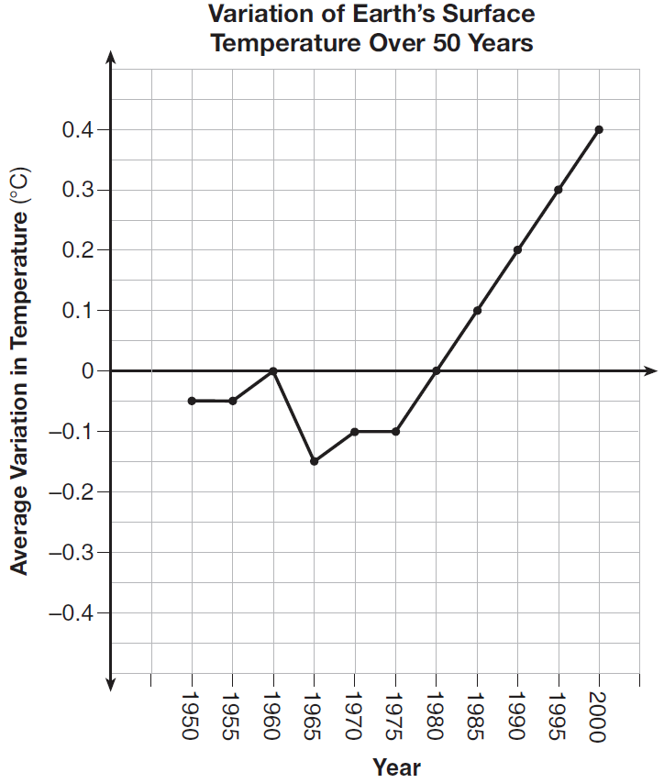

During which years did the temperature variation change the most per unit time? Explain how you determined your answer.

102) The table below shows the year and the number of households in a building that had high-speed broadband internet access.

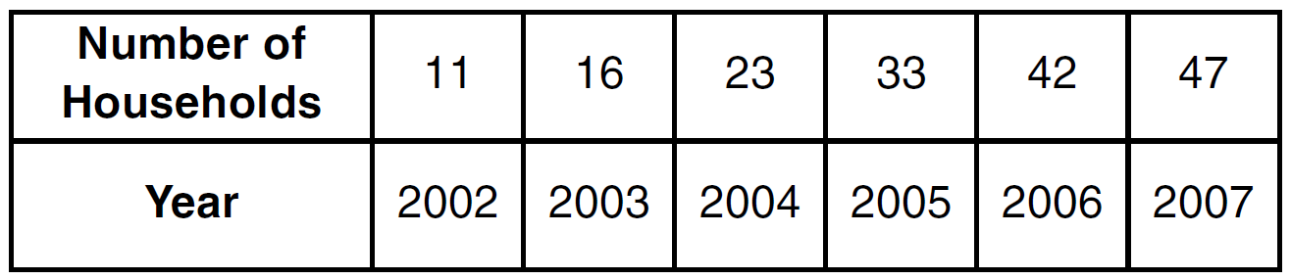

For which interval of time was the average rate of change the smallest?
1) | 2002 - 2004 | 3) | 2004 - 2006
2) | 2003 - 2005 | 4) | 2005 - 2007

103) Which function has a constant rate of change equal to -3?
1) | 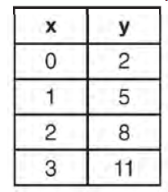 | 3) | 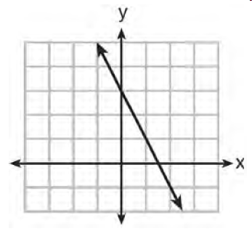
2) | {(1,5), (2,2), (3,-5), (4,4)} | 4)

104) A graph of average resting heart rates is shown below. The average resting heart rate for adults is 72 beats per minute, but doctors consider resting rates from 60-100 beats per minute within normal range.

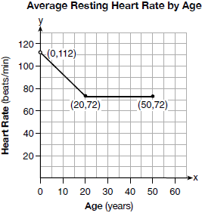

Which statement about average resting heart rates is not supported by the graph?
1) | A 10-year-old has the same average resting heart rate as a 20-year-old. | 3) | A 40-year-old may have the same average resting heart rate for ten years.
2) | A 20-year-old has the same average resting heart rate as a 30-year-old. | 4) | The average resting heart rate for teenagers steadily decreases.

105) A family is traveling from their home to a vacation resort hotel. The table below shows their distance from home as a function of time.

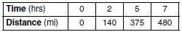

Determine the average rate of change between hour 2 and hour 7, including units.

106) The graph below models the height of a remote-control helicopter over 20 seconds during flight.

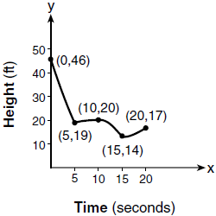

Over which interval does the helicopter have the slowest average rate of change?
1) | 0 to 5 seconds | 3) | 10 to 15 seconds
2) | 5 to 10 seconds | 4) | 15 to 20 seconds

107) Voting rates in presidential elections from 1996-2012 are modeled below.

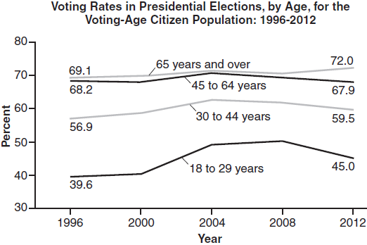

Which statement does not correctly interpret voting rates by age based on the given graph?
1) | For citizens 18-29 years of age, the rate of change in voting rate was greatest between years 2000-2004. | 3) | About 70% of people 45 and older voted in the 2004 election.
2) | From 1996-2012, the average rate of change was positive for only two age groups. | 4) | The voting rates of eligible age groups lies between 35 and 75 percent during presidential elections every 4 years from 1996-2012.

108) A manager wanted to analyze the online shoe sales for his business. He collected data for the number of pairs of shoes sold each hour over a 14-hour time period. He created a graph to model the data, as shown below.

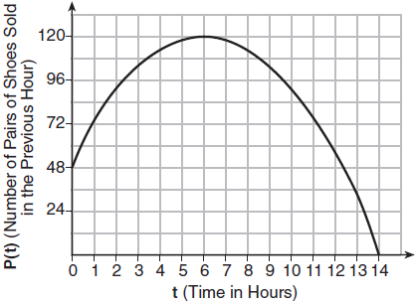

The manager believes the set of integers would be the most appropriate domain for this model. Explain why he is incorrect. State the entire interval for which the number of pairs of shoes sold is increasing. Determine the average rate of change between the sixth and fourteenth hours, and explain what it means in the context of the problem.

109) A population of rabbits in a lab, , can be modeled by the function , where x represents the number of days since the population was first counted. Explain what 20 and 1.014 represent in the context of the problem. Determine, to the nearest tenth, the average rate of change from day 50 to day 100.

SOLUTIONS

93) ANS: 4
Over the interval , the average rate of change for 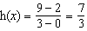, 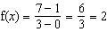, and 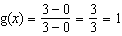.

PTS: 2 NAT: F.IF.B.6 TOP: Rate of Change

94) ANS: 1
Strategy: Use the formula for speed: 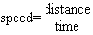 and information from the problem to calculate average speed.

STEP 1. Calculate for and .
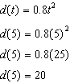 and 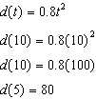
The rock had fallen 20 meters after 5 seconds and 80 meters after 10 seconds.
The total distance traveled was 60 meters in 5 seconds.

STEP 2: Use the speed formula to find average speed.
Substituting distance and time in the speed formula, 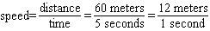.
The rock’s average speed between 5 and 10 seconds after being dropped was 12 meters per second.

DIMS? Does it make sense? Yes. The speed formula makes sense and the answer is expressed in meters per second as required by the problem.

PTS: 2 NAT: F.IF.B.6 TOP: Rate of Change

95) ANS: 1
Step 1. Understand that the problem is asking which hourly interval has the greatest rate of change (slope).
Step 2. Strategy: Calculate for each hourly interval and select the largest ratio.
Step3. Execution of Strategy
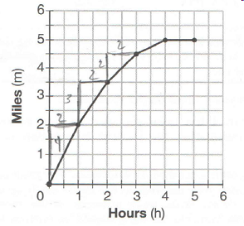
a) between hour 0 and hour 1, 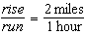.
b) between hour 1 and hour 2, 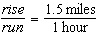.
c) between hour 2 and hour 3, 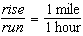.
d) between hour 3 and hour 4, 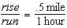.
Answer choice a) has the greatest rate of change.
Step 4. Does it make sense? Yes. The graph starts out steep and gradually gets less steep. The steepest part is between hour 0 and hour 1, which corresponds to the calculated rates of change (slopes).

PTS: 2 NAT: F.IF.B.6

96) ANS: 1
Strategy: Equate speed with rate of change. 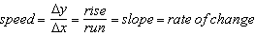
Make a visual estimate of the steepest line segment on the graph, then use the slope formula to calculate the exact rates of change.

STEP 1. The line segment from (1, 40) to (2, 110) appears to be the steepest line segment in the graph. The line segment from (6, 230) to (8, 350) also seems very steep.

STEP 2. Use 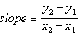
The line segment from (1, 40) to (2, 110) has 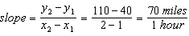.
The line segment from (6, 230) to (8, 350) has 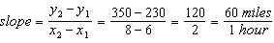.

PTS: 2 NAT: F.IF.B.6 TOP: Rate of Change

97) ANS: 4
Strategy: Rate of change is the same as slope. Use the slope formula to find the rate of change between (20, 4.7) and (80, 2.3).
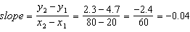.

DIMS? Does it make sense? Yes. The average pupil diameter gets smaller very very slowly. Choices a and c are way too big and choices a and b indicate that the average pupil size is getting bigger rather than smaller.

PTS: 2 NAT: F.IF.B.6 TOP: Rate of Change

98) ANS: 3
Strategy: Use the slope formula and data from the table to calculate the exact rate of change over four enlargements.

STEP 1. Use to compute the rate of change between (0, 15) and (4, 36.6).
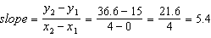.

DIMS? Does it make sense? Yes. If you start with 15 and add 5.4 + 5.4 +5.4 + 5.4, you end up with 36.6. There were four enlargements and the average increase of each enlargement was 5.4 square inches.

PTS: 2 NAT: F.IF.B.6 TOP: Rate of Change

99) ANS: 1
Strategy: Equate rate of change with slope. Make a visual estimate of the steepest line segment on the graph, then use the slope formula to calculate the exact rates of change over given intervals.

STEP 1. The line segment from (0, 200) to (1, 700) appears to be the steepest line segment in the graph. The line segment from (1, 700) to (1.5, 900) also seems very steep. The rate of change gets slower as the temperature of the kiln gets hotter.

STEP 2. Use
The line segment from (0, 200) to (1, 700) has
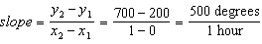.
The line segment from (1, 700) to (1.5, 900) has 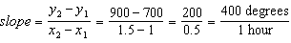
The rate of change was greatest in the first hour.

DIMS? Does it make sense? Yes. The graph shows that rate of change slows down as time increases, so the first hour would have the greatest rate of change.

PTS: 2 NAT: F.IF.B.6 TOP: Rate of Change

100) ANS: 4
Strategy: Find the average rate of change using the slope formula: 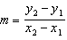.
(a) 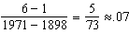
(b) 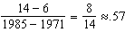
(c) 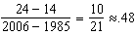
(d) 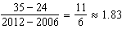

PTS: 2 NAT: F.IF.B.6 TOP: Rate of Change

101) ANS:
During 1960-1965, because the graph has the steepest slope during these years.

PTS: 2 NAT: F.IF.B.6 TOP: Rate of Change

102) ANS: 1
Step 1. Understand the problem as asking for the smallest average rate of change over an interval. The number of households depends on the year, so number of households is the y (dependent) variable and year is the x (independent) variable.
Step 2. Strategy. Average rate of change over an interval is found using the end points of the interval and the slope formula.
Step 3. Execution.
Average rate of change for choice 1: 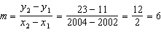
Average rate of change for choice 2: 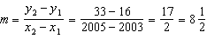
Average rate of change for choice 3: 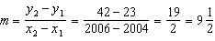
Average rate of change for choice 4: 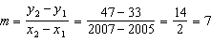
Step 4. Does it make sense? Yes. Choice (1) has the smallest average rate of change.

PTS: 2 NAT: F.IF.B.6 TOP: Rate of Change

103) ANS: 4
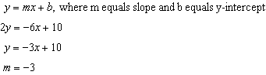

PTS: 2 NAT: F.LE.A.1

104) ANS: 1
The graph shows that a newborn child has age zero and an average resting heartbeat of 112 (0, 112). A 20 year old has an average resting heartbeat of 72 (20, 72). From birth to age 20, the average resting heartbeat decreases at a constant rate. After age 20, the average resting heartbeat stays the same until age 50 (50, 72). The problem wants to know which answer choice is not supported by the graph.
Strategy: Eliminate wrong answers.
a) A 10-year-old has the same average resting heart rate as a 20-year-old. This is not supported by the graph. The graph indicates that the average resting heartbeat of a 10-year-old is 92. . This is the correct answer.
b) A 20-year-old has the same average resting heart rate as a 30-year-old. This is supported by the graph. , so it is a wrong answer.
c) A 40-year-old may have the same average resting heart rate for ten years. This is supported by the graph. , so it is a wrong answer.
d) The average resting heart rate for teenagers steadily decreases. This is supported by the graph, so it is a wrong answer. From birth to age 20, the average resting heartbeat decreases at a constant rate.

PTS: 2 NAT: F.IF.B.6 TOP: Rate of Change

105) ANS:
68 miles per hour

Strategy: The average rate of change is the slope of the straight line between the two points at the ends of the interval. Find the slope of the straight line between (2, 140) and (7, 480) using the slope formula.
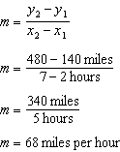

PTS: 2 NAT: F.IF.B.6 TOP: Rate of Change

106) ANS: 2
The average rate of change is slowest between the coordinates (5, 10) and (10, 20), which corresponds to the interval 5 to 10 seconds.

PTS: 2 NAT: F.IF.B.6 TOP: Rate of Change
KEY: AI

107) ANS: 2
From 1996-2012, the average rate of change was positive for three age groups.

PTS: 2 NAT: F.IF.B.6 TOP: Rate of Change

108) ANS:
PART 1
The set of integers includes negative numbers, so it is not an appropriate domain for time.
PART 2
0 < t < 14
The total number of shoes sold increases every hour that shoes are sold.
or
0 < t < 6
The hourly rate of shoe sales increases from 0 hours to 6 hours.
PART 3: Calculate the average rate of change and explain what it means.
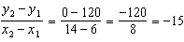
The average rate of change is -15, which means that, on average, 15 fewer shoes were sold each hour between the sixth and fourteenth hours.

PTS: 4 NAT: F.IF.B.6 TOP: Rate of Change

109) ANS:
20 represents the initial number of rabbits.
1.014 represents the rate of population growth.
The average rate of change from day 50 to day 100 is 0.8 rabbits per day.

Strategy: Use the slope formula, , to compute the average rate of change between day 50 and day 100.
STEP 1. Input in a graphing calculator.
STEP 2. Use the table of values view to afind the number of rabbits on day 50 and dat 100.
Day  (x) | Number of Rabbits
50 | 40.08
100 | 80.32
STEP 3. Input (50, 40.08) and (100, 80.32) into the slope formula.
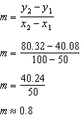

PTS: 2 NAT: F.IF.B.6 TOP: Rate of Change

