**G – Absolute Value, Lesson 1, Graphing Absolute Value Functions (r. 2018)**

ABSOLUTE VALUE

Graphing Absolute Value Functions

|  |  |
| --- | --- |
| **Common Core Standards**  **F-IF.C.7** Graph functions expressed symbolically and show key features of the graph, by hand in simple cases and using technology for more complicated cases. ★  **F-BF.B.3** Identify the effect on the graph of replacing *f(x)* by *f(x) + k, k f(x), ~~f(kx)~~,* and *f(x + k)* for specific values of *k* (both positive and negative); find the value of *k* given the graphs. Experiment with cases and illustrate an explanation of the effects on the graph using technology. Include recognizing ~~even and odd~~ functions from their graphs and algebraic expressions for them.  ~~PARCC: Identifying the effect on the graph of replacing~~ *~~f(x)~~* ~~by~~ *~~f(x) +k~~*~~,~~ *~~kf(x),~~* ~~and~~ *~~f(x+k)~~* ~~for specific values of~~ *~~k~~* ~~(both positive and negative) is limited to linear and quadratic functions. Experimenting with cases and illustrating an explanation of the effects on the graph using technology is limited to linear functions, quadratic functions, square root functions, cube root functions, piecewise-defined functions (including step functions and absolute value functions), and exponential functions with domains in the integers. Tasks do not involve recognizing even and odd functions.~~ | **Next Generation Standards**  **AI-F.IF.7** Graph functions and show key features of the graph by hand and by using technology where appropriate. ★  (Shared standard with Algebra II)  **AI-F.BF.3a** Using *f(x) + k*, *k f(x)*, and *f(x + k):*  i) identify the effect on the graph when replacing *f(x)* by *f(x) + k*, *k f(x)*, and *f(x + k)* for specific values of *k* (both positive and negative);  ii) find the value of *k* given the graphs;  iii) write a new function using the value of *k*;and  iv) use technology to experiment with cases and explore the effects on the graph.  (Shared standard with Algebra II)  **Note: Tasks are limited to linear, quadratic, square root, and absolute value functions; and exponential functions of the form where *a* > 0 and *b* > 0 (*b* ≠ 1).** |

**LEARNING OBJECTIVES**

Students will be able to:

1) Solve and graph absolute value functions with the aid of technology.

**Overview of Lesson**

|  |  |
| --- | --- |
| **Teacher Centered Introduction**  **Overview of Lesson**  **- activate students’ prior knowledge**  **- vocabulary**  **- learning objective(s)**  **- big ideas: direct instruction**  **- modeling** | **Student Centered Activities**  **guided practice ⬅Teacher: anticipates, monitors, selects, sequences, and connects student work**  **- developing essential skills**  **- Regents exam questions**  **- formative assessment assignment (exit slip, explain the math, or journal entry)** |

**VOCABULARY**

absolute value

absolute value function

catalog (of graphing calculator)

plus or minus () sign

ray

transformation

**BIG IDEAS**

The **absolute value** of a number is defined as the number’s distance from zero on a number line. Distance is always positive, so the absolute value of a number is always positive. For example,  , , .

NOTE:   Pay attention to whether a negative sign is inside or outside the absolute value parentheses.

An **absolute value function** is a function that contains an absolute value term or expression. Examples are  and .

**How to Solve an Absolute Value Function**

STEP 1: Isolate the absolute value expression.

STEP 2: Remove absolute value signs and add  to opposite expression.

STEP 3: Eliminate the  sign by writing two new equations.

STEP 4. Solve both equations.

**Examples**:

|  |  |
| --- | --- |
| Solve for *x*.  STEP 1: Isolate the absolute value expression.    STEP 2: Remove absolute value signs and add  to opposite expression.    STEP 3: Eliminate the  sign by writing two new equations.    STEP 4. Solve both equations. (*Unnecessary in this example.*) | Solve for *x*.  STEP 1: Isolate the absolute value expression.    STEP 2: Remove absolute value signs and add  to opposite expression.    STEP 3: Eliminate the  sign by writing two new equations.    STEP 4. Solve both equations. |

**Using a Graphing Calculator with Absolute Value Functions**:

Absolute value functions may be input in a graphing calculator by moving all terms to the right expression of the function and setting the left expression to zero. The inequality is then entered into the graphing calculator’s y-editor using the ABS function, which is found in the calculator’s catalog. Once input, the graph and table views of the function may be inspected.

**Example**: Given: 

|  |  |  |
| --- | --- | --- |
| STEP 1. Transform the absolute value function so that the left expression equals zero, as shown below. | STEP 2.  Input the function.  NOTE: The abs entry is found in the graphing calculator’s catalog.    NOTE: Since this example is an inequality, pay attention to the inequality sign on the far left of the calculator’s input screen. | STEP 3.  Inspect the table and graph views of the function.    . |

**Graphing an Absolute Value Function**

STEP 1. Input the absolute value function in the graphing calculator.

STEP 2. Inspect the graph and table views.

STEP 3. Plot three points: 1) the vertex; 2) a second point for the line to the left of the vertex; and 3) a third point for the line to the right of the vertex.

STEP 4. Draw rays from the vertex through the two points.

**DEVELOPING ESSENTIAL SKILLS**

Use technology to explain how what happens to the graph of under the transformations  and.

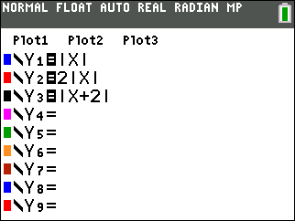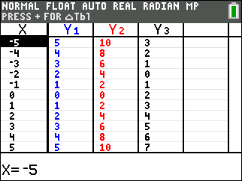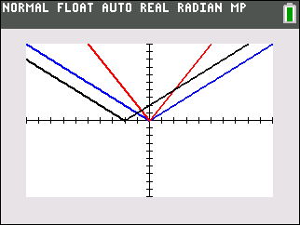

 gets narrower with the vertex at the same point.

 shifts two units to the left.

**REGENTS EXAM QUESTIONS (through June 2018)**

F.IF.C.7b, F.BF.B.3: Graphing Absolute Value Functions

163) On the set of axes below, graph the function .

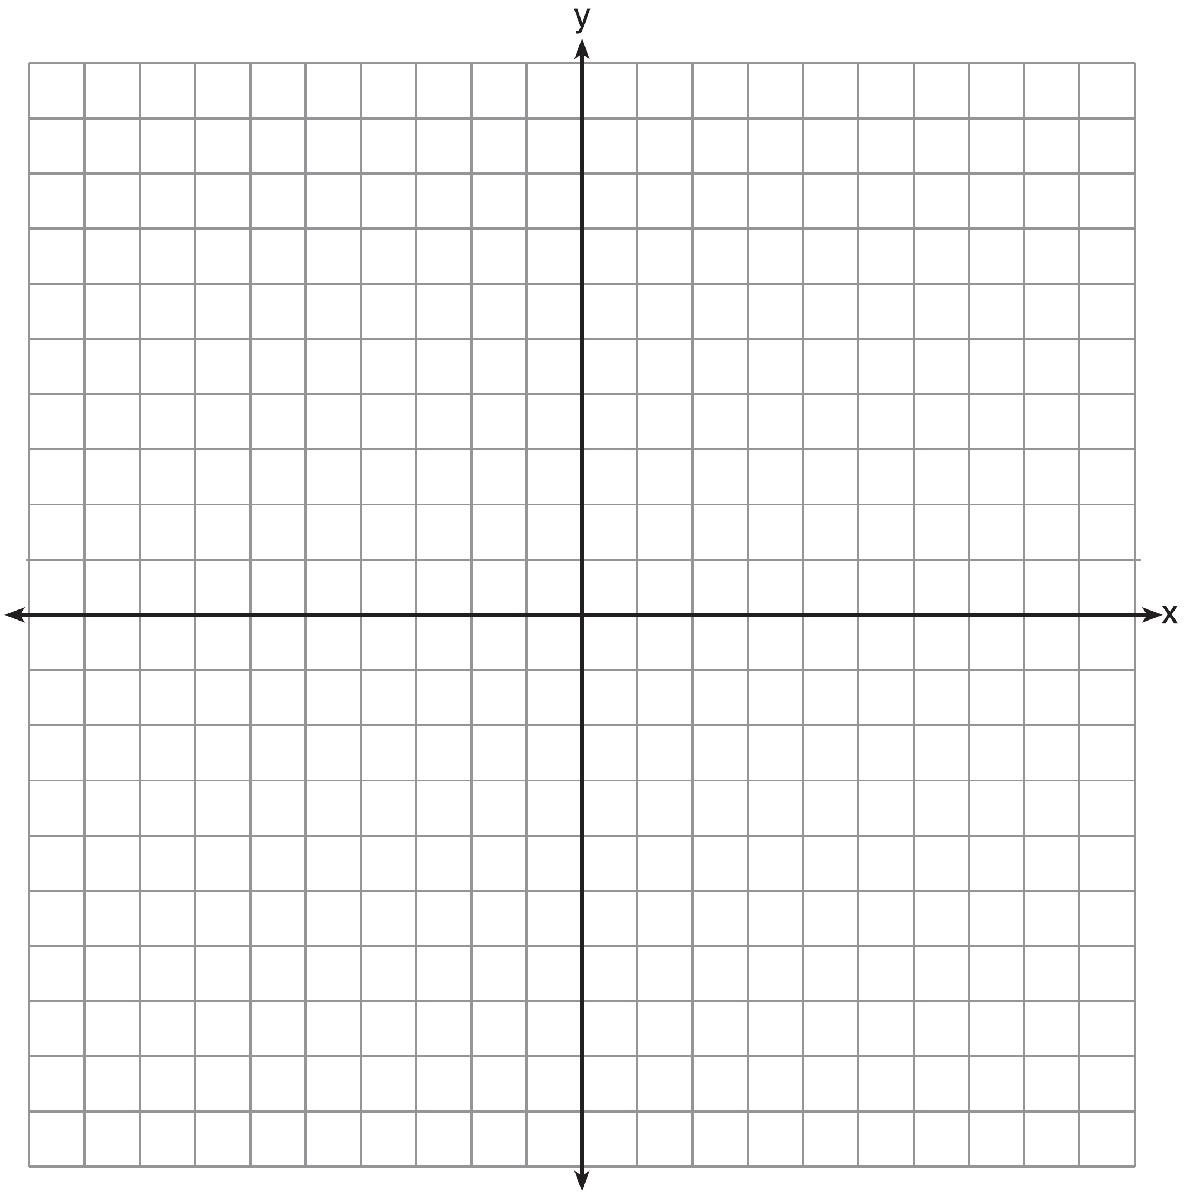

State the range of the function. State the domain over which the function is increasing.

164) What is the *minimum* value of the function ?

|  |  |  |  |
| --- | --- | --- | --- |
| 1) |  | 3) | 3 |
| 2) | 2 | 4) |  |

165) Graph the function  on the set of axes below.



Explain how the graph of  has changed from the related graph .

166) Describe the effect that each transformation below has on the function , where .





167) On the axes below, graph .



If , how is the graph of  translated to form the graph of ?

If , how is the graph of  translated to form the graph of ?

168) On the axes below, graph .



If , how is the graph of  translated to form the graph of ?

If , how is the graph of  translated to form the graph of ?

**SOLUTIONS**

163) ANS:

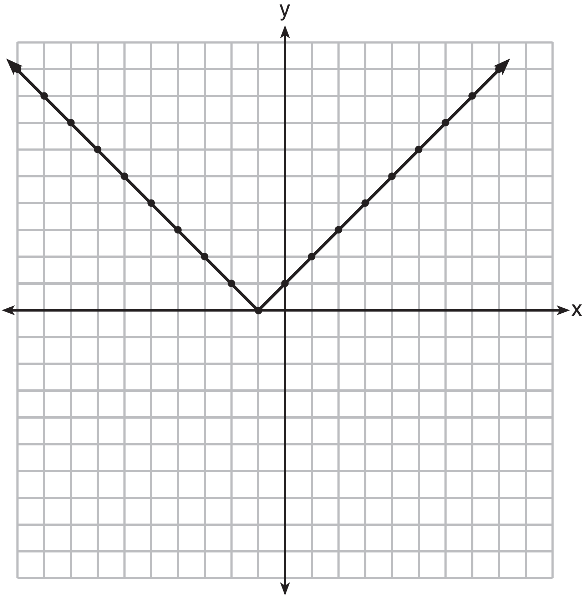

The range is .

The function is increasing for .

Strategy: Input the function in a graphing calculator and use the table and graph views to complete the graph on paper and to answer the questions.

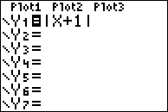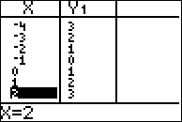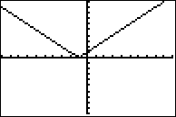

PTS: 4 NAT: F.IF.C.7 TOP: Graphing Absolute Value Functions

164) ANS: 1

Strategy: Input function in graphing calculator and inspect the graph and table views to find answer.

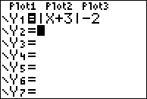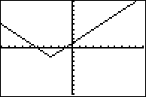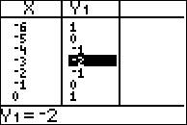

PTS: 2 NAT: F.IF.C.7 TOP: Graphing Absolute Value Functions

165) ANS:

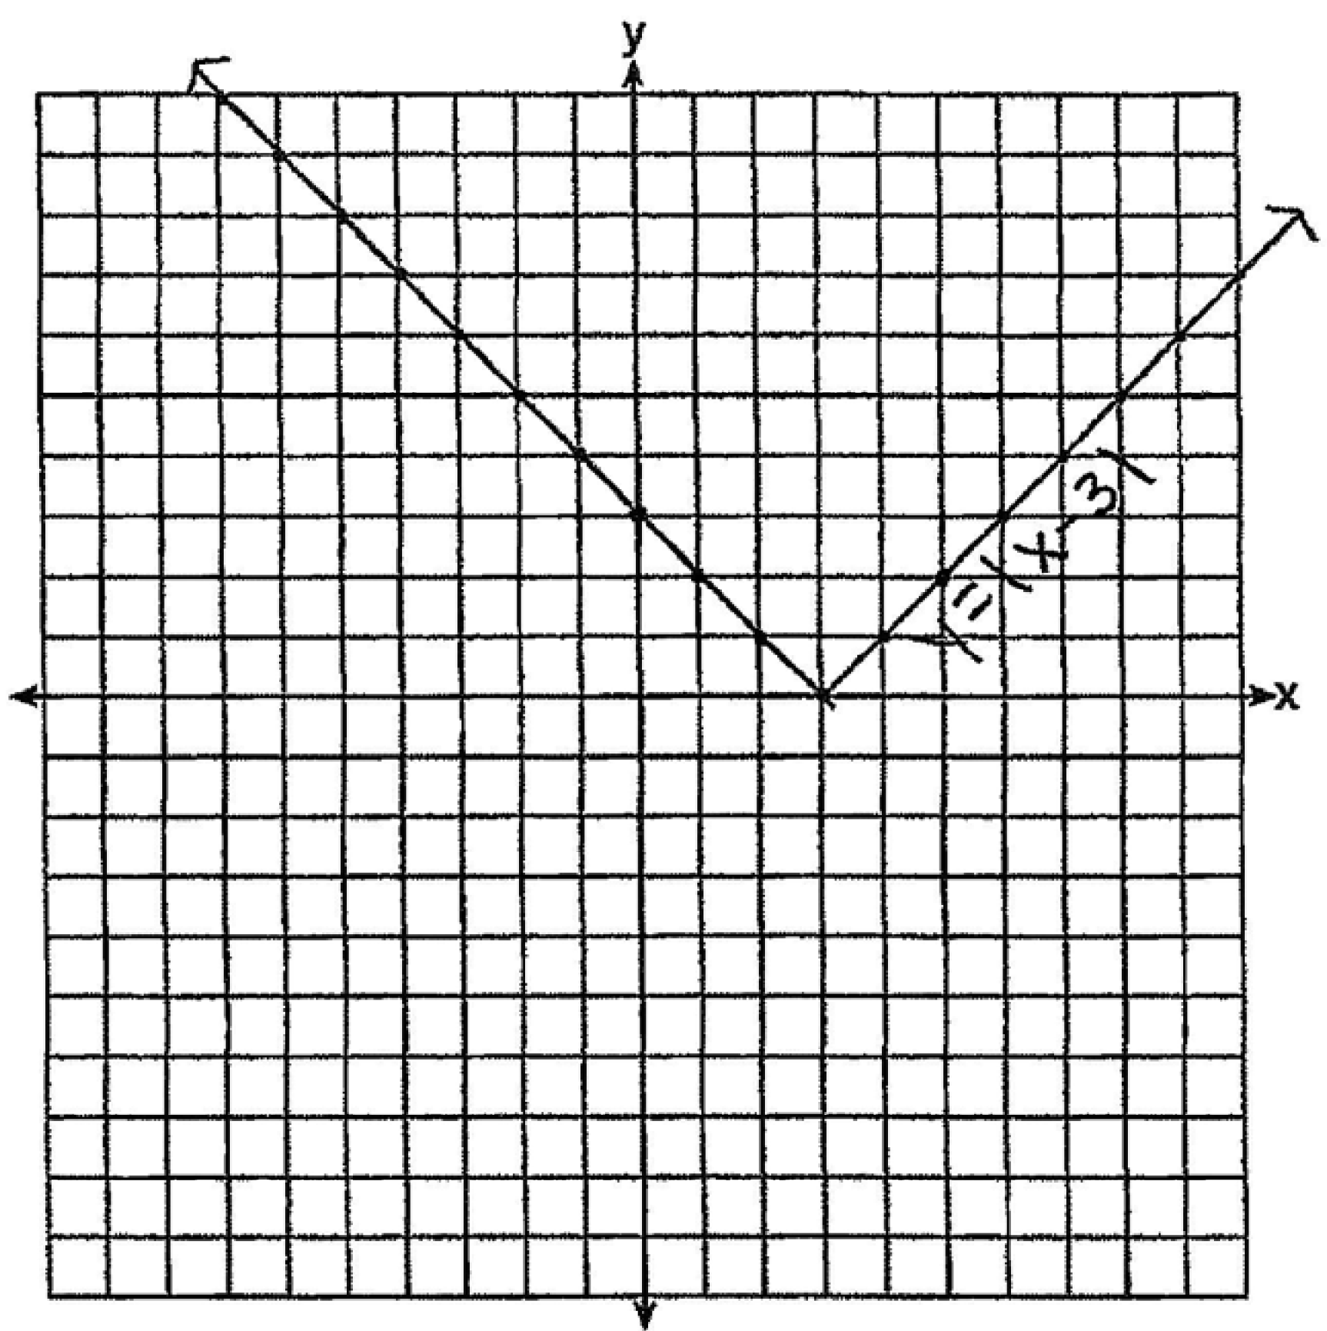

The graph has shifted three units to the right.

Strategy: Input both functions in a graphing calculator and compare the graphs.

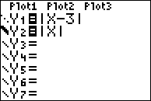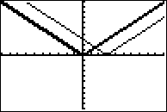

PTS: 2 NAT: F.BF.B.3 TOP: Transformations with Functions and Relations

166) ANS:

 moves  “a” units to the right.

 moves  down by “a” units.

PTS: 2 NAT: F.BF.B.3 TOP: Graphing Absolute Value Functions

167) ANS:

a)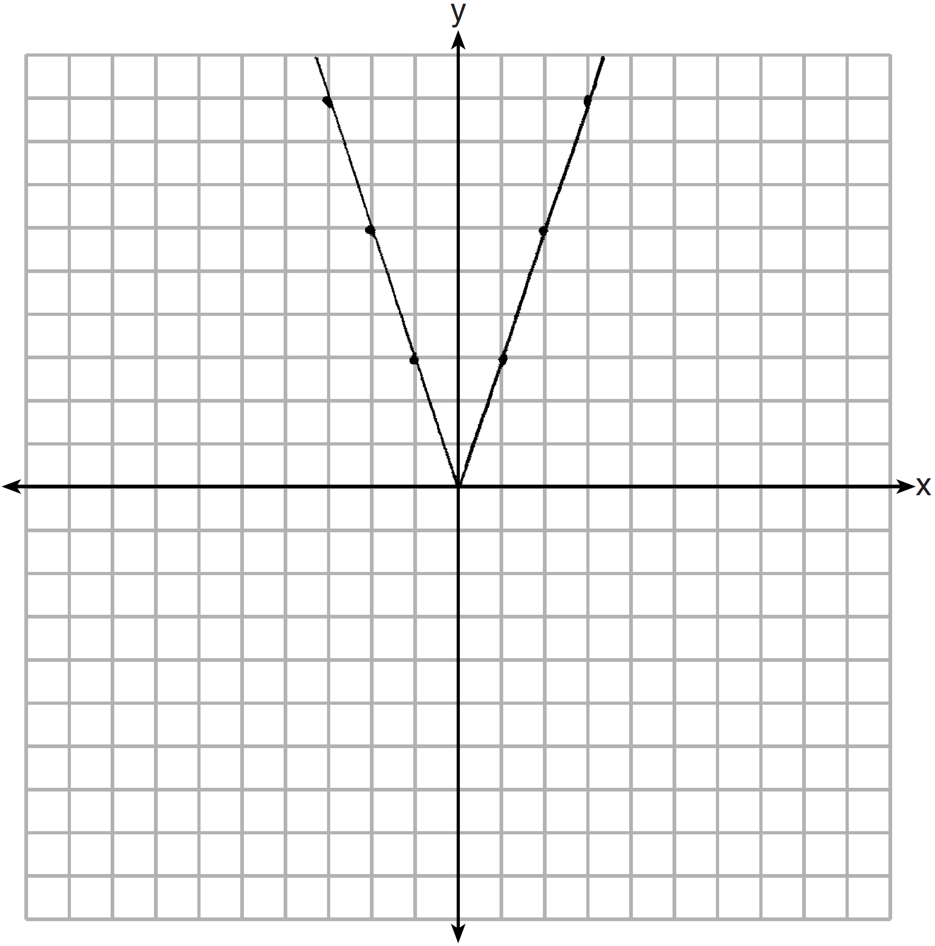

b) If , the graph of  is translated 2 down to form the graph of .

c) If , the graph of  translated 4 right to form the graph of .

Strategy: Input the three functions in a graphing calculator and compare the graphs.

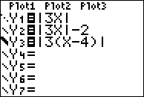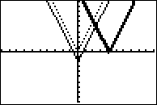

PTS: 4 NAT: F.BF.B.3 TOP: Transformations with Functions and Relations

168) ANS:

a)

b) If , the graph of  is translated 2 down to form the graph of .

c) If , the graph of  translated 4 right to form the graph of .

Strategy: Input the three functions in a graphing calculator and compare the graphs.



PTS: 4 NAT: F.BF.B.3 TOP: Transformations with Functions and Relations