1 A population of rabbits in a lab, , can be modeled by the function , where x represents the number of days since the population was first counted. Explain what 20 and 1.014 represent in the context of the problem. Determine, to the nearest tenth, the average rate of change from day 50 to day 100.

2 A family is traveling from their home to a vacation resort hotel. The table below shows their distance from home as a function of time.

Time (hrs) | 0 | 2 | 5 | 7
Distance (mi) | 0 | 140 | 375 | 480

Determine the average rate of change between hour 2 and hour 7, including units.

3 The table below represents the height of a bird above the ground during flight, with representing height in feet and t representing time in seconds.

t | P(t)
0 | 6.71
3 | 6.26
4 | 6
9 | 3.41

Calculate the average rate of change from 3 to 9 seconds, in feet per second.

4 The table below shows data from a recent car trip for the Burke family.

Hours After Leaving (x) | 1 | 2 | 3 | 4 | 5
Miles from Home (y) | 45 | 112 | 178 | 238 | 305

State the average rate of change for the distance traveled between hours 2 and 4. Include appropriate units.

5 A blizzard occurred on the East Coast during January, 2016. Snowfall totals from the storm were recorded for Washington, D.C. and are shown in the table below.

Washington, D.C.
Time | Snow (inches)
1 a.m. | 1
3 a.m. | 5
6 a.m. | 11
12 noon | 33
3 p.m. | 36

Which interval, 1 a.m. to 12 noon or 6 a.m. to 3 p.m., has the greater rate of snowfall, in inches per hour? Justify your answer.

6 The graph of models the height, in feet, that a bee is flying above the ground with respect to the time it traveled in t seconds.

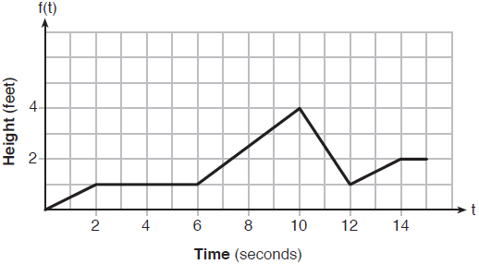

State all time intervals when the bee's rate of change is zero feet per second. Explain your reasoning.

7 The graph below shows the variation in the average temperature of Earth's surface from 1950-2000, according to one source.

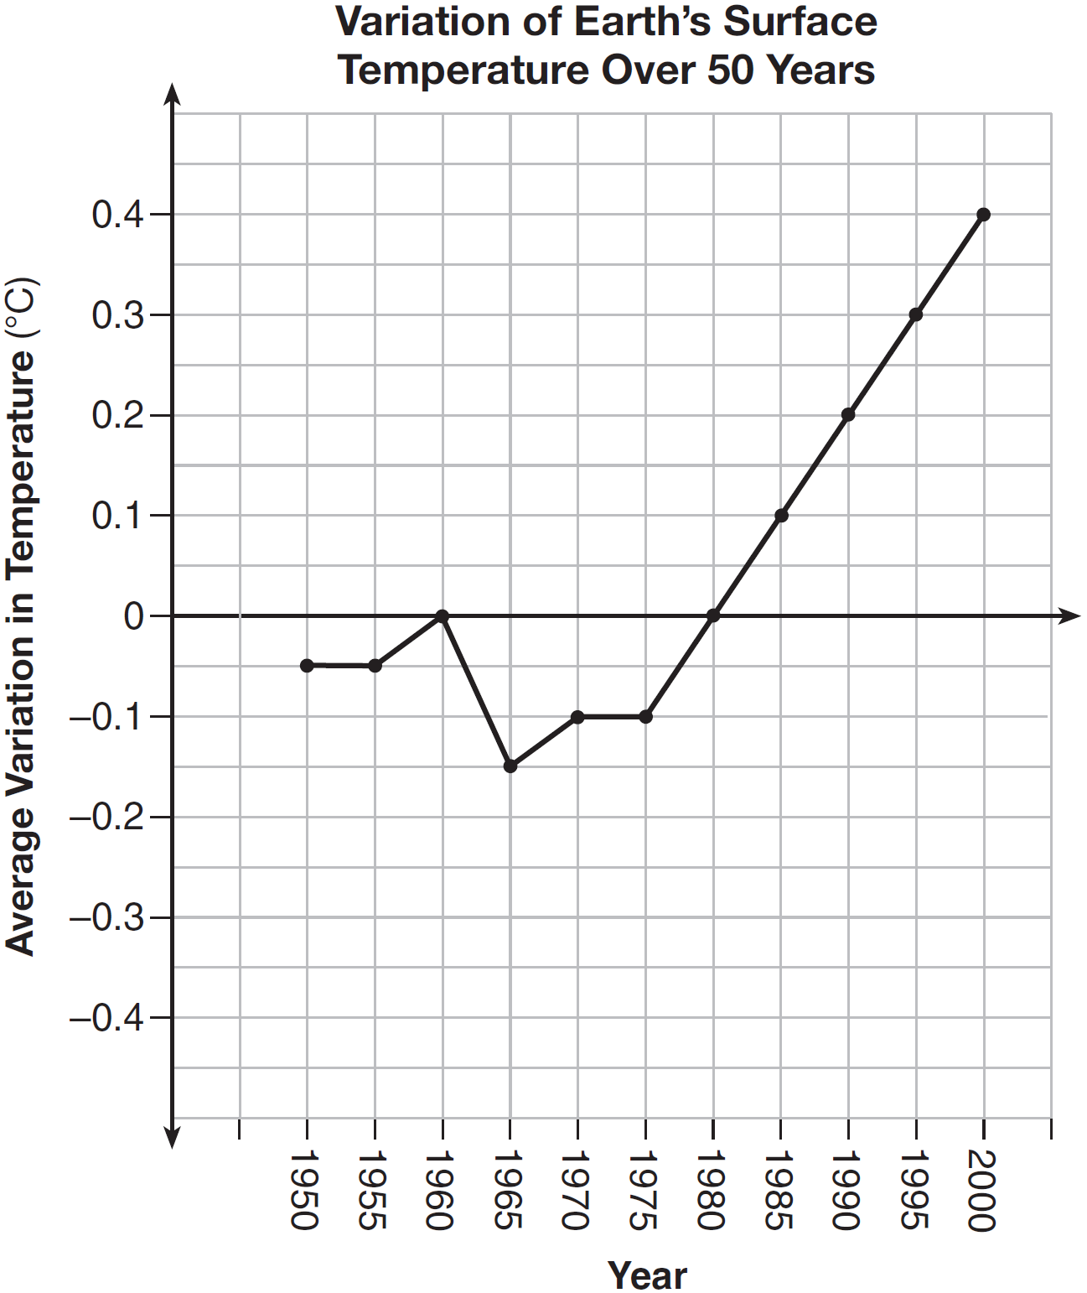

During which years did the temperature variation change the most per unit time? Explain how you determined your answer.

8 A manager wanted to analyze the online shoe sales for his business. He collected data for the number of pairs of shoes sold each hour over a 14-hour time period. He created a graph to model the data, as shown below.

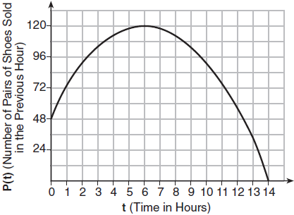

The manager believes the set of integers would be the most appropriate domain for this model. Explain why he is incorrect. State the entire interval for which the number of pairs of shoes sold is increasing. Determine the average rate of change between the sixth and fourteenth hours, and explain what it means in the context of the problem.

9 The total profit earned at a garage sale during the first five hours is modeled by the graph shown below.

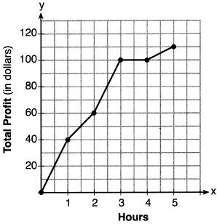

Determine the average rate of change, in dollars per hour, over the interval .

10 Jean recorded temperatures over a 24-hour period one day in August in Syracuse, NY. Her results are shown in the table below.

Time (hour) | 0 | 3 | 6 | 9 | 12 | 15 | 18 | 21 | 24
Temperature (°F) | 80 | 75 | 70 | 78 | 92 | 89 | 85 | 80 | 74

Her data are modeled on the graph below.

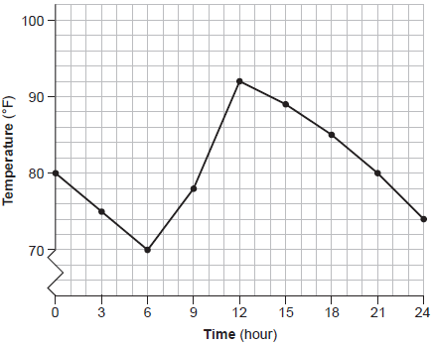

State the entire interval over which the temperature is increasing. State the three-hour interval that has the greatest rate of change in temperature. State the average rate of change from hour 12 to hour 24. Explain what this means in the context of the problem.
1 ANS:
There are 20 rabbits at and they are growing 1.4% per day. 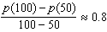

REF: 061833ai

2 ANS:
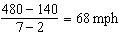

REF: 011731ai

3 ANS:
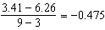

REF: 081827ai

4 ANS:
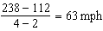

REF: 012427ai

5 ANS:
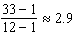 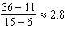 The interval 1 a.m. to 12 noon has the greater rate.

REF: 061929ai

6 ANS:
and because horizontal lines have zero slope.

REF: 011928ai

7 ANS:
During 1960-1965 the graph has the steepest slope.

REF: 011628ai

8 ANS:
The set of integers includes negative numbers, so is not an appropriate domain for time; for , the hourly rate is increasing, or for , the total numbers of shoes is increasing; 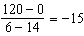, 15 fewer shoes were sold each hour between the sixth and fourteenth hours.

REF: 011836ai

9 ANS:
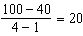

REF: 062227ai

10 ANS:
6-12; 9-12; 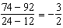; The temperature drops 3° every 2 hours.
REF: 062334ai

