1 Find all values of x in the interval that satisfy the equation .

2 Find all values of in the interval that satisfy the equation .

3 Find all values of in the interval that satisfy the equation .

4 Solve the equation algebraically for all values of x in the interval .

5 Find all values of in the interval which satisfy the equation .

6 Find all values of in the interval that satisfy the equation .

7 In the interval , solve for all values of A in the equation .

8 A solution of the equation is
1) | 240º
2) | 135º
3) | 45º
4)

9 Find, to the nearest ten minutes or nearest tenth of a degree, all values of x in the interval that satisfy the equation .

10 Find, to the nearest degree, all values of θ in the interval that satisfy the equation .

11 Find all values of in the interval that satisfy the equation , and round all answers to the nearest hundredth of a degree. [Only an algebraic solution can receive full credit.]

12 Find, to the nearest degree, all values of θ in the interval which satisfy the equation .

13 Find all values of in the interval that satisfy the equation . Express your answer to the nearest ten minutes or nearest tenth of a degree.

14 Find, to the nearest degree, all values of x between and that satisfy the equation .

15 Find all positive values of less than that satisfy the equation . Express your answers to the nearest ten minutes or nearest tenth of a degree.

16 Find all values of in the interval that satisfy the equation . Express your answer to the nearest ten minutes or nearest tenth of a degree.

17 Solve the equation for all values of , to the nearest tenth of a degree, in the interval .

18 Find, to the nearest degree, all values of x in the interval that satisfy the equation

19 Find, to the nearest ten minutes or nearest tenth of a degree, all values of x in the interval that satisfy the equation .

20 Find all values of in the interval that satisfy the equation . Express your answer to the nearest tenth of a degree or nearest ten minutes.

21 Find all values of x in the interval that satisfy the equation . Express your answers to the nearest degree. [The use of the grid is optional.]


1 ANS:
90°, 270°. 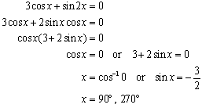.
REF: 010829b

2 ANS:
30º, 90º, 150º, 270º
REF: 089341siii

3 ANS:
0, 60, 180, 300. 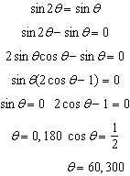
REF: 061037a2

4 ANS:
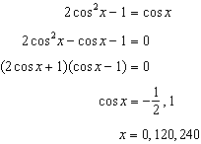
REF: 011638a2

5 ANS:
30º, 150º, 270º
REF: 068541siii

6 ANS:
90º
REF: 088737siii

7 ANS:
. 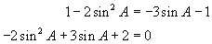. 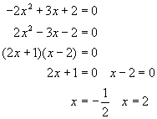. 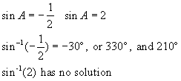.
REF: 060131b

8 ANS: 2 REF: 060024siii

9 ANS:
90º, 194.5º, 270º, 345.5º or 90º, 194º30’, 270º, 345º30’
REF: 069738siii

10 ANS:
42, 138, 210, 330. 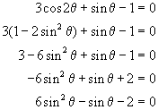. 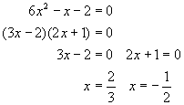. 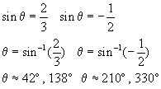. 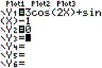. 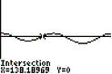.
REF: 060530b

11 ANS:
90°, 221.81°, 318.19°. 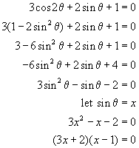. 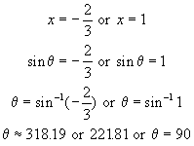. 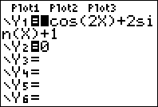. 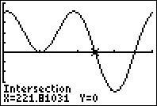.
REF: 060829b

12 ANS:
30º, 150º, 199º, 341º
REF: 068137siii

13 ANS:
14º30’, 90º, 165º30’ or 14.5º, 90º, 165.5º
REF: 010437siii

14 ANS:
30, 150, 194, 346
REF: 089539siii

15 ANS:
14.5, 165.5, 270 or 14º30', 165º30', 270º
REF: 019837siii

16 ANS:
56.4º, 123.6º, 270º or 56º30', 123º30', 270º
REF: 060139siii

17 ANS:
60, 109.5, 250.5, 300. 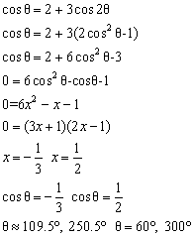
REF: 060932b

18 ANS: 71, 120, 240, 289
REF: 069638siii

19 ANS: 60º, 104º30’, 255º30' and 300º or 60º, 104.5º, 255.5º and 300º
REF: 060337siii

20 ANS: 109º30’, 250º30' or 109.5º, 250.5º
REF: 080340siii

21 ANS:
0°, 146°, 214°. 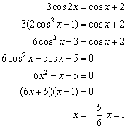. 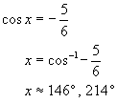. 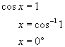. 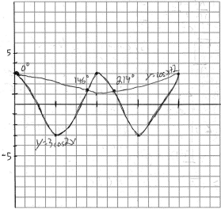. 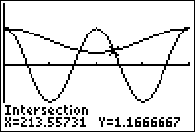.
REF: 080833b

