1 A rectangular fish tank measures 24 inches long, 12 inches wide, and 16 inches high, as modeled in the diagram below.
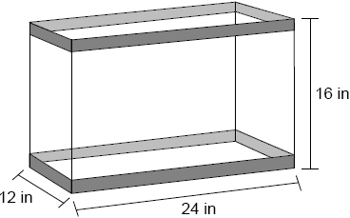
If the empty tank weighs 25 pounds and the fish tank is filled with water to a height of 14 inches, what is the approximate weight of the tank and water? [27.7 in.³=1 pound of water]

2 The square pyramid below models a toy block made of maple wood.
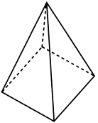

Each side of the base measures 4.5 cm and the height of the pyramid is 10 cm. If the density of maple is 0.676 g/cm³, what is the mass of the block, to the nearest tenth of a gram?
1) | 45.6 | 3) | 136.9
2) | 67.5 | 4) | 202.5

3 A shipping container is in the shape of a right rectangular prism with a length of 12 feet, a width of 8.5 feet, and a height of 4 feet. The container is completely filled with contents that weigh, on average, 0.25 pound per cubic foot. What is the weight, in pounds, of the contents in the container?
1) | 1,632 | 3) | 102
2) | 408 | 4) | 92

4 Lou has a solid clay brick in the shape of a rectangular prism with a length of 8 inches, a width of 3.5 inches, and a height of 2.25 inches. If the clay weighs 1.055 oz/in³, how much does Lou's brick weigh, to the nearest ounce?
1) | 66 | 3) | 63
2) | 64 | 4) | 60

5 The density of the American white oak tree is 752 kilograms per cubic meter. If the trunk of an American white oak tree has a circumference of 4.5 meters and the height of the trunk is 8 meters, what is the approximate number of kilograms of the trunk?
1) | 13 | 3) | 13,536
2) | 9694 | 4) | 30,456

6 A regular pyramid with a square base is made of solid glass. It has a base area of 36 cm² and a height of 10 cm. If the density of glass is 2.7 grams per cubic centimeter, the mass of the pyramid, in grams, is

7 A pyramid with a square base is made of solid glass. The pyramid has a base with a side length of 5.7 cm and a height of 7 cm. The density of the glass is 2.4 grams per cubic centimeter. Determine and state, to the nearest gram, the mass of the pyramid.

8 Molly wishes to make a lawn ornament in the form of a solid sphere. The clay being used to make the sphere weighs .075 pound per cubic inch. If the sphere's radius is 4 inches, what is the weight of the sphere, to the nearest pound?
1) | 34 | 3) | 15
2) | 20 | 4) | 4

9 A standard-size golf ball has a diameter of 1.680 inches. The material used to make the golf ball weighs 0.6523 ounce per cubic inch. What is the weight, to the nearest hundredth of an ounce, of one golf ball?
1) | 1.10 | 3) | 2.48
2) | 1.62 | 4) | 3.81

10 A hemispherical tank is filled with water and has a diameter of 10 feet. If water weighs 62.4 pounds per cubic foot, what is the total weight of the water in a full tank, to the nearest pound?
1) | 16,336 | 3) | 130,690
2) | 32,673 | 4) | 261,381

11 A hemispherical water tank has an inside diameter of 10 feet. If water has a density of 62.4 pounds per cubic foot, what is the weight of the water in a full tank, to the nearest pound?
1) | 16,336 | 3) | 130,690
2) | 32,673 | 4) | 261,381

12 Seawater contains approximately 1.2 ounces of salt per liter on average. How many gallons of seawater, to the nearest tenth of a gallon, would contain 1 pound of salt?
1) | 3.3 | 3) | 4.7
2) | 3.5 | 4) | 13.3

13 A jewelry company makes copper heart pendants. Each heart uses 0.75 in³ of copper and there is 0.323 pound of copper per cubic inch. If copper costs $3.68 per pound, what is the total cost for 24 copper hearts?
1) | $5.81 | 3) | $66.24
2) | $21.40 | 4) | $205.08

14 The table below shows the population and land area, in square miles, of four counties in New York State at the turn of the century.

County | 2000  Census Population | 2000  Land Area
Broome | 200,536 | 706.82
Dutchess | 280,150 | 801.59
Niagara | 219,846 | 522.95
Saratoga | 200,635 | 811.84

Which county had the greatest population density?
1) | Broome | 3) | Niagara
2) | Dutchess | 4) | Saratoga

15 The 2010 U.S. Census populations and population densities are shown in the table below.

State | Population Density 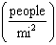 | Population in  2010
Florida | 350.6 | 18,801,310
Illinois | 231.1 | 12,830,632
New York | 411.2 | 19,378,102
Pennsylvania | 283.9 | 12,702,379

Based on the table above, which list has the states' areas, in square miles, in order from largest to smallest?
1) | Illinois, Florida, New York, Pennsylvania | 3) | New York, Florida, Pennsylvania, Illinois
2) | New York, Florida, Illinois, Pennsylvania | 4) | Pennsylvania, New York, Florida, Illinois

16 During an experiment, the same type of bacteria is grown in two petri dishes. Petri dish A has a diameter of 51 mm and has approximately 40,000 bacteria after 1 hour. Petri dish B has a diameter of 75 mm and has approximately 72,000 bacteria after 1 hour.

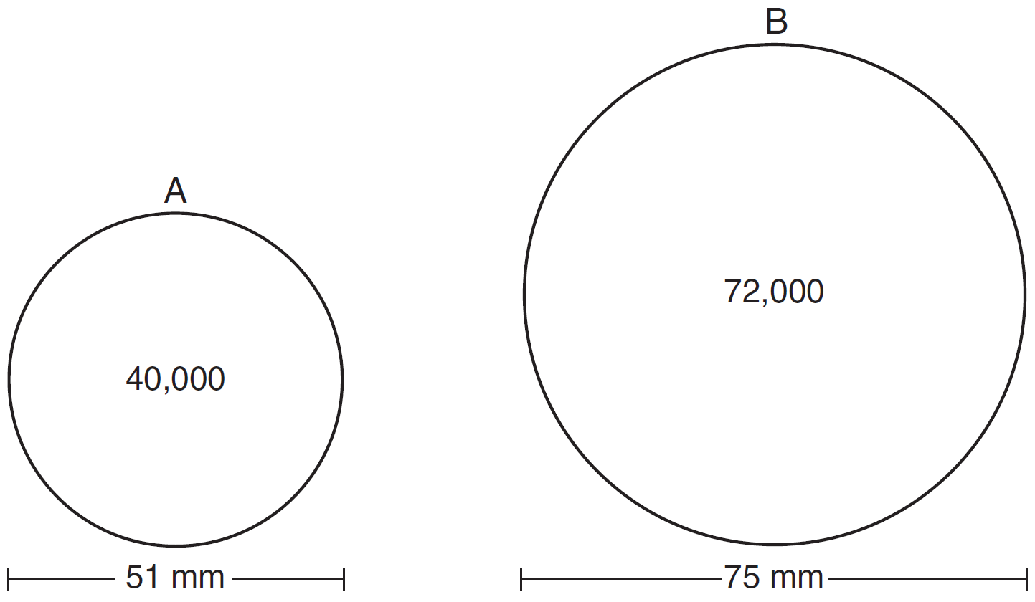

Determine and state which petri dish has the greater population density of bacteria at the end of the first hour.

17 A wooden cube has an edge length of 6 centimeters and a mass of 137.8 grams. Determine the density of the cube, to the nearest thousandth. State which type of wood the cube is made of, using the density table below.

Type of Wood | Density  (g/cm³)
Pine | 0.373
Hemlock | 0.431
Elm | 0.554
Birch | 0.601
Ash | 0.638
Maple | 0.676
Oak | 0.711

18 A rectangular tabletop will be made of maple wood that weighs 43 pounds per cubic foot. The tabletop will have a length of eight feet, a width of three feet, and a thickness of one inch. Determine and state the weight of the tabletop, in pounds.

19 A contractor needs to purchase 500 bricks. The dimensions of each brick are 5.1 cm by 10.2 cm by 20.3 cm, and the density of each brick is . The maximum capacity of the contractor’s trailer is 900 kg. Can the trailer hold the weight of 500 bricks? Justify your answer.

20 A machinist creates a solid steel part for a wind turbine engine. The part has a volume of 1015 cubic centimeters. Steel can be purchased for $0.29 per kilogram, and has a density of 7.95 g/cm³. If the machinist makes 500 of these parts, what is the cost of the steel, to the nearest dollar?

21 Trees that are cut down and stripped of their branches for timber are approximately cylindrical. A timber company specializes in a certain type of tree that has a typical diameter of 50 cm and a typical height of about 10 meters. The density of the wood is 380 kilograms per cubic meter, and the wood can be sold by mass at a rate of $4.75 per kilogram. Determine and state the minimum number of whole trees that must be sold to raise at least $50,000.

22 New streetlights will be installed along a section of the highway. The posts for the streetlights will be 7.5 m tall and made of aluminum. The city can choose to buy the posts shaped like cylinders or the posts shaped like rectangular prisms. The cylindrical posts have a hollow core, with aluminum 2.5 cm thick, and an outer diameter of 53.4 cm. The rectangular-prism posts have a hollow core, with aluminum 2.5 cm thick, and a square base that measures 40 cm on each side. The density of aluminum is 2.7 g/cm³, and the cost of aluminum is $0.38 per kilogram. If all posts must be the same shape, which post design will cost the town less? How much money will be saved per streetlight post with the less expensive design?

23 A candle in the shape of a right pyramid is modeled below. Each side of the square base measures 12 centimeters. The slant height of the pyramid measures 16 centimeters.

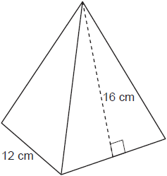

Determine and state the volume of the candle, to the nearest cubic centimeter. The wax used to make the candle weighs 0.032 ounce per cubic centimeter. Determine and state the weight of the candle, to the nearest ounce.

24 Shae has recently begun kickboxing and purchased training equipment as modeled in the diagram below. The total weight of the bag, pole, and unfilled base is 270 pounds. The cylindrical base is 18 inches tall with a diameter of 20 inches. The dry sand used to fill the base weighs 95.46 lbs per cubic foot.

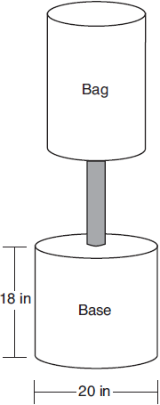

To the nearest pound, determine and state the total weight of the training equipment if the base is filled to 85% of its capacity.

25 Walter wants to make 100 candles in the shape of a cone for his new candle business. The mold shown below will be used to make the candles. Each mold will have a height of 8 inches and a diameter of 3 inches. To the nearest cubic inch, what will be the total volume of 100 candles?

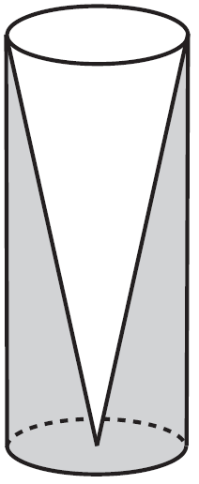

Walter goes to a hobby store to buy the wax for his candles. The wax costs $0.10 per ounce. If the weight of the wax is 0.52 ounce per cubic inch, how much will it cost Walter to buy the wax for 100 candles? If Walter spent a total of $37.83 for the molds and charges $1.95 for each candle, what is Walter's profit after selling 100 candles?

26 A snow cone consists of a paper cone completely filled with shaved ice and topped with a hemisphere of shaved ice, as shown in the diagram below. The inside diameter of both the cone and the hemisphere is 8.3 centimeters. The height of the cone is 10.2 centimeters.

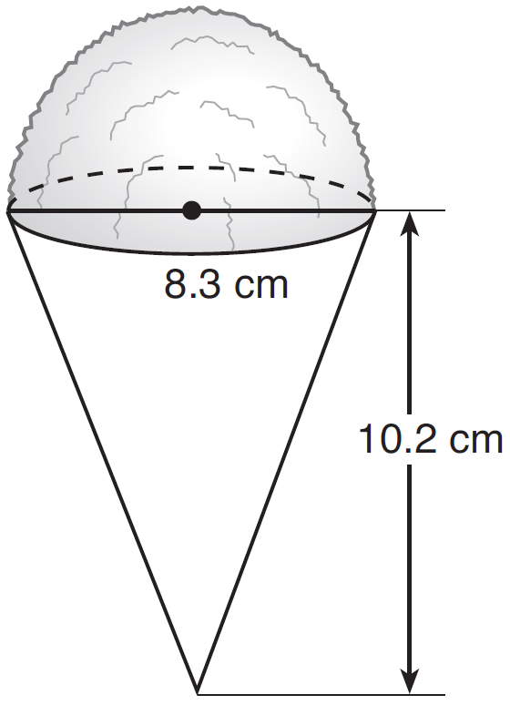

The desired density of the shaved ice is , and the cost, per kilogram, of ice is $3.83. Determine and state the cost of the ice needed to make 50 snow cones.

27 The water tower in the picture below is modeled by the two-dimensional figure beside it. The water tower is composed of a hemisphere, a cylinder, and a cone. Let C be the center of the hemisphere and let D be the center of the base of the cone.

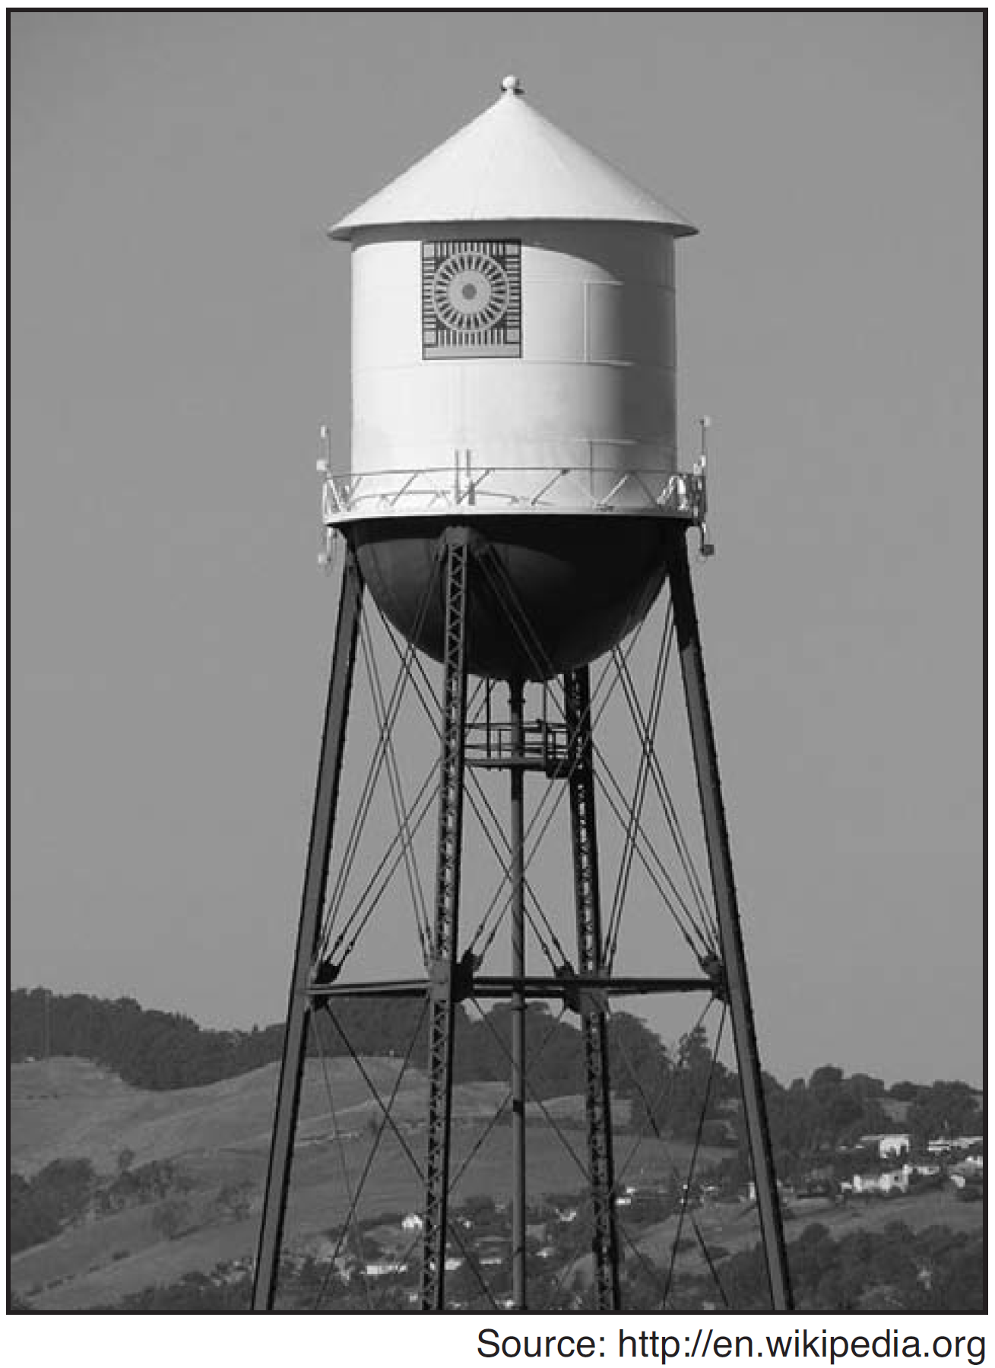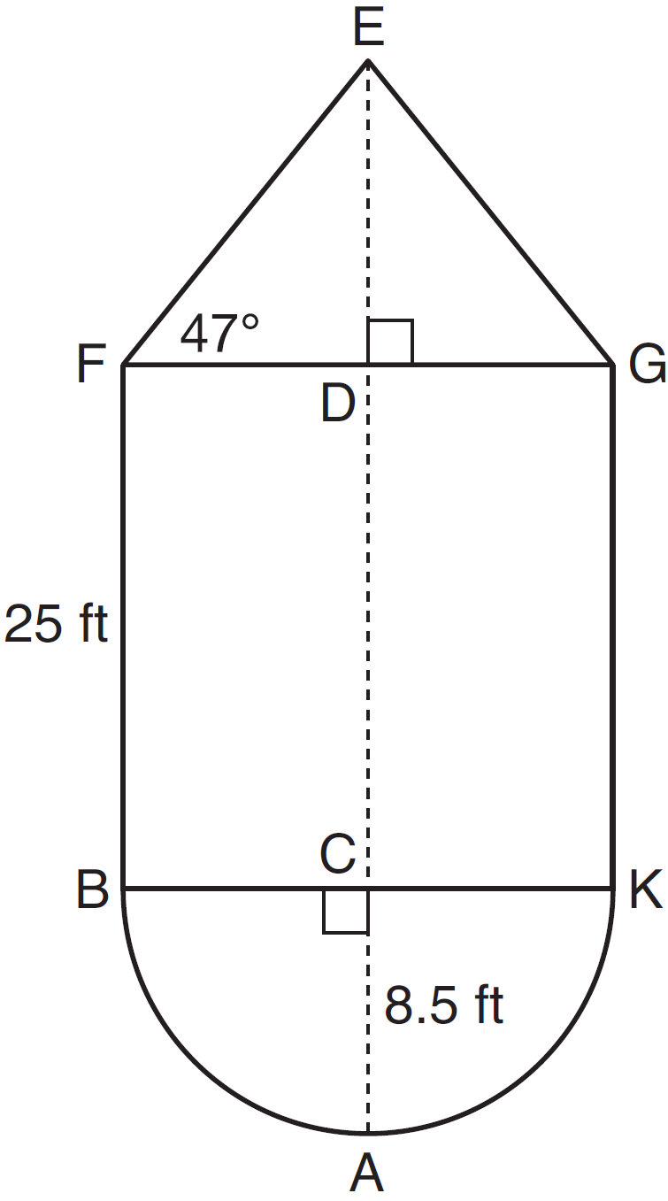

If feet, feet, and , determine and state, to the nearest cubic foot, the volume of the water tower. The water tower was constructed to hold a maximum of 400,000 pounds of water. If water weighs 62.4 pounds per cubic foot, can the water tower be filled to 85% of its volume and not exceed the weight limit? Justify your answer.

28 A packing box for baseballs is the shape of a rectangular prism with dimensions of . Each baseball has a diameter of 2.94 inches.

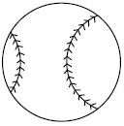

Determine and state the maximum number of baseballs that can be packed in the box if they are stacked in layers and each layer contains an equal number of baseballs. The weight of a baseball is approximately 0.025 pound per cubic inch. Determine and state, to the nearest pound, the total weight of all the baseballs in the fully packed box.

29 Ali made six solid spherical decorations out of modeling clay. Each decoration has a radius of 2.5 inches. The weight of clay is 68 pounds per cubic foot. Determine and state, to the nearest pound, the total weight of the six decorations.

30 A bakery sells hollow chocolate spheres. The larger diameter of each sphere is 4 cm. The thickness of the chocolate of each sphere is 0.5 cm. Determine and state, to the nearest tenth of a cubic centimeter, the amount of chocolate in each hollow sphere. The bakery packages 8 of them into a box. If the density of the chocolate is 1.308 g/cm³, determine and state, to the nearest gram, the total mass of the chocolate in the box.
1 ANS:
171
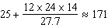

REF: 082423geo

2 ANS: 1
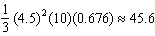

REF: 062212geo

3 ANS: 3
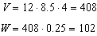

REF: 061507geo

4 ANS: 1

REF: 012014geo

5 ANS: 2
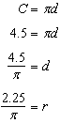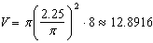

REF: 081617geo

6 ANS:
324
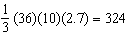

REF: 082312geo

7 ANS:
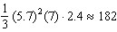

REF: 082431geo

8 ANS: 2
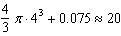

REF: 011619geo

9 ANS: 2
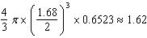

REF: 081914geo

10 ANS: 1
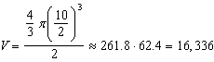

REF: 081516geo

11 ANS: 1
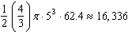

REF: 061620geo

12 ANS: 2
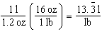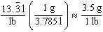

REF: 061618geo

13 ANS: 2
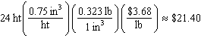

REF: 012306geo

14 ANS: 3
Broome: 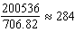 Dutchess: 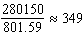 Niagara: 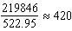 Saratoga: 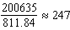

REF: 061902geo

15 ANS: 1
Illinois: 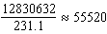 Florida: 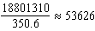 New York: 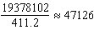 Pennsylvania: 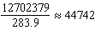

REF: 081720geo

16 ANS:
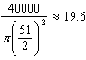 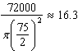 Dish A

REF: 011630geo

17 ANS:
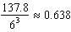 Ash

REF: 081525geo

18 ANS:
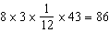

REF: 012027geo

19 ANS:
No, the weight of the bricks is greater than 900 kg. . 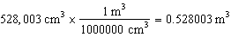. 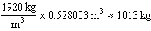.

REF: fall1406geo

20 ANS:
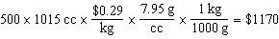

REF: 011829geo

21 ANS:
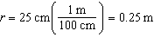 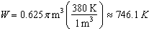 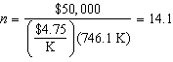 15 trees

REF: spr1412geo

22 ANS:
C: 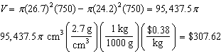
P: 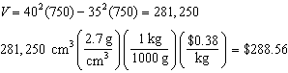

REF: 011736geo

23 ANS:
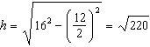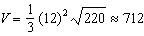

REF: 012433geo

24 ANS:
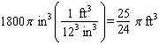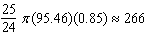

REF: 061834geo

25 ANS:
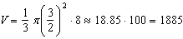

REF: 081536geo

26 ANS:
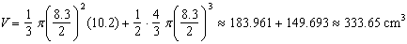

REF: 081636geo

27 ANS:
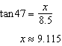 Cone: 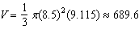 Cylinder: Hemisphere: 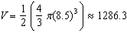 No, because , which is greater than 400,000.

REF: 061535geo

28 ANS:
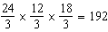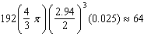

REF: 082234geo

29 ANS:
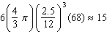

REF: 082434geo

30 ANS:
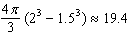

REF: 081834geo

