1 What is the correct factorization of ?
1) |  | 3)
2) |  | 4)

2 Which situation can be modeled by a linear function?
1) | A printer can print one page every three seconds. | 3) | The number of cells in an organism doubles every four days.
2) | A bank account earns 0.5% interest each year, compounded annually. | 4) | The attendance at a professional sports team's games decreases by 1.5% each year.

3 Which expression is equivalent to ?
1) |  | 3)
2) |  | 4)

4 At Adelynn's first birthday party, each guest brought $1 in coins for her piggy bank. Guests brought nickels, dimes, and quarters for a total of $28. There were twice as many dimes as nickels and 12 more quarters than nickels. Which equation could be used to determine the number of nickels, x, that her guests brought to her party?
1) |  | 3)
2) |  | 4)

5 A student creates a fourth-degree trinomial with a leading coefficient of 2 and a constant value of 5. The trinomial could be
1) |  | 3)
2) |  | 4)

6 When solving the equation , Laura wrote as her first step. Which property justifies Laura's first step?
1) | distributive property of multiplication over addition | 3) | commutative property of addition
2) | multiplication property of equality | 4) | addition property of equality

7 Which expression results in an irrational number?
1) |  | 3)
2) | 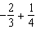 | 4) | 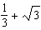

8 Which equation has the same solutions as ?
1) |  | 3)
2) |  | 4)

9 The heights, in inches, of eight football players are given below.
76, 70, 72, 70, 69, 71, 78, 74
Which box plot represents these data?
1) | 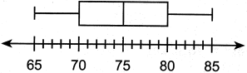 | 3) | 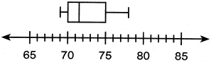
2) | 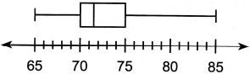 | 4) | 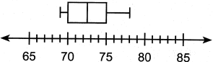

10 A bookstore owner recorded the number of books sold and the profit made selling the books.

Books Sold | Profit
100 | $50.00
250 | $275.00
300 | $350.00
350 | $425.00

What is the average rate of change, in dollars per book, between 100 and 350 books sold?
1) | 0.50 | 3) | 1.50
2) | 0.67 | 4) | 2.00

11 If , then which function represents a shift of the graph of 4 units to the right and 3 units down?
1) |  | 3)
2) |  | 4)

12 The amount of money a plumber charges is represented by the function . The best interpretation of the y-intercept of this function is that the plumber charges
1) | $45 to come to the house | 3) | $90 to come to the house
2) | $45 per hour that he works | 4) | $90 per hour that he works

13 What is the solution to the inequality ?
1) |  | 3)
2) |  | 4)

14 A survey of students at West High School was taken to determine a theme for the prom. The results of the survey are summarized in the table below.

 | Beach Party | Hollywood | Broadway
Girls | 86 | 112 | 68
Boys | 123 | 77 | 79

Approximately what percentage of the students who chose the Broadway theme were girls?
1) | 26 | 3) | 46
2) | 27 | 4) | 68

15 The sum of and is
1) |  | 3)
2) |  | 4)

16 The functions and are graphed on the same set of axes. What are the solutions to the equation ?
1) | and 0 | 3) | and 8
2) | 0 and 2 | 4) | and 7

17 If and , then which polynomial is equivalent to the product of x and y?
1) |  | 3)
2) |  | 4)

18 What is an equation of the line that passes through and has a slope of 2?
1) |  | 3)
2) |  | 4)

19 A geometric sequence with a common ratio of is
1) |  | 3)
2) |  | 4)

20 When the equation is solved for x in terms of a, and , the result is
1) |  | 3)
2) |  | 4)

21 Which function has the zeros , 3, and ?
1) |  | 3)
2) |  | 4)

22 The expression is equivalent to
1) |  | 3)
2) |  | 4)

23 In an arithmetic sequence, the first term is 4 and the third term is . What is the common difference?
1) |  | 3)
2) |  | 4)

24 Joe is ordering water for his swimming pool. He determines the volume of his pool to be about 3240 cubic feet. There are approximately 7.5 gallons of water in 1 cubic foot. A truck load holds 6000 gallons of water. Which expression would allow Joe to correctly calculate the number of truck loads of water he needs to fill his pool?
1) | 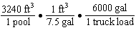 | 3) | 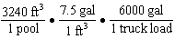
2) | 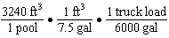 | 4) | 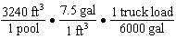

25 On the set of axes below, graph .

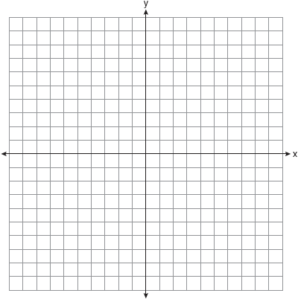

State the coordinates of the minimum.

26 If 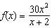, determine the value of 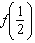.

27 Explain why the relation shown in the table below is a function.

x |  | 0 | 1 | 2
y | 2 | 4 | 4 | 5

Complete the table below with values for both x and y so that this new relation is not a function.

x |  | 0 | 1 | 2
y | 2 | 4 | 4 | 5

28 Solve algebraically for x:

29 Use the quadratic formula to determine the exact roots of the equation .

30 Factor completely.

31 The owner of an ice cream stand kept track of the number of ice cream cones that were sold each day of the first week in June. She compared the ice cream sales to the average daily temperature. The data are shown in the table below.

Average Daily Temp. (x) | 72 | 75 | 81 | 78 | 77 | 76 | 80
Daily Ice Cream Cone Sales (y) | 126 | 183 | 263 | 229 | 200 | 185 | 249

State the linear regression equation for these data, rounding all values to the nearest hundredth. State the correlation coefficient, to the nearest hundredth, for the line of best fit for these data. State what this correlation coefficient indicates about the linear fit of the data.

32 Graph the system of inequalities on the set of axes below:
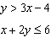
Label the solution set S.
.

Is the point a solution to the system? Justify your answer.

33 An object is launched upward at 64 feet per second from a platform 80 feet above the ground. The function models the height of the object t seconds after launch. If , state the vertex of , and explain in detail what each coordinate means in the context of the problem. After the object is launched, how many seconds does it take for the object to hit the ground? Justify your answer.

34 Solve the systems of equations algebraically for all values of x and y:
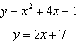

35 Jen joined the Fan Favorite Movie Club at the local movie theater. At this theater, the cost of admission in May and June remains the same. In May, she saw 2 matinees and 3 regular-priced shows and spent $38.50. In June, she went to 6 matinees and one regular-priced show and spent $47.50. Write a system of equations to represent the cost, m, of a matinee ticket and the cost, r, of a regular-priced ticket. Jen said she spent $5.75 on each matinee and $9 on each regular show. Is Jen correct? Justify your answer. Use your system of equations to algebraically determine both the actual cost of each matinee ticket and the actual cost of each regular ticket.
1 ANS: 4 PTS: 2 REF: 082401ai NAT: A.SSE.A.2
TOP: Factoring Polynomials

2 ANS: 1 PTS: 2 REF: 082402ai NAT: F.LE.A.1
TOP: Families of Functions

3 ANS: 4
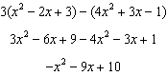

PTS: 2 REF: 082403ai NAT: A.APR.A.1 TOP: Operations with Polynomials
KEY: subtraction

4 ANS: 2 PTS: 2 REF: 082404ai NAT: A.CED.A.1
TOP: Modeling Linear Equations

5 ANS: 1 PTS: 2 REF: 082405ai NAT: A.SSE.A.1
TOP: Modeling Expressions

6 ANS: 4 PTS: 2 REF: 082406ai NAT: A.REI.A.1
TOP: Identifying Properties

7 ANS: 4 PTS: 2 REF: 082407ai NAT: N.RN.B.3
TOP: Operations with Radicals KEY: classify

8 ANS: 2
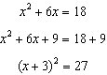

PTS: 2 REF: 082408ai NAT: A.REI.B.4 TOP: Solving Quadratics
KEY: completing the square

9 ANS: 3
69,70,70,71,72,74,76,78 ordered. median: 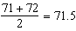

PTS: 2 REF: 082409ai NAT: S.ID.A.1 TOP: Box Plots
KEY: represent

10 ANS: 3
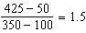

PTS: 2 REF: 082410ai NAT: F.IF.B.6 TOP: Rate of Change

11 ANS: 3 PTS: 2 REF: 082411ai NAT: F.BF.B.3
TOP: Transformations with Functions

12 ANS: 1 PTS: 2 REF: 082412ai NAT: F.LE.B.5
TOP: Modeling Linear Functions

13 ANS: 4
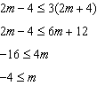

PTS: 2 REF: 082413ai NAT: A.REI.B.3 TOP: Solving Linear Inequalities

14 ANS: 3
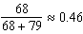

PTS: 2 REF: 082414ai NAT: S.ID.B.5 TOP: Frequency Tables
KEY: two-way

15 ANS: 4

PTS: 2 REF: 082415ai NAT: N.RN.B.3 TOP: Operations with Radicals
KEY: addition

16 ANS: 3
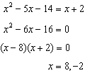

PTS: 2 REF: 082416ai NAT: A.REI.D.11 TOP: Quadratic-Linear Systems

17 ANS: 4

PTS: 2 REF: 082417ai NAT: A.APR.A.1 TOP: Operations with Polynomials
KEY: multiplication

18 ANS: 1 PTS: 2 REF: 082418ai NAT: A.REI.D.10
TOP: Writing Linear Equations KEY: other forms

19 ANS: 4 PTS: 2 REF: 082419ai NAT: F.IF.A.3
TOP: Sequences KEY: difference or ratio

20 ANS: 2
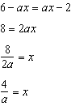

PTS: 2 REF: 082420ai NAT: A.REI.B.3 TOP: Solving Linear Equations
KEY: coefficients represented by letters

21 ANS: 3 PTS: 2 REF: 082421ai NAT: A.APR.B.3
TOP: Zeros of Polynomials

22 ANS: 2

PTS: 2 REF: 082422ai NAT: A.APR.A.1 TOP: Multiplication of Powers

23 ANS: 3
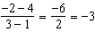

PTS: 2 REF: 082423ai NAT: F.IF.A.3 TOP: Sequences
KEY: difference or ratio

24 ANS: 4 PTS: 2 REF: 082424ai NAT: N.Q.A.1
TOP: Conversions

25 ANS:
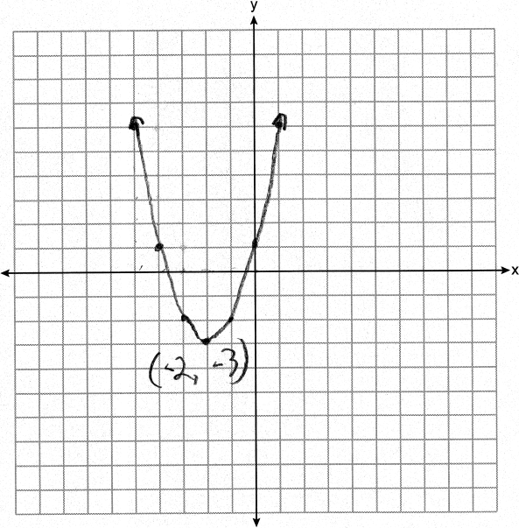
PTS: 2 REF: 082425ai NAT: F.IF.C.7 TOP: Graphing Quadratic Functions

26 ANS:
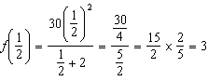
PTS: 2 REF: 082426ai NAT: F.IF.A.2 TOP: Functional Notation

27 ANS:
For every value of x, there is a unique value of y. 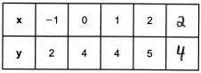
PTS: 2 REF: 082427ai NAT: F.IF.A.1 TOP: Defining Functions

28 ANS:
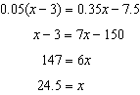
PTS: 2 REF: 082428ai NAT: A.REI.B.3 TOP: Solving Linear Equations

29 ANS:
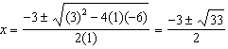
PTS: 4 REF: 082429ai NAT: A.REI.B.4 TOP: Solving Quadratics
KEY: quadratic formula

30 ANS:
PTS: 2 REF: 082430ai NAT: A.SSE.A.2
TOP: Factoring the Difference of Perfect Squares

31 ANS:
, , strong
PTS: 4 REF: 082431ai NAT: S.ID.B.6 TOP: Regression
KEY: linear with correlation coefficient

32 ANS:
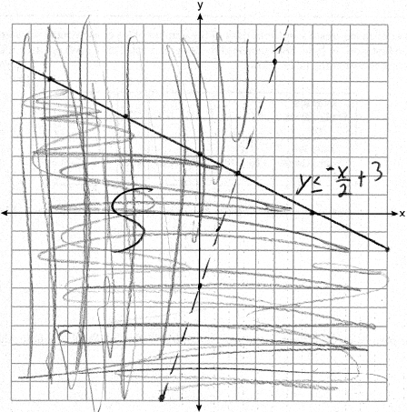; No, because is false.
PTS: 4 REF: 082432ai NAT: A.REI.D.12 TOP: Graphing Systems of Linear Inequalities

33 ANS:
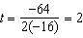 . At 2 seconds, the object is 144 feet above the ground. 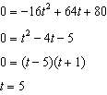
PTS: 4 REF: 082433ai NAT: F.IF.B.4 TOP: Graphing Quadratic Functions
KEY: key features

34 ANS:
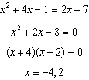 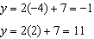 (-4,-1), (2,11)
PTS: 4 REF: 082434ai NAT: A.REI.C.7 TOP: Quadratic-Linear Systems

35 ANS:
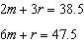 Jen is not correct because the prices are 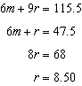 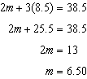
PTS: 6 REF: 082435ai NAT: A.CED.A.3 TOP: Modeling Linear Systems

