1 A sociologist reviews randomly selected surveillance videos from a public park over a period of several years and records the amount of time people spent on a smartphone. The statistical procedure the sociologist used is called
1) | a census | 3) | an observational study
2) | an experiment | 4) | a sample survey

2 Which statement(s) are true for all real numbers?
I
II
1) | I, only | 3) | I and II
2) | II, only | 4) | neither I nor II

3 What is the solution set of the following system of equations?
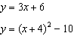
1) |  | 3)
2) |  | 4)

4 Irma initially ran one mile in over ten minutes. She then began a training program to reduce her one-mile time. She recorded her one-mile time once a week for twelve consecutive weeks, as modeled in the graph below.
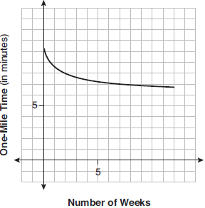
Which statement regarding Irma’s one-mile training program is correct?
1) | Her one-mile speed increased as the number of weeks increased. | 3) | If the trend continues, she will run under a six-minute mile by week thirteen.
2) | Her one-mile speed decreased as the number of weeks increased. | 4) | She reduced her one-mile time the most between weeks ten and twelve.

5 A 7-year lease for office space states that the annual rent is $85,000 for the first year and will increase by 6% each additional year of the lease. What will the total rent expense be for the entire 7-year lease?
1) | $42,809.63 | 3) | $595,000.00
2) | $90,425.53 | 4) | $713,476.20

6 The graph of is shown below.
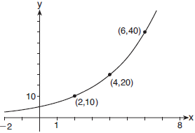

Which expression defines ?
1) |  | 3) | 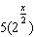
2) |  | 4)

7 Given , which statement is true?
1) | is a factor because . | 3) | is a factor because .
2) | is a factor because . | 4) | is a factor because .

8 For , which equation is false?
1) | 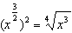 | 3) | 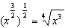
2) | 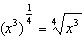 | 4) | 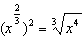

9 What is the inverse of the function ?
1) | 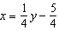 | 3)
2) | 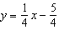 | 4) | 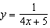

10 Which situation could be modeled using a geometric sequence?
1) | A cell phone company charges $30.00 per month for 2 gigabytes of data and $12.50 for each additional gigabyte of data. | 3) | David’s parents have set a limit of 50 minutes per week that he may play online games during the school year. However, they will increase his time by 5% per week for the next ten weeks.
2) | The temperature in your car is 79°. You lower the temperature of your air conditioning by 2° every 3 minutes in order to find a comfortable temperature. | 4) | Sarah has $100.00 in her piggy bank and saves an additional $15.00 each week.

11 The completely factored form of is
1) |  | 3)
2) |  | 4)

12 What is the solution when the equation is solved for x, where w is a positive integer?
1) |  | 3) | 6
2) | 0 | 4)

13 A group of students was trying to determine the proportion of candies in a bag that are blue. The company claims that 24% of candies in bags are blue. A simulation was run 100 times with a sample size of 50, based on the premise that 24% of the candies are blue. The approximately normal results of the simulation are shown in the dot plot below.

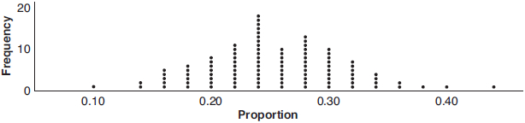

The simulation results in a mean of 0.254 and a standard deviation of 0.060. Based on this simulation, what is a plausible interval containing the middle 95% of the data?
1) |  | 3)
2) |  | 4)

14 Selected values for the functions f and g are shown in the tables below.

x | f(x) |  | x | g(x)
0 |  |  | 0 | 0.58
1.23 |  |  | 8.52 | 2.53
8.52 | 2.53 |  | 13.11 | 3.01
9.01 | 3.01 |  | 16.52 | 3.29

A solution to the equation is
1) | 0 | 3) | 3.01
2) | 2.53 | 4) | 8.52

15 The expression is equivalent to
1) |  | 3)
2) |  | 4)

16 A number, minus twenty times its reciprocal, equals eight. The number is
1) | 10 or | 3) | or
2) | 10 or 2 | 4) | or 2

17 A savings account, S, has an initial value of $50. The account grows at a 2% interest rate compounded n times per year, t, according to the function below.
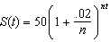
Which statement about the account is correct?
1) | As the value of n increases, the amount of interest per year decreases. | 3) | As the value of n decreases to one, the amount of interest per year increases.
2) | As the value of n increases, the value of the account approaches the function . | 4) | As the value of n decreases to one, the value of the account approaches the function

18 There are 400 students in the senior class at Oak Creek High School. All of these students took the SAT. The distribution of their SAT scores is approximately normal. The number of students who scored within 2 standard deviations of the mean is approximately
1) | 75 | 3) | 300
2) | 95 | 4) | 380

19 The solution set for the equation is
1) |  | 3)
2) |  | 4)

20 Which table best represents an exponential relationship?
1) | 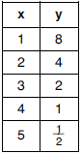 | 3) | 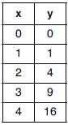
2) | 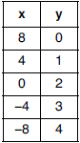 | 4) | 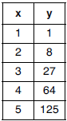

21 A sketch of is shown below.

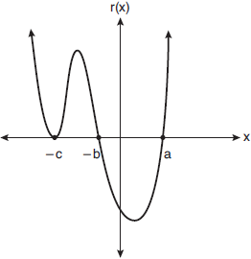

An equation for could be
1) |  | 3)
2) |  | 4)

22 The temperature, in degrees Fahrenheit, in Times Square during a day in August can be predicted by the function , where x is the number of hours after midnight. According to this model, the predicted temperature, to the nearest degree Fahrenheit, at 7 P.M. is
1) | 68 | 3) | 77
2) | 74 | 4) | 81

23 Consider the system of equations below:

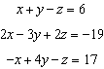

Which number is not the value of any variable in the solution of the system?
1) |  | 3) | 3
2) | 2 | 4)

24 Camryn puts $400 into a savings account that earns 6% annually. The amount in her account can be modeled by where t is the time in years. Which expression best approximates the amount of money in her account using a weekly growth rate?
1) |  | 3)
2) |  | 4)

25 The table below shows the number of hours of daylight on the first day of each month in Rochester, NY.

Month | Hours of Daylight
Jan. | 9.4
Feb. | 10.6
March | 11.9
April | 13.9
May | 14.7
June | 15.4
July | 15.1
Aug. | 13.9
Sept. | 12.5
Oct. | 11.1
Nov. | 9.7
Dec. | 9.0

Given the data, what is the average rate of change in hours of daylight per month from January 1st to April 1st? Interpret what this means in the context of the problem.

26 Algebraically solve for x: 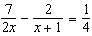

27 Graph on the set of axes below.

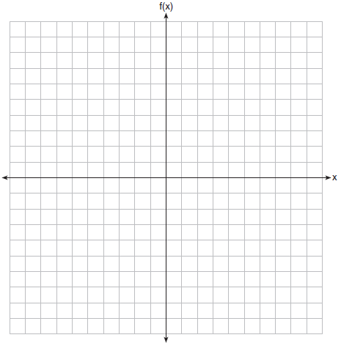

28 Given 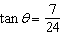, and terminates in Quadrant III, determine the value of .

29 Kenzie believes that for , the expression 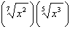 is equivalent to . Is she correct? Justify your response algebraically.

30 When the function is divided by the quotient is 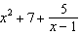. State in standard form.

31 Write a recursive formula for the sequence

32 Robin flips a coin 100 times. It lands heads up 43 times, and she wonders if the coin is unfair. She runs a computer simulation of 750 samples of 100 fair coin flips. The output of the proportion of heads is shown below.

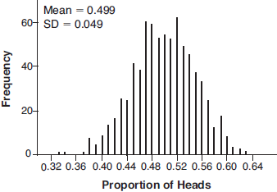

Do the results of the simulation provide strong evidence that Robin’s coin is unfair? Explain your answer.

33 Factor completely over the set of integers: . Sara graphed the polynomial and stated “All the roots of are real.” Is Sara correct? Explain your reasoning.

34 The half-life of a radioactive substance is 15 years. Write an equation that can be used to determine the amount, , of 200 grams of this substance that remains after t years. Determine algebraically, to the nearest year, how long it will take for of this substance to remain.

35 Determine an equation for the parabola with focus and directrix . (Use of the grid below is optional.)



36 Juan and Filipe practice at the driving range before playing golf. The number of wins and corresponding practice times for each player are shown in the table below.

 | Juan Wins | Felipe Wins
Short Practice Time | 8 | 10
Long Practice Time | 15 | 12

Given that the practice time was long, determine the exact probability that Filipe wins the next match. Determine whether or not the two events “Filipe wins” and “long practice time” are independent. Justify your answer.

37 Griffin is riding his bike down the street in Churchville, N.Y. at a constant speed, when a nail gets caught in one of his tires. The height of the nail above the ground, in inches, can be represented by the trigonometric function , where t represents the time (in seconds) since the nail first became caught in the tire. Determine the period of . Interpret what the period represents in this context. On the grid below, graph at least one cycle of that includes the y-intercept of the function.

Does the height of the nail ever reach 30 inches above the ground? Justify your answer.
1 ANS: 3 PTS: 2 REF: 061901aii NAT: S.IC.B.3
TOP: Analysis of Data KEY: type

2 ANS: 4

PTS: 2 REF: 061902aii NAT: A.APR.C.4 TOP: Polynomial Identities

3 ANS: 3
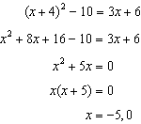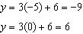

PTS: 2 REF: 061903aii NAT: A.REI.C.7 TOP: Quadratic-Linear Systems

4 ANS: 1 PTS: 2 REF: 061904aii NAT: F.IF.B.4
TOP: Relating Graphs to Events

5 ANS: 4
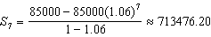

PTS: 2 REF: 061905aii NAT: A.SSE.B.4 TOP: Series

6 ANS: 3 PTS: 2 REF: 061906aii NAT: F.LE.A.2
TOP: Families of Functions

7 ANS: 4 PTS: 2 REF: 061907aii NAT: A.APR.B.2
TOP: Remainder Theorem

8 ANS: 1
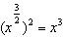

PTS: 2 REF: 061908aii NAT: N.RN.A.2 TOP: Radicals and Rational Exponents
KEY: variables

9 ANS: 2
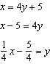

PTS: 2 REF: 061909aii NAT: F.BF.B.4 TOP: Inverse of Functions
KEY: linear

10 ANS: 3 PTS: 2 REF: 061910aii NAT: F.BF.A.2
TOP: Sequences

11 ANS: 2
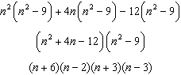
PTS: 2 REF: 061911aii NAT: A.SSE.A.2 TOP: Factoring Polynomials
KEY: factoring by grouping

12 ANS: 4
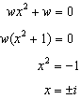
PTS: 2 REF: 061912aii NAT: A.REI.B.4 TOP: Solving Quadratics
KEY: complex solutions | taking square roots

13 ANS: 2
PTS: 2 REF: 061913aii NAT: S.IC.B.5 TOP: Analysis of Data

14 ANS: 4 PTS: 2 REF: 061914aii NAT: A.REI.D.11
TOP: Other Systems

15 ANS: 1
PTS: 2 REF: 061915aii NAT: N.CN.A.2 TOP: Operations with Complex Numbers

16 ANS: 1
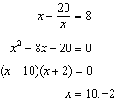
PTS: 2 REF: 061916aii NAT: A.CED.A.1 TOP: Modeling Rationals

17 ANS: 2 PTS: 2 REF: 061917aii NAT: F.LE.B.5
TOP: Modeling Exponential Functions

18 ANS: 4
PTS: 2 REF: 061918aii NAT: S.ID.A.4 TOP: Normal Distributions
KEY: predict

19 ANS: 2
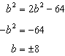 is extraneous.
PTS: 2 REF: 061919aii NAT: A.REI.A.2 TOP: Solving Radicals
KEY: extraneous solutions

20 ANS: 1
2) linear, 3) quadratic, 4) cubic
PTS: 2 REF: 061920aii NAT: F.LE.A.2 TOP: Families of Functions

21 ANS: 4 PTS: 2 REF: 061921aii NAT: A.APR.B.3
TOP: Graphing Polynomial Functions

22 ANS: 3
PTS: 2 REF: 061922aii NAT: F.TF.A.2 TOP: Determining Trigonometric Functions
KEY: radians

23 ANS: 2
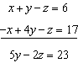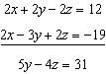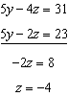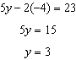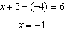
PTS: 2 REF: 061923aii NAT: A.REI.C.6 TOP: Solving Linear Systems
KEY: three variables

24 ANS: 4
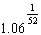
PTS: 2 REF: 061924aii NAT: F.BF.A.1 TOP: Modeling Exponential Functions

25 ANS:
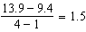 The average rate of change in the number of hours of daylight from January 1-April 1 is 1.5.
PTS: 2 REF: 061925aii NAT: F.IF.B.6 TOP: Rate of Change

26 ANS:
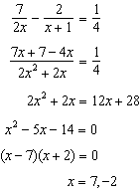
PTS: 2 REF: 061926aii NAT: A.REI.A.2 TOP: Solving Rationals
KEY: rational solutions

27 ANS:
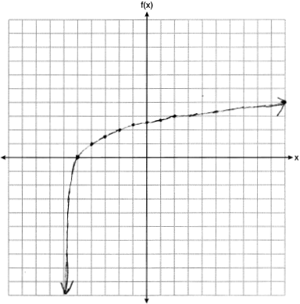
PTS: 2 REF: 061927aii NAT: F.IF.C.7 TOP: Graphing Logarithmic Functions

28 ANS:
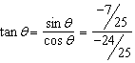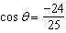
PTS: 2 REF: 061928aii NAT: F.TF.C.8 TOP: Determining Trigonometric Functions

29 ANS:
No. 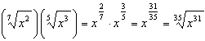
PTS: 2 REF: 061929aii NAT: N.RN.A.2 TOP: Radicals and Rational Exponents
KEY: variables

30 ANS:
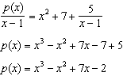
PTS: 2 REF: 061930aii NAT: A.APR.D.6 TOP: Rational Expressions
KEY: division

31 ANS:
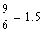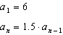
PTS: 2 REF: 061931aii NAT: F.BF.A.2 TOP: Sequences

32 ANS:
No. . Since 0.43 falls within this interval, Robin’s coin is likely not unfair.
PTS: 2 REF: 061932aii NAT: S.IC.A.2 TOP: Analysis of Data

33 ANS:
. No, because are roots.
PTS: 4 REF: 061933aii NAT: F.IF.C.7 TOP: Graphing Polynomial Functions

34 ANS:
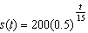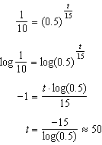
PTS: 4 REF: 061934aii NAT: F.LE.A.4 TOP: Exponential Decay

35 ANS:
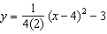 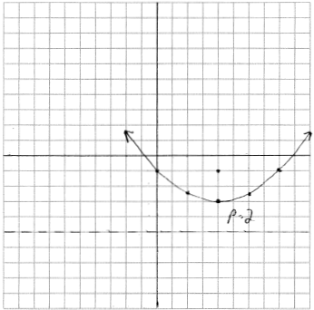 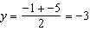. The vertex is and .
PTS: 4 REF: 061935aii NAT: G.GPE.A.2 TOP: Graphing Quadratic Functions

36 ANS:
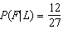 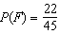 Since , the events are not independent.
PTS: 4 REF: 061936aii NAT: S.CP.A.4 TOP: Conditional Probability

37 ANS:
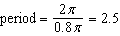. The wheel rotates once every 2.5 seconds. 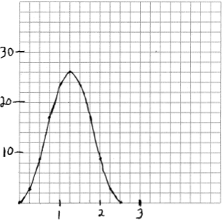 No, because the maximum of .
PTS: 6 REF: 061937aii NAT: F.IF.C.7 TOP: Graphing Trigonometric Functions
KEY: graph

