1 For all positive values of x, which expression is equivalent to ?
1) |  | 3) | 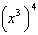
2) |  | 4)

2 Mrs. Favata's statistics class wants to conduct a survey to see how students feel about changing the school mascot's name. Which plan is the best process for gathering an appropriate sample?
1) | Survey students in a random sample of senior homerooms.
2) | Survey every tenth student entering art classes in the school.
3) | Survey every fourth student entering the cafeteria during each lunch period.
4) | Survey all members of the school's varsity sports teams.

3 Given , the expression 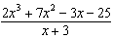 is equivalent to
1) | 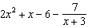 | 3)
2) | 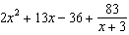 | 4) | 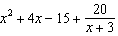

4 In a group of 40 people, 20 have brown hair, 22 have blue eyes, and 15 have both brown hair and blue eyes. How many people have neither brown hair nor blue eyes?
1) | 0 | 3) | 27
2) | 13 | 4) | 32

5 Consider the function , defined by the graph below.

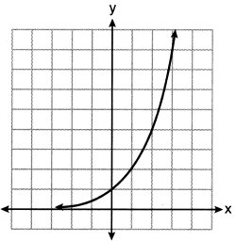

Which equation could be used to represent the graph shown below?

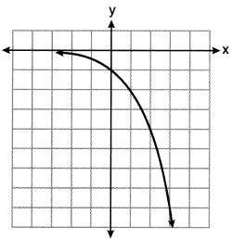
1) |  | 3)
2) |  | 4)

6 For the polynomial , if , it can be concluded that
1) | is a factor of | 3) | when is divided by 3, the remainder is zero
2) | is a factor of | 4) | when is divided by , the remainder is zero

7 The solution to the equation is
1) | 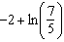 | 3)
2) | 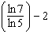 | 4)

8 Consider the system of equations below?
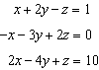
What is the solution to the given system of equations?
1) |  | 3)
2) |  | 4)

9 Monthly mortgage payments can be found using the formula below, where M is the monthly payment, P is the amount borrowed, r is the annual interest rate, and n is the total number of monthly payments.
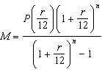
If Adam takes out a 15-year mortgage, borrowing $240,000 at an annual interest rate of 4.5%, his monthly payment will be
1) | $1379.09 | 3) | $1835.98
2) | $1604.80 | 4) | $9011.94

10 For all real values of x, if and , what is ?
1) |  | 3)
2) | 0 | 4)

11 If 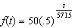 represents a mass, in grams, of carbon-14 remaining after t years, which statement(s) must be true?
I. The mass of the carbon-14 is decreasing by half each year.
II. The mass of the original sample is 50 g.
1) | I, only | 3) | I and II
2) | II, only | 4) | neither I nor II

12 Consider the graph of g and the table representing t below.

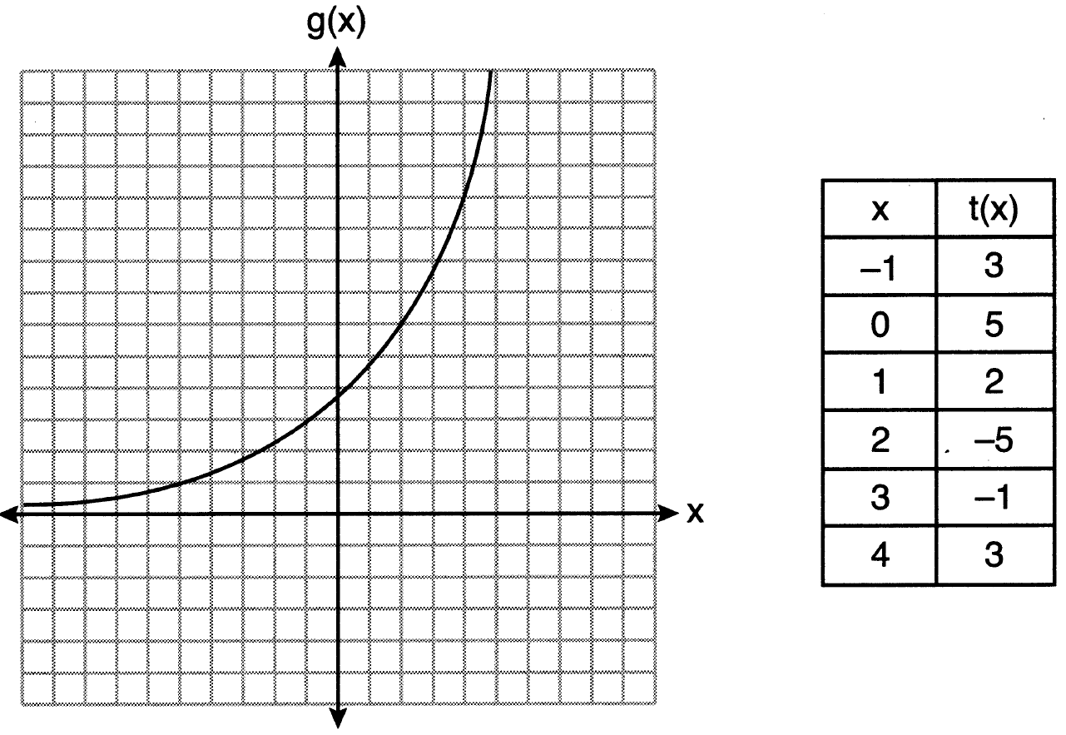

Over the interval , which statement regarding the average rate of change for g and t is true?
1) | g has a greater average rate of change. | 3) | The average rate of change for g is twice the average rate of change for t.
2) | The average rates of change are equal. | 4) | The average rate of change for g is half the average rate of change for t.

13 A parabola has a directrix of and a vertex at . Which ordered pair is the focus of the parabola?
1) |  | 3)
2) |  | 4)

14 The heights of the 3300 students at Oceanview High School are approximately normally distributed with a mean of 65.5 inches and a standard deviation of 2.9 inches. The number of students at Oceanview who are between 64 and 68 inches tall is closest to
1) | 1660 | 3) | 2244
2) | 1070 | 4) | 1640

15 Which statement below about the graph of is true?
1) | has a y-intercept at . | 3) | As
2) | has a y-intercept at . | 4)

16 A researcher wants to determine if room-darkening shades cause people to sleep longer. Which method of data collection is most appropriate?
1) | census | 3) | observation study
2) | survey | 4) | controlled experiment

17 The inverse of 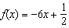 is
1) | 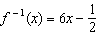 | 3) | 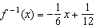
2) | 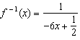 | 4) | 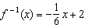

18 The expression 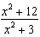 can be rewritten as
1) | 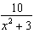 | 3)
2) | 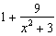 | 4) | 4

19 An angle, , is rotated counterclockwise on the unit circle, with its terminal side in the second quadrant, as shown in the diagram below.

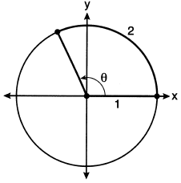

Which value represents the radian measure of angle ?
1) | 1 | 3) | 65.4
2) | 2 | 4) | 114.6

20 The depth of the water, , in feet, on a given day at Thunder Bay, t hours after midnight is modeled by 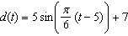. Which statement about the Thunder Bay tide is false?
1) | A low tide occurred at 2 a.m. | 3) | The water depth at 9 a.m. was approximately 11 feet.
2) | The maximum depth of the water was 12 feet. | 4) | The difference in water depth between high tide and low tide is 14 feet.

21 A function is defined as , where . What is the value of ?
1) | 8 | 3) | 9.2
2) | 8.5 | 4) | 10

22 Which function has a maximum y-value of 4 and a midline of ?
1) | 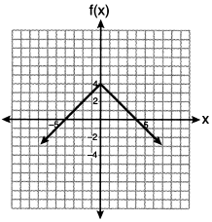 | 3) | 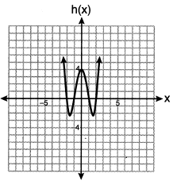
2) |  | 4)

23 Which expression is equivalent to , where i is the imaginary unit?
1) |  | 3)
2) |  | 4)

24 The growth of a $500 investment can be modeled by the function , where t represents time in years. In terms of the monthly rate of growth, the value of the investment can be best approximated by
1) |  | 3)
2) |  | 4) | 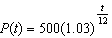

25 Does the equation have imaginary solutions? Justify your answer.

26 The initial push of a child on a swing causes the swing to travel a total of 6 feet. Each successive swing travels 80% of the distance of the previous swing. Determine the total distance, to the nearest hundredth of a foot, a child travels in the first five swings.

27 Solve algebraically for n: 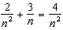

28 Factor completely over the set of integers:

29 The relative frequency table shows the proportion of a population who have a given eye color and the proportion of the same population who wear glasses.

 | Wear Glasses | Don’t Wear Glasses
Blue Eyes | 0.14 | 0.26
Brown Eyes | 0.11 | 0.24
Green Eyes | 0.10 | 0.15

Given the data, are the events of having blue eyes and wearing glasses independent? Justify your answer.

30 For and , . Determine the value of a.

31 Graph 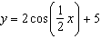 on the interval , using the axes below.

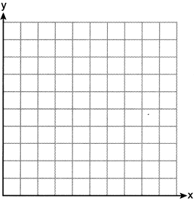

32 A cup of coffee is left out on a countertop to cool. The table below represents the temperature, , in degrees Fahrenheit, of the coffee after it is left out for t minutes.

t | 0 | 5 | 10 | 15 | 20 | 25
F(t) | 180 | 144 | 120 | 104 | 93.3 | 86.2

Based on these data, write an exponential regression equation, , to model the temperature of the coffee. Round all values to the nearest thousandth.

33 On the set of axes below, graph and for the given functions.
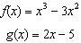

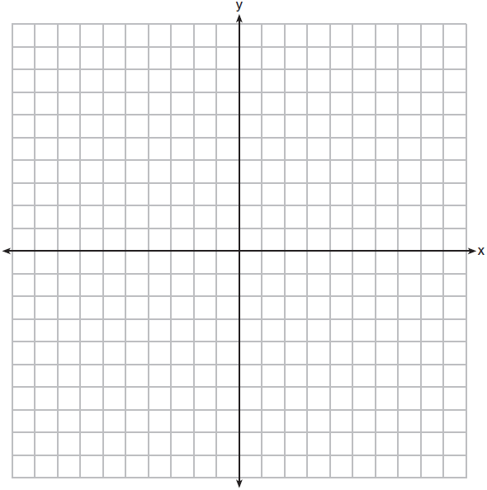

State the number of solutions to the equation .

34 A Foucault pendulum can be used to demonstrate that the Earth rotates. The time, t, in seconds, that it takes for one swing or period of the pendulum can be modeled by the equation 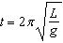 where L is the length of the pendulum in meters and g is a constant of 9.81 m/s². The first Foucault pendulum was constructed in 1851 and has a pendulum length of 67 m. Determine, to the nearest tenth of a second, the time it takes this pendulum to complete one swing. Another Foucault pendulum at the United Nations building takes 9.6 seconds to complete one swing. Determine, to the nearest tenth of a meter, the length of this pendulum.

35 In order to decrease the percentage of its residents who drive to work, a large city launches a campaign to encourage people to use public transportation instead. Before starting the campaign, the city's Department of Transportation uses census data to estimate that 65% of its residents drive to work. The Department of Transportation conducts a simulation, shown below, run 400 times based on this estimate. Each dot represents the proportion of 200 randomly selected residents who drive to work.

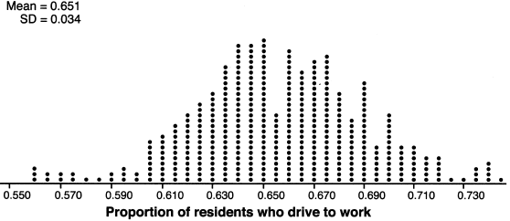

Use the simulation results to construct a plausible interval containing the middle 95% of the data. Round your answer to the nearest hundredth. One year after launching the campaign, the Department of Transportation conducts a survey of 200 randomly selected city residents and finds that 122 of them drive to work. Should the department conclude that the city's campaign was effective? Use statistical evidence from the simulation to explain your answer.

36 Solve the system of equations algebraically.
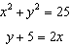

37 The population, in millions of people, of the United States can be represented by the recursive formula below, where represents the population in 1910 and n represents the number of years since 1910.
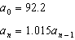
Identify the percentage of the annual rate of growth from the equation . Write an exponential function, P, where represents the United States population in millions of people, and t is the number of years since 1910. According to this model, determine algebraically the number of years it takes for the population of the United States to be approximately 300 million people. Round your answer to the nearest year.
1 ANS: 1 PTS: 2 REF: 062201aii NAT: N.RN.A.2
TOP: Radicals and Rational Exponents

2 ANS: 3
To determine student opinion, survey the widest range of students.

PTS: 2 REF: 062202aii NAT: S.IC.B.3 TOP: Analysis of Data
KEY: bias

3 ANS: 1
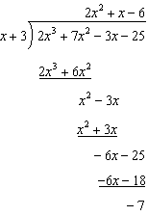

PTS: 2 REF: 062203aii NAT: A.APR.D.6 TOP: Rational Expressions
KEY: division

4 ANS: 2

PTS: 2 REF: 062204aii NAT: S.CP.A.1 TOP: Venn Diagrams

5 ANS: 3 PTS: 2 REF: 062205aii NAT: F.BF.B.3
TOP: Transformations with Functions

6 ANS: 2 PTS: 2 REF: 062206aii NAT: A.APR.B.2
TOP: Remainder Theorem

7 ANS: 1
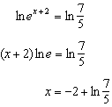

PTS: 2 REF: 062207aii NAT: F.LE.A.4 TOP: Exponential Equations
KEY: without common base

8 ANS: 2
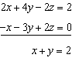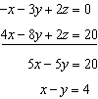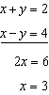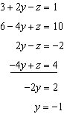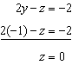

PTS: 2 REF: 062208aii NAT: A.REI.C.6 TOP: Solving Linear Systems
KEY: three variables

9 ANS: 3
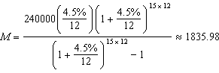

PTS: 2 REF: 062209aii NAT: F.IF.B.4 TOP: Evaluating Exponential Expressions

10 ANS: 3

PTS: 2 REF: 062210aii NAT: F.BF.A.1 TOP: Operations with Functions

11 ANS: 2
The mass of the carbon-14 is decreasing by half every 5715 years.

PTS: 2 REF: 062211aii NAT: F.LE.B.5 TOP: Modeling Exponential Functions

12 ANS: 4
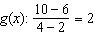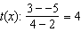

PTS: 2 REF: 062212aii NAT: F.IF.C.9 TOP: Comparing Functions

13 ANS: 1
The vertical distance from the directrix to the vertex, p, is 2. The vertical distance from the vertex to the focus must also be 2.

PTS: 2 REF: 062213aii NAT: G.GPE.A.2 TOP: Graphing Quadratic Functions

14 ANS: 1 PTS: 2 REF: 062214aii NAT: S.ID.A.4
TOP: Normal Distributions KEY: predict

15 ANS: 4 PTS: 2 REF: 062215aii NAT: F.IF.C.7
TOP: Graphing Logarithmic Functions

16 ANS: 4 PTS: 2 REF: 062216aii NAT: S.IC.B.3
TOP: Analysis of Data KEY: type

17 ANS: 3
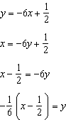

PTS: 2 REF: 062217aii NAT: F.BF.B.4 TOP: Inverse of Functions
KEY: linear

18 ANS: 2
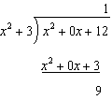

PTS: 2 REF: 062218aii NAT: A.APR.D.6 TOP: Rational Expressions
KEY: division

19 ANS: 2 PTS: 2 REF: 062219aii NAT: F.TF.A.1
TOP: Unit Circle

20 ANS: 4
1) ; 2) ; 3) ; 4)

PTS: 2 REF: 062220aii NAT: F.IF.B.4 TOP: Graphing Trigonometric Functions

21 ANS: 2
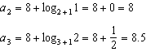

PTS: 2 REF: 062221aii NAT: F.IF.A.3 TOP: Sequences

22 ANS: 2 PTS: 2 REF: 062222aii NAT: F.IF.C.9
TOP: Comparing Functions

23 ANS: 4

PTS: 2 REF: 062223aii NAT: N.CN.A.2 TOP: Operations with Complex Numbers

24 ANS: 1
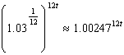

PTS: 2 REF: 062224aii NAT: A.SSE.B.3 TOP: Modeling Exponential Functions

25 ANS:
imaginary

PTS: 2 REF: 062225aii NAT: A.REI.B.4 TOP: Using the Discriminant
KEY: determine nature of roots given equation, graph, table

26 ANS:
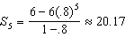

PTS: 2 REF: 062226aii NAT: A.SSE.B.4 TOP: Series

27 ANS:
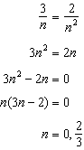 0 is an extraneous solution.

PTS: 2 REF: 062227aii NAT: A.REI.A.2 TOP: Solving Rationals

28 ANS:
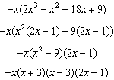

PTS: 2 REF: 062228aii NAT: A.SSE.A.2 TOP: Factoring Polynomials
KEY: factoring by grouping

29 ANS:
Yes. 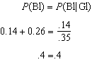

PTS: 2 REF: 062229aii NAT: S.CP.A.4 TOP: Conditional Probability

30 ANS:
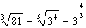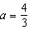

PTS: 2 REF: 062230aii NAT: N.RN.A.2 TOP: Radicals and Rational Exponents
KEY: variables

31 ANS:
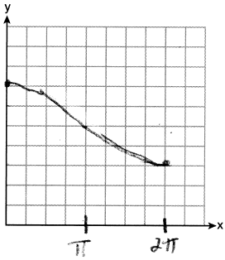

PTS: 2 REF: 062231aii NAT: F.IF.C.7 TOP: Graphing Trigonometric Functions
KEY: graph

32 ANS:

PTS: 2 REF: 062232aii NAT: S.ID.B.6 TOP: Regression
KEY: exponential

33 ANS:
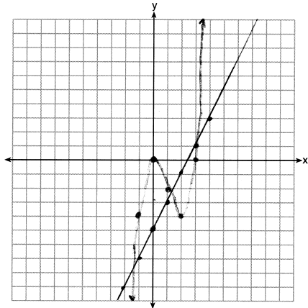 3

PTS: 4 REF: 062233aii NAT: A.REI.D.11 TOP: Other Systems

34 ANS:
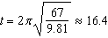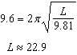

PTS: 4 REF: 062234aii NAT: A.REI.A.2 TOP: Solving Radicals
KEY: context

35 ANS:
. No, since .61 (122/200) falls within the 95% interval.

PTS: 4 REF: 062235aii NAT: S.IC.A.2 TOP: Analysis of Data

36 ANS:
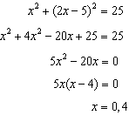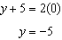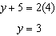

PTS: 4 REF: 062236aii NAT: A.REI.C.7 TOP: Quadratic-Linear Systems

37 ANS:
1.5%; ; 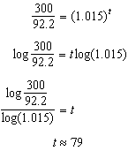

PTS: 6 REF: 062237aii NAT: A.CED.A.1 TOP: Exponential Growth

