1 The function 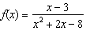 is undefined when x equals
1) |  | 3) | 3, only
2) |  | 4)

2 Which expression is equivalent to , where i is the imaginary unit?
1) |  | 3)
2) |  | 4)

3 The roots of the equation are
1) |  | 3)
2) |  | 4)

4 The solution set for the equation is
1) |  | 3)
2) |  | 4)

5 As x increases from 0 to , the graph of the equation will
1) | increase from 0 to 2 | 3) | increase without limit
2) | decrease from 0 to | 4) | decrease without limit

6 Which equation represents a parabola with the focus at and the directrix of ?
1) |  | 3)
2) |  | 4)

7 Which diagram represents an angle, , measuring radians drawn in standard position, and its reference angle, ?
1) | 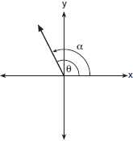 | 3) | 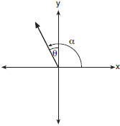
2) | 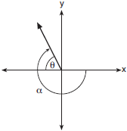 | 4) | 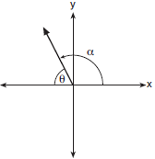

8 What are the zeros of ?
1) |  | 3)
2) |  | 4)

9 The value of a new car depreciates over time. Greg purchased a new car in June 2011. The value, V, of his car after t years can be modeled by the equation 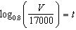. What is the average decreasing rate of change per year of the value of the car from June 2012 to June 2014, to the nearest ten dollars per year?
1) | 1960 | 3) | 2450
2) | 2180 | 4) | 2770

10 lridium-192 is an isotope of iridium and has a half-life of 73.83 days. If a laboratory experiment begins with 100 grams of Iridium-192, the number of grams, A, of Iridium-192 present after t days would be 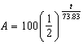. Which equation approximates the amount of Iridium-192 present after t days?
1) | 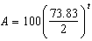 | 3)
2) | 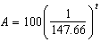 | 4)

11 The distribution of the diameters of ball bearings made under a given manufacturing process is normally distributed with a mean of 4 cm and a standard deviation of 0.2 cm. What proportion of the ball bearings will have a diameter less than 3.7 cm?
1) | 0.0668 | 3) | 0.8664
2) | 0.4332 | 4) | 0.9500

12 A polynomial equation of degree three, , is used to model the volume of a rectangular box. The graph of has x intercepts at , 10, and 14. Which statements regarding could be true?
A. The equation of .
B. The equation of .
C. The maximum volume occurs when .
D. The maximum volume of the box is approximately 56.
1) | A and C | 3) | B and C
2) | A and D | 4) | B and D

13 Which expression is equivalent to 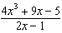, where 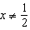?
1) |  | 3)
2) | 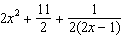 | 4) | 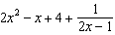

14 The inverse of the function 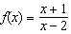 is
1) | 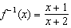 | 3) | 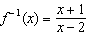
2) | 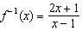 | 4) | 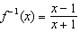

15 Which expression has been rewritten correctly to form a true statement?
1) |  | 3)
2) |  | 4)

16 A study conducted in 2004 in New York City found that 212 out of 1334 participants had hypertension. Kim ran a simulation of 100 studies based on these data. The output of the simulation is shown in the diagram below.

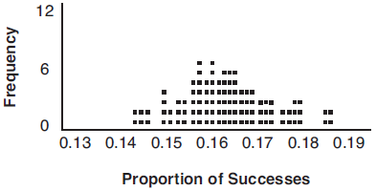

At a 95% confidence level, the proportion of New York City residents with hypertension and the margin of error are closest to
1) |  | 3)
2) |  | 4)

17 Which scenario is best described as an observational study?
1) | For a class project, students in Health class ask every tenth student entering the school if they eat breakfast in the morning. | 3) | A researcher wants to learn whether or not there is a link between children's daily amount of physical activity and their overall energy level. During lunch at the local high school, she distributed a short questionnaire to students in the cafeteria.
2) | A social researcher wants to learn whether or not there is a link between attendance and grades. She gathers data from 15 school districts. | 4) | Sixty seniors taking a course in Advanced Algebra Concepts are randomly divided into two classes. One class uses a graphing calculator all the time, and the other class never uses graphing calculators. A guidance counselor wants to determine whether there is a link between graphing calculator use and students' final exam grades.

18 Which sinusoid has the greatest amplitude?
1) | 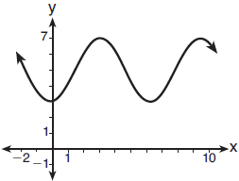 | 3) | 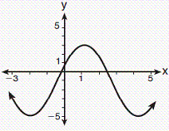
2) |  | 4)

19 Consider the system shown below.
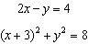
The two solutions of the system can be described as
1) | both imaginary | 3) | both rational
2) | both irrational | 4) | one rational and one irrational

20 Which binomial is not a factor of the expression ?
1) |  | 3)
2) |  | 4)

21 A ball is dropped from a height of 32 feet. It bounces and rebounds 80% of the height from which it was falling. What is the total downward distance, in feet, the ball traveled up to the 12th bounce?
1) | 29 | 3) | 120
2) | 58 | 4) | 149

22 A public opinion poll was conducted on behalf of Mayor Ortega's reelection campaign shortly before the election. 264 out of 550 likely voters said they would vote for Mayor Ortega; the rest said they would vote for his opponent. Which statement is least appropriate to make, according to the results of the poll?
1) | There is a 48% chance that Mayor Ortega will win the election. | 3) | It is most likely that between 44% and 52% of voters will vote for Mayor Ortega.
2) | The point estimate of voters who will vote for Mayor Ortega is 48%. | 4) | Due to the margin of error, an inference cannot be made regarding whether Mayor Ortega or his opponent is most likely to win the election.

23 What does 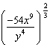 equal?
1) | 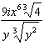 | 3) | 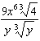
2) | 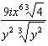 | 4) | 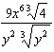

24 The Rickerts decided to set up an account for their daughter to pay for her college education. The day their daughter was born, they deposited $1000 in an account that pays 1.8% compounded annually. Beginning with her first birthday, they deposit an additional $750 into the account on each of her birthdays. Which expression correctly represents the amount of money in the account n years after their daughter was born?
1) |  | 3) | 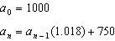
2) |  | 4) | 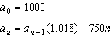

25 Explain how 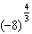 can be evaluated using properties of rational exponents to result in an integer answer.

26 A study was designed to test the effectiveness of a new drug. Half of the volunteers received the drug. The other half received a sugar pill. The probability of a volunteer receiving the drug and getting well was 40%. What is the probability of a volunteer getting well, given that the volunteer received the drug?

27 Verify the following Pythagorean identity for all values of x and y:

28 Mrs. Jones had hundreds of jelly beans in a bag that contained equal numbers of six different flavors. Her student randomly selected four jelly beans and they were all black licorice. Her student complained and said "What are the odds I got all of that kind?" Mrs. Jones replied, "simulate rolling a die 250 times and tell me if four black licorice jelly beans is unusual." Explain how this simulation could be used to solve the problem.

29 While experimenting with her calculator, Candy creates the sequence 4, 9, 19, 39, 79, .... Write a recursive formula for Candy's sequence. Determine the eighth term in Candy's sequence.

30 In New York State, the minimum wage has grown exponentially. In 1966, the minimum wage was $1.25 an hour and in 2015, it was $8.75. Algebraically determine the rate of growth to the nearest percent.

31 Algebraically determine whether the function is odd, even, or neither.

32 On the axes below, sketch a possible function , where a, b, and c are positive, , and has a positive y-intercept of d. Label all intercepts.

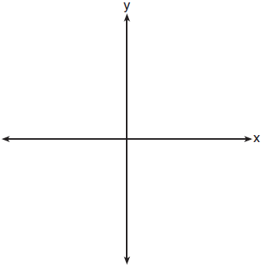

33 Solve for all values of p: 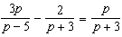

34 Simon lost his library card and has an overdue library book. When the book was 5 days late, he owed $2.25 to replace his library card and pay the fine for the overdue book. When the book was 21 days late, he owed $6.25 to replace his library card and pay the fine for the overdue book. Suppose the total amount Simon owes when the book is n days late can be determined by an arithmetic sequence. Determine a formula for , the nth term of this sequence. Use the formula to determine the amount of money, in dollars, Simon needs to pay when the book is 60 days late.

35 a) On the axes below, sketch at least one cycle of a sine curve with an amplitude of 2, a midline at 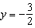, and a period of .

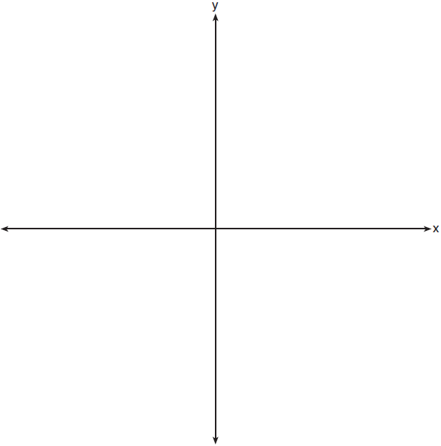

b) Explain any differences between a sketch of 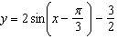 and the sketch from part a.

36 Using a microscope, a researcher observed and recorded the number of bacteria spores on a large sample of uniformly sized pieces of meat kept at room temperature. A summary of the data she recorded is shown in the table below.

Hours (x) | Average Number  of Spores (y)
0 | 4
0.5 | 10
1 | 15
2 | 60
3 | 260
4 | 1130
6 | 16,380

Using these data, write an exponential regression equation, rounding all values to the nearest thousandth. The researcher knows that people are likely to suffer from food-borne illness if the number of spores exceeds 100. Using the exponential regression equation, determine the maximum amount of time, to the nearest quarter hour, that the meat can be kept at room temperature safely.

37 The value of a certain small passenger car based on its use in years is modeled by , where is the value in dollars and t is the time in years. Zach had to take out a loan to purchase the small passenger car. The function , where is measured in dollars, and t is the time in years, models the unpaid amount of Zach's loan over time. Graph and over the interval , on the set of axes below.



State when , to the nearest hundredth, and interpret its meaning in the context of the problem. Zach takes out an insurance policy that requires him to pay a $3000 deductible in case of a collision. Zach will cancel the collision policy when the value of his car equals his deductible. To the nearest year, how long will it take Zach to cancel this policy? Justify your answer.
1 ANS: 1
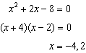

PTS: 2 REF: 081701aii NAT: A.APR.D.6 TOP: Undefined Rationals

2 ANS: 3

PTS: 2 REF: 081702aii NAT: N.CN.A.2 TOP: Operations with Complex Numbers

3 ANS: 3
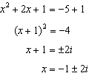

PTS: 2 REF: 081703aii NAT: A.REI.B.4 TOP: Solving Quadratics
KEY: complex solutions | completing the square

4 ANS: 2
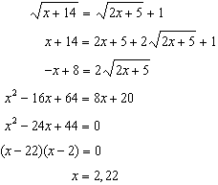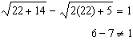

PTS: 2 REF: 081704aii NAT: A.REI.A.2 TOP: Solving Radicals
KEY: advanced

5 ANS: 3 PTS: 2 REF: 081705aii NAT: F.IF.B.4
TOP: Graphing Trigonometric Functions KEY: increasing/decreasing

6 ANS: 2
The vertex of the parabola is . The distance, p, between the vertex and the focus or the vertex and the directrix is 1. 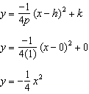

PTS: 2 REF: 081706aii NAT: G.GPE.A.2 TOP: Graphing Quadratic Functions

7 ANS: 4 PTS: 2 REF: 081707aii NAT: F.TF.A.2
TOP: Reference Angles

8 ANS: 4 PTS: 2 REF: 081708aii NAT: A.APR.B.3
TOP: Zeros of Polynomials KEY: AII

9 ANS: 3
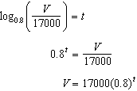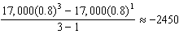

PTS: 2 REF: 081709aii NAT: F.IF.B.6 TOP: Rate of Change
KEY: AII

10 ANS: 3
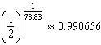

PTS: 2 REF: 081710aii NAT: A.SSE.B.3 TOP: Modeling Exponential Functions
KEY: AII

11 ANS: 1
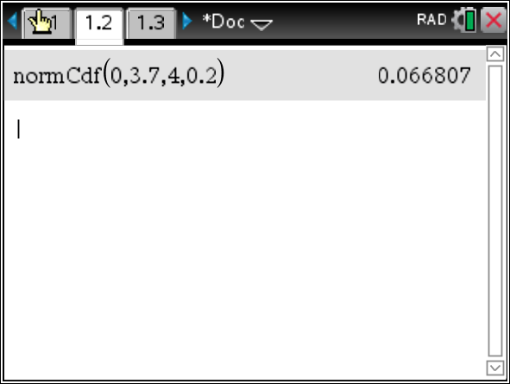

PTS: 2 REF: 081711aii NAT: S.ID.A.4 TOP: Normal Distributions
KEY: percent

12 ANS: 4
The maximum volume of is about 56, at

PTS: 2 REF: 081712aii NAT: F.IF.B.4 TOP: Graphing Polynomial Functions

13 ANS: 1
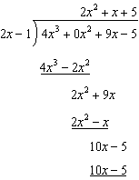

PTS: 2 REF: 081713aii NAT: A.APR.D.6 TOP: Rational Expressions

14 ANS: 2
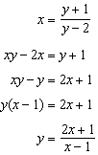

PTS: 2 REF: 081714aii NAT: F.BF.B.4 TOP: Inverse of Functions
KEY: equations

15 ANS: 1
1) let , then 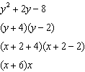

PTS: 2 REF: 081715aii NAT: A.SSE.A.2 TOP: Factoring Polynomials
KEY: multivariable

16 ANS: 2
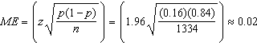

PTS: 2 REF: 081716aii NAT: S.IC.B.4 TOP: Analysis of Data

17 ANS: 2 PTS: 2 REF: 081717aii NAT: S.IC.B.3
TOP: Analysis of Data KEY: type

18 ANS: 4 PTS: 2 REF: 081718aii NAT: F.IF.C.7
TOP: Graphing Trigonometric Functions KEY: amplitude

19 ANS: 1
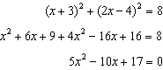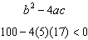

PTS: 2 REF: 081719aii NAT: A.REI.C.7 TOP: Quadratic-Linear Systems
KEY: AII

20 ANS: 2
-4 | 1 | -11 | 16 | 84
 |  | -4 | 60 | -304
 | 1 | -15 | 76
Since there is a remainder when the cubic is divided by , this binomial is not a factor.

PTS: 2 REF: 081720aii NAT: A.APR.B.2 TOP: Remainder Theorem

21 ANS: 4
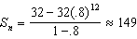

PTS: 2 REF: 081721aii NAT: A.SSE.B.4 TOP: Series

22 ANS: 1 PTS: 2 REF: 081722aii NAT: S.IC.B.6
TOP: Analysis of Data

23 ANS: 4
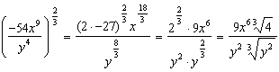

PTS: 2 REF: 081723aii NAT: N.RN.A.2 TOP: Radicals and Rational Exponents
KEY: variables

24 ANS: 3 PTS: 2 REF: 081724aii NAT: F.BF.A.2
TOP: Sequences

25 ANS:
Rewrite as , using the power of a power rule.

PTS: 2 REF: 081725aii NAT: N.RN.A.1 TOP: Radicals and Rational Exponents

26 ANS:
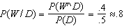

PTS: 2 REF: 081726aii NAT: S.CP.B.6 TOP: Conditional Probability

27 ANS:
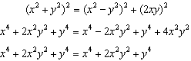

PTS: 2 REF: 081727aii NAT: A.APR.C.4 TOP: Polynomial Identities

28 ANS:
Since there are six flavors, each flavor can be assigned a number, 1-6. Use the simulation to see the number of times the same number is rolled 4 times in a row.

PTS: 2 REF: 081728aii NAT: S.IC.A.2 TOP: Analysis of Data

29 ANS:
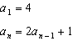

PTS: 2 REF: 081729aii NAT: F.LE.A.2 TOP: Sequences

30 ANS:
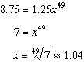 4

PTS: 2 REF: 081730aii NAT: F.LE.A.4 TOP: Exponential Growth

31 ANS:
Since , the function is even.

PTS: 2 REF: 081731aii NAT: F.BF.B.3 TOP: Even and Odd Functions

32 ANS:
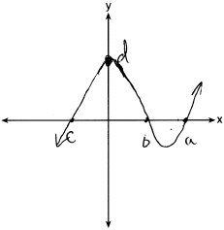

PTS: 2 REF: 081732aii NAT: A.APR.B.3 TOP: Zeros of Polynomials
KEY: AII

33 ANS:
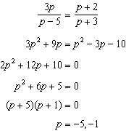

PTS: 4 REF: 081733aii NAT: A.REI.A.2 TOP: Solving Rationals
KEY: rational solutions

34 ANS:
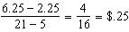 fine per day. replacement fee. .

PTS: 4 REF: 081734aii NAT: F.LE.A.2 TOP: Sequences

35 ANS:
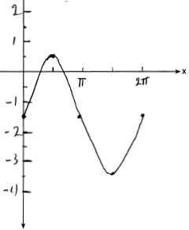Part a sketch is shifted units right.

PTS: 4 REF: 081735aii NAT: F.IF.C.7 TOP: Graphing Trigonometric Functions
KEY: graph

36 ANS:
. 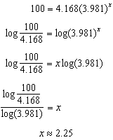

PTS: 4 REF: 081736aii NAT: S.ID.B.6 TOP: Regression
KEY: exponential AII

37 ANS:
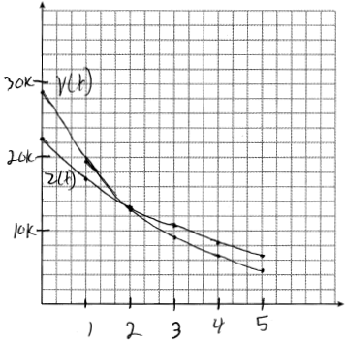 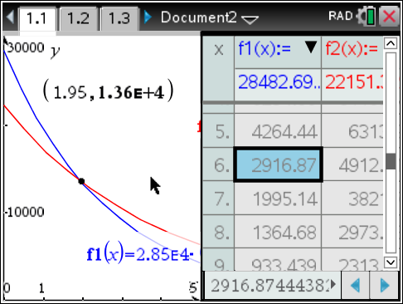 At 1.95 years, the value of the car equals the loan balance. Zach can cancel the policy after 6 years.

PTS: 4 REF: 081737aii NAT: A.REI.D.11 TOP: Other Systems
KEY: AII

