1 On the set of axes below, triangle ABC is graphed. Triangles and , the images of triangle ABC, are graphed after a sequence of rigid motions.

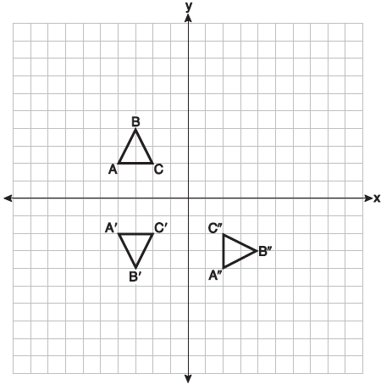

Identify which sequence of rigid motions maps onto and then maps onto .
1) | a rotation followed by another rotation | 3) | a reflection followed by a translation
2) | a translation followed by a reflection | 4) | a reflection followed by a rotation

2 The table below shows the population and land area, in square miles, of four counties in New York State at the turn of the century.

County | 2000  Census Population | 2000  Land Area
Broome | 200,536 | 706.82
Dutchess | 280,150 | 801.59
Niagara | 219,846 | 522.95
Saratoga | 200,635 | 811.84

Which county had the greatest population density?
1) | Broome | 3) | Niagara
2) | Dutchess | 4) | Saratoga

3 If a rectangle is continuously rotated around one of its sides, what is the three-dimensional figure formed?
1) | rectangular prism | 3) | sphere
2) | cylinder | 4) | cone

4 Which transformation carries the parallelogram below onto itself?

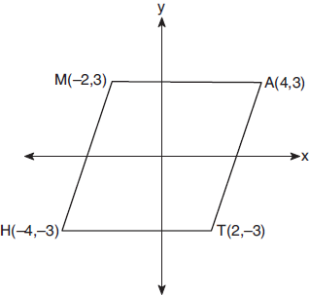
1) | a reflection over | 3) | a rotation of 90° counterclockwise about the origin
2) | a reflection over | 4) | a rotation of 180° counterclockwise about the origin

5 After a dilation centered at the origin, the image of is . If the coordinates of the endpoints of these segments are , , , and , the scale factor of the dilation is
1) |  | 3) | 3
2) |  | 4)

6 A tent is in the shape of a right pyramid with a square floor. The square floor has side lengths of 8 feet. If the height of the tent at its center is 6 feet, what is the volume of the tent, in cubic feet?
1) | 48 | 3) | 192
2) | 128 | 4) | 384

7 The line is transformed by a dilation centered at the origin. Which linear equation could represent its image?
1) | 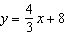 | 3) | 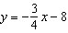
2) | 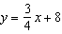 | 4) | 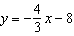

8 In the diagram below, and intersect at E.
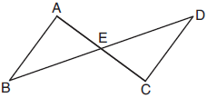

Which information is always sufficient to prove ?
1) |  | 3) | E is the midpoint of .
2) | and | 4) | and bisect each other.

9 The expression is equal to
1) |  | 3)
2) |  | 4)

10 What is the volume of a hemisphere that has a diameter of 12.6 cm, to the nearest tenth of a cubic centimeter?
1) | 523.7 | 3) | 4189.6
2) | 1047.4 | 4) | 8379.2

11 In the diagram below of , D is a point on , E is a point on , and is drawn.

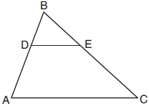

If , , and , what is the length of so that ?
1) | 23.8 | 3) | 15.6
2) | 16.8 | 4) | 8.6

12 A quadrilateral must be a parallelogram if
1) | one pair of sides is parallel and one pair of angles is congruent | 3) | one pair of sides is both parallel and congruent
2) | one pair of sides is congruent and one pair of angles is congruent | 4) | the diagonals are congruent

13 In the diagram below of circle O, chords and intersect at M.

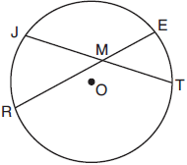

If and , the lengths of and could be
1) | 12 and 9.5 | 3) | 16 and 7.5
2) | 14 and 8.5 | 4) | 18 and 6.5

14 Triangles JOE and SAM are drawn such that and . Which mapping would not always lead to ?
1) | maps onto | 3) | maps onto
2) | maps onto | 4) | maps onto

15 In shown below, is a right angle, E is a point on , and is drawn perpendicular to hypotenuse .

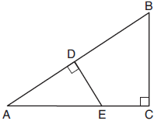

If , , and , what is the length of ?
1) | 5 | 3) | 7
2) | 6 | 4) | 8

16 Which equation represents a line parallel to the line whose equation is and passes through the point ?
1) | 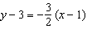 | 3) | 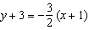
2) | 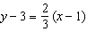 | 4) | 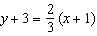

17 In rhombus , diagonals and intersect at R. The perimeter of TIGE is 68, and .
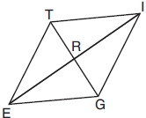

What is the length of diagonal ?
1) | 15 | 3) | 34
2) | 30 | 4) | 52

18 In circle O two secants, and , are drawn to external point P. If , and , what is the measure of ?
1) | 19º | 3) | 53º
2) | 38º | 4) | 106º

19 What are the coordinates of point C on the directed segment from to that partitions the segment such that is 2:1?
1) |  | 3)
2) |  | 4)

20 The equation of a circle is . What are the coordinates of the center and the length of the radius of the circle?
1) | center and radius 12 | 3) | center and radius 14
2) | center and radius 12 | 4) | center and radius 14

21 In parallelogram PQRS, is extended to point T and is drawn.

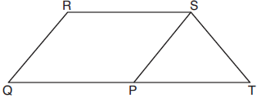

If and , what is ?
1) | 130° | 3) | 65°
2) | 80° | 4) | 50°

22 A 12-foot ladder leans against a building and reaches a window 10 feet above ground. What is the measure of the angle, to the nearest degree, that the ladder forms with the ground?
1) | 34 | 3) | 50
2) | 40 | 4) | 56

23 In the diagram of equilateral triangle ABC shown below, E and F are the midpoints of and , respectively.

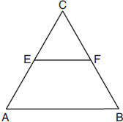

If and , what is the perimeter of trapezoid ABFE?
1) | 36 | 3) | 100
2) | 60 | 4) | 120

24 Which information is not sufficient to prove that a parallelogram is a square?
1) | The diagonals are both congruent and perpendicular. | 3) | The diagonals are perpendicular and one pair of adjacent sides are congruent.
2) | The diagonals are congruent and one pair of adjacent sides are congruent. | 4) | The diagonals are perpendicular and one pair of adjacent sides are perpendicular.

25 Triangle A'B'C' is the image of triangle ABC after a dilation with a scale factor of and
centered at point A. Is triangle ABC congruent to triangle A'B'C'? Explain your answer.

26 Determine and state the area of triangle PQR, whose vertices have coordinates , , and . [The use of the set of axes below is optional.]

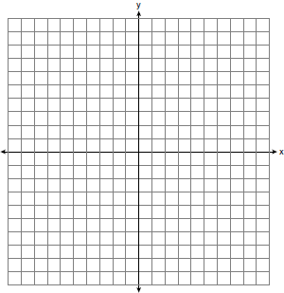

27 A support wire reaches from the top of a pole to a clamp on the ground. The pole is perpendicular to the level ground and the clamp is 10 feet from the base of the pole. The support wire makes a 68° angle with the ground. Find the length of the support wire to the nearest foot.

28 In the diagram below, circle O has a radius of 10.

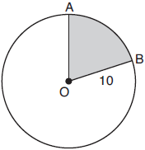

If , find the area of shaded sector AOB, in terms of .

29 On the set of axes below, .

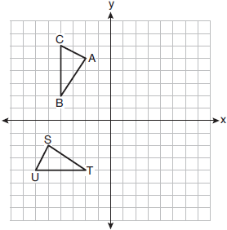

Describe a sequence of rigid motions that maps onto .

30 In right triangle PRT, , altitude is drawn to hypotenuse , , and .
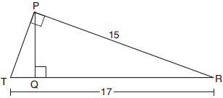

Determine and state, to the nearest tenth, the length of .

31 Given circle O with radius , use a compass and straightedge to construct an equilateral triangle inscribed in circle O. [Leave all construction marks.]

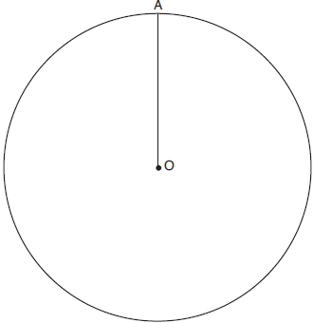

32 Riley plotted , , , and to form a quadrilateral. Prove that Riley's quadrilateral ABCD is a trapezoid. [The use of the set of axes on the next page is optional.] Riley defines an isosceles trapezoid as a trapezoid with congruent diagonals. Use Riley's definition to prove that ABCD is not an isosceles trapezoid.

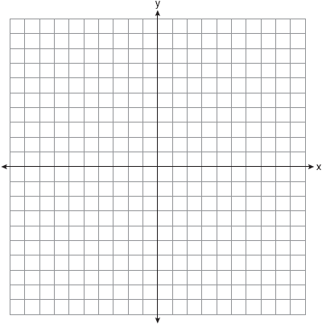

33 A child-sized swimming pool can be modeled by a cylinder. The pool has a diameter of feet and a height of 12 inches. The pool is filled with water to of its height. Determine and state the volume of the water in the pool, to the nearest cubic foot. One cubic foot equals 7.48 gallons of water. Determine and state, to the nearest gallon, the number of gallons of water in the pool.

34 Nick wanted to determine the length of one blade of the windmill pictured below. He stood at a point on the ground 440 feet from the windmill's base. Using surveyor's tools, Nick measured the angle between the ground and the highest point reached by the top blade and found it was 38.8°. He also measured the angle between the ground and the lowest point of the top blade, and found it was 30°.

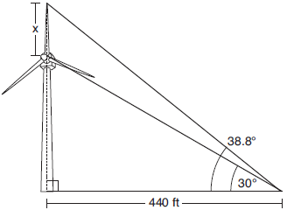

Determine and state a blade's length, x, to the nearest foot.

35 Given: Quadrilateral MATH, , , , and

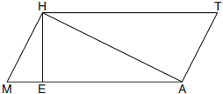

Prove:
1 ANS: 4 PTS: 2 REF: 061901geo NAT: G.CO.A.5
TOP: Compositions of Transformations KEY: identify

2 ANS: 3
Broome: 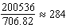 Duchess: 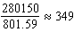 Niagara: 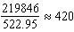 Saratoga: 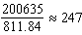

PTS: 2 REF: 061902geo NAT: G.MG.A.2 TOP: Density

3 ANS: 2 PTS: 2 REF: 061903geo NAT: G.GMD.B.4
TOP: Rotations of Two-Dimensional Objects

4 ANS: 4 PTS: 2 REF: 061904geo NAT: G.CO.A.3
TOP: Mapping a Polygon onto Itself

5 ANS: 1
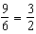

PTS: 2 REF: 061905geo NAT: G.SRT.A.1 TOP: Line Dilations

6 ANS: 2
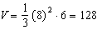

PTS: 2 REF: 061906geo NAT: G.GMD.A.3 TOP: Volume
KEY: pyramids

7 ANS: 2
The slope of is .

PTS: 2 REF: 061907geo NAT: G.SRT.A.1 TOP: Line Dilations

8 ANS: 4
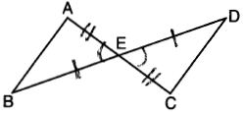

PTS: 2 REF: 061908geo NAT: G.SRT.B.5 TOP: Triangle Proofs
KEY: statements

9 ANS: 2

PTS: 2 REF: 061909geo NAT: G.SRT.C.7 TOP: Cofunctions

10 ANS: 1
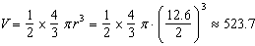

PTS: 2 REF: 061910geo NAT: G.GMD.A.3 TOP: Volume
KEY: spheres

11 ANS: 1
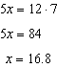

PTS: 2 REF: 061911geo NAT: G.SRT.B.5 TOP: Side Splitter Theorem

12 ANS: 3 PTS: 2 REF: 061912geo NAT: G.CO.C.11
TOP: Parallelograms

13 ANS: 3

PTS: 2 REF: 061913geo NAT: G.C.A.2 TOP: Chords, Secants and Tangents
KEY: intersecting chords, length

14 ANS: 4
d) is SSA

PTS: 2 REF: 061914geo NAT: G.CO.B.7 TOP: Triangle Congruency

15 ANS: 2
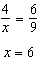

PTS: 2 REF: 061915geo NAT: G.SRT.B.5 TOP: Similarity
KEY: basic

16 ANS: 2
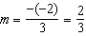

PTS: 2 REF: 061916geo NAT: G.GPE.B.5 TOP: Parallel and Perpendicular Lines
KEY: write equation of parallel line

17 ANS: 2

PTS: 2 REF: 061917geo NAT: G.CO.C.11 TOP: Special Quadrilaterals

18 ANS: 1
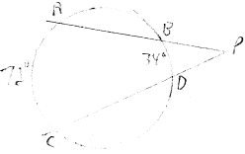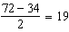

PTS: 2 REF: 061918geo NAT: G.C.A.2 TOP: Chords, Secants and Tangents
KEY: secants drawn from common point, angle

19 ANS: 4
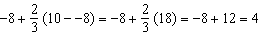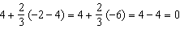

PTS: 2 REF: 061919geo NAT: G.GPE.B.6 TOP: Directed Line Segments

20 ANS: 4
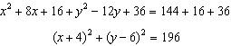

PTS: 2 REF: 061920geo NAT: G.GPE.A.1 TOP: Equations of Circles
KEY: completing the square

21 ANS: 2
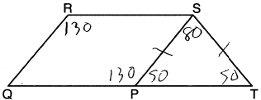

PTS: 2 REF: 061921geo NAT: G.CO.C.11 TOP: Interior and Exterior Angles of Polygons

22 ANS: 4
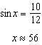

PTS: 2 REF: 061922geo NAT: G.SRT.C.8 TOP: Using Trigonometry to Find an Angle

23 ANS: 3
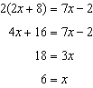 . Since is a midsegment, 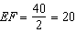. Since is equilateral, 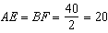.

PTS: 2 REF: 061923geo NAT: G.CO.C.10 TOP: Midsegments

24 ANS: 3 PTS: 2 REF: 061924geo NAT: G.CO.C.11
TOP: Special Quadrilaterals

25 ANS:
No, because dilations do not preserve distance.

PTS: 2 REF: 061925geo NAT: G.SRT.A.2 TOP: Dilations

26 ANS:
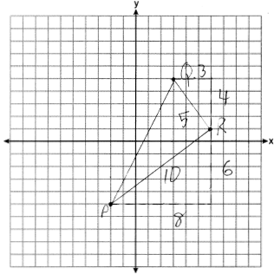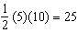

PTS: 2 REF: 061926geo NAT: G.GPE.B.7 TOP: Polygons in the Coordinate Plane

27 ANS:
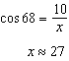

PTS: 2 REF: 061927geo NAT: G.SRT.C.8 TOP: Using Trigonometry to Find a Side

28 ANS:
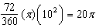

PTS: 2 REF: 061928geo NAT: G.C.B.5 TOP: Sectors

29 ANS:
or or

PTS: 2 REF: 061929geo NAT: G.CO.A.5 TOP: Compositions of Transformations
KEY: identify

30 ANS:
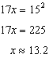

PTS: 2 REF: 061930geo NAT: G.SRT.B.5 TOP: Similarity
KEY: leg

31 ANS:
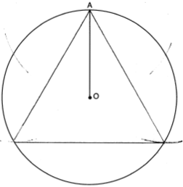

PTS: 2 REF: 061931geo NAT: G.CO.D.13 TOP: Constructions

32 ANS:
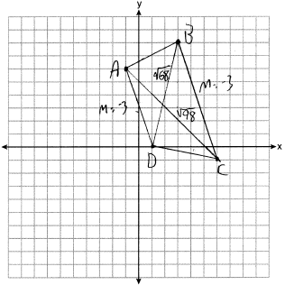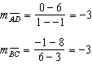 because their slopes are equal. ABCD is a trapezoid because it has a pair of parallel sides. 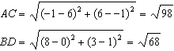 ABCD is not an isosceles trapezoid because its diagonals are not congruent.

PTS: 4 REF: 061932geo NAT: G.GPE.B.4 TOP: Quadrilaterals in the Coordinate Plane
KEY: grids

33 ANS:
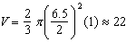

PTS: 4 REF: 061933geo NAT: G.GMD.A.3 TOP: Volume
KEY: cylinders

34 ANS:
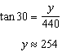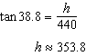
PTS: 4 REF: 061934geo NAT: G.SRT.C.8 TOP: Using Trigonometry to Find a Side
KEY: advanced

35 ANS:
Quadrilateral MATH, , , , and (given); and are right angles (perpendicular lines form right angles); (all right angles are congruent); MATH is a parallelogram (a quadrilateral with two pairs of congruent opposite sides is a parallelogram); (opposite sides of a parallelogram are parallel); (alternate interior angles of parallel lines and a transversal are congruent); (AA); 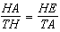 (corresponding sides of similar triangles are in proportion); (product of means equals product of extremes).
PTS: 6 REF: 061935geo NAT: G.SRT.B.5 TOP: Quadrilateral Proofs

