1 A rectangular prism is shown in the diagram below.

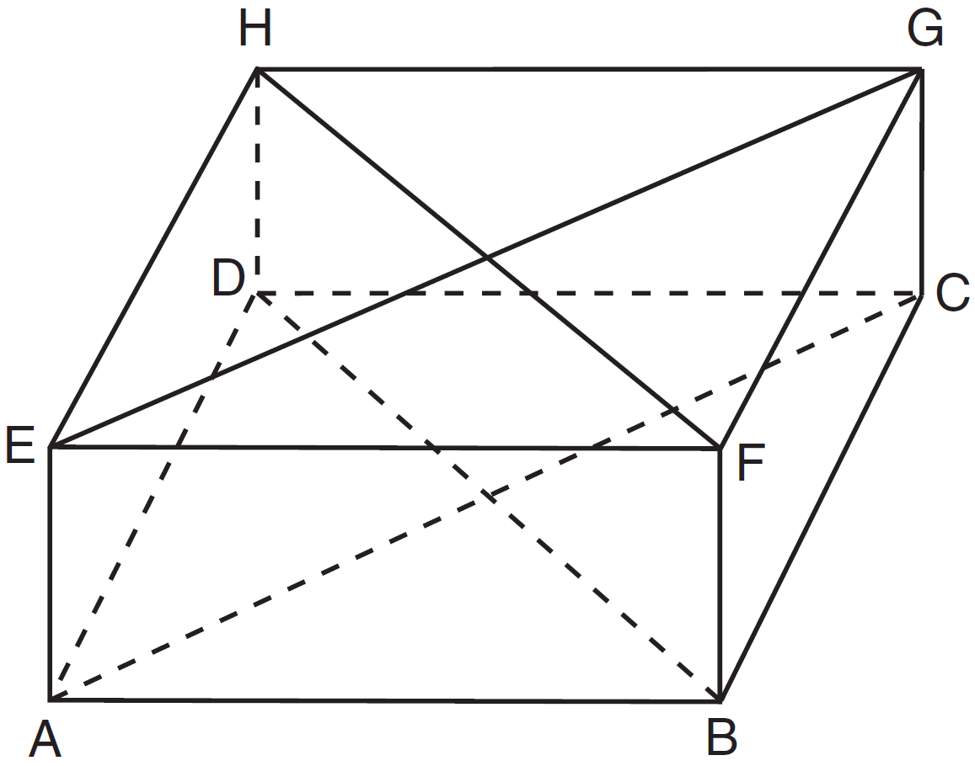

Which pair of line segments would always be both congruent and parallel?
1) | and
2) | and
3) | and
4) | and

2 In parallelogram QRST, diagonal is drawn. Which statement must always be true?
1) | is an isosceles triangle.
2) | is an acute triangle.
3)
4)

3 In the diagram below of circle O, diameter and chord intersect at E.

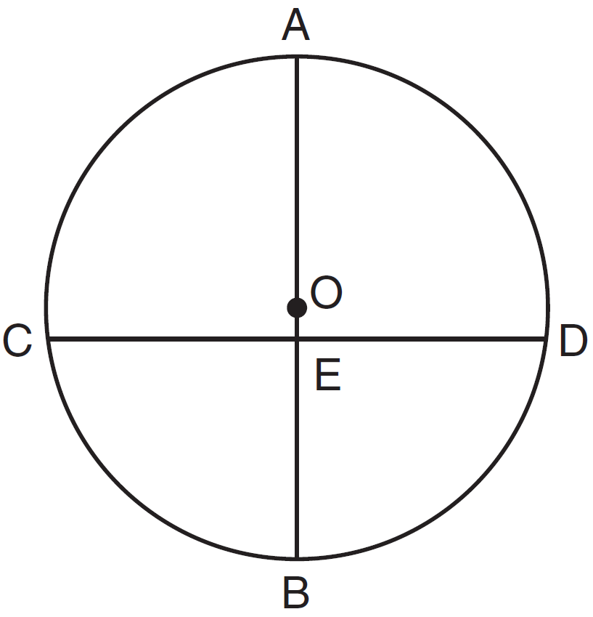

If , which statement is always true?
1)
2)
3)
4)

4 What is an equation of the line that passes through and is perpendicular to the line whose equation is 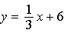?
1) | 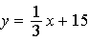
2)
3) | 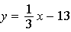
4)

5 In the diagram below, under which transformation is the image of ?

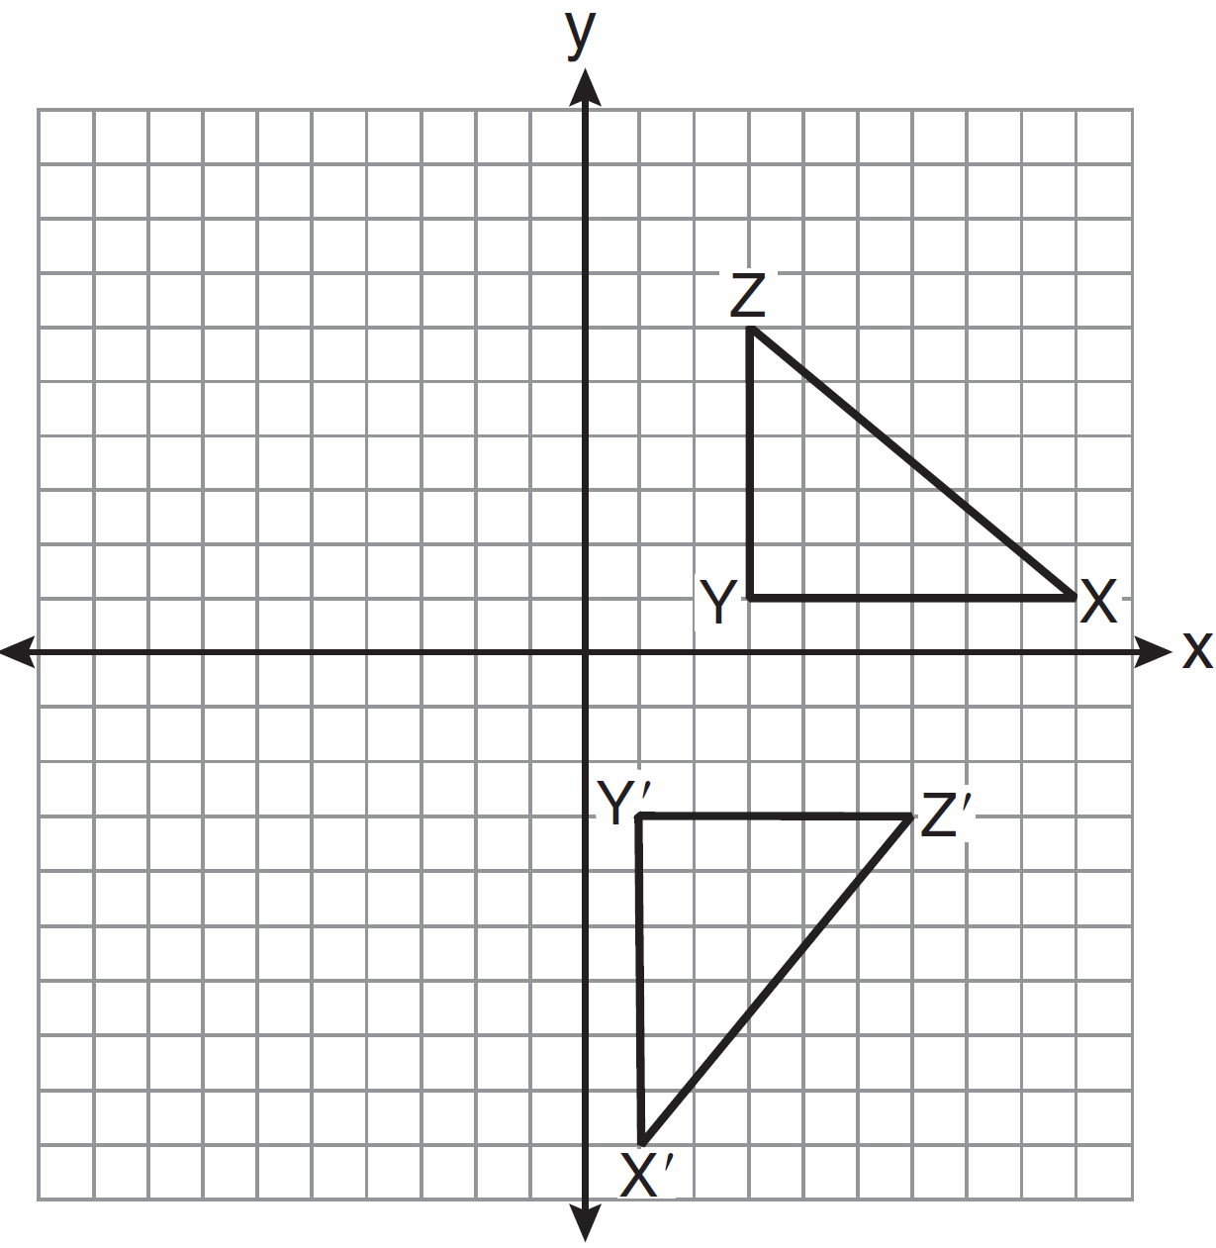
1) | dilation
2) | reflection
3) | rotation
4) | translation

6 What is the solution of the system of equations and ?
1) | and
2) | and
3) | and
4) | and

7 In the diagram below, parallelogram ABCD has vertices , , , and . Diagonals and intersect at E.

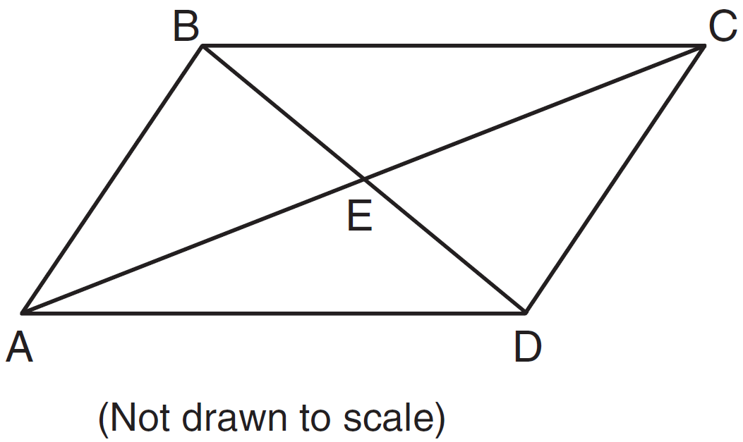

What are the coordinates of point E?
1)
2)
3)
4)

8 Right triangle ABC is shown in the graph below.

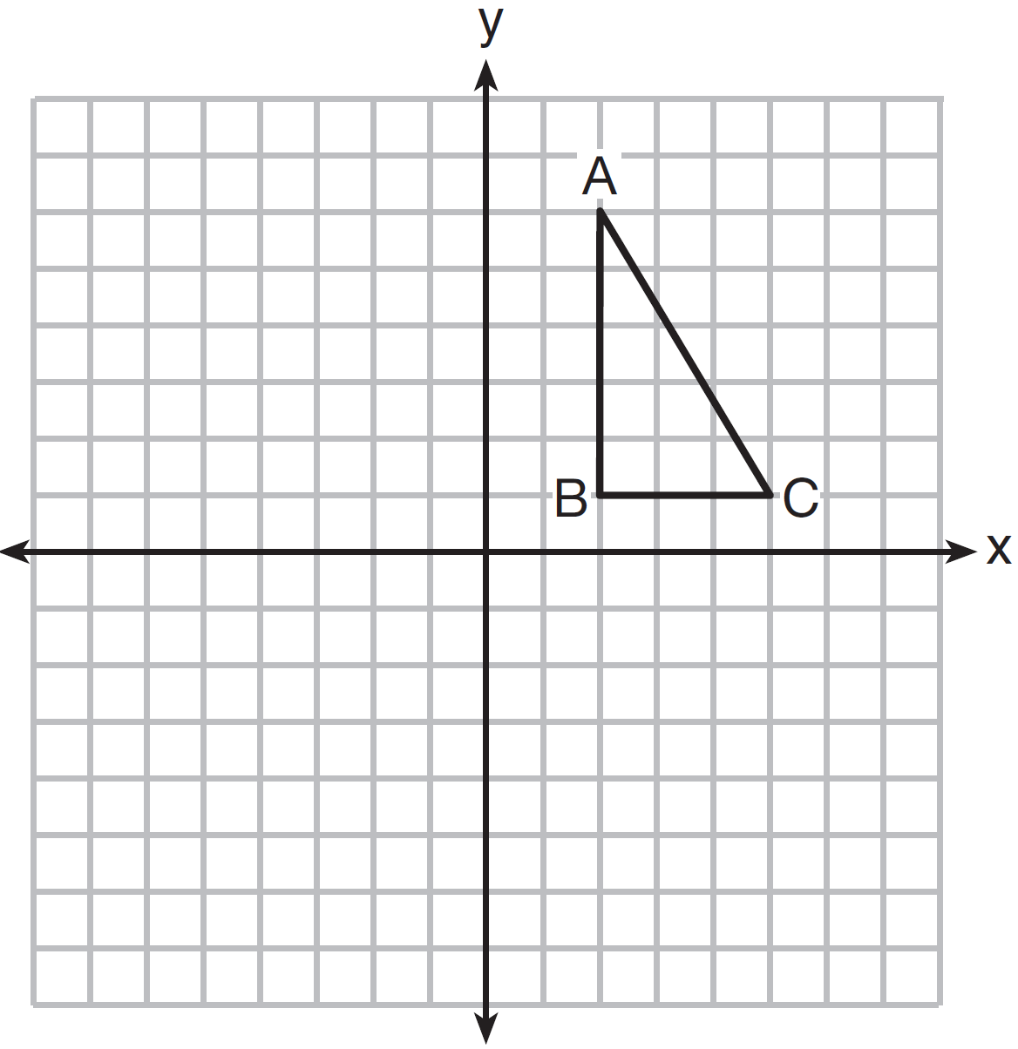

After a reflection over the y-axis, the image of is . Which statement is not true?
1)
2)
3)
4)

9 What is an equation of circle O shown in the graph below?

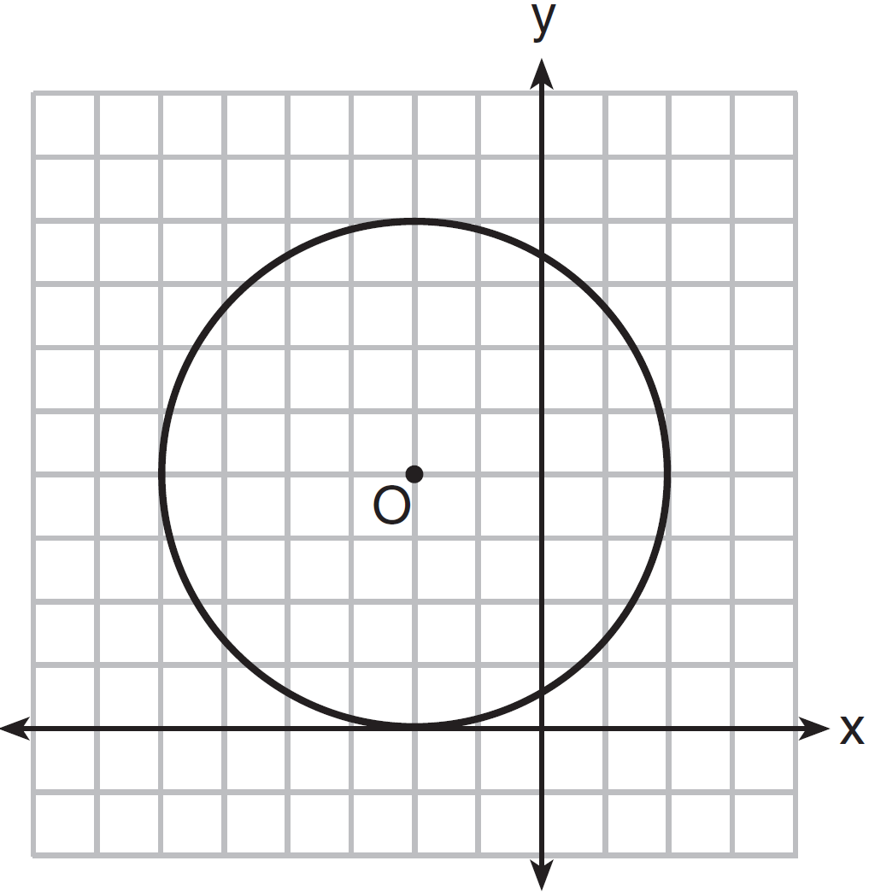
1)
2)
3)
4)

10 In the diagram below of right triangle ABC, an altitude is drawn to the hypotenuse .

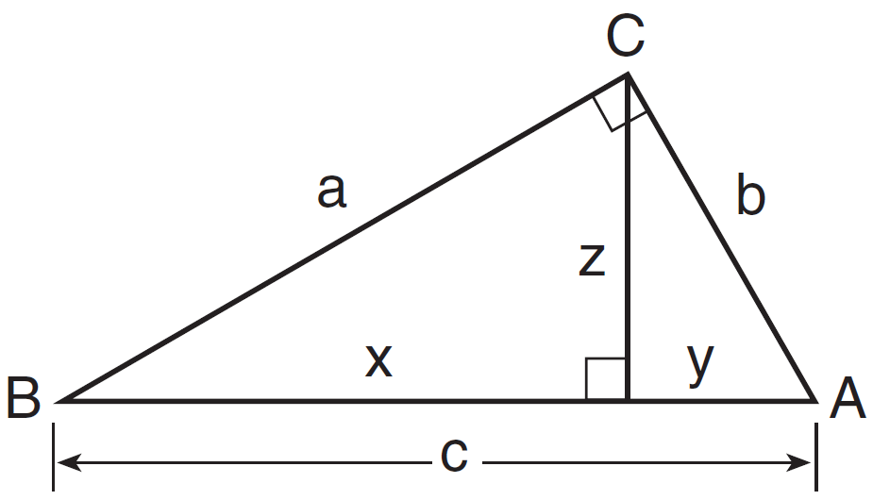

Which proportion would always represent a correct relationship of the segments?
1) | 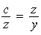
2) | 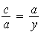
3) | 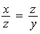
4) | 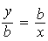

11 Quadrilateral ABCD is graphed on the set of axes below.

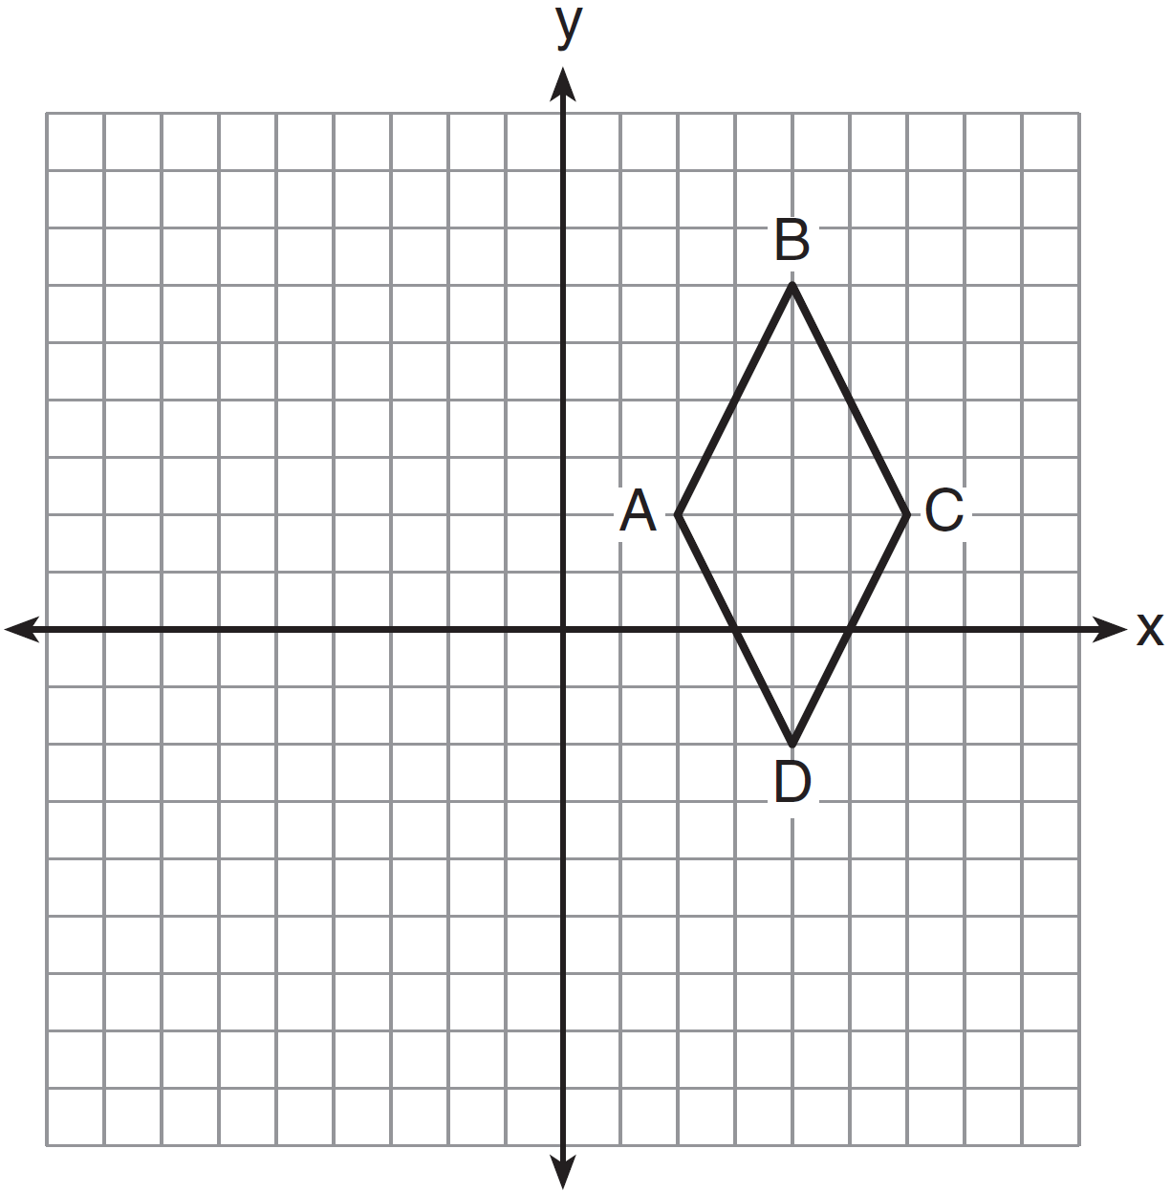

Which quadrilateral best classifies ABCD?
1) | trapezoid
2) | rectangle
3) | rhombus
4) | square

12 Circle O is represented by the equation . The coordinates of the center and the length of the radius of circle O are
1) | and
2) | and 24
3) | and
4) | and 24

13 In the diagram below of circle O, chord is parallel to chord .

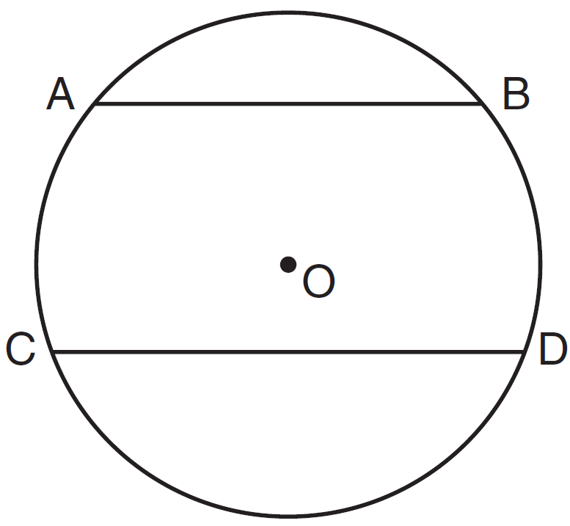

A correct justification for in circle O is
1) | parallel chords intercept congruent arcs
2) | congruent chords intercept congruent arcs
3) | if two chords are parallel, then they are congruent
4) | if two chords are equidistant from the center, then the arcs they intercept are congruent

14 What is the slope of a line perpendicular to the line whose equation is ?
1)
2)
3) | 3
4)

15 Line segment AB has endpoint A located at the origin. Line segment AB is longest when the coordinates of B are
1)
2)
3)
4)

16 In , , , , and . The length of is
1) | 20
2) | 40
3) | 60
4) | 80

17 In the diagram below of quadrilateral ABCD, diagonals and are perpendicular at E.

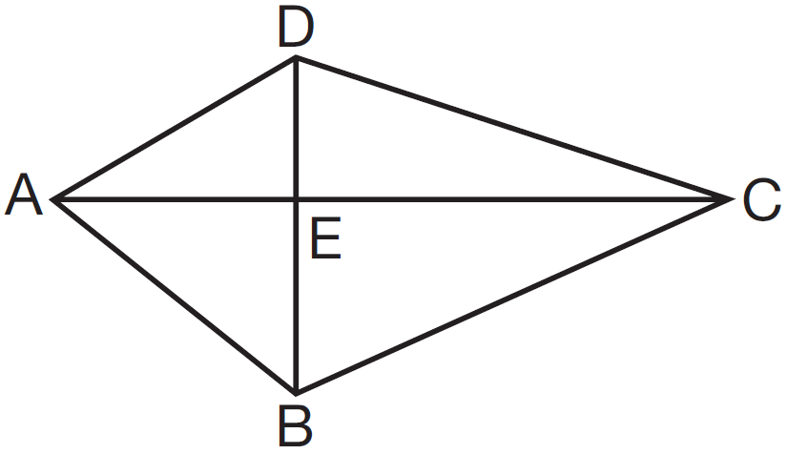

Which statement is always true based on the given information?
1)
2)
3)
4)

18 Which set of numbers could represent the lengths of the sides of a right triangle?
1)
2)
3)
4)

19 In quadrilateral ABCD, the diagonals bisect its angles. If the diagonals are not congruent, quadrilateral ABCD must be a
1) | square
2) | rectangle
3) | rhombus
4) | trapezoid

20 Line m and point P are shown in the graph below.

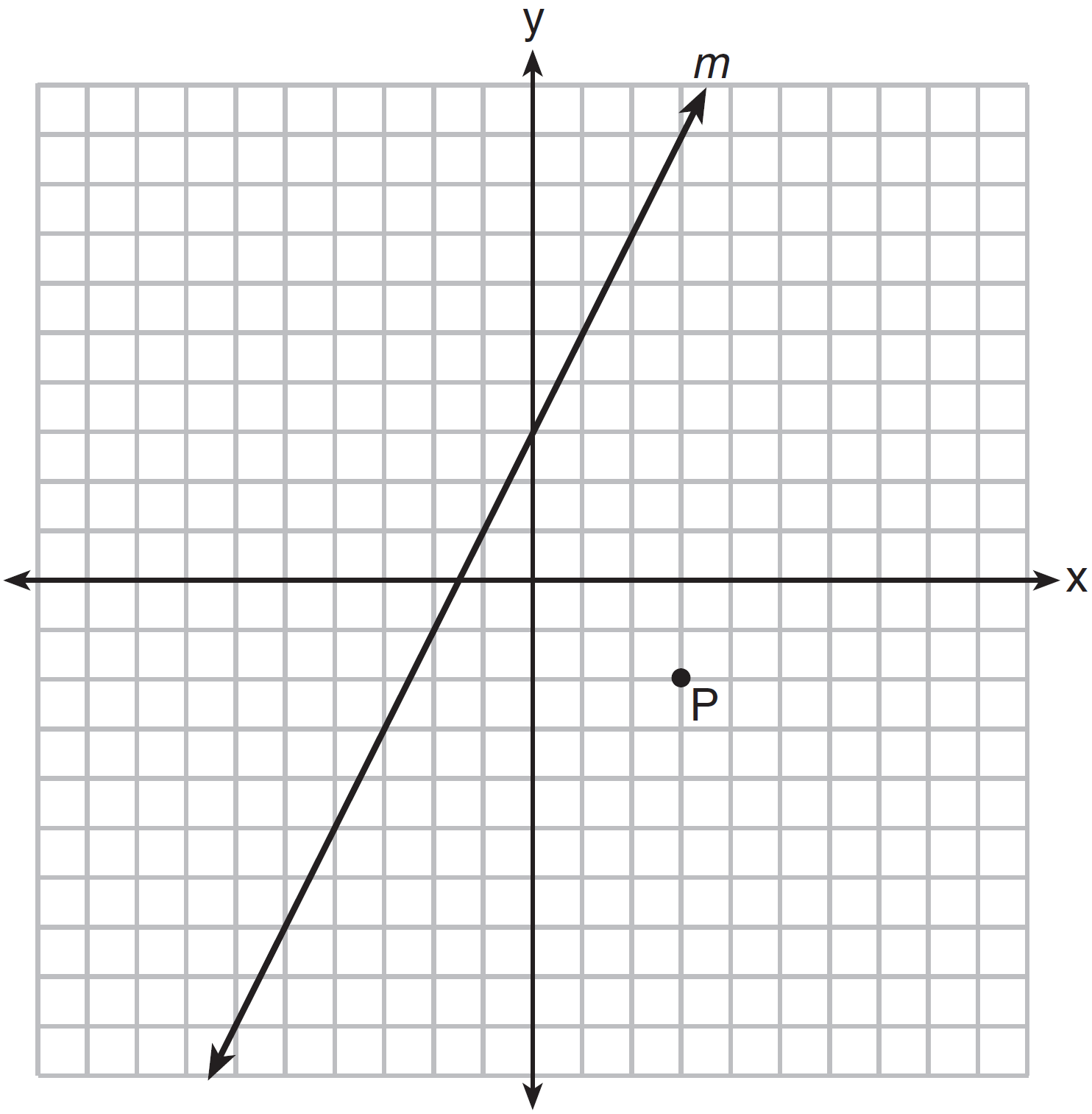

Which equation represents the line passing through P and parallel to line m?
1)
2)
3) | 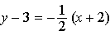
4) | 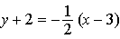

21 Which compound statement is true?
1) | A square has four sides or a hexagon has eight sides.
2) | A square has four sides and a hexagon has eight sides.
3) | If a square has four sides, then a hexagon has eight sides.
4) | A square has four sides if and only if a hexagon has eight sides.

22 In , , , and B is a point on side , such that . Which line segment is shortest?
1)
2)
3)
4)

23 In the diagram of below, , , , and .

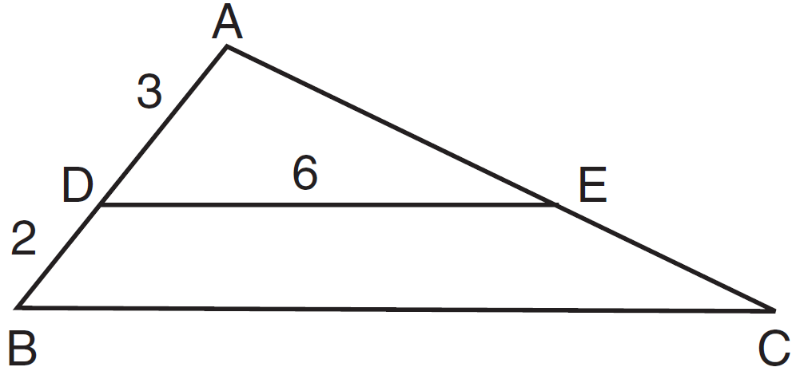

What is the length of ?
1) | 12
2) | 10
3) | 8
4) | 4

24 In , an exterior angle at C measures 50º. If . which inequality must be true?
1)
2)
3)
4)

25 Which graph represents the graph of the equation ?
1) | 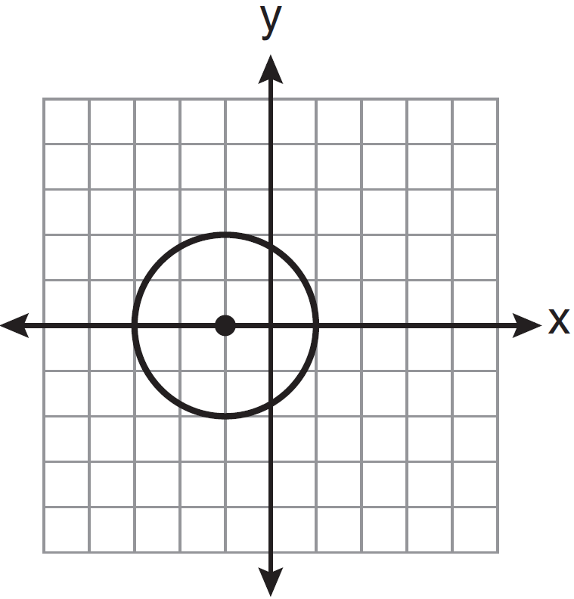
2) | 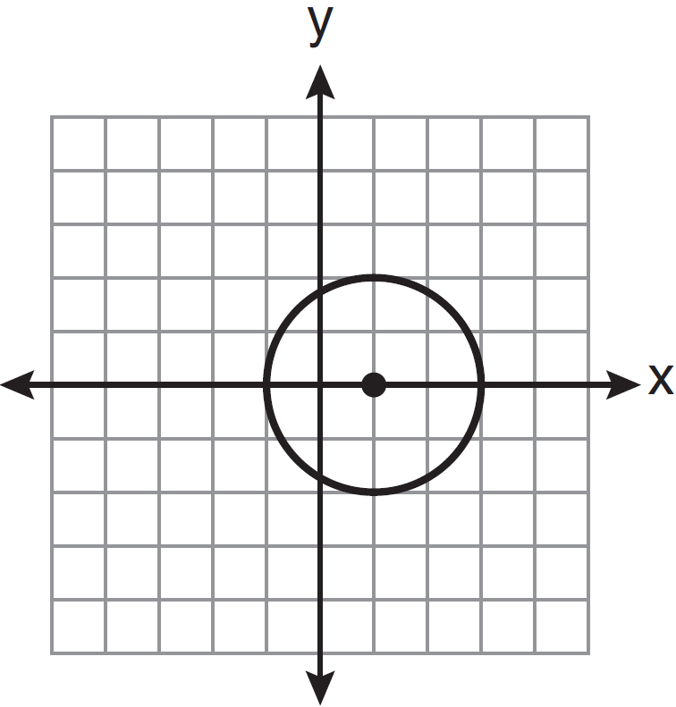
3) | 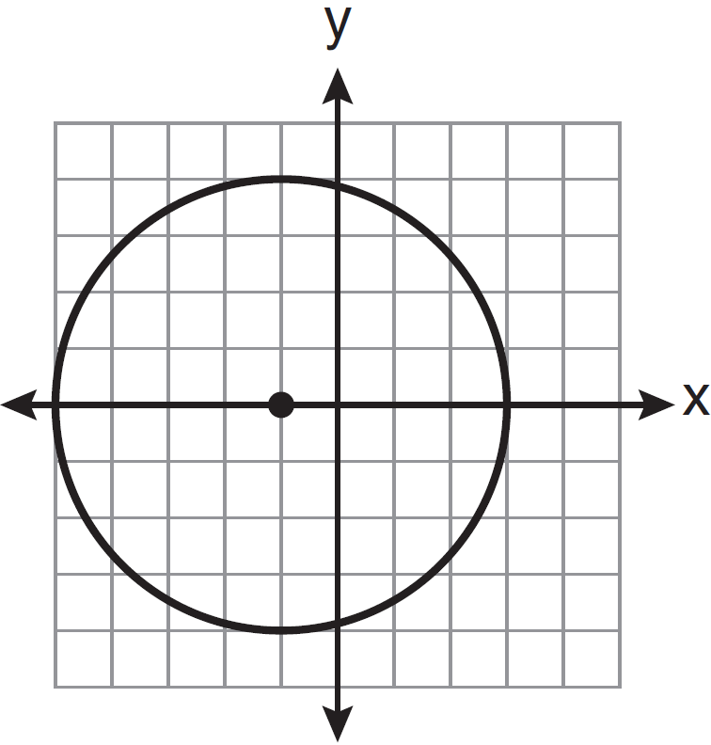
4) | 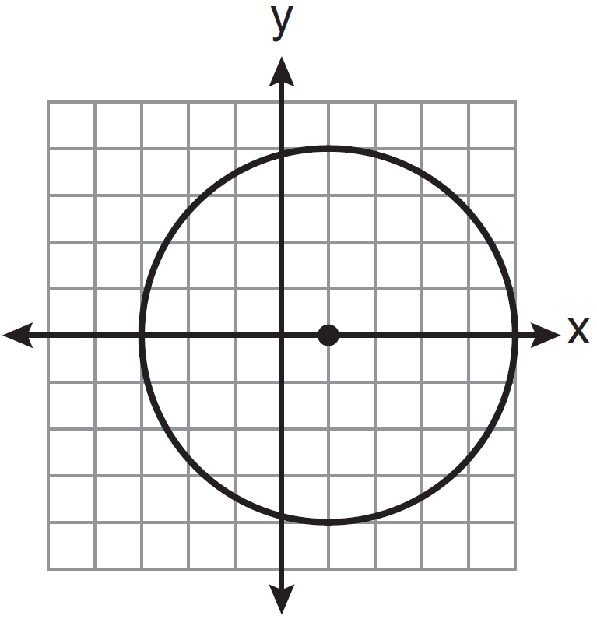

26 The equations of lines k, p, and m are given below:
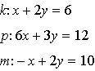
Which statement is true?
1)
2)
3)
4)

27 Peach Street and Cherry Street are parallel. Apple Street intersects them, as shown in the diagram below.

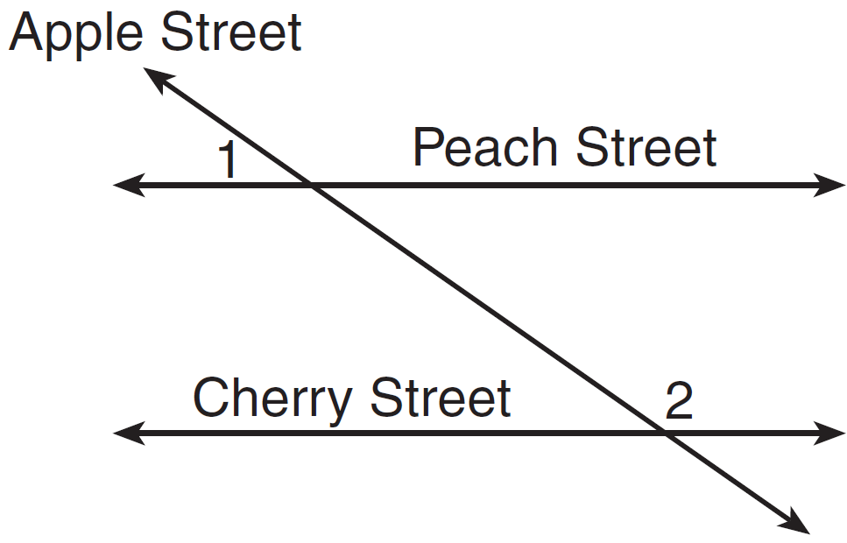

If and , what is ?
1) | 9
2) | 17
3) | 54
4) | 70

28 A regular pyramid has a height of 12 centimeters and a square base. If the volume of the pyramid is 256 cubic centimeters, how many centimeters are in the length of one side of its base?
1) | 8
2) | 16
3) | 32
4) | 64

29 Triangle ABC has coordinates , , and . On the set of axes below, graph and label , the image of after a dilation of 2.

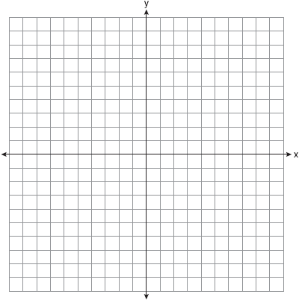

30 In the diagram below of , and are midsegments.

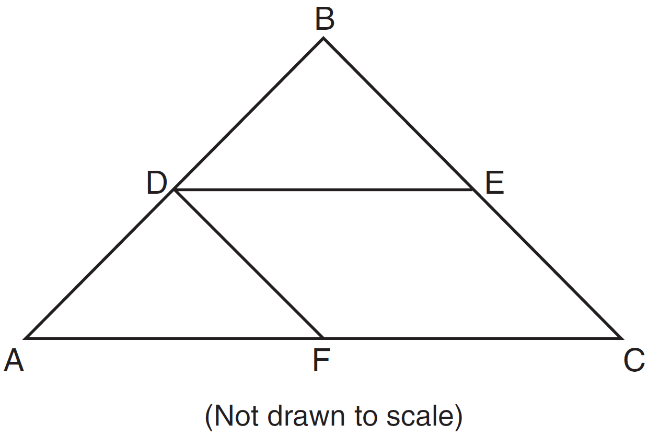

If , and , determine and state the perimeter of quadrilateral FDEC.

31 The image of under a translation is . Under this translation, maps onto . Using this translation, the coordinates of image are . Determine and state the coordinates of point A.

32 As shown in the diagram below, quadrilateral DEFG is inscribed in a circle and .

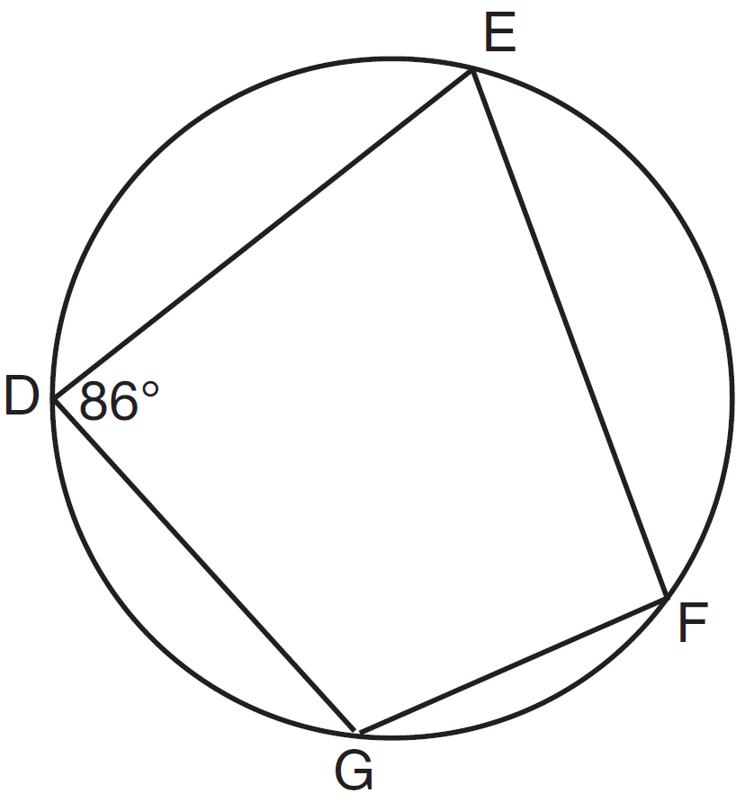

Determine and state . Determine and state .

33 In the diagram below, is a median of triangle PQR and point C is the centroid of triangle PQR.

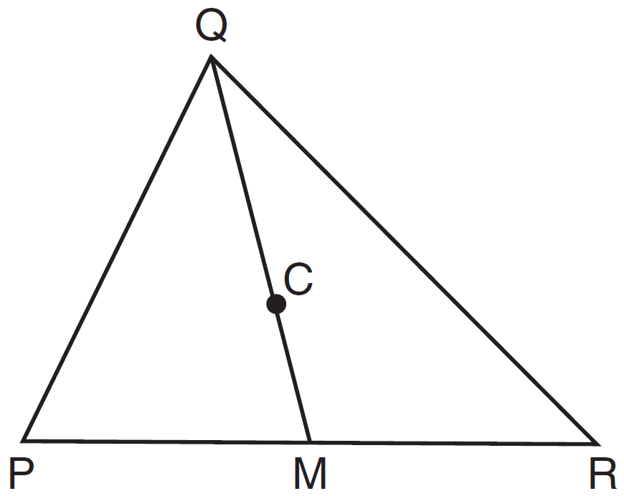

If and , determine and state the length of .

34 The sum of the interior angles of a regular polygon is 540°. Determine and state the number of degrees in one interior angle of the polygon.

35 Given: and intersect at B, , and bisects .

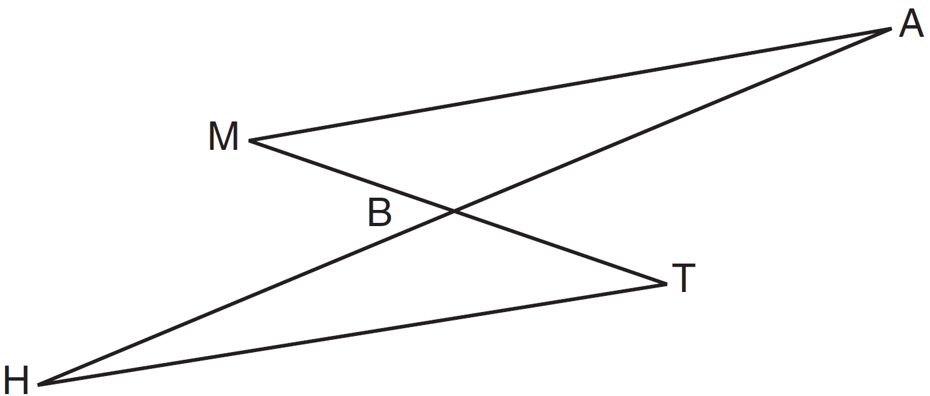

Prove:

36 A right circular cone has an altitude of 10 ft and the diameter of the base is 6 ft as shown in the diagram below. Determine and state the lateral area of the cone, to the nearest tenth of a square foot.

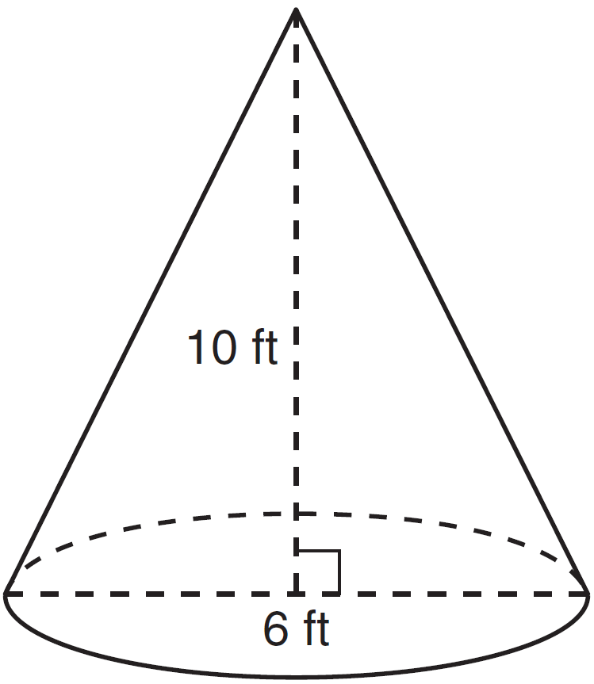

37 Use a compass and straightedge to divide line segment AB below into four congruent parts. [Leave all construction marks.]

38 On the set of axes below, graph the locus of points 5 units from the point . On the same set of axes, graph the locus of points equidistant from the points and . State the coordinates of all points that satisfy both conditions.

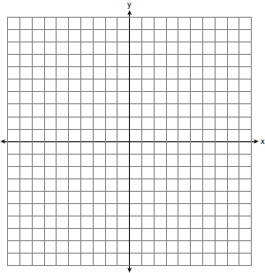
1 ANS: 4 PTS: 2 REF: 081401ge STA: G.G.10
TOP: Solids

2 ANS: 3
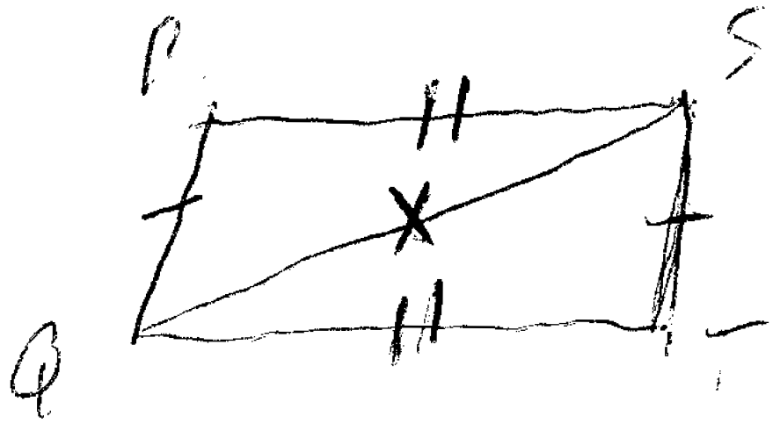

PTS: 2 REF: 081402ge STA: G.G.38 TOP: Parallelograms

3 ANS: 4 PTS: 2 REF: 081403ge STA: G.G.49
TOP: Chords

4 ANS: 2
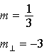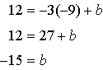

PTS: 2 REF: 081404ge STA: G.G.64 TOP: Parallel and Perpendicular Lines

5 ANS: 3 PTS: 2 REF: 081405ge STA: G.G.56
TOP: Identifying Transformations

6 ANS: 1
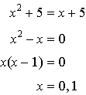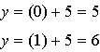

PTS: 2 REF: 081406ge STA: G.G.70 TOP: Quadratic-Linear Systems

7 ANS: 3
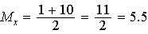 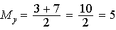.

PTS: 2 REF: 081407ge STA: G.G.66 TOP: Midpoint
KEY: graph

8 ANS: 4 PTS: 2 REF: 081408ge STA: G.G.55
TOP: Properties of Transformations

9 ANS: 4 PTS: 2 REF: 081409ge STA: G.G.72
TOP: Equations of Circles

10 ANS: 3 PTS: 2 REF: 081410ge STA: G.G.47
TOP: Similarity KEY: altitude

11 ANS: 3
Both pairs of opposite sides are parallel, so not a trapezoid. None of the angles are right angles, so not a rectangle or square. All sides are congruent, so a rhombus.

PTS: 2 REF: 081411ge STA: G.G.69 TOP: Quadrilaterals in the Coordinate Plane

12 ANS: 1
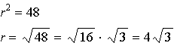

PTS: 2 REF: 081412ge STA: G.G.73 TOP: Equations of Circles

13 ANS: 1
Parallel lines intercept congruent arcs.

PTS: 2 REF: 081413ge STA: G.G.52 TOP: Chords

14 ANS: 2
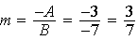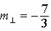

PTS: 2 REF: 081414ge STA: G.G.62 TOP: Parallel and Perpendicular Lines

15 ANS: 2 PTS: 2 REF: 081415ge STA: G.G.67
TOP: Distance KEY: general

16 ANS: 3
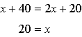

PTS: 2 REF: 081416ge STA: G.G.31 TOP: Isosceles Triangle Theorem

17 ANS: 4 PTS: 2 REF: 081417ge STA: G.G.24
TOP: Statements

18 ANS: 4

PTS: 2 REF: 081418ge STA: G.G.48 TOP: Pythagorean Theorem

19 ANS: 3 PTS: 2 REF: 081419ge STA: G.G.39
TOP: Special Parallelograms

20 ANS: 2 PTS: 2 REF: 081421ge STA: G.G.65
TOP: Parallel and Perpendicular Lines

21 ANS: 1 PTS: 2 REF: 081421ge STA: G.G.25
TOP: Compound Statements KEY: general

22 ANS: 2
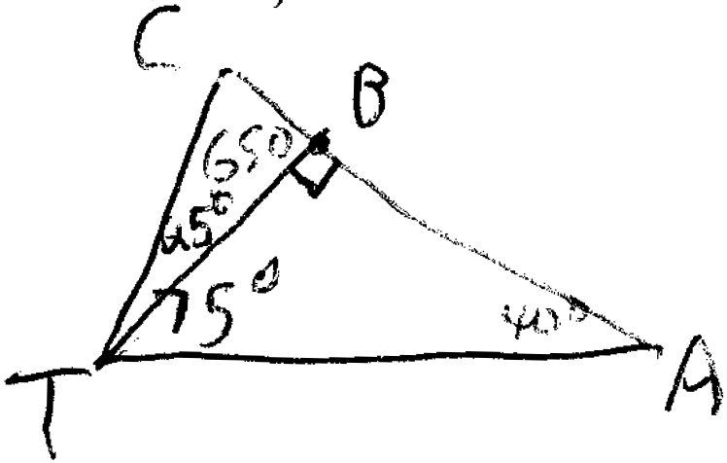

PTS: 2 REF: 081422ge STA: G.G.34 TOP: Angle Side Relationship

23 ANS: 2
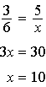

PTS: 2 REF: 081423ge STA: G.G.46 TOP: Side Splitter Theorem

24 ANS: 1
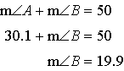

PTS: 2 REF: 081424ge STA: G.G.32 TOP: Exterior Angle Theorem

25 ANS: 2 PTS: 2 REF: 081425ge STA: G.G.74
TOP: Graphing Circles

26 ANS: 1
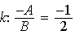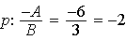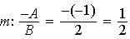

PTS: 2 REF: 081426ge STA: G.G.63 TOP: Parallel and Perpendicular Lines

27 ANS: 4
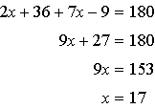

PTS: 2 REF: 081427ge STA: G.G.35 TOP: Parallel Lines and Transversals

28 ANS: 1
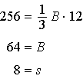

PTS: 2 REF: 081428ge STA: G.G.13 TOP: Volume

29 ANS:
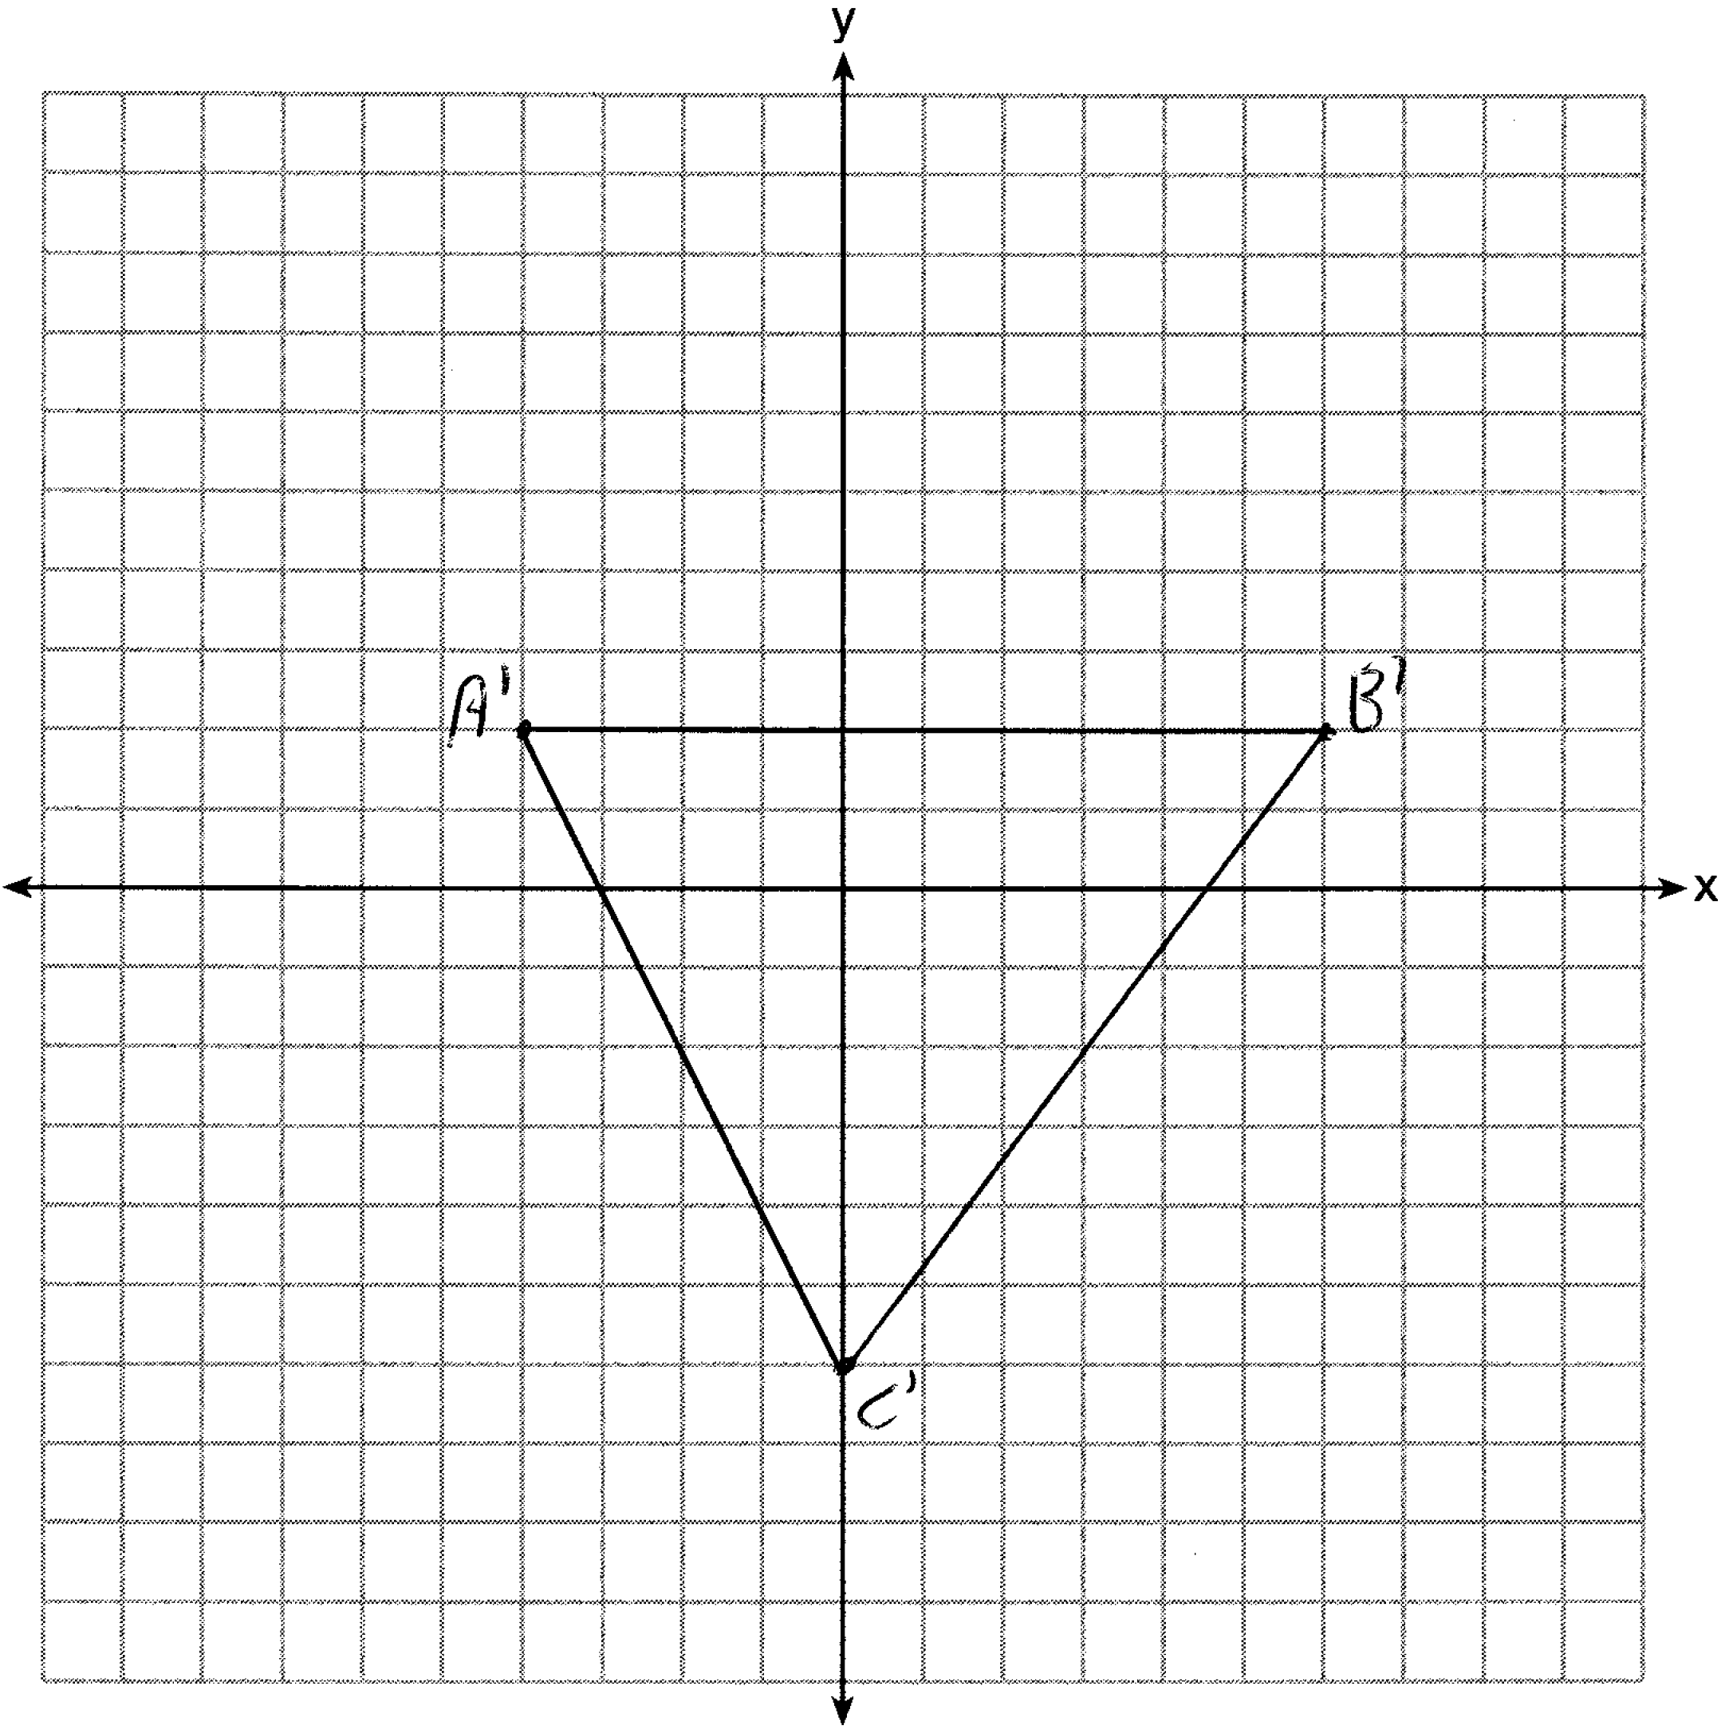

PTS: 2 REF: 081429ge STA: G.G.58 TOP: Dilations

30 ANS:
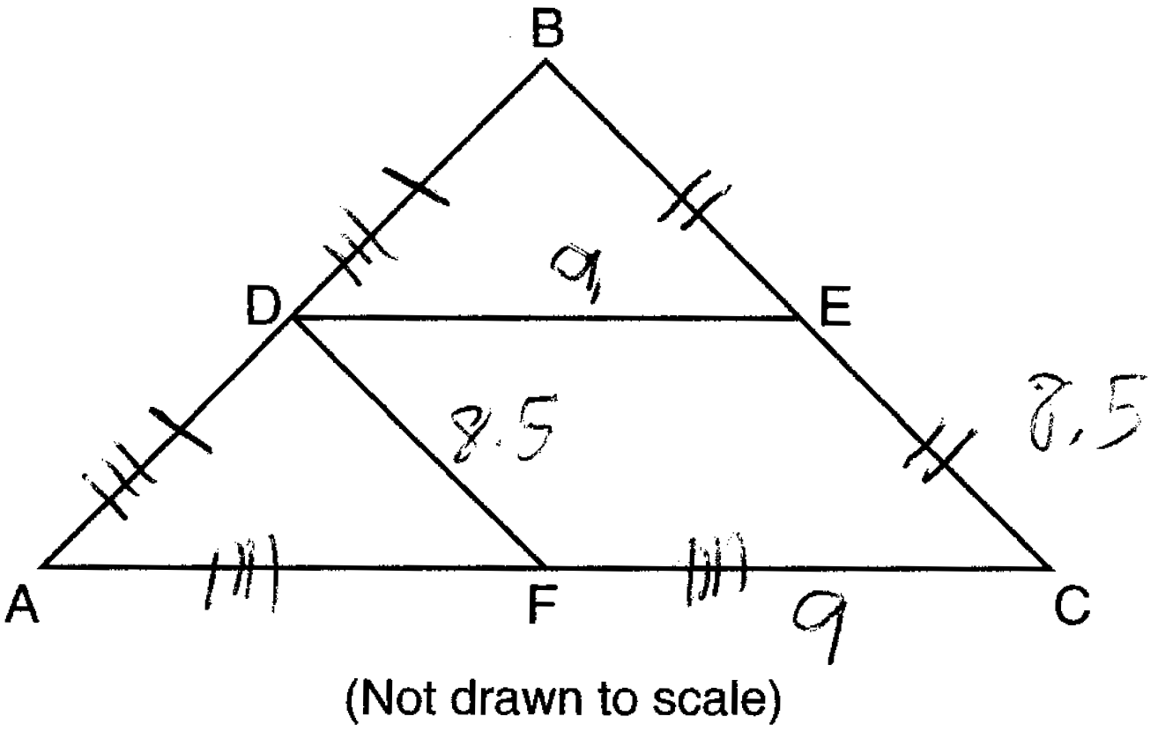

PTS: 2 REF: 081430ge STA: G.G.42 TOP: Midsegments

31 ANS:

PTS: 2 REF: 081431ge STA: G.G.54 TOP: Translations

32 ANS:

PTS: 2 REF: 081432ge STA: G.G.51 TOP: Arcs Determined by Angles
KEY: inscribed

33 ANS:
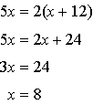

PTS: 2 REF: 081433ge STA: G.G.43 TOP: Centroid

34 ANS:
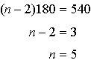. 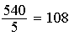

PTS: 2 REF: 081434ge STA: G.G.37 TOP: Interior and Exterior Angles of Polygons

35 ANS:
and intersect at B, , and bisects (Given). (Vertical Angles). (Alternate Interior Angles). (The bisection of a line segment creates two congruent segments). (ASA). (CPCTC).

PTS: 4 REF: 081435ge STA: G.G.27 TOP: Triangle Proofs

36 ANS:
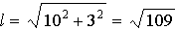

PTS: 4 REF: 081436ge STA: G.G.15 TOP: Volume and Lateral Area

37 ANS:
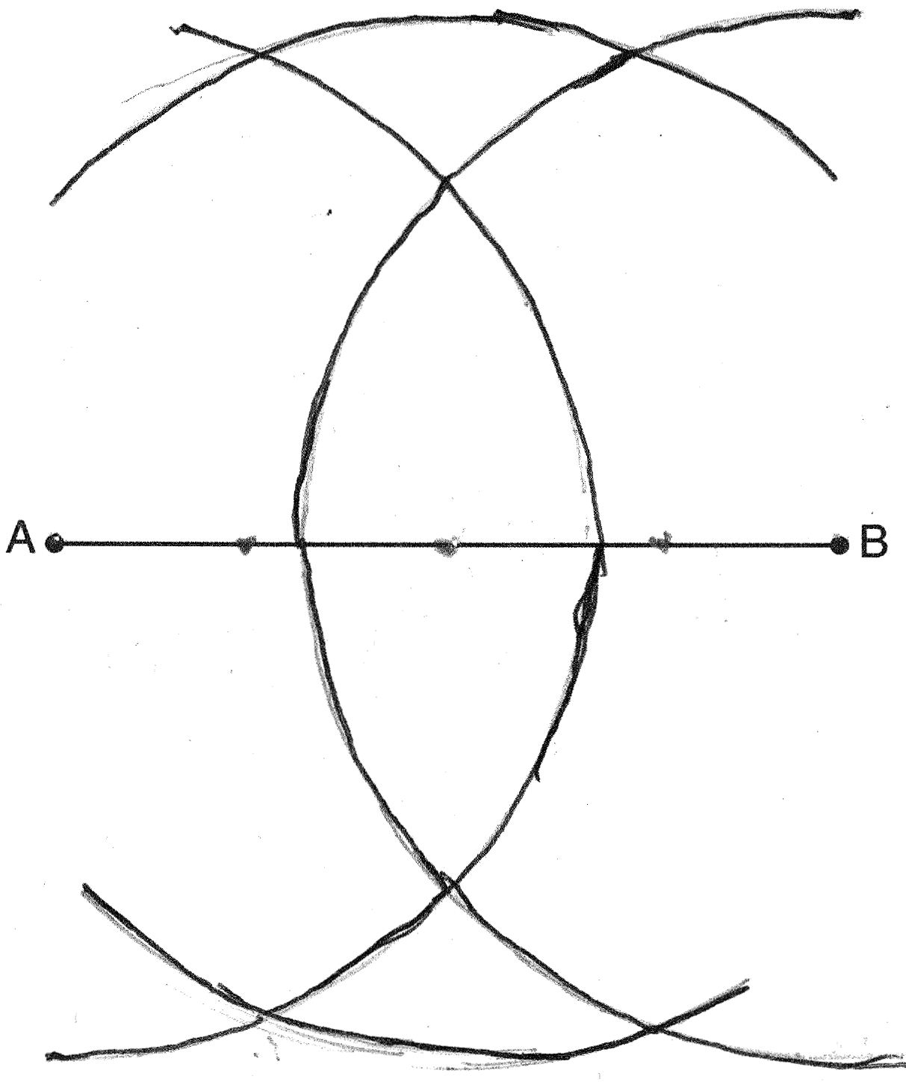

PTS: 4 REF: 081437ge STA: G.G.18 TOP: Constructions

38 ANS:
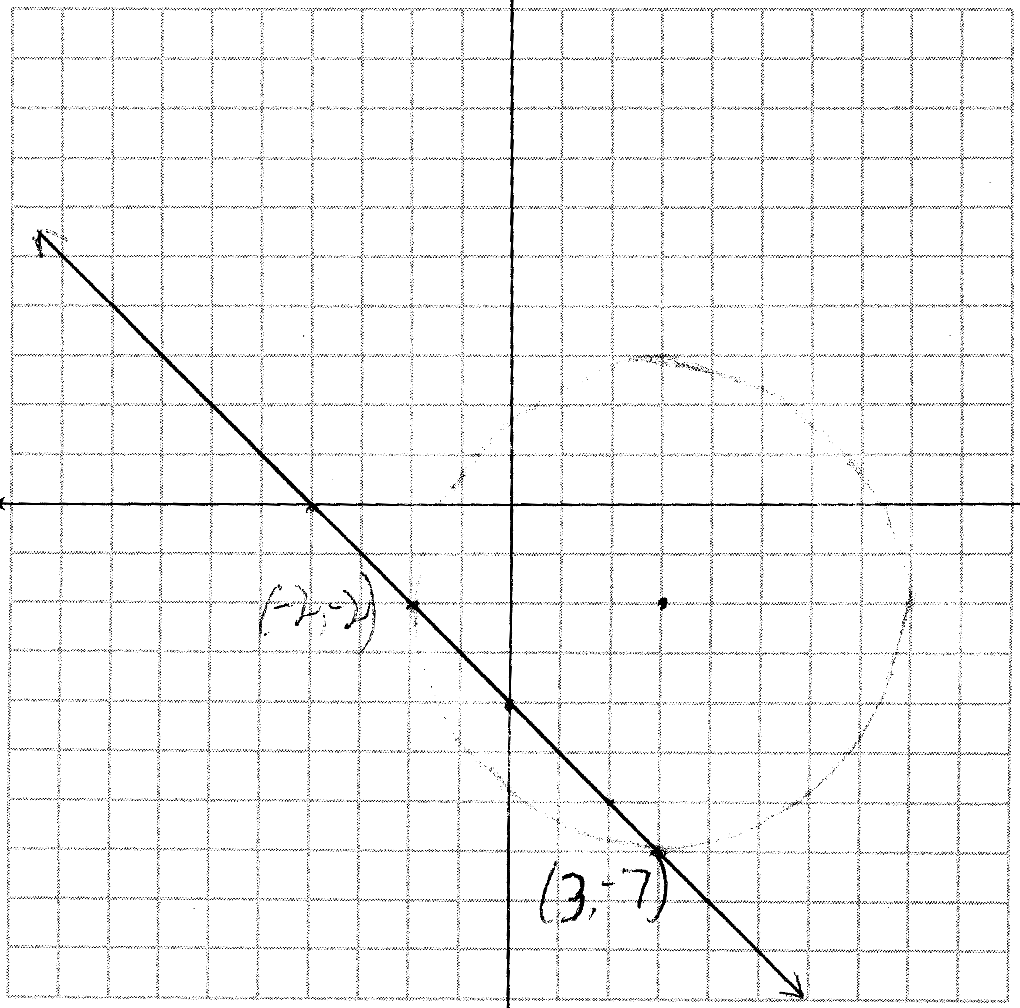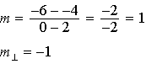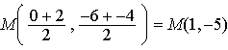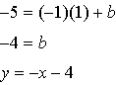

PTS: 6 REF: 081438ge STA: G.G.23 TOP: Locus

