**K – Polynomials, Lesson 5, Zeros of Polynomials (r. 2018)**

POLYNOMIALS

Zeros of Polynomials

|  |  |
| --- | --- |
| **Common Core Standard**  **A-APR.3** Identify zeros of polynomials when suitable factorizations are available, ~~and use the zeros to construct a rough graph of the function defined by the polynomial~~.  PARCC: Tasks are limited to quadratic and cubic polynomials in which linear and quadratic factors are available. *For example, find the zeros of  .* | **Next Generation Standard**  **AI-A.APR.3** Identify zeros of polynomial functions when suitable factorizations are available.  (Shared standard with Algebra II)  Note: Algebra I tasks will focus on identifying the zeros of quadratic and cubic polynomial functions. For tasks that involve finding the zeros of cubic polynomial functions, the linear and quadratic factors of the cubic polynomial function will be given (e.g., find the zeros of  ). |

**LEARNING OBJECTIVES**

Students will be able to:

1. Identify the zeros of a polynomial expression given its factors.
2. Identify the factors of a polynomial expression given its zeros.
3. Identify the zeros and factors of a polynomial expression given the graph of the expression.

**Overview of Lesson**

|  |  |
| --- | --- |
| **Teacher Centered Introduction**  **Overview of Lesson**  **- activate students’ prior knowledge**  **- vocabulary**  **- learning objective(s)**  **- big ideas: direct instruction**  **- modeling** | **Student Centered Activities**  **guided practice ⬅Teacher: anticipates, monitors, selects, sequences, and connects student work**  **- developing essential skills**  **- Regents exam questions**  **- formative assessment assignment (exit slip, explain the math, or journal entry)** |

**VOCABULARY**

**Multiplication Property of Zero**: The **multiplication property of zero** says that if the product of two numbers or expressions is zero, then one or both of the numbers or expressions must equal zero. More simply, if , then either  or , or, x and y both equal zero.

**Factor**: A **facto**r is:

1) a whole number that is a **divisor** of another number, or

2) an algebraic expression that is a **divisor** of another algebraic expression.

Examples:

o 1, 2, 3, 4, 6, and 12 all divide the number 12,

so 1, 2, 3, 4, 6, and 12 are all factors of 12.

o  will divide the trinomial expression ,

so are both factors of the .

**Zeros:** A **zero** of an equation is a **solution** or **root** of the equation. The words **zero**, **solution**, and **root** all mean the same thing. The zeros of a polynomial expression are found by finding the value of x when the value of y is 0. This done by making and solving an equation with the value of the polynomial expression equal to zero.

**Example:**

o The **zeros** of the trinomial expression  can be found by writing and then factoring the equation:



After factoring the equation, use the **multiplication property of zero** to find the zeros, as follows:

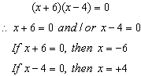

The zeros of the expression  are -6 and +4.

Check: You can check this by substituting both -6 or +4 into the expression, as follows:

Check for -6

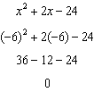

Check for +4

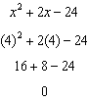

**x-axis intercepts**: The zeros of an expression can also be understood as the **x-axis intercepts** of the graph of the equation when . This is because the coordinates of the x-axis intercepts, by definition, have y-values equal to zero, and is the same as writing an equation where the expression is equal to zero.

|  |  |  |
| --- | --- | --- |
| The roots of  are  and. These are the x coordinate values of the x-axis intercepts. |  |  |

**BIG IDEA #1**

**Starting with Factors and Finding Zeros**

Remember that the **factors** of an expression are *related to* the **zeros** of the expression by the **multiplication property of zero**. Thus, if you know the **factors**, it is easy to find the **zeros**.

Example: The factors of an expression are ,  and .

The zeros are found as follows using the multiplication property of zero:

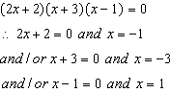

The zeros are -3, -1, and +1.

|  |  |  |
| --- | --- | --- |
| Be sure to input all factors. |  |  |

**BIG IDEA #2**

**Starting with Zeros and Finding Factors**

If you know the **zeros** of an expression, you can work backwards using the **multiplication property of zero** to find the **factors** of the expression. For example, if you inspect the graph of an equation and find that it has **x-intercepts** at  and , you can write:

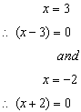

The equation of the graph has **factors** of  and , so you can write the equation:



which simplifies to



With practice, you can probably move back and forth between the **zeros** of an expression and the **factors** of an expression with ease.

**DEVELOPING ESSENTIAL SKILLS**

Identify the factors, zeros, and x-axis intercepts of the following polynomials:

|  |  |  |  |
| --- | --- | --- | --- |
| Polynomial | Factors | Zeros | x-axis Intercepts |
|  |  |  |  |
|  |  |  |  |
|  |  |  |  |
|  |  |  |  |
|  |  |  |  |
|  |  |  |  |
|  |  |  |  |
|  |  |  |  |

ANSWERS

Identify the factors, zeros, and x-axis intercepts of the following polynomials:

|  |  |  |  |
| --- | --- | --- | --- |
| Polynomial | Factors | Zeros | x-axis Intercepts |
|  |  |  |  |
|  |  |  |  |
|  |  |  |  |
|  |  |  |  |
|  |  |  |  |
|  |  |  |  |
|  |  |  |  |
|  |  |  |  |

**REGENTS EXAM QUESTIONS (through June 2018)**

A.APR.B.3: Zeros of Polynomials

356) The graphs below represent functions defined by polynomials. For which function are the zeros of the polynomials 2 and ?

|  |  |  |  |
| --- | --- | --- | --- |
| 1) |  | 3) |  |
| 2) |  | 4) |  |

357) Which equation(s) represent the graph below?

I 

II 

III 

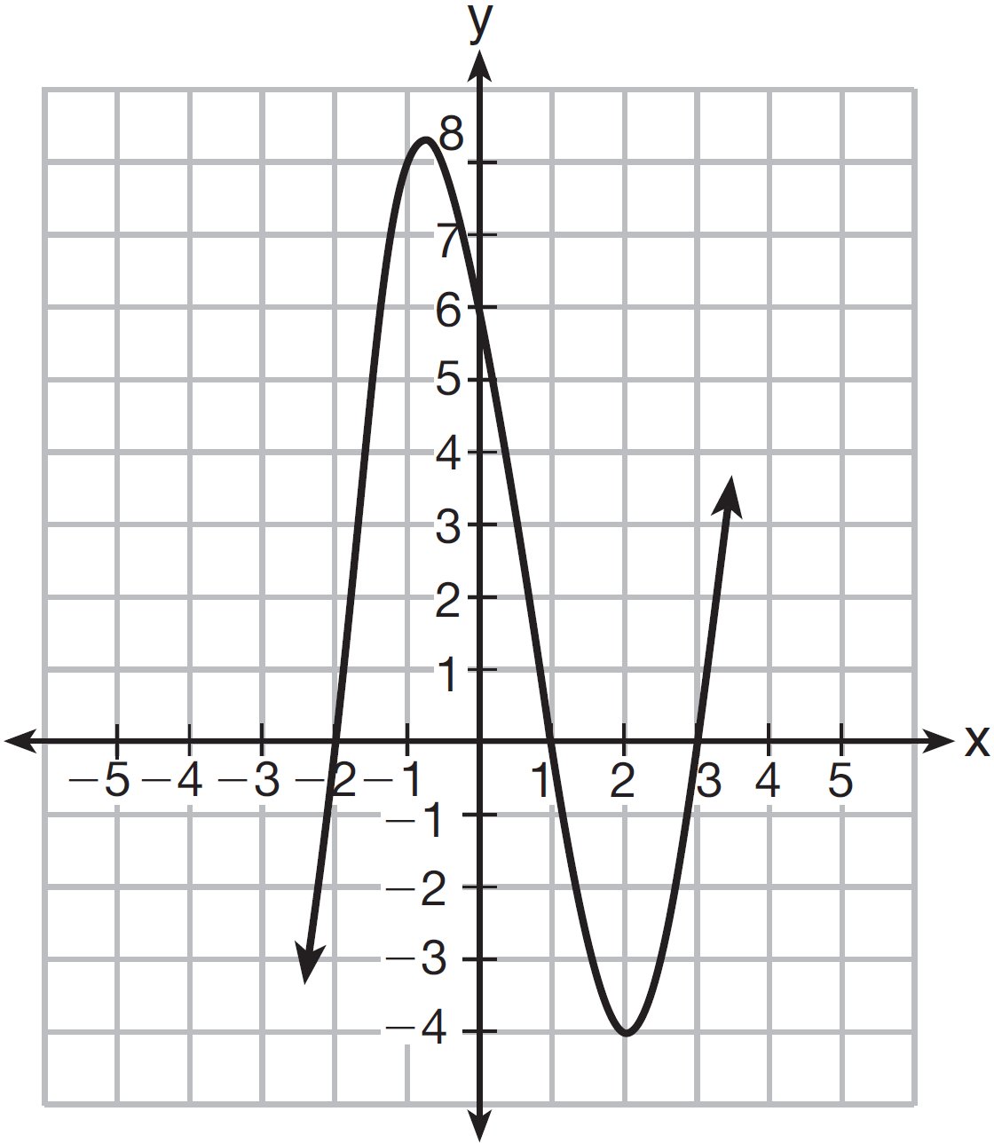

|  |  |  |  |
| --- | --- | --- | --- |
| 1) | I, only | 3) | I and II |
| 2) | II, only | 4) | II and III |

358) For which function defined by a polynomial are the zeros of the polynomial  and ?

|  |  |  |  |
| --- | --- | --- | --- |
| 1) |  | 3) |  |
| 2) |  | 4) |  |

359) The zeros of the function  are

|  |  |  |  |
| --- | --- | --- | --- |
| 1) | and 5 | 3) | and 2 |
| 2) | and 7 | 4) | and 3 |

360) The graph of  is shown below.

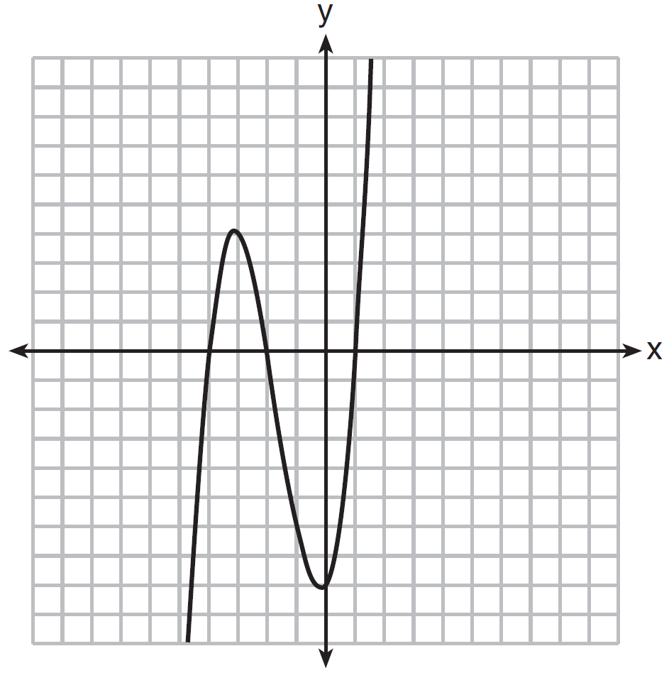

Which function could represent the graph of ?

|  |  |  |  |
| --- | --- | --- | --- |
| 1) |  | 3) |  |
| 2) |  | 4) |  |

361) A polynomial function contains the factors *x*, , and . Which graph(s) below could represent the graph of this function?

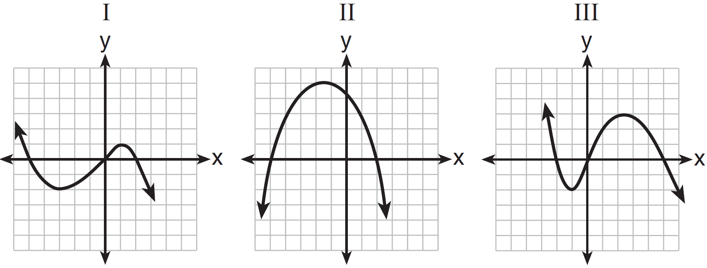

|  |  |  |  |
| --- | --- | --- | --- |
| 1) | I, only | 3) | I and III |
| 2) | II, only | 4) | I, II, and III |

362) What are the zeros of the function ?

|  |  |  |  |
| --- | --- | --- | --- |
| 1) | and 3 | 3) | and 2 |
| 2) | 10 and | 4) | 15 and |

363) The zeros of the function  are

|  |  |  |  |
| --- | --- | --- | --- |
| 1) | and 6 | 3) | 2 and |
| 2) | 1 and | 4) | and 3 |

364) Based on the graph below, which expression is a possible factorization of *p(x)*?

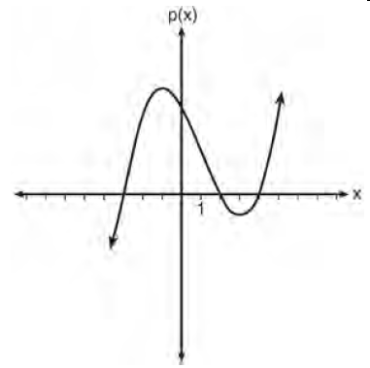

|  |  |  |  |
| --- | --- | --- | --- |
| 1) |  | 3) |  |
| 2) |  | 4) |  |

365) Which function has zeros of -4 and 2?

|  |  |  |  |
| --- | --- | --- | --- |
| 1) |  | 3) |  |
| 2) |  | 4) |  |

366) Which polynomial function has zeros at -3, 0, and 4?

|  |  |  |  |
| --- | --- | --- | --- |
| 1) |  | 3) |  |
| 2) |  | 4) |  |

367) The zeros of the function  are

|  |  |  |  |
| --- | --- | --- | --- |
| 1) |  | 3) |  |
| 2) |  | 4) |  |

368) Determine all the zeros of , algebraically.

369) Wenona sketched the polynomial  as shown on the axes below.

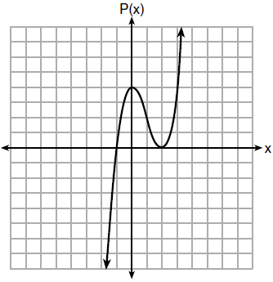

Which equation could represent ?

|  |  |  |  |
| --- | --- | --- | --- |
| 1) |  | 3) |  |
| 2) |  | 4) |  |

370) The zeros of the function  are

|  |  |  |  |
| --- | --- | --- | --- |
| 1) | and 3 | 3) | and 6 |
| 2) | and 4 | 4) | and 8 |

371) A cubic function is graphed on the set of axes below.

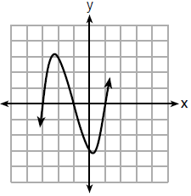

Which function could represent this graph?

|  |  |  |  |
| --- | --- | --- | --- |
| 1) |  | 3) |  |
| 2) |  | 4) |  |

**SOLUTIONS**

356) ANS: 3

Strategy: Look for the coordinates of the x-intercepts (where the graph crosses the x-axis). The zeros are the x-values of those coordinates.

Answer c is the correct choice. The coordinates of the x-intercepts of the graph are (2, 0) and (-3, 0). The zeros of the polynomial are 2 and -3.

PTS: 2 NAT: A.APR.B.3 TOP: Zeros of Polynomials

KEY: bimodalgraph

357) ANS: 2

Strategy: Factor the trinomials in each equation, then convert the factors into zeros and select the equations that have zeros at -2, 1, and 3.

STEP 1.

|  |  |  |
| --- | --- | --- |
| I | II | III |

The correct answer choice is *b*.

PTS: 2 NAT: A.APR.B.3 TOP: Zeros of Polynomials

358) ANS: 2

Strategy. Input each function in a graphing calculator and look at the table views to find the values of x when y equals zero.

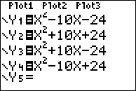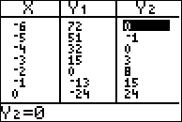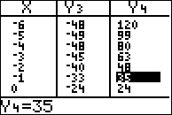

Answer choice b, enterred as , has zeros at  and .

PTS: 2 NAT: A.APR.B.3 TOP: Zeros of Polynomials

359) ANS: 4

Strategy: Use root operations to solve  for .

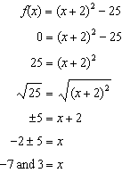

PTS: 2 NAT: F.IF.C.8 TOP: Zeros of Polynomials

360) ANS: 1

Strategy:

STEP 1. Identify the zeros and convert them into factors.

The graph has zeros at -4, -2, and 1. Convert these zeros of the function into the following factors: (x+4)(x+2)(x-1). The functiuon rule is f(x)= (x+4)(x+2)(x-1)

STEP 2. Eliminate wrong answers. Choices b and d can be eliminated because (x-2) is not a factor.

|  |  |
| --- | --- |
| b. | d. |

STEP 3. Choose between remaining choices by factoring the trinomials.

|  |  |
| --- | --- |
| a. | c. |

PTS: 2 NAT: A.APR.B.3 TOP: Zeros of Polynomials

361) ANS: 1

Stategy 1. Convert the factors to zeros, then find the graph(s) with the corresponding zeros.

STEP 1. Convert the factors to zeros.

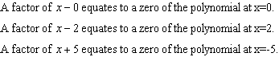

STEP 2. Find the zeros of the graphs.

Graph I has zeros at -5, 0, and 2.

Graph II has zeros at -5 and 2.

Graph III has zeros at -2, 0, and 5.

Answer choice *a* is correct.

Strategy 2: Input the factors into a graphing calculator and view the graph of the function .

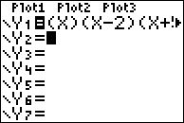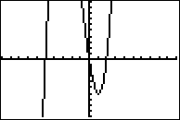

Note: This graph has the same zeros as graph I, but the end behaviors of the graph are reversed. This graph is a reflection in the x-axis of graph I and the reversal is caused by a change in the sign of the leading coefficient in the expansion of . It makes no difference in answering this problem. The zeros are the same and the correct answer choice is answer choice *a*.

PTS: 2 NAT: A.APR.B.3 TOP: Zeros of Polynomials

362) ANS: 4

Strategy: Find the factors of , then convert the factors to zeros.

STEP 1. Find the factors of .

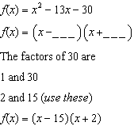

STEP 2. Convert the factors to zeros.



DIMS? Does It Make Sense? Yes. Check by inputting  into a graphing calculator and verify that there are zeros when 

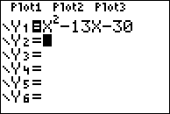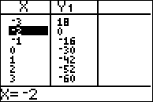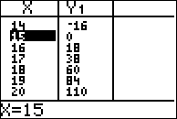

PTS: 2 NAT: A.SSE.B.3 TOP: Zeros of Polynomials

363) ANS: 1

Step 1. Understand that the zeros of a function are the x values when .

Step 2. Strategy: Solve for x when .

Step 3. Execute the strategy

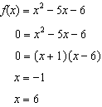

Step 4. Does it make sense? Yes. Check by inputting the function in a graphing calculator and inspecting the graph and table of values.

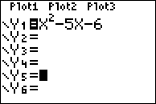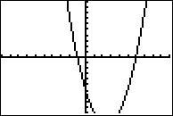

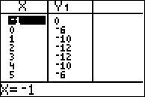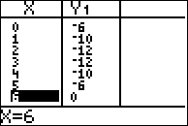

PTS: 2 NAT: A.APR.B.3 TOP: Zeros of Polynomials

364) ANS: 1

Strategy: Convert the zeros of the function to factors.

|  |  |
| --- | --- |
| Zeros occur at | Factors are: |
| (-3, 0) | (x+3) |
| (2, 0) | (x-2) |
| (4, 0) | (x-4) |

PTS: 2 NAT: A.APR.B.3

365) ANS: 4

The zeros of a function are the x values when y = 0.

Strategy: Eliminate wrong answers.

~~a)~~ Solve for 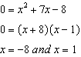 Eliminate this choice.

~~b)~~ Solve for 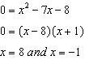 Eliminate this choice.

c) The graph shows x-axis intercepts at  and at , so the zeros are -2 and 4. Eliminate this choice.

d) The graph shows x-axis intercepts at  and at , so the zeros are -4 and 2. This is the correct choice.

PTS: 2 NAT: A.APR.B.3 TOP: Zeros of Polynomials

366) ANS: 3

The zeros of a function are the x-values when 

Strategy: Convert the zeros to factors, then combine the factors to write the function.

|  |  |
| --- | --- |
| Zeros | Factors |
|  |  |
|  |  |
|  |  |



Check by inputting the function in a graphing calculator and inspecting the zeros

PTS: 2 NAT: A.APR.B.3 TOP: Zeros of Polynomials

367) ANS: 3

Strategy #1. Find the factors and use the multiplication property of zero to find the zeros.

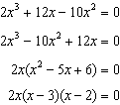

If the factors are 2x, x-3, and x-2, the zeros are 0, 2, and 3.

Strategy #2: Use a graphing calculator.

|  |  |  |
| --- | --- | --- |
|  |  |  |

PTS: 2 NAT: A.APR.B.3 TOP: Zeros of Polynomials

368) ANS:

Strategy 1: Use factoring.

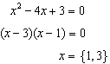

Strategy 2: Use the quadratic formula

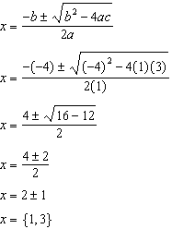

Strategy 3. Complete the square

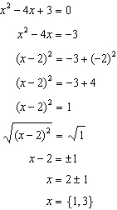

PTS: 2 NAT: A.APR.B.3 TOP: Zeros of Polynomials

369) ANS: 1

Note that the zeros (x-intercepts) occur at -1 and +2. This means that the factors of the equation are (x+1) and (x-2). Eliminate  and  because they have the wrong factors.

The choice is between  and .  is a third degree equation and  is a second degree (quadratic) equation.

The graph is definitely not a parabola, so it cannot be the graph of a quadratic function. Eliminate . The correct answer is .

Check in a graphing calculator.

|  |  |
| --- | --- |
|  |  |

PTS: 2 NAT: A.APR.B.3 TOP: Zeros of Polynomials

KEY: AI

370) ANS: 3

Strategy: Let  and solve the quadratic.

|  |  |  |  |
| --- | --- | --- | --- |
| Notes | Left Expression | Sign | Right Expression |
| Given |  | = |  |
| Let | 0 | = |  |
| Factor | 0 | = |  |

By the zero property of multiplication: If , then .

By the zero property of multiplication: If , then .

NOTE: The zero property of multiplication says that if the product of two numbers is zero, then one or both of those numbers must be zero.

PTS: 2 NAT: A.APR.B.3 TOP: Zeros of Polynomials

371) ANS: 2

Strategy: Find the zeros of the cubic function, then convert the zeros to factors.

STEP 1

|  |  |  |  |
| --- | --- | --- | --- |
|  | Zeros | Conversions to Factors | Factors |
|  |  |  |
|  |  |  |
|  |  |  |

STEP 2: Combine all factors into one expression.



The correct answer choice is 

PTS: 2 NAT: A.APR.B.3 TOP: Zeros of Polynomials