**I – Systems, Lesson 2, Modeling Linear Systems (r. 2018)**

SYSTEMS

Modeling Linear Systems

|  |  |
| --- | --- |
| **Common Core Standard**  **A-CED.3** Represent constraints by equations or inequalities, and by systems of equations and/or inequalities, and interpret solutions as viable or non-viable options in a modeling context. *For example, represent inequalities describing nutritional and cost constraints on combinations of different foods.* | **Next Generation Standard**  **AI-A.CED.3** Represent constraints by equations or inequalities, and by systems of equations and/or inequalities, and interpret solutions as viable or non-viable options in a modeling context.  e.g., Represent inequalities describing nutritional and cost constraints on combinations of different foods. |

NOTE: This lesson is related to Expressions and Equations, Lesson 4, Modeling Linear Equations.

**LEARNING OBJECTIVES**

Students will be able to:

1. Create function rules for systems of linear equations from real-world contexts.
2. Solve problems involving systems of equations based on real-world contexts.

**Overview of Lesson**

|  |  |
| --- | --- |
| **Teacher Centered Introduction**  **Overview of Lesson**  **- activate students’ prior knowledge**  **- vocabulary**  **- learning objective(s)**  **- big ideas: direct instruction**  **- modeling** | **Student Centered Activities**  **guided practice ⬅Teacher: anticipates, monitors, selects, sequences, and connects student work**  **- developing essential skills**  **- Regents exam questions**  **- formative assessment assignment (exit slip, explain the math, or journal entry)** |

**VOCABULARY**

system of equations

defining variables

key words

**BIG IDEAS**

**General Approach**

The general approach is as follows:

1. Read and understand the entire problem.
2. Underline key words, focusing on variables, operations, and equalities or inequalities.
3. Convert the key words to mathematical notation (consider meaningful variable names other than x and y).
4. Write two or more equations with the same variables.
5. Check the final system of linear equations for reasonableness.

|  |  |  |
| --- | --- | --- |
| ***Example*** | ***Equations*** | ***Check*** |
| *Jack bought 3 slices of cheese pizza and 4 slices of mushroom pizza for a total cost of $12.50.*  *Grace bought 3 slices of cheese pizza and 2 slices of mushroom pizza for a total cost of $8.50.*  *What is the cost of one slice of mushroom pizza?* | *Equation #1.*    *Equation #2.* |  |
| ***Variable****s:*  *Let C represent the cost of one slice of cheeses pizza.*  *Let M represent the cost of one slice of mushroom pizza.* | |
| ***Solution:*** | | |

**DEVELOPING ESSENTIAL SKILLS**

Write and solve a system of linear equations for each real-world context below:

|  |  |
| --- | --- |
| **Problem 1** | **Problem 2** |
| Tanisha and Rachel had lunch at the mall.  Tanisha ordered three slices of pizza and two colas. Tanisha’s bill was $6.00.  Rachel ordered two slices of pizza and three colas. Rachel’s bill was $5.25.  What was the price of one slice of pizza? What was the price of one cola? | When Tony received his weekly allowance, he decided to purchase candy bars for all his friends.  Tony bought three Milk Chocolate bars and four Creamy Nougat bars, which cost a total of $4.25 without tax.  Then he realized this candy would not be enough for all his friends, so he returned to the store and bought an additional six Milk Chocolate bars and four Creamy Nougat bars, which cost a total of $6.50 without tax.  How much did *each* type of candy bar cost? |
| **Problem 3** | **Problem 4** |
| Alexandra purchases two doughnuts and three cookies at a doughnut shop and is charged $3.30.  Briana purchases five doughnuts and two cookies at the same shop for $4.95.  All the doughnuts have the same price and all the cookies have the same price. Find the cost of one doughnut and find the cost of one cookie. | Ramón rented a sprayer and a generator.  On his first job, he used each piece of equipment for 6 hours at a total cost of $90.  On his second job, he used the sprayer for 4 hours and the generator for 8 hours at a total cost of $100.  What was the hourly cost of *each* piece of equipment? |
| **Problem 5** | |
| The cost of 3 markers and 2 pencils is $1.80.  The cost of 4 markers and 6 pencils is $2.90.  What is the cost of each item? Include appropriate units in your answer. | |

**Answers**

|  |  |  |
| --- | --- | --- |
| **Problem 1** 080233a | **Equations** | **Check** |
| Tanisha and Rachel had lunch at the mall.  Tanisha ordered three slices of pizza and two colas. Tanisha’s bill was $6.00.  Rachel ordered two slices of pizza and three colas. Rachel’s bill was $5.25.  What was the price of one slice of pizza? What was the price of one cola? | Equation #1.    Equation #2. | Equation #1.    Equation #2. |
| **Variable**s:  Let P represent the cost of a slice of pizza.  Let C represent the cost of a cola. | |
| **Solution** | | |

|  |  |  |
| --- | --- | --- |
| **Problem 2** 010232a | **Equations** | **Check** |
| When Tony received his weekly allowance, he decided to purchase candy bars for all his friends.  Tony bought three Milk Chocolate bars and four Creamy Nougat bars, which cost a total of $4.25 without tax.  Then he realized this candy would not be enough for all his friends, so he returned to the store and bought an additional six Milk Chocolate bars and four Creamy Nougat bars, which cost a total of $6.50 without tax.  How much did *each* type of candy bar cost? | Equation #1.    Equation #2. | Equation #1.    Equation #2. |
| **Variable**s:  Let C represent the cost of a Creamy Nougat bar.  Let M represent the cost of a Milk Chocolate bar. | |
| **Solution** | | |

|  |  |  |
| --- | --- | --- |
| **Problem 3** 010332a | **Equations** | **Check** |
| Alexandra purchases two doughnuts and three cookies at a doughnut shop and is charged $3.30.  Briana purchases five doughnuts and two cookies at the same shop for $4.95.  All the doughnuts have the same price and all the cookies have the same price. Find the cost of one doughnut and find the cost of one cookie. | Equation #1.    Equation #2. | Equation #1.    Equation #2. |
| **Variable**s:  Let D represent the cost of a donut.  Let C represent the cost of a cookie. | |
| **Solution** | | |

|  |  |  |
| --- | --- | --- |
| **Problem 4** 060133a | **Equations** | **Check** |
| Ramón rented a sprayer and a generator.  On his first job, he used each piece of equipment for 6 hours at a total cost of $90.  On his second job, he used the sprayer for 4 hours and the generator for 8 hours at a total cost of $100.  What was the hourly cost of *each* piece of equipment? | Equation #1.    Equation #2. | Equation #1.    Equation #2. |
| **Variable**s:  Let S represent the hourly cost of a sprayer.  Let G represent the hourly cost of a generator. | |
| **Solution** | | |

|  |  |  |
| --- | --- | --- |
| **Problem 5** 080837ia | **Equations** | **Check** |
| The cost of 3 markers and 2  pencils is $1.80.  The cost of 4 markers and 6 pencils is $2.90.  What is the cost of each item? Include appropriate units in your answer. | Equation #1.    Equation #2. | Equation #1.    Equation #2. |
| **Variable**s:  Let M represent the cost of a marker.  Let P represent the cost of a pencil | |
| **Solution** | | |

**REGENTS EXAM QUESTIONS**

A.CED.A.2: Modeling Linear Systems

249) An animal shelter spends $2.35 per day to care for each cat and $5.50 per day to care for each dog. Pat noticed that the shelter spent $89.50 caring for cats and dogs on Wednesday. Write an equation to represent the possible numbers of cats and dogs that could have been at the shelter on Wednesday. Pat said that there might have been 8 cats and 14 dogs at the shelter on Wednesday. Are Pat’s numbers possible? Use your equation to justify your answer. Later, Pat found a record showing that there were a total of 22 cats and dogs at the shelter on Wednesday. How many cats were at the shelter on Wednesday?

250) During the 2010 season, football player McGee’s earnings, *m*, were 0.005 million dollars more than those of his teammate Fitzpatrick’s earnings, *f*. The two players earned a total of 3.95 million dollars. Which system of equations could be used to determine the amount each player earned, in millions of dollars?

|  |  |  |  |
| --- | --- | --- | --- |
| 1) |  | 3) |  |
| 2) |  | 4) |  |

251) Jacob and Zachary go to the movie theater and purchase refreshments for their friends. Jacob spends a total of $18.25 on two bags of popcorn and three drinks. Zachary spends a total of $27.50 for four bags of popcorn and two drinks. Write a system of equations that can be used to find the price of one bag of popcorn and the price of one drink. Using these equations, determine and state the price of a bag of popcorn and the price of a drink, to the *nearest cent.*

252) Mo's farm stand sold a total of 165 pounds of apples and peaches. She sold apples for $1.75 per pound and peaches for $2.50 per pound. If she made $337.50, how many pounds of peaches did she sell?

|  |  |  |  |
| --- | --- | --- | --- |
| 1) | 11 | 3) | 65 |
| 2) | 18 | 4) | 100 |

253) At Bea's Pet Shop, the number of dogs, *d*, is initially five less than twice the number of cats, *c*. If she decides to add three more of each, the ratio of cats to dogs will be · Write an equation or system of equations that can be used to find the number of cats and dogs Bea has in her pet shop. Could Bea's Pet Shop initially have 15 cats and 20 dogs? Explain your reasoning. Determine algebraically the number of cats and the number of dogs Bea initially had in her pet shop.

254) Last week, a candle store received $355.60 for selling 20 candles. Small candles sell for $10.98 and large candles sell for $27.98. How many large candles did the store sell?

|  |  |  |  |
| --- | --- | --- | --- |
| 1) | 6 | 3) | 10 |
| 2) | 8 | 4) | 12 |

255) The Celluloid Cinema sold 150 tickets to a movie. Some of these were child tickets and the rest were adult tickets. A child ticket cost $7.75 and an adult ticket cost $10.25. If the cinema sold $1470 worth of tickets, which system of equations could be used to determine how many adult tickets, *a*, and how many child tickets, *c*, were sold?

|  |  |  |  |
| --- | --- | --- | --- |
| 1) |  | 3) |  |
| 2) |  | 4) |  |

256) For a class picnic, two teachers went to the same store to purchase drinks. One teacher purchased 18 juices boxes and 32 bottles of water, and spent $19.92. The other teacher purchased 14 juice boxes and 26 bottles of water, and spent $15.76.

Write a system of equations to represent the costs of a juice box, *j*, and a bottle of water, *w*.

Kara said that the juice boxes might have cost 52 cents each and that the bottles of water might have cost 33 cents each. Use your system of equations to justify that Kara’s prices are *not* possible.

Solve your system of equations to determine the actual cost, in dollars, of each juice box and each bottle of water.

257) Alicia purchased *H* half-gallons of ice cream for $3.50 each and *P* packages of ice cream cones for $2.50 each. She purchased 14 items and spent $43. Which system of equations could be used to determine how many of each item Alicia purchased?

|  |  |  |  |
| --- | --- | --- | --- |
| 1) |  | 3) |  |
| 2) |  | 4) |  |

258) Two friends went to a restaurant and ordered one plain pizza and two sodas. Their bill totaled $15.95. Later that day, five friends went to the same restaurant. They ordered three plain pizzas and each person had one soda. Their bill totaled $45.90. Write and solve a system of equations to determine the price of one plain pizza. [Only an algebraic solution can receive full credit.]

259) Ian is borrowing $1000 from his parents to buy a notebook computer. He plans to pay them back at the rate of $60 per month. Ken is borrowing $600 from his parents to purchase a snowboard. He plans to pay his parents back at the rate of $20 per month. Write an equation that can be used to determine after how many months the boys will owe the same amount. Determine algebraically and state in how many months the two boys will owe the same amount. State the amount they will owe at this time. Ian claims that he will have his loan paid off 6 months after he and Ken owe the same amount. Determine and state if Ian is correct. Explain your reasoning.

260) The graph below models the cost of renting video games with a membership in Plan *A* and Plan *B*.

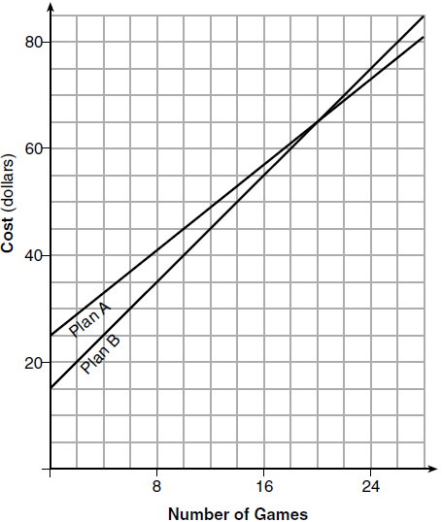

Explain why Plan *B* is the better choice for Dylan if he only has $50 to spend on video games, including a membership fee. Bobby wants to spend $65 on video games, including a membership fee. Which plan should he choose? Explain your answer.

261) Dylan has a bank that sorts coins as they are dropped into it. A panel on the front displays the total number of coins inside as well as the total value of these coins. The panel shows 90 coins with a value of $17.55 inside of the bank. If Dylan only collects dimes and quarters, write a system of equations in two variables or an equation in one variable that could be used to model this situation. Using your equation or system of equations, algebraically determine the number of quarters Dylan has in his bank. Dylan's mom told him that she would replace each one of his dimes with a quarter. If he uses all of his coins, determine if Dylan would then have enough money to buy a game priced at $20.98 if he must also pay an 8% sales tax. Justify your answer.

262) There are two parking garages in Beacon Falls. Garage *A* charges $7.00 to park for the first 2 hours, and each additional hour costs $3.00. Garage *B* charges $3.25 per hour to park. When a person parks for at least 2 hours, write equations to model the cost of parking for a total of *x* hours in Garage *A* and Garage *B*. Determine algebraically the number of hours when the cost of parking at both garages will be the same.

**SOLUTIONS**

249) ANS:

a) 

b) Pat’s numbers are not possible, because the equation does not balance using Pat’s numbers.

c) There were 10 cats in the shelter on Wednesday

Strategy: Use information from the first two sentences to write the equation, then use the equation to see if Pat is correct, then modify the equation for the last part of the question.

STEP 1: Write the equation

Let *c* represent the number of cats in the shelter.

Let *d* represent the number of dogs in the shelter.



STEP 2: Use the equation to see if Pat is correct.

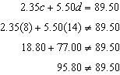

STEP 3: Modify the equation to reflect the total number of animals in the shelter.

Let *c* represent the number of cats in the shelter.

Let *(22-c)* represent the number of dogs in the shelter.

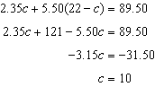

DIMS? Does It Make Sense? Yes. If there were 10 cats in the shelter and 12 dogs, the total costs of caring for the animals would be $89.50.

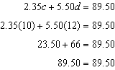

PTS: 4 NAT: A.CED.A.2 TOP: Modeling Linear Equations

250) ANS: 4

Strategy: Eliminate wrong answers and choose between the remaining choices..

The problem states that McGee (*m*) and Fitzpatrick’s (*f*) combined earning were 3.95 million dollars. This can be represented mathematically as . Eliminate answer choices b and c because they state that , which is the difference of their salaries, not the sum.

Choose between answer choices *a* and *d*. Choice a says that Fitzpatrick (*f*) makes more. Choice *d* says that McGee (*m*) makes more. The problem states that McGee (*m*) makes more, so choice *d* is the correct answer.

DIMS? Does It Make Sense? Yes. Solve the system in answer choice D using the substitution method, as follows:

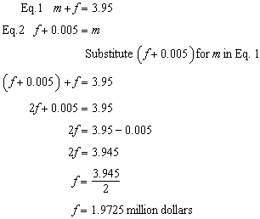

Fitzpatrick earns $1,972,500 and McGee earns , which is  more than Fitzpatrick. $5,000 is 0.005 million dollars, so everything agrees with the information contained in the problem.

PTS: 2 NAT: A.CED.A.3 TOP: Modeling Linear Systems

251) ANS:

a) 

b) Drinks cost $2.25 and popcorn costs $5.75

Strategy: Write one equation for Jacob and one equation for Zachary, then solve them as a system of equations.

STEP 1: Write 2 equations.

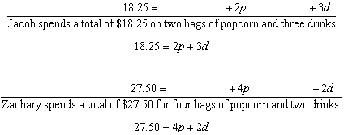

STEP 2. Solve both equations as a system of equations.

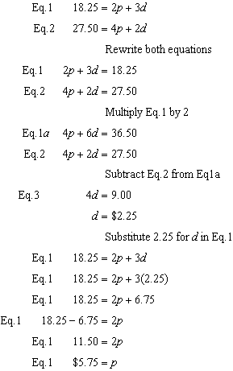

Drinks cost $2.25 and popcorn costs $5.75

DIMS? Does It Make Sense? Yes. Both equations balance if drinks cost $2.25 and popcorn costs $5.75, as shown below:

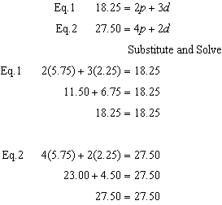

PTS: 2 NAT: A.CED.A.3 TOP: Modeling Linear Systems

252) ANS: 3

Strategy: Write and solve a system of equations to represent the problem.

Let *a* represent the number pounds of apples sold.

Let *p* represent the number of pounds of peaches sold.

STEP 1. Write a system of equations.

Eq. 1 

Eq. 2 

STEP 2. Solve the system.

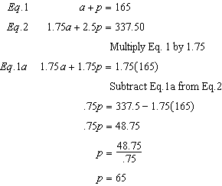

DIMS? Does It Make Sense? Yes. If , then , and these values make both equations balance.

|  |  |
| --- | --- |
| Eq. 1 | Eq. 2 |

PTS: 2 NAT: A.REI.C.6 TOP: Solving Linear Systems

253) ANS:

PART 1: Write an equation or system of equations.

STEP 1. Write an equation from the first sentence to describe the *initial relationship* between the number of dogs and cats.

Let c represent the initial number of cats.

Let d represent the initial number of dogs.



STEP 2. Express the current ratio of cats and dogs in the fraction form of 

STEP 3. Modify the current ratio of cats and dogs to show the addition of three cats and three dogs.



STEP 4. Write a proportion that equates the modified ratio with the fraction .



STEP 5. Write a system of equations using the equation from STEP 1 and the proportion from STEP 4.

|  |
| --- |
|  |

PART 2. Answer the question, “Could Bea’s Pet Shop initially have 15 cats and 20 dogs?” and explain your reasoning.

|  |
| --- |
| No. The initial relationship between the number of cats and dogs can be expressed mathematically as . This equation does not balance when  and . |

Part 3. Solve the system of equations to determine the initial number of dogs and cats.

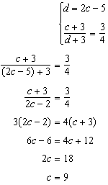 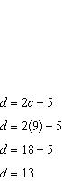

|  |
| --- |
| The initial number of cats is 9 and the initial number of dogs is 13. |

PTS: 6 NAT: A.CED.A.3 TOP: Modeling Linear Systems

254) ANS: 2

Strategy: Write and solve a system of equations to represent the problem.

Let *L* represent the number of large candles sold.

Let *S* represent the number of small candles sold.

STEP 1. Write a system of equations.

Eq. 1 

Eq. 2 

STEP 2. Solve the system.

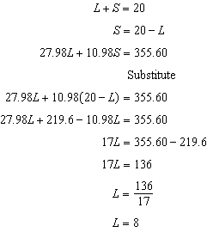

DIMS? Does It Make Sense? Yes. If , then , and these values make both equations balance.

|  |  |
| --- | --- |
| Eq. 1 | Eq. 2 |

PTS: 2 NAT: A.REI.C.6 TOP: Modeling Linear Systems

255) ANS: 1

Step 1. Recognize this problem as having two variables, a and c.

Step 2. Strategy: Write a system of equations to model the problem.

Step 3. Use information from the first two sentences to write the first equation.

The Celluloid Cinema sold 150 tickets to a movie.

Some of these were child tickets and the rest were adult tickets.



Eliminate answer choices b) and d).

Use information from the next two sentences to write the second equation.

A child ticket cost $7.75 and an adult ticket cost $10.25.

If the cinema sold $1470 worth of tickets, ....



Eliminate choice c). The answer is choice a).

Step 4. Does it make sense? Yes. Answer choice a) shows that the number of adult tickets added to the number of children tickets equals 150, and the income from the adult tickets added to the income from the children tickets equals 1470.

PTS: 2 NAT: A.REI.C. TOP: Modeling Linear Systems

256) ANS:

PART 1: Write a system of equations.

Eq. 1. 

Eq. 2. 

PART 2. Use the system to justify that Kara’s prices are not possible.

Eq. 1. 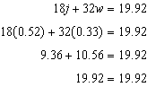 Kara’s prices work in equation 1.

Eq. 2. 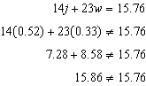 Kara’s prices do not work with equation 2.

Kara’s prices do not work with both equations, so they do not solve the system of equations.

PART 3 Solve the system of equation to find the price of each juice box and each bottle of water.

Eq. 1. 

Eq. 2. 

Eq. 2a 

Substitute using Eq. 1 and Eq. 2a

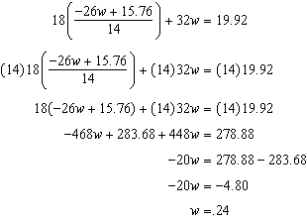 A bottle of water costs 24 cents.

Solve for juice.

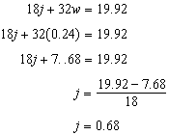 A box of juice costs 68 cents.

PTS: 6 NAT: A.CED.A.2

257) ANS: 1

STEP 1: Define the variables.

Let *H* represent the number of half-gallons of ice cream.

Let *P* represent the number of packages of ice cream cones.

STEP 2: Write two equations:

Eq. #1 

This equation says that $3.50 times the number of half-gallons of ice cream plus $2.50 times the number of packages of ice cream cones is $43.00

Eq.#2 

This equation says the the number of half-gallons of ice cream and the number of packages of ice cream cones is 14.

PTS: 2 NAT: A.CED.A.3 TOP: Modeling Linear Systems

258) ANS:

One plain pizza costs $12.05

Step 1. Define Variables

Let P represent the cost of one plain pizza

Let S represent the cost of one soda.

Step 2. Write 2 equations.

Eq. #1  (from first and second sentences)

Eq. #2  (from third, fourth and fifth sentences)

Step 3. Multiply Eq. #1 times 3

Eq. #1a 

Step 4. Subtract Eq.#2 from Eq.#1a

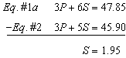

Step 5. Solve for P by substituting 1.95 for S in Eq.#1.

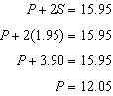

Step 6. Check to see that  and  satisfy both equations.

Eq. #1 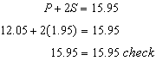

Eq. #2 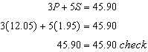

PTS: 4 NAT: A.CED.A.3 TOP: Modeling Linear Systems

259) ANS:

Strategy - Part 1:



Let m represent the number of months.

Ian’s debt is modeled by 

Ken’s debt is modeled by 

Ian and Ken will owe the same amount when , so set both expressions equal, as follows:



Strategy - Part 2

Ian and Ken will owe the same amount after 10 months. Both will owe $400.

|  |  |  |  |
| --- | --- | --- | --- |
| Given |  | = |  |
| Add (60m) |  |  | +60*m* |
| Simplify | 1000 | = |  |
| Subtract (600) | -600 |  | -600 |
| Simplify | 400 | = | 40*m* |
| Divide (40) |  | = |  |
| Answer | 10 | = | *m* |

Solve for amount owed after 10 months.





Strategy - Part 3

Ian is wrong. He will still owe his parents $40 after 16 months.



PTS: 6 NAT: A.CED.A.3 TOP: Modeling Linear Systems

260) ANS:

When the cost is $50, the graph shows that Plan A purchases a smaller number of games than Plan B.

When $65 is spent, both plans purchase the same amount of games, so it doesn’t matter.

PTS: 2 NAT: A.CED.A.3 TOP: Modeling Linear Systems

261) ANS:

Equation 1. 

Equation 2. 

Dylan has 57 quarters

With all 90 coins being quarters, Dylan would not have enough money to buy the game and pay the sales tax.

Strategy: Let d represent the number of dimes and let q represent the number of quarters. Write two equations: 1) one to represent the total amount of money; and 2) another to represent the total number of coins. Convert all money to cents to avoid working with decimals.

STEP 1. Write two equations.

Equation 1. 

Equation 2. 

STEP 2. Multiply equation 2 by 10, so that the second equation has 10d as a term.

Equation 2b. 

STEP 3. Subtract equation 2b from equation 1 and solve for *q*, as follows:

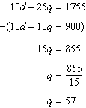

The number of quarters Dylan has is 57.

STEP 4. Find out how much money Dylan will have if his mother replaces all the dimes with quarters.

Dylan will still have 90 coins, but they will all be quarters.

 cents, or $22.50.

STEP 5. Determine how much a $20.95 game costs with 8% sales tax.



STEP 6. Compare the amount Dylan has from STEP 5 to the amount Dylan needs from STEP 6.

$22.50 < $22.65

Dylan does not have enough money.

PTS: 6 NAT: A.CED.A.3 TOP: Modeling Linear Systems

262) ANS:

Strategy: Write and solve a system of linear equations.

STEP 1.

Let represent the cost of parking in Garage *A*.

Let represent the cost of parking in Garage *B*.

Let *x* represent the number of parking hours.

STEP 2.

Write two equations.

**

STEP 3

Let  to determine the number of hours when the cost of parking will be the same.

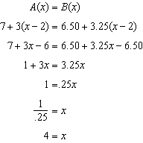

The cost of parking in both garages will be the same for 4 hours.

CHECK

|  |  |  |
| --- | --- | --- |
| Hours |  |  |
| 2 | $7.00 | $6.50 |
| 3 | $10.00 | $9.75 |
| 4 | $13.00 | $13.00 |

PTS: 4 NAT: A.CED.A.3 TOP: Modeling Linear Systems