**I – Systems, Lesson 1, Solving Linear Systems (r. 2018)**

SYSTEMS

Solving Linear Systems

|  |  |
| --- | --- |
| **Common Core Standards**  **A-REI.C.5** Prove that, given a system of two equations in two variables, replacing one equation by the sum of that equation and a multiple of the other produces a system with the same solutions.  **A-REI.C.6** Solve systems of linear equations exactly and approximately (e.g., with graphs), focusing on pairs of linear equations in two variables.  PARCC: Tasks have a real-world context. Tasks have hallmarks of modeling as a mathematical practice (less defined tasks, more of the modeling cycle, etc.). | **Next Generation Standard**  **STANDARD REMOVED**  **AI-A.REI.6a** Solve systems of linear equations in two variables **both algebraically and graphically.**  **Note: Algebraic methods include both elimination and substitution**. |

**LEARNING OBJECTIVES**

Students will be able to:

1. Solve systems of linear equation by graphing.
2. Solve systems of linear equations using the substitution method.
3. Solve systems of linear equations using the elimination method.

**Overview of Lesson**

|  |  |
| --- | --- |
| **Teacher Centered Introduction**  **Overview of Lesson**  **- activate students’ prior knowledge**  **- vocabulary**  **- learning objective(s)**  **- big ideas: direct instruction**  **- modeling** | **Student Centered Activities**  **guided practice ⬅Teacher: anticipates, monitors, selects, sequences, and connects student work**  **- developing essential skills**  **- Regents exam questions**  **- formative assessment assignment (exit slip, explain the math, or journal entry)** |

**VOCABULARY**

context view

distinct

elimination method

equation rule view

graph view

non-distinct

point of intersection

solution to a system of equations

substitution method

system of equations

table view

**BIG IDEAS**

**Facts About Systems of Linear Equations**

1. A **system of linear equations** is a collection of two or more linear equations that have the same set of variables.
2. A **solution of a system of linear equations** is the set of values that simultaneously satisfy each and every linear equation in the system. Systems of linear equations can be grouped into three categories according to the number of solutions they have.
3. **Infinitely Many Solutions**: A system of linear equations has infinitely many solutions when the equations represent the same line on a graph.
4. **No Solutions**: A system of linear equations has no solutions when the equations represent parallel lines on a graph.
5. **One Solution**: A system of linear equations has one and only solution when the equations represent distinct, non-parallel lines on a graph.
6. For a system of linear equations to have one solution, the number of distinct linear equations in the system must correspond to the number of variables in the system. For example, two variables require two distinct linear equations, three variables require three distinct linear equations, etc.

**Distinct vs Non-Distinct Equations**

Two equations are distinct if they describe different mathematical relationships between the variables. For example  and  describe different mathematical relationships between the variables *x* and *y*.

Two equations are non-distinct if they describe the same mathematical relationships between the variables. For example  and  and  all describe the same mathematical relationships between the variables *x* and *y*, which is the idea that the value of *y* is two times the value of *x*. When linear equations are non-distinct, their graphs and tables of values will be identical.

**Views of Linear Equations vs Views of Systems of Linear Equations**

Linear equations can be expressed in four different ways, called views. These views are:

1. an equation (or function rule) view;
2. a table view;
3. a graph view; and
4. a context view.

Systems of linear equations can be expressed using the same four views. With systems of linear equations, however, each of the four views shows two or more equations simultaneously, and it becomes important to know which values are associated with each equation. Color is used in the following examples to help distinguish between equations.

|  |  |  |  |
| --- | --- | --- | --- |
|  | Single Linear Equation | Single Linear Equation | System of Linear Equations |
| Context View | Two numbers are in the ratio 2:5. | If 6 is subtracted from the sum of two numbers, the result is 50. | Two numbers are in the ratio 2:5. If 6 is subtracted from their sum, the result is 50. What is the larger number? |
| Equation View |  |  |  |
| Equation View (Calculator Input) |  |  |  |
| Table View  *Note that the table view for the system of linear equations has only one column for the x values.* |  |  |  |
| Graph View |  |  |  |

**Solutions to systems of equations**

The solution to a system of linear equation is ordered pair of values that satisfies each equation in the system simultaneously (at the same time).

* In the **function rule view**, the solution is the ordered pair of values that makes each equation balance.

EXAMPLE: The system  has a common solution of.

When the values and  are inputs, both equations balance, as shown below:

  

* In the **table view**, the solution is the ordered pair of values that are the same for both equations.

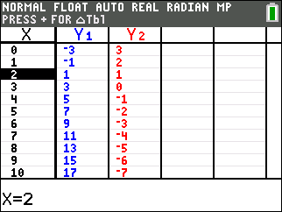

* In the **graph view**, the solutions are the coordinates of the point of intersection.

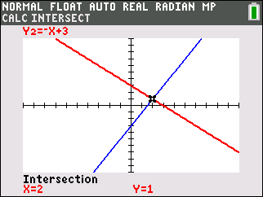

**Solution Strategies**

**Elimination Method – an Algebraic Strategy**

Overview of Strategy: Eliminate one variable by addition or subtraction, then solve for the remaining variable, then the second variable.

|  |  |
| --- | --- |
| STEPS | EXAMPLE |
| STEP 1  Read and understand the problem. | Solve the following system of equations by elimination. |
| STEP 2  Line up the like terms in columns |  |
| STEP 3  Multiply each equation by the leading coefficient of the other equation, which will result in both equations having the same leading coefficient. |  |
| STEP 4  Add or subtract the like terms in the two equations to form a third equation, in which the leading coefficient is zero. |  |
| STEP 5  Solve the new equation for the first variable. |  |
| STEP 6  Input the value found in STEP 5 into either of the original equations and solve for the second variable. |  |
| STEP 7  Check your solutions in both equations. |  |

**Substitution Method – an Algebraic Strategy**

Overview of Strategy: Isolate one variable in either equation, then substitute its equivalent expression into the other equation. This results in a new equation with only one variable. Solve for the first variable, then use the value of the first variable in either equation to solve for the second variable.

|  |  |
| --- | --- |
| STEPS | EXAMPLE |
| STEP 1  Read and understand the problem. | Solve the following system of equations by substitution. |
| STEP 2  Isolate one variable from one equation. |  |
| STEP 3  Substitute the isolated value into the other equation. |  |
| STEP 4  Solve the new equation with one variable. |  |
| STEP 5  Input the value found in STEP 4 into either of the original equations and solve for the second variable. |  |
| STEP 6  Check your solutions in both equations. |  |

**DEVELOPING ESSENTIAL SKILLS**

Solve each of the following systems by two algebraic methods: 1) by elimination; and 2) by substitution.

1. 

1. 
2. 
3. 
4. 

**Answers**

1. 

Elimination











Substitution



1. 

Elimination











Substitution



1. 

Elimination











Substitution



1. 

Elimination











Substitution





1. 

Elimination











Substitution



**REGENTS EXAM QUESTIONS (through June 2018)**

A.REI.C.5, A.REI.C.6: Solving Linear Systems

239) Albert says that the two systems of equations shown below have the same solutions.

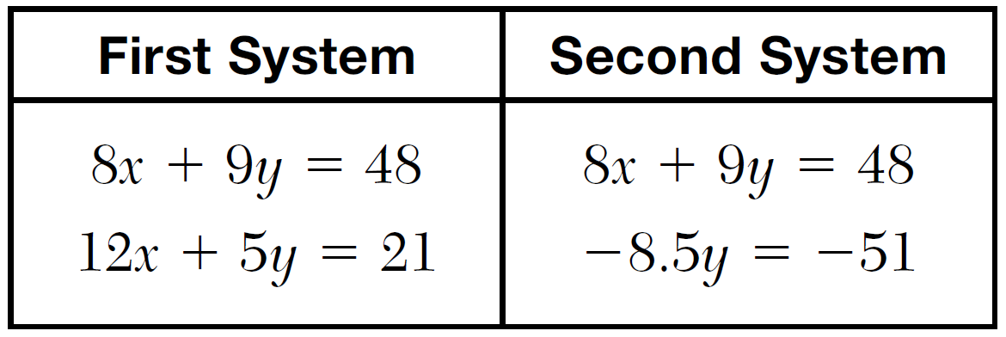

Determine and state whether you agree with Albert. Justify your answer.

240) Which system of equations has the same solution as the system below?



|  |  |  |  |
| --- | --- | --- | --- |
| 1) |  | 3) |  |
| 2) |  | 4) |  |

241) Which pair of equations could *not* be used to solve the following equations for *x* and *y*?



|  |  |  |  |
| --- | --- | --- | --- |
| 1) |  | 3) |  |
| 2) |  | 4) |  |

242) A system of equations is given below.



Which system of equations does *not* have the same solution?

|  |  |  |  |
| --- | --- | --- | --- |
| 1) |  | 3) |  |
| 2) |  | 4) |  |

243) A system of equations is shown below.

Equation *A*: 

Equation *B*: 

Which method eliminates one of the variables?

|  |  |  |  |
| --- | --- | --- | --- |
| 1) | Multiply equation *A* by  and add the result to equation *B*. | 3) | Multiply equation *A* by 2 and equation *B* by  and add the results together. |
| 2) | Multiply equation *B* by 3 and add the result to equation *A*. | 4) | Multiply equation *B* by 5 and equation *A* by 4 and add the results together. |

244) Which system of equations does *not* have the same solution as the system below?



|  |  |  |  |
| --- | --- | --- | --- |
| 1) |  | 3) |  |
| 2) |  | 4) |  |

245) Guy and Jim work at a furniture store. Guy is paid $185 per week plus 3% of his total sales in dollars, *x*, which can be represented by . Jim is paid $275 per week plus 2.5% of his total sales in dollars, *x*, which can be represented by . Determine the value of *x*, in dollars, that will make their weekly pay the same.

246) In attempting to solve the system of equations  and , John graphed the two equations on his graphing calculator. Because he saw only one line, John wrote that the answer to the system is the empty set. Is he correct? Explain your answer.

247) What is the solution to the system of equations below?



|  |  |  |  |
| --- | --- | --- | --- |
| 1) | no solution | 3) |  |
| 2) | infinite solutions | 4) |  |

248) The line represented by the equation  shares a solution point with the line represented by the table below.

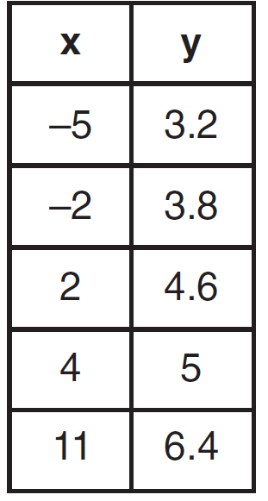

The solution for this system is

|  |  |  |  |
| --- | --- | --- | --- |
| 1) |  | 3) |  |
| 2) |  | 4) |  |

**SOLUTIONS**

239) ANS:

Albert is correct. Both systems have the same solution .

Strategy: Solve one system of equations, then test the solution in the second system of equations.

STEP 1. Solve the first system of equations.

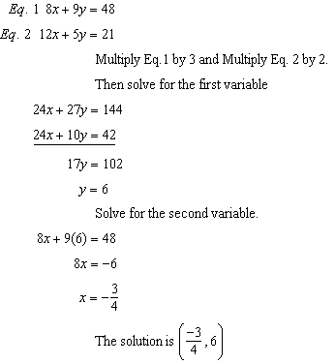

STEP 2: Test the second system of equations using the same solution set.

|  |  |
| --- | --- |
|  |  |

DIMS? Does It Make Sense? Yes. The solution  makes both equations balance.

PTS: 4 NAT: A.REI.C.5 TOP: Solving Linear Systems

240) ANS: 2

Strategy: Find equivalent forms of the system and eliminate wrong answers.

STEP 1. Eliminate answer choices *c* and *d* because the first equation in each system is not a multiple of any equation in the original system.

STEP 2. Eliminate answer choice *a* because  is not a multiple of .

Choose answer choice *b* as the only remaining choice.

DIMS? Does It Make Sense? Yes. Check using the matrix feature of a graphing calculator.

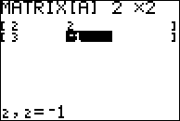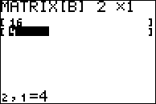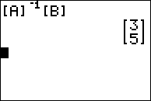

The solution set  also works for the system in answer choice *b*.

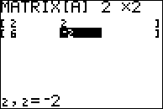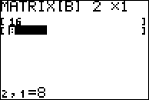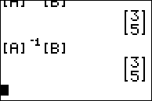

PTS: 2 NAT: A.REI.C.5 TOP: Solving Linear Systems

241) ANS: 4

Strategy: Eliminate wrong answers by deciding which systems of equations are made of multiples of the original system of equations and which system is made of equations that are not multiples of the orginal system of equations.

Choice (a) is a multiple of the original system of equations.



Choice (b) is a multiple of the original system of equations.



Choice (c) is a multiple of the original system of equations.



Choice (d) is ***not*** a multiple of the original system of equations.



PTS: 2 NAT: A.REI.C.5 TOP: Solving Linear Systems

242) ANS: 4

Strategy: Determine which equations in the answer choices describe the same relationshops between variables as the equations in the problem. If one equation is a multiple of another equation, both equation describe the same relationship between variables and both equations will have the same solutions.

Eliminate  because 

Eliminate  because 

Eliminate  because 

Choose  because 

PTS: 2 NAT: A.REI.C.5 TOP: Other Systems

243) ANS: 2

STEP 1: Multiply equation B by 3

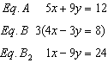

STEP 2: Add Eq.A and Eq.B2

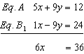

Note that the *y* variable is eliminated.

PTS: 2 NAT: A.REI.C.5 TOP: Solving Linear Systems

244) ANS: 4

Strategy: Determine which systems are multiples of the original system.

|  |  |  |
| --- | --- | --- |
|  |  |  |
|  |  |  |
|  |  |  |
|  |  |  |
|  |  | NOTE: The second equation is not a multiple of |



PTS: 2 NAT: A.REI.C.5 TOP: Solving Linear Systems

245) ANS:

$18,000

Strategy: Set both function equal to one another and solve for *x*.

STEP 1. Set both functions equal to one another.

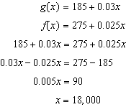

PTS: 2 NAT: A.REI.C.6 TOP: Solving Linear Systems

246) ANS:

No. There are infinite solutions.

The equations  and  describe identical relationships between the variables x and y. When  is transformed to sloped intercept format (), the result is . Therefore, this systems consists of two identical relationships between variables, and every solution to  solves both equations. Thus, there are infinite solutions.

|  |  |  |  |
| --- | --- | --- | --- |
| Given (Eq. #2) |  | = | 4 |
| Divide (2) |  | = |  |
| Simplify |  | = | 2 |
| Subtract (3x) | -3x | = | -3x |
| Simplify | -y | = | -3x+2 |
| Multiply (-1) | y | = | 3x-2 |
|  |  |  |  |
|  |  |  |  |

PTS: 2 NAT: A.REI.C.6 TOP: Solving Linear Systems

KEY: substitution

247) ANS: 1

Use substitution to solve.

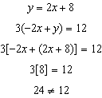

There is no solution to this system of equations.

PTS: 2 NAT: A.REI.C.6 TOP: Solving Linear Systems

KEY: substitution

248) ANS: 4

Step 1. Understand that this question is asking for the coordinates of the intersection of two different lines: the first line is represented by the equation  and the second line is represented by the table.

Step 2. Strategy: a) Identify the function rule for the data in the table; b) transform  into  format; and c) input both equations into a graphing calculator to find their intersection.

Step 3. Execution of strategy:

a) Use linear regression to identify an equation for the table.

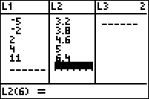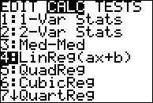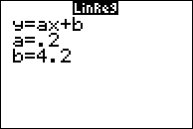

The table values can be represented by the equation 

b) Transform  into  format.

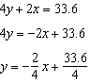

cI Input both equations in a graphing calculator.

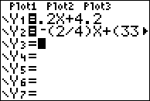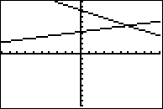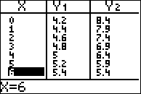

The lines intersect at (6, 5.4). Choice d) is the correct answer.

PTS: 2 NAT: A.REI.C.6 TOP: Solving Linear Systems