**J – Powers, Lesson 1, Modeling Exponential Functions (r. 2018)**

POWERS

Modeling Exponential Functions

|  |  |
| --- | --- |
| **Common Core Standards**  **A-SSE.B.3c** Use the properties of exponents to transform expressions ~~for exponential functions.~~ *~~For example, the expression 1.15t can be rewritten as (1.151/12)12t= 1.01212t to reveal the approximate equivalent monthly interest rate if the annual rate is 15%.~~*  PARCC: Tasks are limited to exponential expressions with integer exponents. Tasks have a real-world context. As described in the standard, there is an interplay between the mathematical structure of the expression and the structure of the situation such that choosing and producing an equivalent form of the expression reveals something about the situation.  **A-CED.1** Create equations and inequalities in one variable ~~and use them to solve problems~~. *Include equations arising from linear and quadratic functions, ~~and simple rational~~ and exponential functions.*  PARCC: Tasks are limited to linear, quadratic, or exponential equations with integer exponents.  **F-BF.A.1** Write a function that describes a relationship between two quantities.  **F-LE.A.2** Construct linear and exponential functions, ~~including arithmetic and geometric sequences,~~ given a graph, a description of a relationship, or two input-output pairs (include reading these from a table).  PARCC: Tasks are limited to constructing linear and exponential functions in simple context (not multi-step).  **F-LE.5** Interpret the parameters in a linear or exponential function in terms of a context.  PARCC: Tasks have a real-world context. Exponential functions are limited to those with domains in the integers. | **Next Generation Standards**  **AI-A.SSE.3c** Use the properties of exponents to rewrite exponential expressions.  (Shared standard with Algebra II)  **e.g.,**  • **32x = (32)x = 9x**  • **32x+3 = 32x** ∙ **33=9x** ∙ **27**  Note: Exponential expressions will include those with integer exponents, **as well as those whose exponents are linear expressions**. **Any linear term in those expressions will have an integer coefficient. Rational exponents are an expectation for Algebra II.**  **AI-A.CED.1** Create equations and inequalities in one variable to **represent a real-world context**.  (Shared standard with Algebra II)  Notes:  • **This is strictly the development of the model (equation/inequality).**  • **Limit equations to linear, quadratic, and exponentials of the form  where *a* > 0 and**  ***b* > 0 (*b* ≠ 1).**  • **Work with geometric sequences may involve an exponential equation/formula of the form an = arn-1, where a is the first term and r is the common ratio.**  • **Inequalities are limited to linear inequalities.**  • Algebra I tasks do not involve compound inequalities.  **AI-F.BF.1** Write a function that describes a relationship between two quantities.  (Shared standard with Algebra II)  **AI-F.LE.2** Construct a linear or exponential function **symbolically** given:  i) a graph;  ii) a description of the relationship;  iii) two input-output pairs (include reading these from a table).  (Shared standard with Algebra II)  Note: Tasks are limited to constructing linear and exponential functions in simple context (not multi-step).  **AI-F.LE.5** Interpret the parameters in a linear or exponential function in terms of a context.  (Shared standard with Algebra II)  Note: Tasks have a real-world context. **Exponential functions are limited to those with domains in the integers and are of the form  where**  ***a* > 0 and *b* > 0 (*b* ≠ 1).** |

**LEARNING OBJECTIVES**

Students will be able to:

1. Transform expressions and equations between equivalent exponential and radical forms.
2. Create and solve exponential functions based on real-world contexts.

**Overview of Lesson**

|  |  |
| --- | --- |
| **Teacher Centered Introduction**  **Overview of Lesson**  **- activate students’ prior knowledge**  **- vocabulary**  **- learning objective(s)**  **- big ideas: direct instruction**  **- modeling** | **Student Centered Activities**  **guided practice ⬅Teacher: anticipates, monitors, selects, sequences, and connects student work**  **- developing essential skills**  **- Regents exam questions**  **- formative assessment assignment (exit slip, explain the math, or journal entry)** |

**VOCABULARY**



base

cycle

exponential decay

exponential growth

exponential regression

initial amount

power

rate of decay

rate of growth

rational exponents

root

scientific notation

**BIG IDEAS**

Rules for Rational Exponents:

Rule: For any nonzero number a, , and 

Rule: For any nonzero number a and any rational numbers m and n, 

Rule: For any nonzero number a and any rational numbers m and n, 

Rule: For any nonzero numbers a and b and any rational number n 

Rule: For any nonzero number a and any rational numbers m and n, 

A number is in **scientific notation** if it is written in the form , where n is an integer and 

Exponential Growth and Decay



A common formula for exponential growth or decay is



Where:

*A* is the *amount after* growth or decay.

*P* is the original *amount before* growth or decay.

 is 100% of the original plus-or-minus the *rate* of growth or decay.

• + is used to model growth.

• - is used to model decay.

*t* is the number of growth or decay cycles, usually measured in units of time.

**Sample Problem**

PROBLEM

The equation  can be used to find the amount of money in a bank account if the initial amount deposited was $1,500 and the money grows with interest compounded annually at the rate of 3%. Rewrite this equation to reflect a monthly rate of growth.

SOLUTION

The problem wants us to write a new equation in which the rate of growth is expressed in months instead of years.

STEP 1. The rate of growth will be smaller if interest compounds monthly rather than annually. Therefore, the base of the exponent (in parentheses) must be reduced.

Using the rule: For any nonzero number *a* and any rational numbers *m* and *n*, , rewrite the exponential base (in parentheses) and its power as follows:

.

NOTE: Both expressions reflect the amount after one year of growth.

• In the *left* expression, *t represents time in years*.

• In the *right* expression, *t represents time in months*.

STEP 2. Simplify the base of the exponent (the term in parentheses) as follows:

, which rounds to 1.0025

NOTE: *This reveals the approximate equivalent monthly interest rate.*

STEP 3. Rewrite the entire equation with the new exponent.



NOTE: 12t represents one year, or 12 months. To find growth in months, eliminate the multiplication by 12.

STEP 4. Write the new equation.



CHECK

If the new equation reflects the same mathematical relationship as the original equation, both equations should produce similar outputs for similar amounts of time.

Original Equation Expressing Growth in Years

 

New Equation Expressing Growth in Months



**DEVELOPING ESSENTIAL SKILLS**

Solve the following problems using exponential growth or exponential decay formulas.

|  |  |  |
| --- | --- | --- |
|  | Problems | Solutions |
| 1 | Daniel’s Print Shop purchased a new printer for $35,000. Each year it depreciates (loses value) at a rate of 5%. What will its approximate value be at the end of the fourth year? |  |
| 2 | Kathy plans to purchase a car that depreciates (loses value) at a rate of 14% per year. The initial cost of the car is $21,000. Write an equation that represents the value, *v*, of the car after 3 years. |  |
| 3 | A bank is advertising that new customers can open a savings account with a  interest rate compounded annually. Robert invests $5,000 in an account at this rate. If he makes no additional deposits or withdrawals on his account, find the amount of money he will have, to the *nearest cent*, after three years. |  |
| 4 | Cassandra bought an antique dresser for $500. If the value of her dresser increases 6% annually, what will be the value of Cassandra's dresser at the end of 3 years to the *nearest dollar*? |  |
| 5 | The Booster Club raised $30,000 for a sports fund. No more money will be placed into the fund. Each year the fund will decrease by 5%. Determine the amount of money, to the *nearest cent*, that will be left in the sports fund after 4 years. |  |

**REGENTS EXAM QUESTIONS (through June 2018)**

POWERS

A.SSE.B.3c, A.CED.A.1, F.BF.A.1, F.LE.A.2, F.LE.B.5:

Modeling Exponential Functions

301) Miriam and Jessica are growing bacteria in a laboratory. Miriam uses the growth function  while Jessica uses the function , where *n* represents the initial number of bacteria and *t* is the time, in hours. If Miriam starts with 16 bacteria, how many bacteria should Jessica start with to achieve the same growth over time?

|  |  |  |  |
| --- | --- | --- | --- |
| 1) | 32 | 3) | 8 |
| 2) | 16 | 4) | 4 |

302) Jacob and Jessica are studying the spread of dandelions. Jacob discovers that the growth over *t* weeks can be defined by the function . Jessica finds that the growth function over *t* weeks is .

Calculate the number of dandelions that Jacob and Jessica will each have after 5 weeks.

Based on the growth from both functions, explain the relationship between  and .

303) The growth of a certain organism can be modeled by , where  is the total number of cells after *t* hours. Which function is approximately equivalent to ?

|  |  |  |  |
| --- | --- | --- | --- |
| 1) |  | 3) |  |
| 2) |  | 4) |  |

304) A computer application generates a sequence of musical notes using the function , where *n* is the number of the note in the sequence and  is the note frequency in hertz. Which function will generate the same note sequence as ?

|  |  |  |  |
| --- | --- | --- | --- |
| 1) |  | 3) |  |
| 2) |  | 4) |  |

305) Mario's $15,000 car depreciates in value at a rate of 19% per year. The value, *V*, after *t* years can be modeled by the function . Which function is equivalent to the original function?

|  |  |  |  |
| --- | --- | --- | --- |
| 1) |  | 3) |  |
| 2) |  | 4) |  |

306) Nora inherited a savings account that was started by her grandmother 25 years ago. This scenario is modeled by the function , where  represents the value of the account, in dollars, *t* years after the inheritance. Which function below is equivalent to ?

|  |  |  |  |
| --- | --- | --- | --- |
| 1) |  | 3) |  |
| 2) |  | 4) |  |

307) The Ebola virus has an infection rate of 11% per day as compared to the SARS virus, which has a rate of 4% per day. If there were one case of Ebola and 30 cases of SARS initially reported to authorities and cases are reported each day, which statement is true?

|  |  |  |  |
| --- | --- | --- | --- |
| 1) | At day 10 and day 53 there are more Ebola cases. | 3) | At day 10 there are more SARS cases, but at day 53 there are more Ebola cases. |
| 2) | At day 10 and day 53 there are more SARS cases. | 4) | At day 10 there are more Ebola cases, but at day 53 there are more SARS cases. |

308) Dylan invested $600 in a savings account at a 1.6% annual interest rate. He made no deposits or withdrawals on the account for 2 years. The interest was compounded annually. Find, to the *nearest cent*, the balance in the account after 2 years.

309) Rhonda deposited $3000 in an account in the Merrick National Bank, earning 4.2% interest, compounded annually. She made no deposits or withdrawals. Write an equation that can be used to find *B*, her account balance after *t* years.

310) Krystal was given $3000 when she turned 2 years old. Her parents invested it at a 2% interest rate compounded annually. No deposits or withdrawals were made. Which expression can be used to determine how much money Krystal had in the account when she turned 18?

|  |  |  |  |
| --- | --- | --- | --- |
| 1) |  | 3) |  |
| 2) |  | 4) |  |

311) The country of Benin in West Africa has a population of 9.05 million people. The population is growing at a rate of 3.1% each year. Which function can be used to find the population 7 years from now?

|  |  |  |  |
| --- | --- | --- | --- |
| 1) |  | 3) |  |
| 2) |  | 4) |  |

312) A student invests $500 for 3 years in a savings account that earns 4% interest per year. No further deposits or withdrawals are made during this time. Which statement does not yield the correct balance in the account at the end of 3 years?

|  |  |  |  |
| --- | --- | --- | --- |
| 1) |  | 3) |  |
| 2) |  | 4) |  |

313) Anne invested $1000 in an account with a 1.3% annual interest rate. She made no deposits or withdrawals on the account for 2 years. If interest was compounded annually, which equation represents the balance in the account after the 2 years?

|  |  |  |  |
| --- | --- | --- | --- |
| 1) |  | 3) |  |
| 2) |  | 4) |  |

314) Write an exponential equation for the graph shown below.

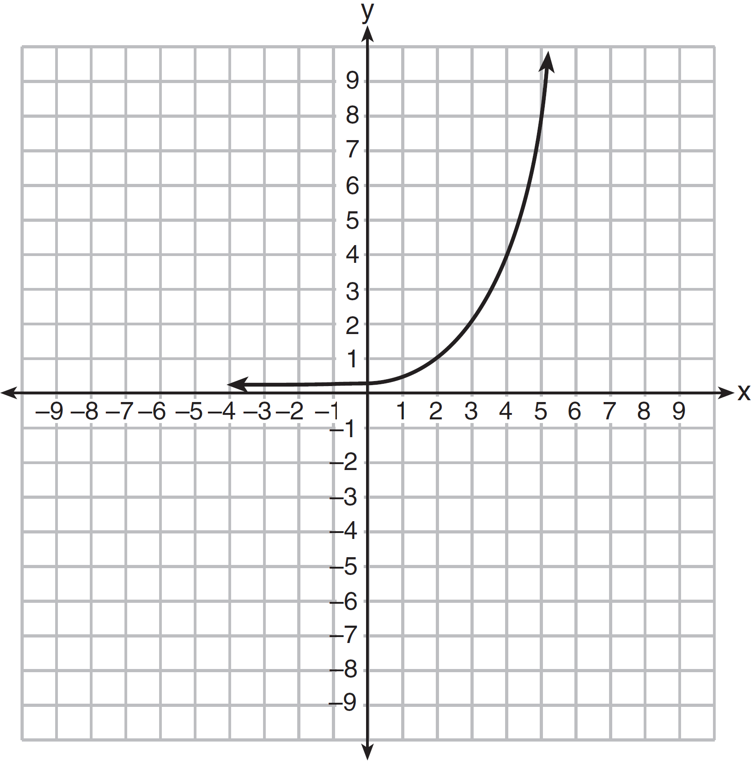

Explain how you determined the equation.

315) The table below shows the temperature *T(m)*, of a cup of hot chocolate that is allowed to chill over several minutes, *m*.

|  |  |  |  |  |  |
| --- | --- | --- | --- | --- | --- |
| Time, m (minutes) | 0 | 2 | 4 | 6 | 8 |
| Temperature, T(m) (°F) | 150 | 108 | 78 | 56 | 41 |

Which expression best fits the data for *T(m)*?

|  |  |  |  |
| --- | --- | --- | --- |
| 1) |  | 3) |  |
| 2) |  | 4) |  |

316) Jill invests $400 in a savings bond. The value of the bond, , in hundreds of dollars after *x* years is illustrated in the table below.

|  |  |
| --- | --- |
| **x** | **V(x)** |
| 0 | 4 |
| 1 | 5.4 |
| 2 | 7.29 |
| 3 | 9.84 |

Which equation and statement illustrate the approximate value of the bond in hundreds of dollars over time in years?

|  |  |  |  |
| --- | --- | --- | --- |
| 1) | and it grows. | 3) | and it grows. |
| 2) | and it decays. | 4) | and it decays. |

317) The breakdown of a sample of a chemical compound is represented by the function , where  represents the number of milligrams of the substance and *t* represents the time, in years. In the function , explain what 0.5 and 300 represent.

318) Some banks charge a fee on savings accounts that are left inactive for an extended period of time. The equation  represents the value, *y*, of one account that was left inactive for a period of *x* years. What is the *y*-intercept of this equation and what does it represent?

|  |  |  |  |
| --- | --- | --- | --- |
| 1) | 0.98, the percent of money in the account initially | 3) | 5000, the amount of money in the account initially |
| 2) | 0.98, the percent of money in the account after *x* years | 4) | 5000, the amount of money in the account after *x* years |

319) The function  represents the value , in dollars, of a comic book *t* years after its purchase. The yearly rate of appreciation of the comic book is

|  |  |  |  |
| --- | --- | --- | --- |
| 1) | 17% | 3) | 1.017% |
| 2) | 1.7% | 4) | 0.017% |

320) The number of carbon atoms in a fossil is given by the function , where *x* represents the number of years since being discovered. What is the percent of change each year? Explain how you arrived at your answer.

321) The equation  is being used to calculate the amount of money in a savings account. What does 1.02 represent in this equation?

|  |  |  |  |
| --- | --- | --- | --- |
| 1) | 0.02% decay | 3) | 2% decay |
| 2) | 0.02% growth | 4) | 2% growth |

322) Milton has his money invested in a stock portfolio. The value, v(x), of his portfolio can be modeled with the function , where *x* is the number of years since he made his investment. Which statement describes the rate of change of the value of his portfolio?

|  |  |  |  |
| --- | --- | --- | --- |
| 1) | It decreases 78% per year. | 3) | It increases 78% per year. |
| 2) | It decreases 22% per year. | 4) | It increases 22% per year. |

323) The 2014 winner of the Boston Marathon runs as many as 120 miles per week. During the last few weeks of his training for an event, his mileage can be modeled by , where *w* represents the number of weeks since training began. Which statement is true about the model ?

|  |  |  |  |
| --- | --- | --- | --- |
| 1) | The number of miles he runs will increase by 90% each week. | 3) | represents the total mileage run in a given week. |
| 2) | The number of miles he runs will be 10% of the previous week. | 4) | *w* represents the number of weeks left until his marathon. |

324) The value, , of a car depreciates according to the function , where *P* is the purchase price of the car and *t* is the time, in years, since the car was purchased. State the percent that the value of the car *decreases* by each year. Justify your answer.

**SOLUTIONS**

301) ANS: 4

Understanding the Problem.

Miriam’s exponential growth function is modeled by . The problem tells us that *n* equals 16, so Miriam’s exponential growth function can be rewritten as 

Jessica’s exponential growth function is modeled by . The quantity *n* is unknown for Jessica’s exponential growth function and the problem wants us to find the value of *n* that will make .

Strategy: Substitute equivalent expresseions for  and , then solve for *n*.

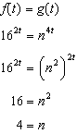 or 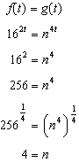 or 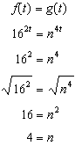

DIMS? Does It Make Sense? Yes. The outputs of  and  are identical.

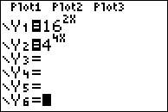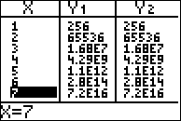

PTS: 2 NAT: A.SSE.B.3c TOP: Solving Exponential Equations

302) ANS:

Jacob and Jessica will both have 256 dandelions after 5 weeks.

|  |  |
| --- | --- |
|  |  |

Both functions express the same mathematical relationships.

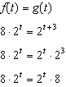

PTS: 2 NAT: A.SSE.B.3c TOP: Exponential Equations

303) ANS: 3

Step 1. Understand that this problem wants you to find the function in the answer choices that is equivalent to .

Step 2. Strategy. Use properties of exponents to rewrite the expression.

Step 3. Execute the strategy.

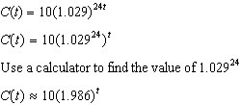

Choice c is the correct answer.

Step 4. Does it make sense? Yes. Check by inputting both functions in a graphing calculator.

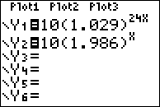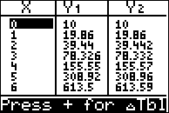

PTS: 2 NAT: A.SSE.B.3c TOP: Exponential Equations

304) ANS: 2

Strategy #1: Isolate the exponent n in each answer choice so that the structure of each function is identical, then eliminate any answer choice that is not equivalent to the original function..

|  |  |  |  |
| --- | --- | --- | --- |
|  |  |  |  |
| Eliminate this choice. | Choose this, because  . | Eliminate this choice. | Eliminate this choice. |

Strategy #2: Input the original function and all four answer choices in a graphing calculator. Choose the answer choice that produces the same function outputs (y-values) as the original function.

PTS: 2 NAT: A.SSE.B.3 TOP: Modeling Exponential Functions

305) ANS: 2

Strategy #1: Use properties of exponents.



Strategy #2: Use graphing calculator.

|  |  |
| --- | --- |
|  |  |

 produces the same table of values as the original function .

PTS: 2 NAT: A.SSE.B.3 TOP: Modeling Exponential Functions

306) ANS: 4



Therefore:



PTS: 2 NAT: A.SSE.B.3 TOP: Modeling Exponential Functions

307) ANS: 3

Step 1. Use  to set up exponential growth equations to represent both viruses.

Ebola Virus: 

SARS Virus: 

Step 2. Find  and  for both equations, then choose the correct answer.

|  |  |  |
| --- | --- | --- |
|  |  |  |

At day 10, there are more SARS cases than Ebola cases.



At day 53, there are more Ebola cases than SARS cases.



PTS: 2 NAT: F.LE.A.2 TOP: Modeling Exponential Functions

308) ANS:

After 2 years, the balance in the account is $619.35.

Strategy: Write an exponential growth equation to model the problem. Then solve the equation for two years.

STEP 1: Exponential growth is modeled by the formula , where:

A represents the amount after t cycles of growth,

*P* represents the starting amount, which is $600.

*r* represents the rate of growth, which is 1.6% or .016 as a decimal, and

*t* represents the number of cycles of growth, which are measured in years with annual compounding.

The equation is: 

STEP 2: Solve for two years growth.

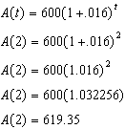

DIMS: Does It Make Sense? Yes. Each year, the interest on each $100 is $1.60, so the first year, there will be  interest. The second year interest will be another $9.60 for the original $600 plus 1.6% on the $9.60. The total interest after two years will be . Add this interest to the original $600 and the amount in the account will be $619.35.

PTS: 2 NAT: A.CED.A.1 TOP: Modeling Exponential Equations

NOT: NYSED classifies this problem as A.CED.A.1

309) ANS:



Strategy: Use the formula for exponential growth to model the problem.

The formula for exponential **growth** is .

The formula for exponential **decay** is .

*y =* **final amount** after measuring growth/decay

*a* = **initial amount** before measuring growth/decay

*r* = growth/decay **rate** (usually a percent)

*t* = **number of time intervals** that have passed

The problem states that *B* should be used to represent the **final amount** after growth.

The problem states that $3,000 is the **initial amount**.

The problem states that the **growth factor** is 4.2%, which is added to 1 and written as 1.042

The problem states that interest is compounded annually, so the number of time intervals is t years.

The final equation is written as 

PTS: 2 NAT: F.BF.A.1 TOP: Modeling Exponential Equations

310) ANS: 1

Strategy 1: Use the formula for exponential growth to model the problem.

The formula for exponential **growth** is .

The formula for exponential **decay** is .

*y =* **final amount** after measuring growth/decay

*a* = **initial amount** before measuring growth/decay

*r* = growth/decay **rate** (usually a percent)

*t* = **number of time intervals** that have passed

The problem asks for the *right side expression for exponential growth*.

The problem states that $3,000 is the **initial amount**.

The problem states that the **growth factor** is 2%, which is written as .02 and added to 1.

The problem states that interest is compounded annually from age 2 through age 18, so the number of time intervals is 16 years.

The final expression for the right side of the exponential growth equation is written as .

Strategy 2. Build a model and eliminate wrong answers.

Model the words using a table of values to see the pattern.

|  |  |  |
| --- | --- | --- |
| Krystal’s Age | # Times Compounding | Amount |
| 2 | 0 | 3000 |
| 3 | 1 | 3060 |
| 4 | 2 | 3121.2 |
| 5 | 3 | 3183.624 |
| ... | ... | ... |
| 18 | 16 | ? |

It is clear from the table that the number of times interest compounds is 2 less than Krystal’s age. Eliminate answer choices *c* and *d*, because both show exponents of 18, which is Krystal’s age, not the number of times the interest will compound.

The choices now are a and b. The table shows that the amounts are increasing, which is exponential growth, not exponential decay. Eliminate choice *b* because it shows exponential decay.

Check by putting choice a in a graphing calculator using x as the exponent.

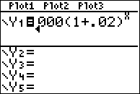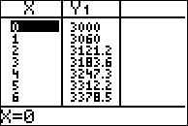

Answer choice *a* creates the same table of values, and the amount of money on Krystal’s 18th birthday will be  dollars.

PTS: 2 NAT: F.BF.A.1 TOP: Modeling Exponential Equations

311) ANS: 3

Strategy: Use the formula for exponential growth: , where

*A* represents the amount after growth, which in this problem will be .

*P* represents the initial amount, which in this problem will be .

*r* represents the rate of growth expressed as a decimal, which in this problem will be 0.031 per year.

*t* represents the number of growth cycles, which in this problem will be 7

Use the exponential growth formula and substitution to write:



Answer choice *c* is correct.

PTS: 2 NAT: F.LE.A.2 TOP: Modeling Exponential Functions

312) ANS: 2

Step 1. Understand from the problem that only one of the answer choices will be different from the others, and one that is different will be the correct answer.

Step 2. Strategy: Use a graphing calculator to find the values of each expression.

Step 3. Execute the strategy.

a) 

b) 

c) 

d) 

Answer choice b) is the correct answer, because produces a different value.

Step 4. Does it make sense? Yes. You can model an investment problem with compounding interest using the formula , where A is the amount, P is the initial amount invested, r is the interest rate expressed as a decimal, and t is the numer of compounding periods. Using this formula, the problem can be modelled as follows:

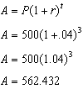

PTS: 2 NAT: F.BF.A.1 TOP: Modeling Exponential Functions

313) ANS: 2

Use the formula , where A representes the amount in the accout, P represents the amount invested, r represents the rate, and t represents time.

Anne invested $1000: 

1.3% annual interest rate: 

2 years: 

Write: 

Then, eliminate wrong answers.

a  The minus sign is wrong.

b  This is correct.

c  The minus sign is wrong and the annual interest rate is wrong.

d  The annual interest rate is wrong.

PTS: 2 NAT: F.BF.A.1 TOP: Modeling Exponential Functions

KEY: AI

314) ANS:

.

Strategy: Input the four integral values from the graph into a graphing calculator and use exponental regression to find the equation.

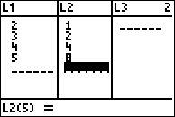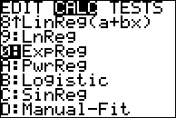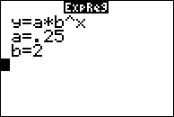

Alternative Strategy: Use the standard form of an exponential equation, which is .

Substitute the integral pairs of (2,1) and (3,2) from the graph into the standard form of an exponential equation and obtain the following:  and .

Therefore, 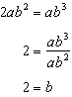

Accordingly, the equation for the graph can now be written as .

Substitute the integral pair (4,4) from the graph into the new equation and solve for *a*, as follows:



The graph of the equation can now be written as 

PTS: 2 NAT: F.LE.A.2 TOP: Modeling Exponential Equations

315) ANS: 1

Strategy #1: Check each answer using a graphing calculator.

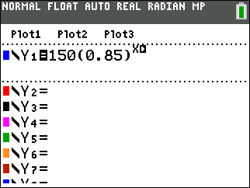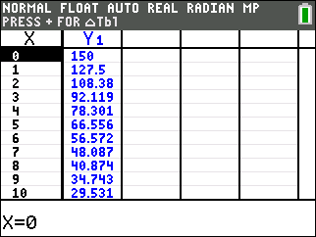

Strategy #2: Use exponential regression to model the data in the table.



PTS: 2 NAT: F.BF.A.1

316) ANS: 3

All of the answer choices involve exponential equations and are in the form of



where *A* represents the current value, *P* represents the starting amount, *r* represents the rate of growth or decay, and *t* represents the number of times that growth occurs.

This answer choices involve two equations, and  combined with the words growth and decay. The table shows that the value of V(x) is growing.

Therefore, any answer choices showing exponential decay must be eliminated and any answer choices where the value of  must be eliminated. This leaves only and it grows as the only correct answer.

This can be checked by inputting  into a graphing calculator and inspecting the resulting table to see it it matches the table given in the problem.

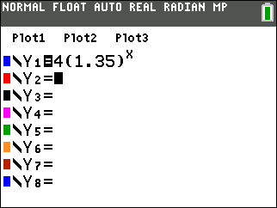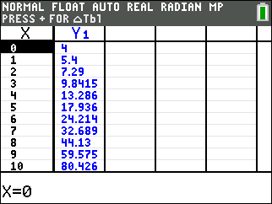

PTS: 2 NAT: F.LE.A.2 TOP: Modeling Exponential Functions

KEY: AI

317) ANS:

0.5 represents the rate of decay and 300 represents the initial amount of the compound.

Strategy: Use information from the problem together with the standard formula for exponential decay, which is , where *A* represents the amount remaining, *P* represents the initial amount, *r* represents the rate of decay, and *t* represents the number of cycles of decay.



The structures of the equations show that  and .

Accordingly, 300 represents the initial amount of chemical substance in milligrams and 0.5 represents the rate of decay each year.

PTS: 2 NAT: F.LE.B.5 TOP: Modeling Exponential Equations

318) ANS: 3

Strategy 1: The y-intercept of a function occurs when the value of *x* is 0. The strategy is to evaluate the function for 

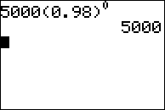

This represents the amount of money in the account before exponential decay begins.

Strategy 2. Input the equation in a graphing calculator and view the table of values.

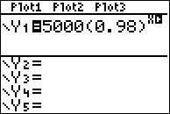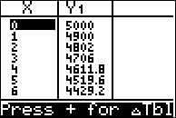

The table of values clearly shows the initial value of the account and its exponential decay.

PTS: 2 NAT: F.IF.C.8 TOP: Modeling Exponential Equations

319) ANS: 2

Strategy: Identify each of the parts of the function , then answer the question.

 represents the current value of the comic book in dollars.

1350 represents the original value of the comic book when it was purchased.

(1.017) represents the growth factor, which consists of (1+r), where r is the rate of growth per year. The value of r is 0.017, which is found by subtracting 1 from (1.017).

*t* represents the number of years since its purchase.

The problem wants to know the value of r, which is 0.017. However, all of the answer choices are expressed as percents rather than decimals. A decimal may be converted to a percent as follows:

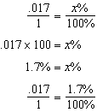

The yearly appreciation rate of the comic book is 1.7% and the correct answer is b.

DIMS? Does It Make Sense? The appreciation rate seems to make sense, but it is difficult to understand why someone would originally pay $1,350 for a comic book.

PTS: 2 NAT: A.SSE.A.1 TOP: Modeling Exponential Equations

320) ANS:

The percent of change each year is 5%.

Strategy: Use information from the problem together with the standard formula for exponential decay, which is , where *A* represents the amount remaining, *P* represents the initial amount, *r* represents the rate of decay, and *t* represents the number of cycles of decay.



The structures of the equations show that .

Solving for r shows that , or 5%.

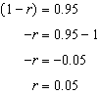

PTS: 2 NAT: F.LE.B.5 TOP: Modeling Exponential Functions

321) ANS: 4

Strategy: Use the formula for exponential growth or decay, which is , where

*A* represents the amount after *t* growth or decay cycles.

*P* represents the starting amount.

*r* represents the rate of growth expressed as a decimal, and

*t* represents the number of growth or decay cycles.

In the equation , the number 1.02 corresponds to , so write

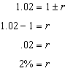

1.02 means that the growth rate is 2%.

PTS: 2 NAT: A.SSE.A.1 TOP: Modeling Exponential Functions

322) ANS: 2

The function  is of the form , which represents exponential growth or decay. The term in parenthesis (0.78) is equal to (1+r), so we can write and solve the following equation:

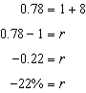

PTS: 2 NAT: F.LE.B.5

323) ANS: 3

Strategy: Input the function in a graphing calculator and study the graph and table views, then eliminate wrong answers.

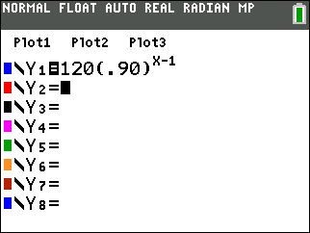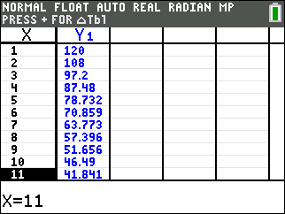

~~a)~~ The number of miles he runs will ~~increase~~ by 90% each week.

~~b)~~ The number of miles he runs will be ~~10%~~ of the previous week.

c)  represents the total mileage run in a given week.

~~d)~~ *w* represents the number of weeks ~~left until his marathon~~.

PTS: 2 NAT: F.LE.B.5 TOP: Modeling Exponential Functions

324) ANS:

The percent that the value of the car decreases each year is 15%.

Strategy: Note that  is of the exponential growth/decay form , and that the value (.85) in parentheses corresponds to the expression . Since the value of the car decreases, this is exponential decay. The relationship between the corresponding expressions can be written as .

Solve for *r* as follows:

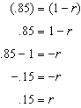

PTS: 2 NAT: F.LE.B.5 TOP: Modeling Exponential Functions