**M – Functions, Lesson 1, Defining Functions (r. 2018)**

FUNCTIONS

Defining Functions

|  |  |
| --- | --- |
| **Common Core Standard**  **F-IF.A.1** Understand that a function from one set (called the domain) to another set (called the range) assigns to each element of the domain exactly one element of the range. If *f* is a function and *x* is an element of its domain, then *f(x)* denotes the output of *f* corresponding to the input *x*. The graph of *f* is the graph of the equation *y = f(x)*. | **Next Generation Standard**  **AI-F.IF.1** Understand that a function from one set (called the domain) to another set (called the range) assigns to each element of the domain exactly one element of the range. If *f* is a function and *x* is an element of its domain, then *f(x)* denotes the output of *f* corresponding to the input *x*. The graph of *f* is the graph of the equation *y = f(x).*  **Note: Domain and range can be expressed using inequalities, set builder notation, verbal description, and interval notations for functions of subsets of real numbers to the real numbers.** |

**LEARNING OBJECTIVES**

Students will be able to:

1) Define and identify functions.

**Overview of Lesson**

|  |  |
| --- | --- |
| **Teacher Centered Introduction**  **Overview of Lesson**  **- activate students’ prior knowledge**  **- vocabulary**  **- learning objective(s)**  **- big ideas: direct instruction**  **- modeling** | **Student Centered Activities**  **guided practice ⬅Teacher: anticipates, monitors, selects, sequences, and connects student work**  **- developing essential skills**  **- Regents exam questions**  **- formative assessment assignment (exit slip, explain the math, or journal entry)** |

**VOCABULARY**

**Function**: A rule that assigns to each number  in the **function's** *domain* (x-axis) a unique number in the function’s *range (y-axis)*.A function takes the input value of an independent variable and pairs it with *one and only one* output value of a dependent variable.

**BIG IDEAS**





**Expressed as ordered Pairs**:

Function: (1,5) (2,6) (3,5)

Not a Function: (1,5) (2,7) (3,8) (1,6)

|  |  |
| --- | --- |
|  | **Function**: A **function** is a relation that assigns exactly one value of the dependent variable to each value of the independent variable. A **function** is always a relation.  Example: y=2x |
|  | **Relation**: A relation may produce more than one output for a given input. A relation may or may not be a function.  Example:  This is not a function, because when x=16, there is more than one y-value. . |

A function can be represented four ways. These are:

▪ a context (verbal description)

▪ a function rule (equation)

▪ a table of values

▪ a graph.

**Function Rules** show the relationship between dependent and independent variables in the form of an equation with two variables.

▪ The *independent* variable is the *input* of the function and is typically denoted by the x-variable.

▪ The *dependent* variable is the *output* of the function and is typically denoted by the y-variable.

All linear equations in the form  are functions except vertical lines.

2nd degree and higher equations may or may not be functions.

**Tables of Values** show the relationship between dependent and independent variables in the form of a table with columns and rows:

▪ The *independent variable is the input* of the function and is typically shown in the left column of a vertical table or the top row of a horizontal table.

▪ The *dependent variable is the output* of the function and is typically shown in the right column of a vertical table or the bottom row of a horizontal table.

|  |  |  |  |  |
| --- | --- | --- | --- | --- |
| Function | |  | Not A Function | |
| x | y | x | y |
| 1 | 5 | 1 | 5 |
| 2 | 6 | 2 | 6 |
| 3 | 7 | 3 | 7 |
| 4 | 8 | 4 | 8 |
| 5 | 9 | 2 | 9 |

**Graphs** show the relationship between dependent and independent variables in the form of line or curve on a coordinate plane:

▪ The value of independent variable is input of the function and is typically shown on the x-axis (horizontal axis) of the coordinate plane.

▪ The value of the dependent variable is the output of the function and is typically shown on the y-axis (vertical axis) of the coordinate plane.

**Vertical Line Test**: If a vertical line passes through a graph of an equation more than once, the graph is *not* a graph of a function.

If you can draw a vertical line through any value of x in a relation, and the vertical line intersects the graph in two or more places, the relation is not a function.

|  |  |  |  |
| --- | --- | --- | --- |
| Circles and Ellipses  …are **not functions**. | Parabola-like graphs that open to the side  …are **not functions**. | S-Curves  …are **not functions** | Vertical lines  …are **not functions**. |

**DEVELOPING ESSENTIAL SKILLS**

1. Which graph represents a function?

|  |  |  |  |
| --- | --- | --- | --- |
| a. |  | c. |  |
| b. |  | d. |  |

2. Which relation is *not* a function?

|  |  |  |  |
| --- | --- | --- | --- |
| a. |  | c. |  |
| b. |  | d. |  |

3. Which graph represents a function?

|  |  |  |  |
| --- | --- | --- | --- |
| a. |  | c. |  |
| b. |  | d. |  |

4. Which relation is *not* a function?

|  |  |  |  |
| --- | --- | --- | --- |
| a. |  | c. |  |
| b. |  | d. |  |

5. Which relation is a function?

|  |  |  |  |
| --- | --- | --- | --- |
| a. |  | c. |  |
| b. |  | d. |  |

6. Which set is a function?

|  |  |  |  |
| --- | --- | --- | --- |
| a. |  | c. |  |
| b. |  | d. |  |

**ANSWERS**

1. ANS: D

2. ANS: C

3. ANS: A

4. ANS: D

5. ANS: A

6. ANS: B

**REGENTS EXAM QUESTIONS (through June 2018)**

F.IF.A.1: Defining Functions

399) Which table represents a function?

|  |  |  |  |
| --- | --- | --- | --- |
| 1) |  | 3) |  |
| 2) |  | 4) |  |

400) The function *f* has a domain of  and a range of . Could *f* be represented by ? Justify your answer.

401) Which representations are functions?

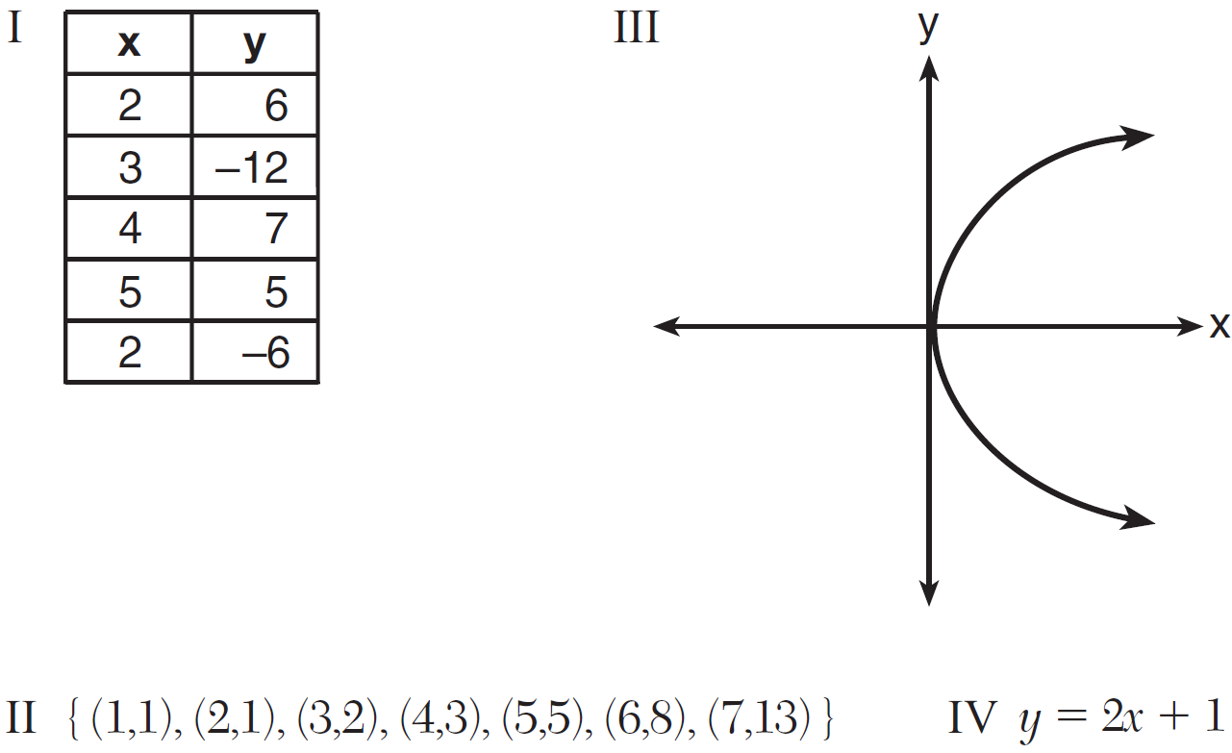

|  |  |  |  |
| --- | --- | --- | --- |
| 1) | I and II | 3) | III, only |
| 2) | II and IV | 4) | IV, only |

402) A mapping is shown in the diagram below.

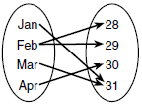

This mapping is

|  |  |  |  |
| --- | --- | --- | --- |
| 1) | a function, because Feb has two outputs, 28 and 29 | 3) | not a function, because Feb has two outputs, 28 and 29 |
| 2) | a function, because two inputs, Jan and Mar, result in the output 31 | 4) | not a function, because two inputs, Jan and Mar, result in the output 31 |

403) A function is shown in the table below.

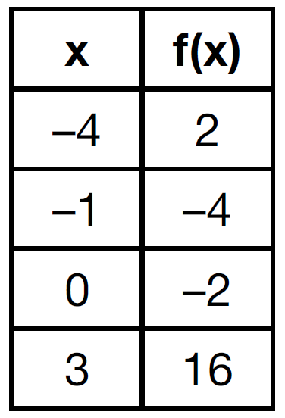

If included in the table, which ordered pair,  or , would result in a relation that is no longer a function? Explain your answer.

404) Marcel claims that the graph below represents a function.

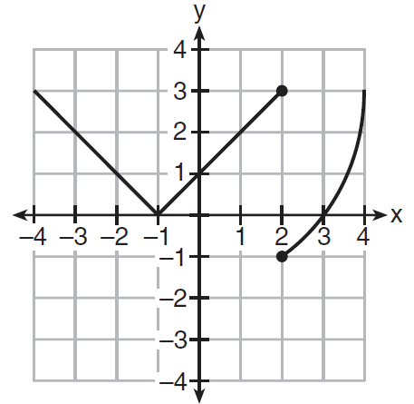

State whether Marcel is correct. Justify your answer.

405) Nora says that the graph of a circle is a function because she can trace the whole graph without picking up her pencil. Mia says that a circle graph is *not* a function because multiple values of *x* map to the same *y*-value. Determine if either one is correct, and justify your answer completely.

406) A relation is graphed on the set of axes below.

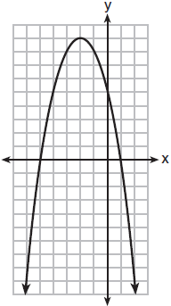

Based on this graph, the relation is

|  |  |  |  |
| --- | --- | --- | --- |
| 1) | a function because it passes the horizontal line test | 3) | not a function because it fails the horizontal line test |
| 2) | a function because it passes the vertical line test | 4) | not a function because it fails the vertical line test |

407) A function is defined as . Isaac is asked to create one more ordered pair for the function. Which ordered pair can he add to the set to keep it a function?

|  |  |  |  |
| --- | --- | --- | --- |
| 1) |  | 3) |  |
| 2) |  | 4) |  |

**SOLUTIONS**

399) ANS: 3

Strategy: Eliminate wrong answers. A function is a relation that assigns exactly one value of the dependent variable to each value of the independent variable.

Answer choice a ***is not*** a function because there are two values of y when .

Answer choice b ***is not*** a function because there are two values of y when .

Answer choice c ***is*** a function because only one value of y is paired with each value of x.

Answer choice d ***is not*** a function because there are two values of y when .

.

PTS: 2 NAT: F.IF.A.1 TOP: Defining Functions

400) ANS:

Yes, because every element of the domain is assigned one unique element in the range.

Strategy: Determine if any value of *x* has more that one associated value of *y*. A function has one and only one value of *y* for every value of *x*.

PTS: 2 NAT: F.IF.A.1 TOP: Defining Functions

401) ANS: 2

Strategy: Determine if each of the for views are functions, then select from the answer choices. A function is a relation that assigns exactly one value of the dependent variable to each value of the independent variable.

I ***is not*** a function because when , y can equal both 6 and -6.

II **is** a function because there are no values of x that have more than one value of y.

III ***is not*** a function because it fails the vertical line test, which means there are values of x that have more than one value of y.

IV ***is*** a function because it is a straight line that is not vertical.

Answer choice b is the correct answer.

PTS: 2 NAT: F.IF.A.1 TOP: Defining Functions

402) ANS: 3

A function has one and only one output for each input. The diagram shows that February maps to two different output numbers, so the diagram cannot represent a function.

PTS: 2 NAT: F.IF.A.1 TOP: Defining Functions

KEY: ordered pairs

403) ANS:

, because then every element of the domain is not assigned one unique element in the range.

PTS: 2 NAT: F.IF.A.1 TOP: Defining Functions

404) ANS:

Marcel is not correct, because the relation does not pass the vertical line test. If you draw the vertical line , there will be more than one value of y. A function can have one and only one value of y for every value of x.

PTS: 2 NAT: F.IF.A.1 TOP: Defining Functions

KEY: graphs

405) ANS:

Neither is correct.

Nora’s reason is wrong since a circle is not a function because it fails the vertical line test.

Although Mia correctly states that a circle is not a function, her reasoning is wrong. She confuses the variables in the definition of a function, which states that a function has one and only one value of y for each value of x. It is okay for a y to be associated with multiple values of x in a function. It is not okay for an x to be associated with multiple values of y.

PTS: 2 NAT: F.IF.A.1 TOP: Defining Functions

KEY: graphs

406) ANS: 2

A function has one and only one value of y for each value of x. A graph represents a function if there are no vertical lines that intersect the graph at more than one point.

PTS: 2 NAT: F.IF.A.1 TOP: Defining Functions

KEY: graphs

407) ANS: 4

Strategy. The the definition of a function to eliminate wrong answers. (i.e. for each value of x in a function, there can be one and only one value of y).

Choice 1:  Wrong, because 0 is already paired with .

Choice 2:  Wrong, because 5 is already paired with .

Choice 3:  Wrong, because 7 is already paired with .

Choice 4:  Correct, because 1 is not paired with any other value of y.

PTS: 2 NAT: F.IF.A.1 TOP: Defining Functions

KEY: ordered pairs