**M – Functions, Lesson 2, Function Notation, Evaluating Functions (r. 2018)**

FUNCTIONS

Function Notation, Evaluating Functions

|  |  |
| --- | --- |
| **Common Core Standard**  **F-IF.2** Use function notation, evaluate functions for inputs in their domains, and interpret statements that use function notation in terms of a context. | **Next Generation Standard**  **AI-F.IF.2** Use function notation, evaluate functions for inputs in their domains, and interpret statements that use function notation in terms of a context. |

**LEARNING OBJECTIVES**

Students will be able to:

1. use function notation,
2. evaluate functions for specific input values, and
3. use function notation in context.

**Overview of Lesson**

|  |  |
| --- | --- |
| **Teacher Centered Introduction**  **Overview of Lesson**  **- activate students’ prior knowledge**  **- vocabulary**  **- learning objective(s)**  **- big ideas: direct instruction**  **- modeling** | **Student Centered Activities**  **guided practice ⬅Teacher: anticipates, monitors, selects, sequences, and connects student work**  **- developing essential skills**  **- Regents exam questions**  **- formative assessment assignment (exit slip, explain the math, or journal entry)** |

**VOCABULARY**

function notation

dependent variable

independent variable

composition of functions

**BIG IDEAS**

**Function Notation**

In function notation, *f* (*x*) is used instead of the letter y to denote the dependent variable. It is read as “f of x” or “the value f(x) is a function of x,” which is the independent variable. Other letters may also be used.

There are four primary advantages to using function notation:

1. The use of function notation indicates that the relationship is a function.
2. The use of function notation explicitly defines which variable is the dependent variable and which variable is the independent variable.
3. The use of function notation simplifies evaluation of the dependent variable for specific values of the independent variable.

Example: If 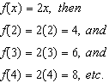

1. The use of function notation allows greater flexibility and specificity in naming variables.

Example #1: If total cost is a function of the number of pencils bought, a function rule might begin with *C(p)=*.

Example #2: If miles driven at a constant speed is a function of hours driving, a function rule might begin with *M(h)=*.

When graphing using function notation, the label of the y-axis is changed to reflect the function notation being used.

**Evaluating Functions**

To evaluate a function for a specific input, simply replace the dependent variable with the desired input throughout the function.

Example: Given the function , find the value of  as follows:

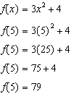

**Composition of Functions**

Some functions are defined using other functions. Such functions are called compositions of functions. For example, ifand, then the functionis defined in terms of the function. Since we know that, we can use substitution to write .

**DEVELOPING ESSENTIAL SKILLS**

Evaluate the following functions for the given input values:

|  |  |
| --- | --- |
|  |  |
|  |  |

ANSWERS

|  |  |
| --- | --- |
|  |  |
|  |  |

**REGENTS EXAM QUESTIONS (through June 2018)**

F.IF.A.2: Function Notation, Evaluating Functions

408) Given that , find  if .

409) The graph of  is shown below.

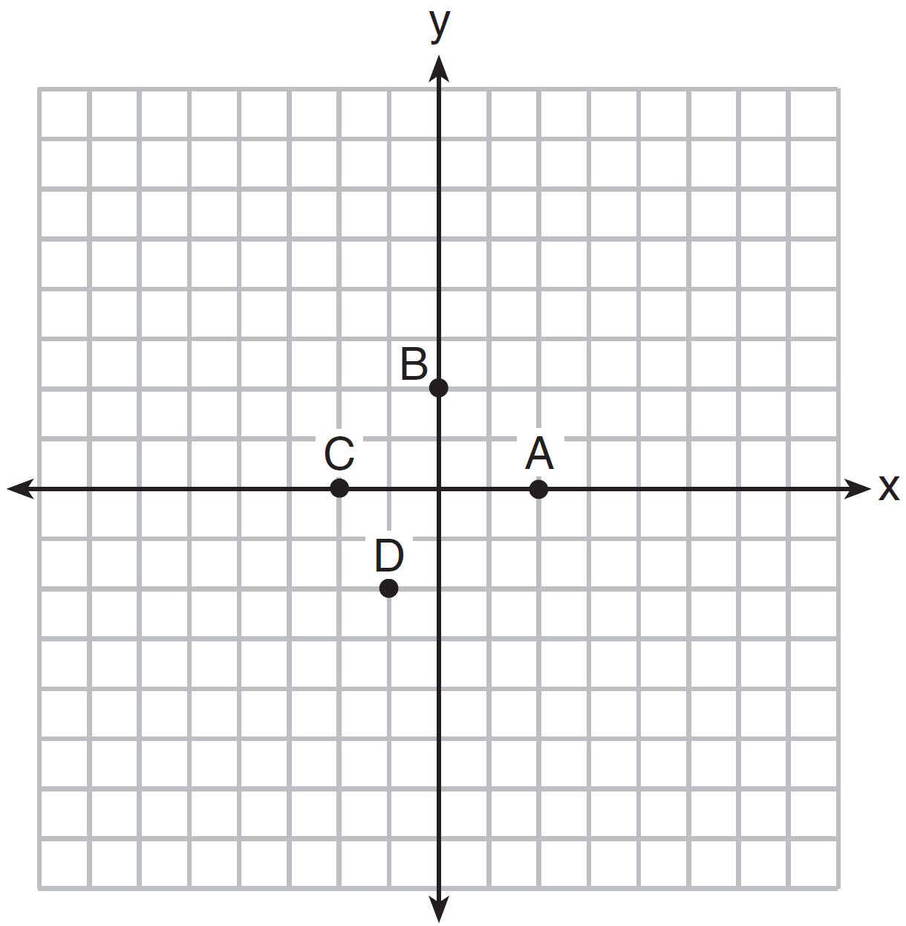

Which point could be used to find ?

|  |  |  |  |
| --- | --- | --- | --- |
| 1) | *A* | 3) | *C* |
| 2) | *B* | 4) | *D* |

410) The value in dollars, , of a certain car after *x* years is represented by the equation . To the *nearest dollar*, how much more is the car worth after 2 years than after 3 years?

|  |  |  |  |
| --- | --- | --- | --- |
| 1) | 2589 | 3) | 15,901 |
| 2) | 6510 | 4) | 18,490 |

411) If , which statement is true?

|  |  |  |  |
| --- | --- | --- | --- |
| 1) |  | 3) |  |
| 2) |  | 4) |  |

412) The equation to determine the weekly earnings of an employee at The Hamburger Shack is given by , where *x* is the number of hours worked.



Determine the difference in salary, *in dollars*, for an employee who works 52 hours versus one who works 38 hours. Determine the number of hours an employee must work in order to earn $445. Explain how you arrived at this answer.

413) If , then 

|  |  |  |  |
| --- | --- | --- | --- |
| 1) | 1 | 3) |  |
| 2) | -2 | 4) |  |

414) Lynn, Jude, and Anne were given the function , and they were asked to find . Lynn's answer was 14, Jude's answer was 4, and Anne's answer was ±4. Who is correct?

|  |  |  |  |
| --- | --- | --- | --- |
| 1) | Lynn, only | 3) | Anne, only |
| 2) | Jude, only | 4) | Both Lynn and Jude |

415) If , what is the value of ?

|  |  |  |  |
| --- | --- | --- | --- |
| 1) | 11 | 3) | 27 |
| 2) | 17 | 4) | 33 |

416) For a recently released movie, the function  models the revenue earned, *y*, in millions of dollars each week, *x*, for several weeks after its release. Based on the equation, how much more money, in millions of dollars, was earned in revenue for week 3 than for week 5?

|  |  |  |  |
| --- | --- | --- | --- |
| 1) | 37.27 | 3) | 17.06 |
| 2) | 27.16 | 4) | 10.11 |

417) If , then  is

|  |  |  |  |
| --- | --- | --- | --- |
| 1) | 315 | 3) | 159 |
| 2) | 307 | 4) | 153 |

**SOLUTIONS**

408) ANS:

Step 1. Understand this as a composition of functions problem.

Step 2. Strategy: Substitute the expression for f(x) into the equation for g(x).

Step 3. Execution of Strategy.

 and 

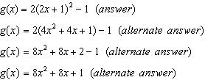

PTS: 2 NAT: F.IF.A.2 TOP: Functional Notation Evaluating Functions

409) ANS: 1

Strategy: Understand that the meaning of  is the value of y when , then eliminate wrong answers.

Choose answer choice A because represents  with coordinates . .

Answer choice b is wrong because if represents . 

Answer choice c is wrong because if represents . 

Answer choice d is wrong because if represents . 

PTS: 2 NAT: F.IF.A.2 TOP: Functional Notation Evaluating Functions

410) ANS: 1

Strategy #1

Input  into a graphing calculator and press enter.

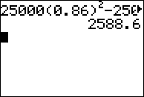



Strategy #2: Input the function rule in a graphing calculator and obtain the value of the car after 2 years and 3 years from the table of values. Then, compute the difference.

STEP 1: Input the function rule and obtain data from the table of values.

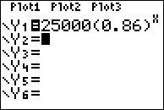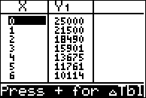

STEP 2: Compare the value of the car after 2 years and after 3 years.

The car is worth $18,490 after 2 years.

The car is worth $15,901 after 3 years.

The difference is 



PTS: 2 NAT: F.IF.A.2 TOP: Functional Notation Evaluating Functions

411) ANS: 2

Strategy #1: Input  into a graphing calculator and inspect the table of values.

|  |  |
| --- | --- |
| *x* | *f(x)* |
| 3 | 13 |
| -2 | 3 |
| -15 | 211 |

Strategy #2: Manually calculate the answer.

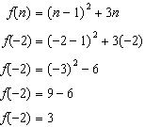

PTS: 2 NAT: F.IF.A.2 TOP: Functional Notation Evaluating Functions

412) ANS:

a) The difference in salary, *in dollars*, for an employee who works 52 hours versus one who works 38 hours, is $200.

b) An employee must work 43 hours in order to earn $445. See work below.

Strategy: Part a: Use the piecewise function to first determine the salaries of 1) an employee who works 52 hours, and 2) an employee who works 38 hours. Then, find the difference of the two salaries.

|  |  |
| --- | --- |
| Working 38 Hours | Working 52 Hours |

The difference between the values of  and  is $200.

Strategy: Part b: The employee must work more than 40 hours, and compensation for hours worked in excess of 40 hours is found in the second formula and is equal to $15 per hour. The compensation worked in excess of 40 hours is , so



The employee must work a total of 43 hours. The employee receives $400 for the first 40 hours and $45 for the 3 hours in excess of 40 hours.

PTS: 4 NAT: F.IF.A.2 TOP: Functional Notation Evaluating Functions

413) ANS: 3

Strategy: Substitute  for x, and solve.

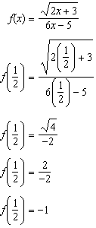

PTS: 2 NAT: F.IF.A.2 TOP: Functional Notation Evaluating Functions

414) ANS: 1

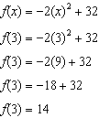

PTS: 2 NAT: F.IF.A.2 TOP: Functional Notation

415) ANS: 3

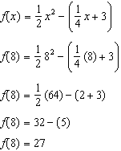

PTS: 2 NAT: F.IF.A.2 TOP: Functional Notation

416) ANS: 3

Strategy #1. Input the function rule in a graphing calculator, then use the table of values to identify the revenues earned in weeks 3 and 5, then compute the difference.

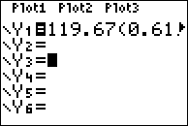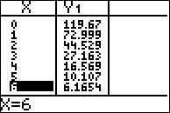

The table of values shows that the movie earned 27.163 million dollars in week 3.

The table of values shows that the movie earned 10.107 million dollars in week 5.

The difference is 

Strategy #2. Use a graphing calculator to evaluate the expression , which equals 17.056..

PTS: 2 NAT: F.IF.A.2 TOP: Functional Notation Evaluating Functions

417) ANS: 4

Strategy: Substitute and solve.

|  |  |  |  |
| --- | --- | --- | --- |
| Notes | Left Expression | Sign | Right Expression |
| Given |  | = |  |
| Substitute 9 for x |  | = |  |
| Exponents and Radicals |  | = |  |
| Simplify |  | = | 162-9 |
| Simplify |  | = | 153 |

PTS: 2 NAT: F.IF.A.2 TOP: Functional Notation