**L – Radicals, Lesson 2, Graphing Root Functions (r. 2018)**

RADICALS

Graphing Root Functions

|  |  |
| --- | --- |
| **Common Core Standard**  **F-IF.7b** Graph square root, ~~cube root~~, and piecewise-defined functions, including step functions and absolute value functions. | **Next Generation Standard**  **AI-F.IF.7b** Graph square root, and piecewise-defined functions, including step functions and absolute value functions and **show key features.**  **Note: Algebra I key features include the following: intercepts, zeros; intervals where the function is increasing, decreasing, positive, or negative; maxima, minima; and symmetries.** |

**LEARNING OBJECTIVES**

Students will be able to:

1) Graph functions involving square roots.

**Overview of Lesson**

|  |  |
| --- | --- |
| **Teacher Centered Introduction**  **Overview of Lesson**  **- activate students’ prior knowledge**  **- vocabulary**  **- learning objective(s)**  **- big ideas: direct instruction**  **- modeling** | **Student Centered Activities**  **guided practice ⬅Teacher: anticipates, monitors, selects, sequences, and connects student work**  **- developing essential skills**  **- Regents exam questions**  **- formative assessment assignment (exit slip, explain the math, or journal entry)** |

**VOCABULARY**

square root

cube root

nth root

**BIG IDEAS**

NOTE: All of the functions in this lesson require special consideration for the domain of the independent variable (the x-axis).

**ROOT FUNCTIONS**

Root functions are associated with equations involving square roots, cube roots, or nth roots. The easiest way to graph a root function is to use the three views of a function that are associated with a graphing calculator.

STEP 1. Input the root function in the y-editor of the calculator.

(Note: The use of rational exponents is recommended, i.e.







STEP 2. Look at the graph of the function.

STEP 3. Use the table of values to transfer coordinate pairs to graph paper.

Example: Graph the root function 

|  |  |  |
| --- | --- | --- |
| STEP 1 Input the function rule in the y-editor of your graphing calculator | STEP 2. Look at the graph view of the function. | STEP 3. Select coordinate pairs from the table view to create your graph. |
|  |  |  |

**DEVELOPING ESSENTIAL SKILLS**

Use technology to graph the following the following functions:











ANSWERS

|  |  |  |
| --- | --- | --- |
|  |  |  |
|  |  |  |
|  |  |  |
|  |  |  |
|  |  |  |

**REGENTS EXAM QUESTIONS (through June 2018)**

F.IF.C.7: Graphing Root Functions

394) Which graph represents ?

|  |  |  |  |
| --- | --- | --- | --- |
| 1) |  | 3) |  |
| 2) |  | 4) |  |

395) On the set of axes below, graph the function represented by  for the domain .

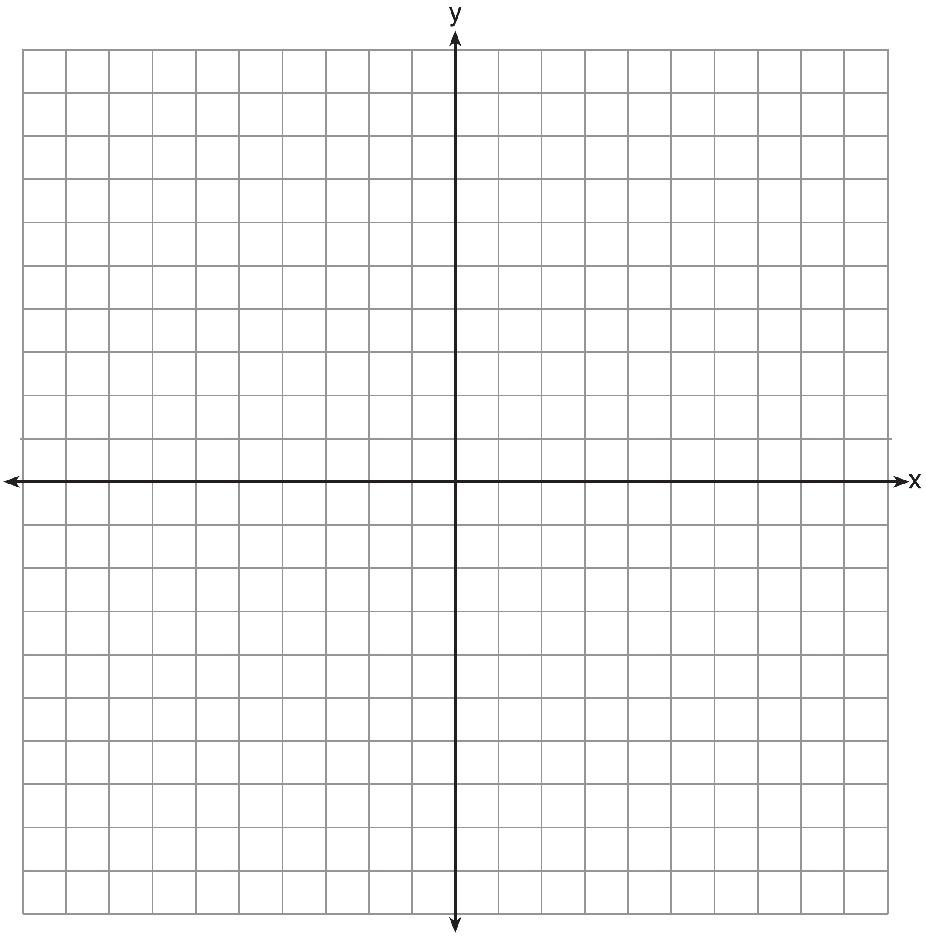

396) Draw the graph of  on the set of axes below.



397) Graph the function  on the set of axes below.



398) Graph  over the domain .

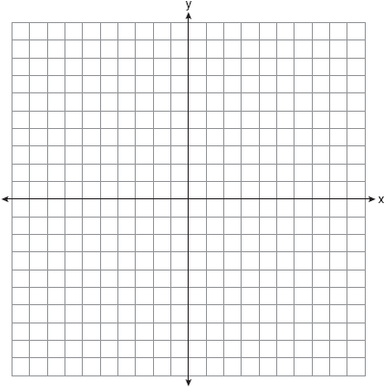

**SOLUTIONS**

394) ANS: 4

 is a root function, so its graph must look like a root function.

|  |  |
| --- | --- |
| a)  This is a quadratic function. | c)  This is a quadratic function. |
| b)  This is a linear function. | d)  By the process of elimination, this is the only root function. |

You can also solve this problem by inputting the equation  into a graphing calcualtor and looking at the graph, as fopllows:

|  |  |
| --- | --- |
|  |  |

PTS: 2 NAT: F.IF.C.7 TOP: Graphing Root Functions

KEY: bimodalgraph

395) ANS:

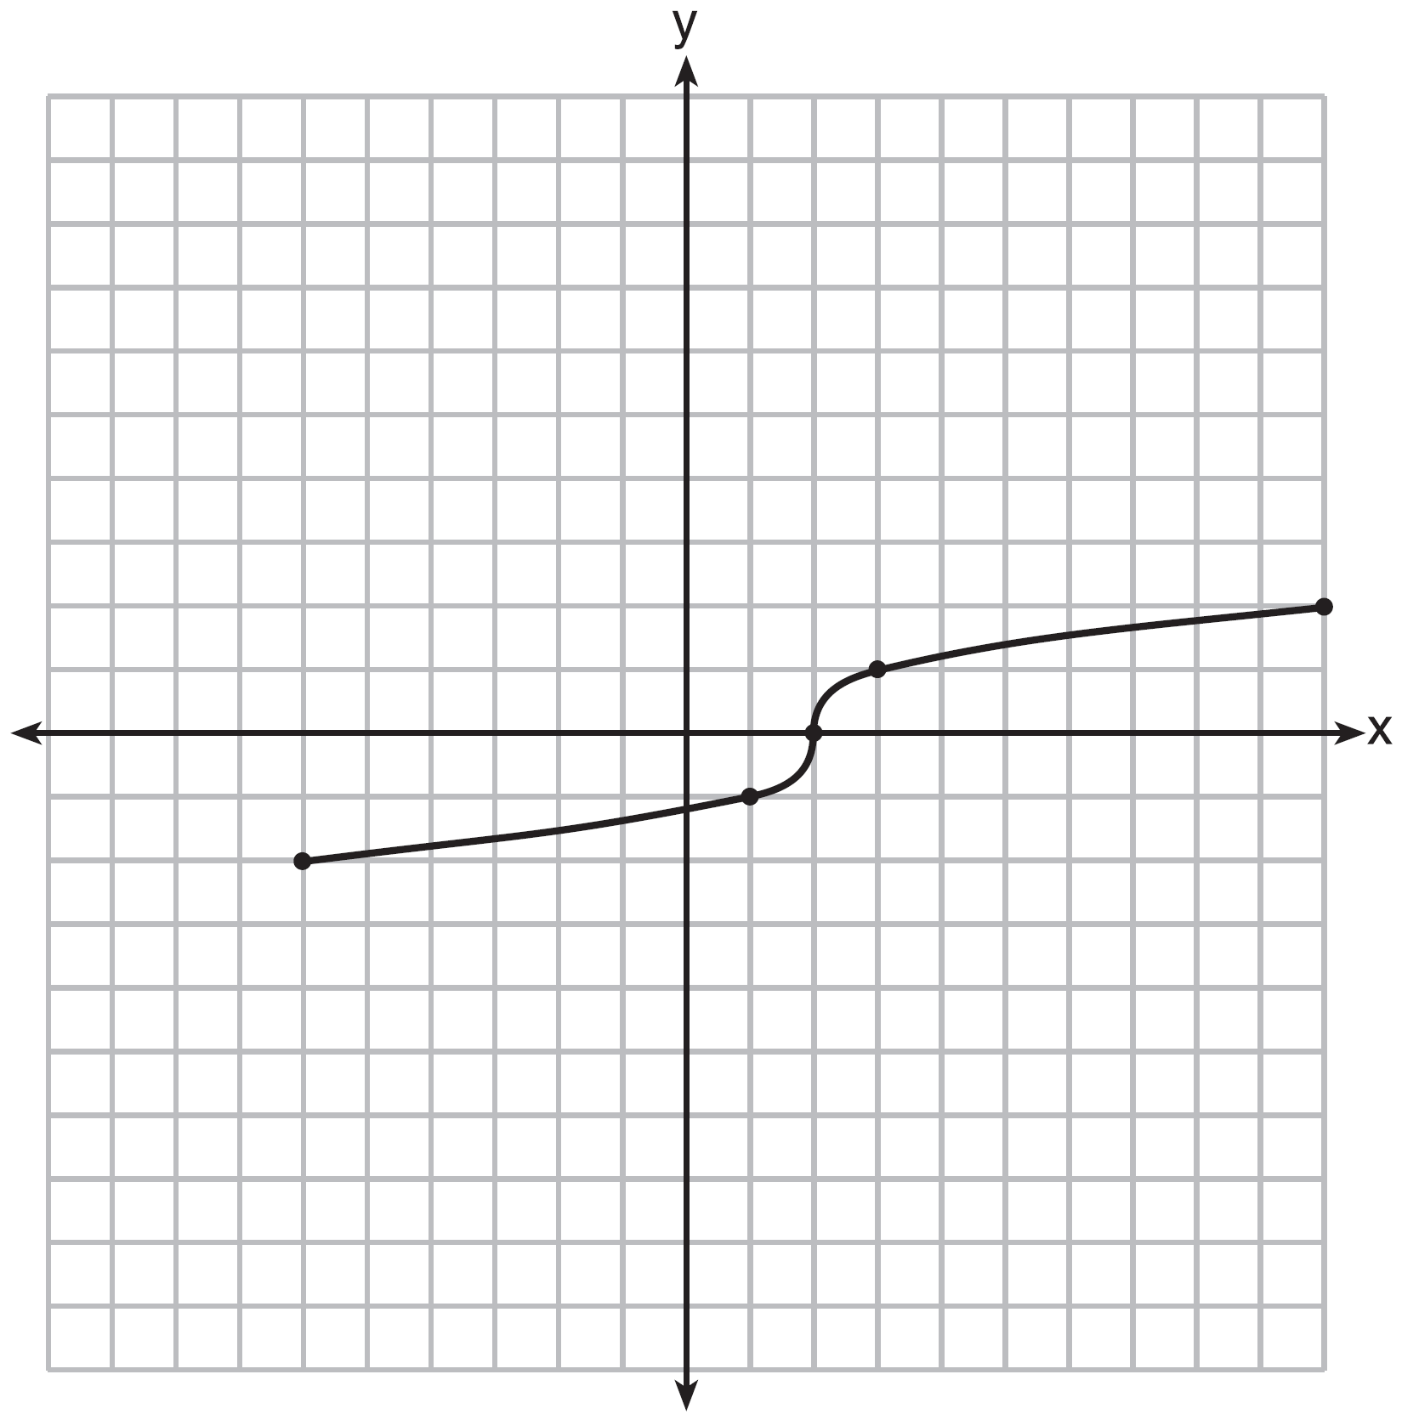

Strategy: Input the function in a graphing calculator, then use the graph and table views to construct the graph on paper. Limit the domain of the graph to .

STEP 1: Use exponential notation to input the function into the graphing calculator, where . Then use the table and graph views to reproduce the graph on paper.

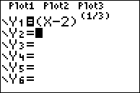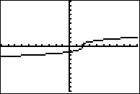

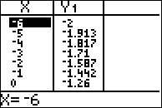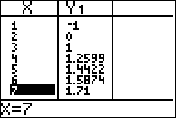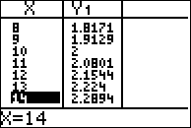

STEP 2: Limit the domain of the function to . Used closed dots to show the ends of the function at coordinates (-6, -2) and for (10, 2).

PTS: 2 NAT: F.IF.C.7 TOP: Graphing Root Functions

396) ANS:

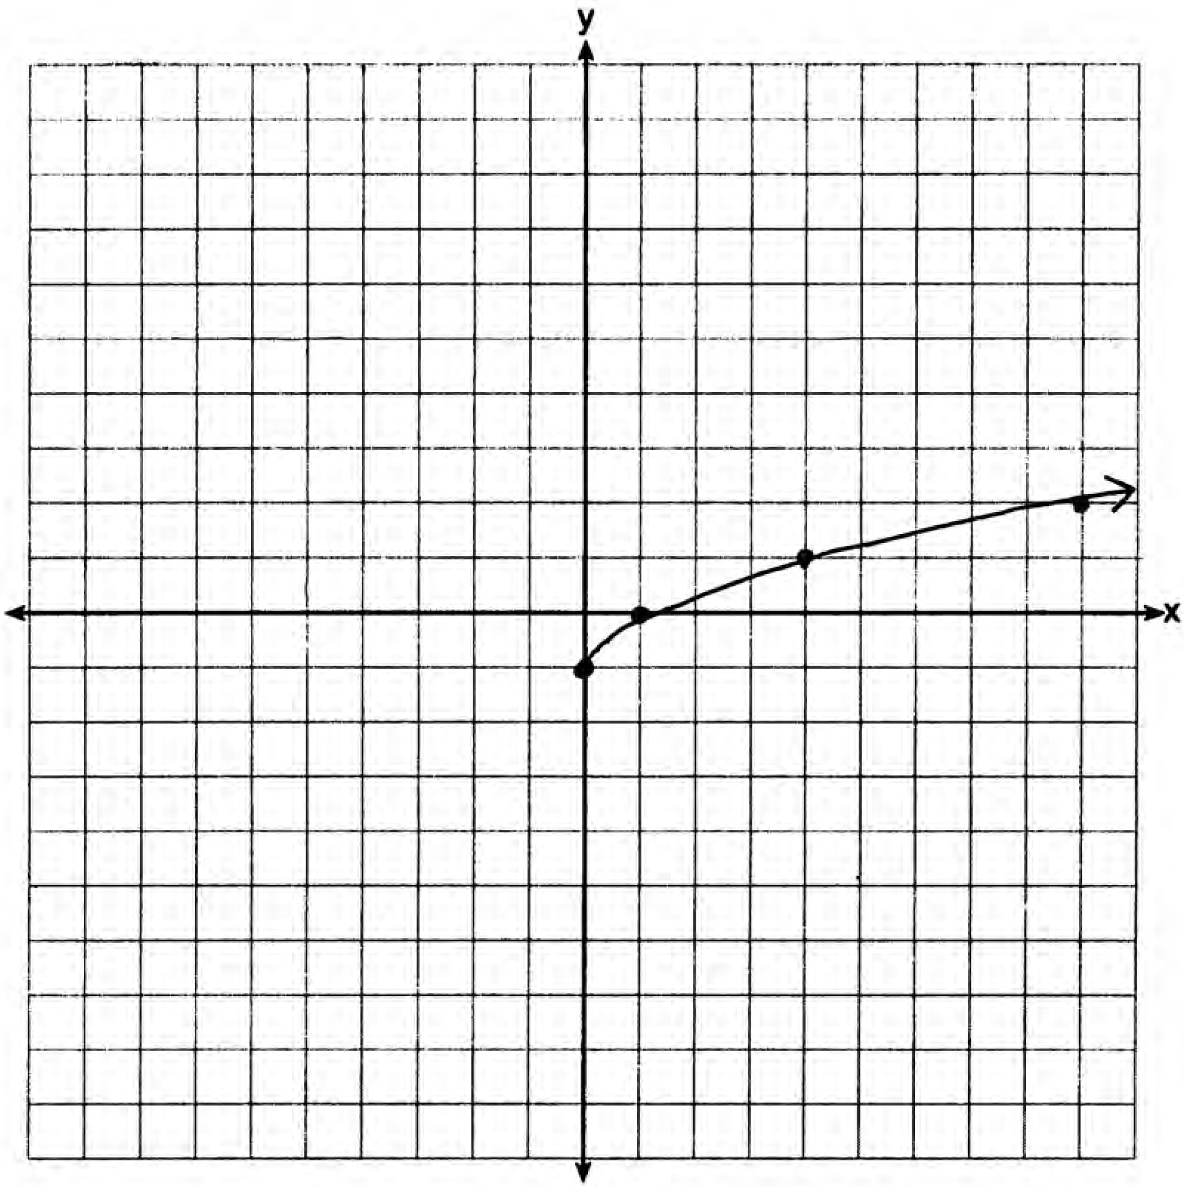

Strategy: Input the function in a graphing calculator, then use the graph and table views to construct the graph on paper.

STEP 1: Use exponential notation to input the function into the graphing calculator, where . Then use the table and graph views to reproduce the graph on paper.

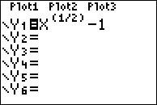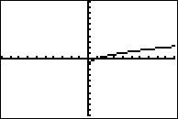

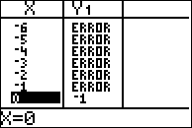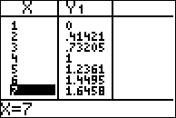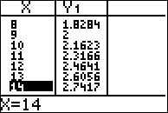

Note: Do nopt plot coordinates with errors. Focus on plotting coordinates with integer values and estimate the graph between the points with integer values when drawing the graph.

STEP 2: Limit the domain of the function to . Used closed dots to show the ends of the function at coordinates (-6, -2) and for (10, 2).

PTS: 2 NAT: F.IF.C.7 TOP: Graphing Root Functions

397) ANS:

Strategy: Input the equation in a graphing calculator. Plot the coordinates with integer values. Complete the graph.

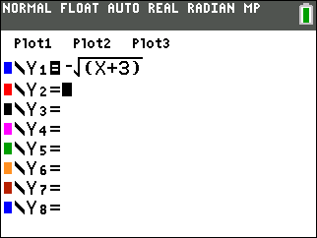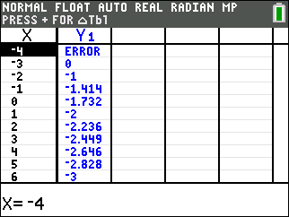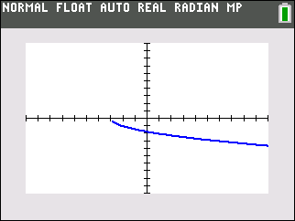

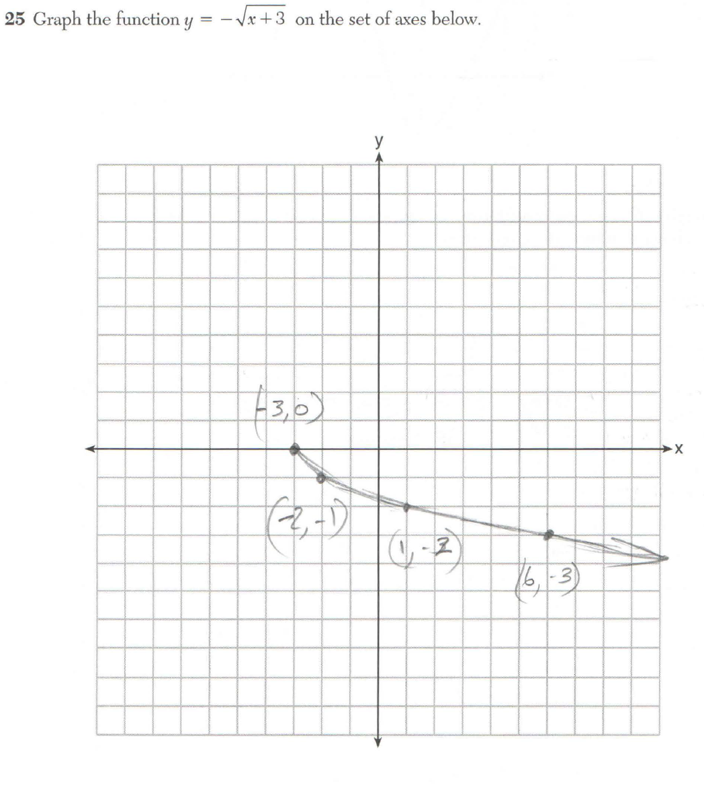

PTS: 2 NAT: F.IF.C.7

398) ANS:

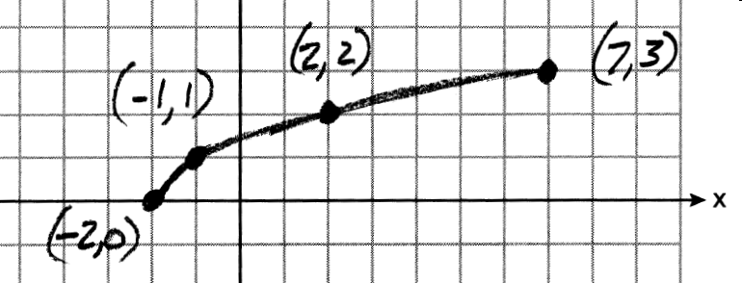

Strategy: Input the function  in a graphing calculator and use the table of values and graph views to plot the graph for integer values.

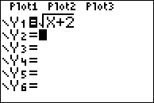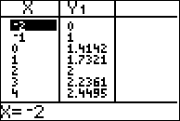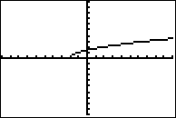

PTS: 2 NAT: F.IF.C.7 TOP: Graphing Root Functions