M – Functions, Lesson 10, Graphing Step Functions (r. 2018)

FUNCTIONS
Graphing Step Functions
Common Core Standard  F-IF.C.7 Graph functions expressed symbolically and show key features of the graph, by hand in simple cases and using technology for more complicated cases. | Next Generation Standard  AI-F.IF.7 Graph functions and show key features of the graph by hand and by using technology where appropriate.  (Shared standard with Algebra II)
NOTE: This lesson is related to Functions, Lesson 9, Graphing Piecewise Functions

LEARNING OBJECTIVES
Students will be able to:
1) Graph and interpret step functions.

Overview of Lesson
Teacher Centered Introduction  Overview of Lesson  - activate students’ prior knowledge  - vocabulary  - learning objective(s)  - big ideas: direct instruction  - modeling | Student Centered Activities  guided practice ⬅Teacher: anticipates, monitors, selects, sequences, and connects student work  - developing essential skills  - Regents exam questions  - formative assessment assignment (exit slip, explain the math, or journal entry)

VOCABULARY

closed dot
continuous
function
interval
open dot
piece
piecewise function
sub function

BIG IDEAS

STEP FUNCTIONS
A step function is typically a piecewise function with many sub functions that resemble stair steps.
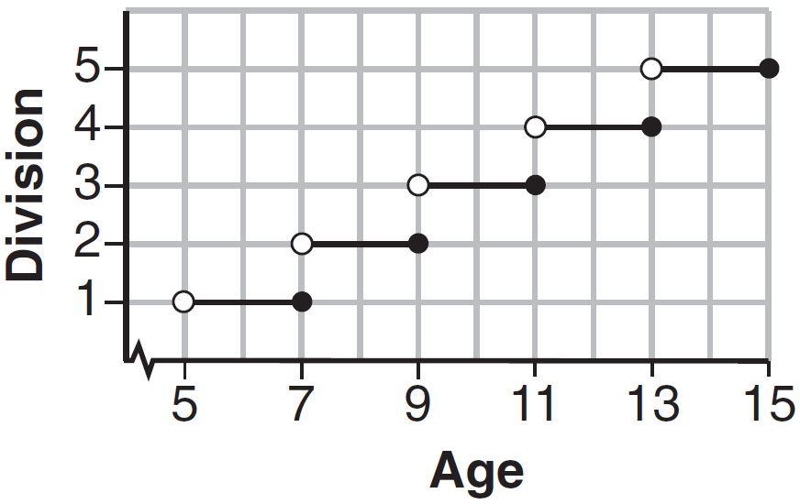
Each step corresponds to a specific domain. The function rule for the graph above is:
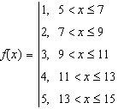
DEVELOPING ESSENTIAL SKILLS
Model each context with a step function.
- You want to bring cupcakes to math club to celebrate your birthday. Each box of cupcakes contains 6 cupcakes and costs $4.00. You expect as many as 30 students to be at math club. Create a function rule that models the cost in terms of the number of students in math club.
- You’re ordering pizza for your math teacher’s birthday party. You estimate that each pizza will serve 4 people and that up to 26 people may attend. Create a function rule that models the number of pizzas you need to order in terms of the number of people attending.

REGENTS EXAM QUESTIONS (through June 2018)
F.IF.C.7: Graphing Step Functions

485) Morgan can start wrestling at age 5 in Division 1. He remains in that division until his next odd birthday when he is required to move up to the next division level. Which graph correctly represents this information?
1) | 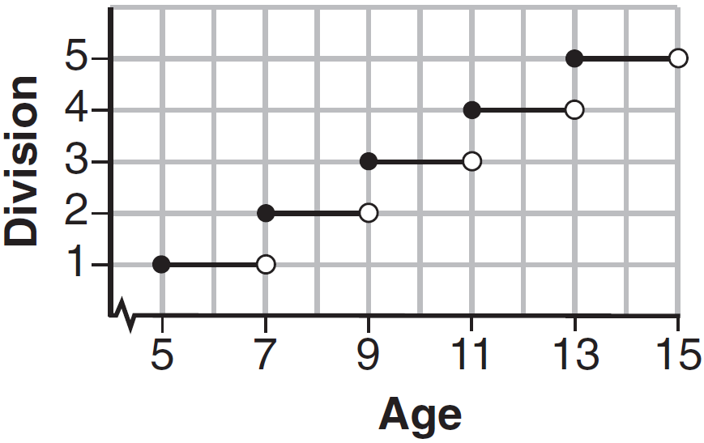 | 3) | 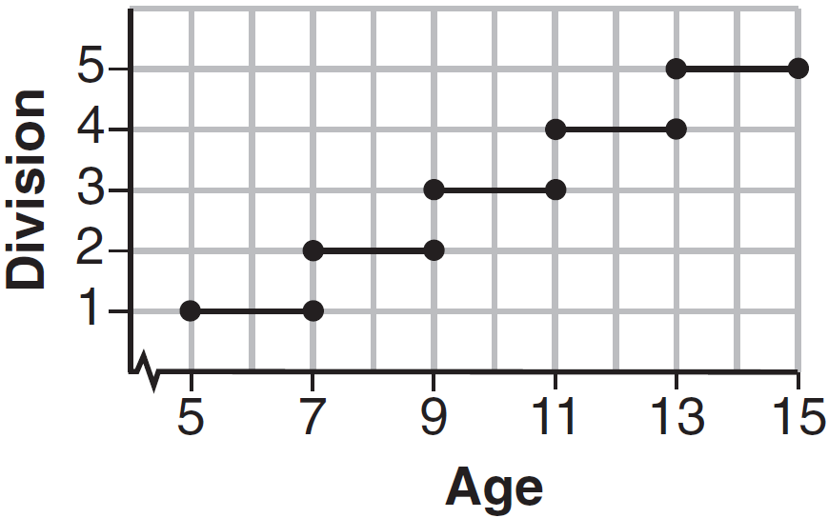
2) |  | 4) | 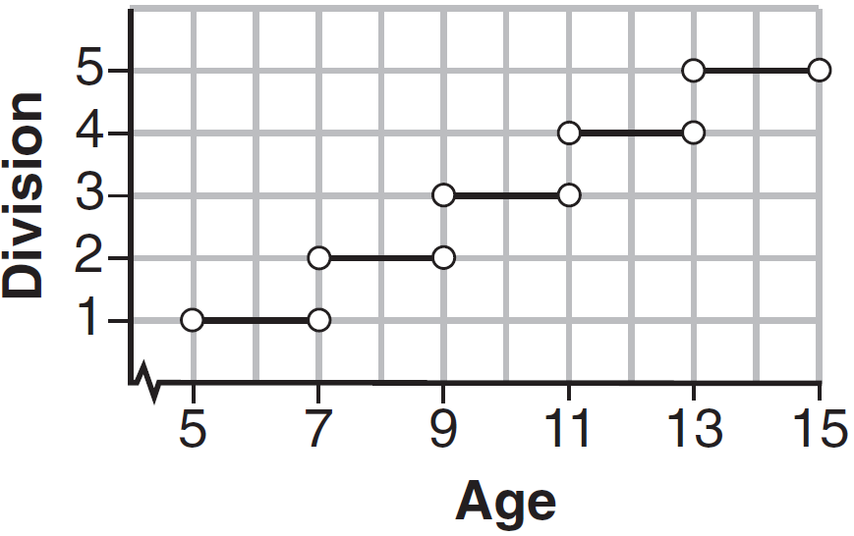

486) The table below lists the total cost for parking for a period of time on a street in Albany, N.Y. The total cost is for any length of time up to and including the hours parked. For example, parking for up to and including 1 hour would cost $1.25; parking for 3.5 hours would cost $5.75.

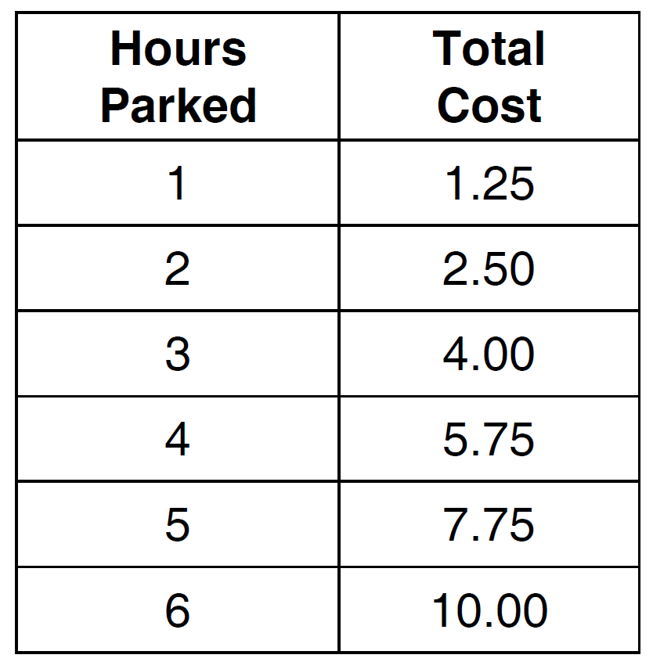

Graph the step function that represents the cost for the number of hours parked.

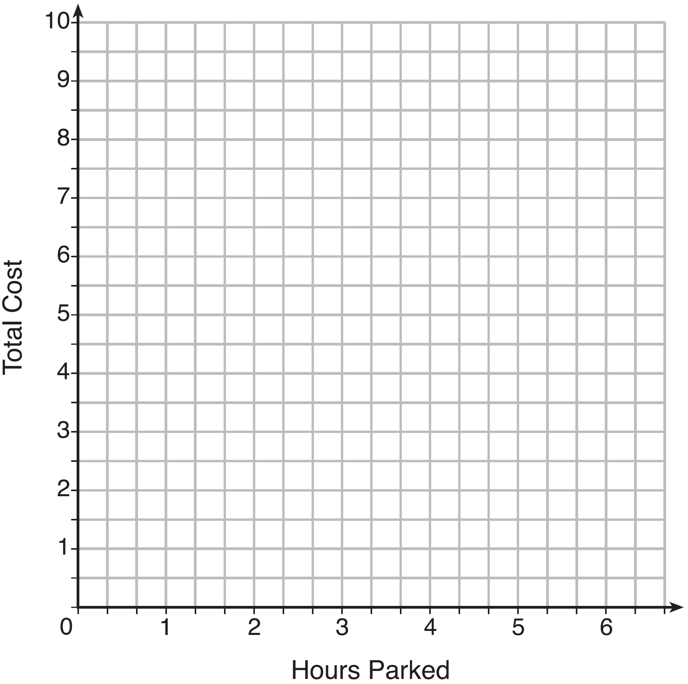

Explain how the cost per hour to park changes over the six-hour period.

SOLUTIONS

485) ANS: 1
Strategy: Focus on whether the line segments should begin and end with closed or open circles. A closed circle is included. An open circle is not included.

PTS: 2 NAT: F.IF.C.7 TOP: Graphing Step Functions
KEY: bimodalgraph

486) ANS:

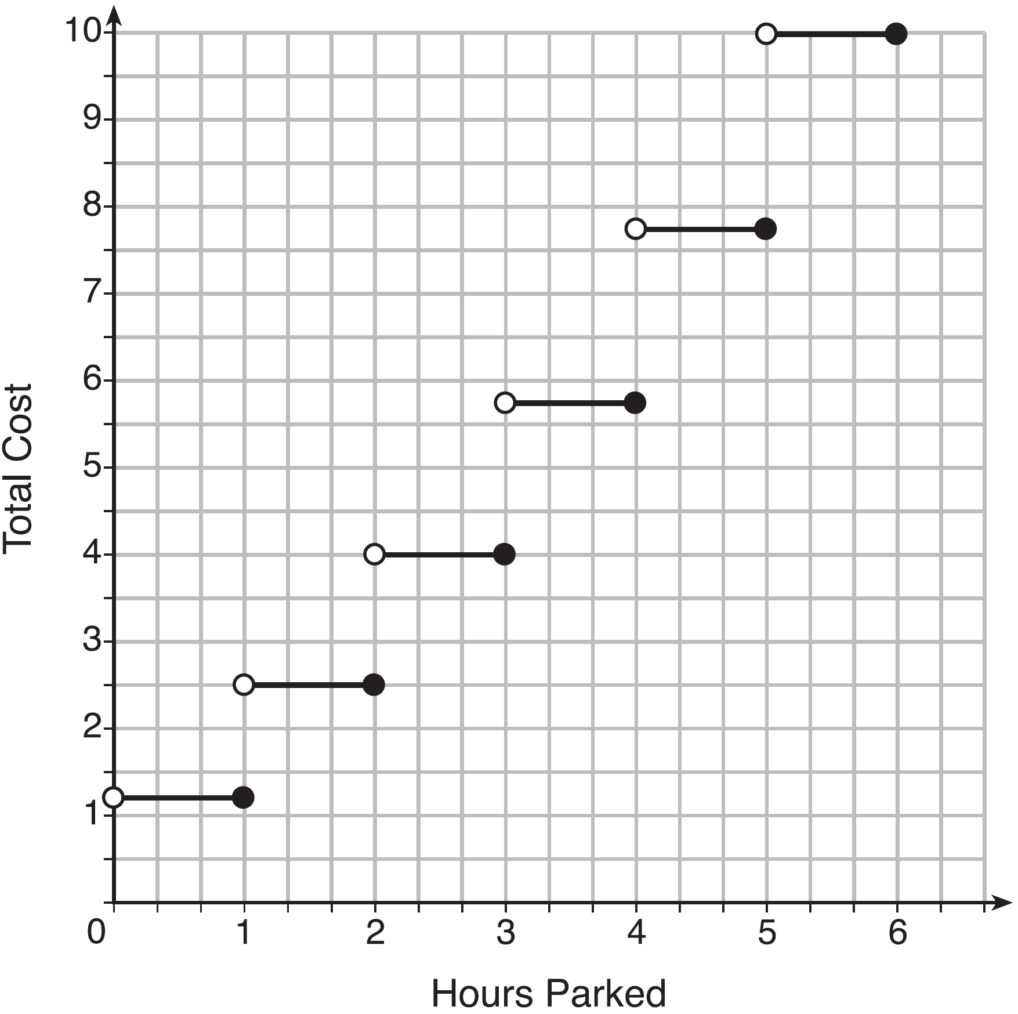
The cost per houir to park gets bigger over the six hour period.

Strategy: Graph this step function by hand using information from the table. This function has too many sections to easily input into a graphing calculator.

STEP 1. Graph the section for the domain . The table shows that this interval corresponds to a cost of $1.25 on the y-axis. Use an open dot at (0, 1.25) and a closed dot at (1, 1.25). Connect the two dots with a solid line.
STEP 2. Graph the section for the domain . The table shows that this interval corresponds to a cost of $2.50 on the y-axis. Use an open dot at (1, 2.50) and a closed dot at (2, 2.50). Connect the two dots with a solid line.
STEP 3. Graph the section for the domain . The table shows that this interval corresponds to a cost of $4.00 on the y-axis. Use an open dot at (2, 4.00) and a closed dot at (3, 4.00). Connect the two dots with a solid line.
STEP 4. Graph the section for the domain . The table shows that this interval corresponds to a cost of $5.75 on the y-axis. Use an open dot at (3, 4.75) and a closed dot at (4, 4.75). Connect the two dots with a solid line.
STEP 5. Graph the section for the domain . The table shows that this interval corresponds to a cost of $7.75 on the y-axis. Use an open dot at (4, 7.75) and a closed dot at (5, 7.75). Connect the two dots with a solid line.
STEP 6. Graph the section for the domain . The table shows that this interval corresponds to a cost of $10.00 on the y-axis. Use an open dot at (5, 10.00) and a closed dot at (6, 10.00). Connect the two dots with a solid line.

STEP 7: Answer the question based on the graph and the table.

PTS: 4 NAT: F.IF.C.7 TOP: Graphing Step Functions

