1 The graph of is shown below.

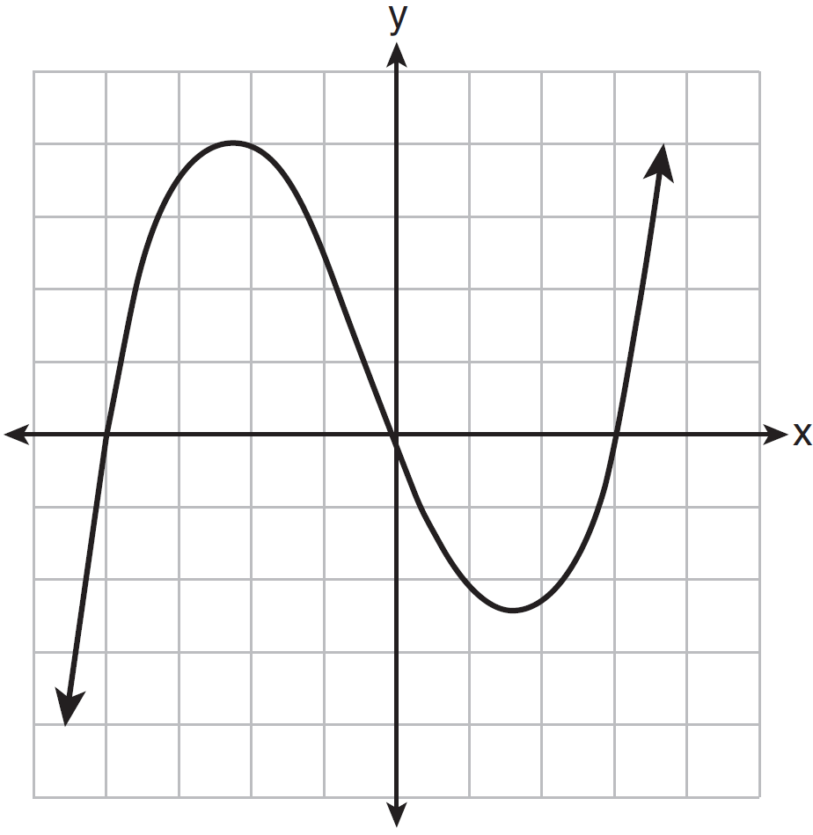

What is the remainder when is divided by ?
1)
2)
3) | 0
4) | 4

2 Which binomial is not a factor of the expression ?
1)
2)
3)
4)

3 Which expression is a factor of ?
1)
2)
3)
4)

4 What is the remainder when is divided by ?
1)
2)
3) | 13
4) | 29

5 If , what is the remainder of ?
1)
2) | 0
3) | 40
4) | 240

6 If is a factor of , what is the value of k?
1) | 0
2) | 2
3) | 3
4)

7 Which binomial is a factor of ?
1)
2)
3)
4)

8 If is a factor of , then which statement must be true?
1)
2)
3)
4)

9 Given , which statement is true?
1) | is a factor because .
2) | is a factor because .
3) | is a factor because .
4) | is a factor because .

10 Consider the function . Which statement is true?
1) | is a factor of .
2) | is a factor of .
3) | 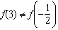
4) | 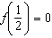

11 For the polynomial , if , it can be concluded that
1) | is a factor of
2) | is a factor of
3) | when is divided by 3, the remainder is zero
4) | when is divided by , the remainder is zero

12 When is divided by , the remainder is 0. Given , which conclusion about is true?
1)
2)
3) | is a factor of .
4) | No conclusion can be made regarding .

13 If , then 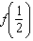
1) | equals 0 and is a factor of
2) | equals 0 and is a factor of
3) | does not equal 0 and is not a factor of
4) | does not equal 0 and is a factor of

14 Which statements must be true about the polynomial function ?
I. is a factor of
II.
III. 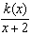 has a remainder of 5
1) | II, only
2) | I and II
3) | II and III
4) | I, II, and III

15 Show why is a factor of . Justify your answer.

16 Use an appropriate procedure to show that is a factor of the function . Explain your answer.

17 Determine if is a factor of . Explain your answer.

18 Determine if is a factor of . Explain your answer.

19 Is a factor of ? Justify your answer.

20 Given , find the value of . What does your answer tell you about as a factor of ? Explain.

21 Determine for which polynomial(s) is a factor. Explain your answer.
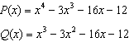

22 The polynomial function has a factor of . Determine the value of a.

23 Evaluate given . Explain what your answer tells you about as a factor. Algebraically find the remaining zeros of .
1 ANS: 3
Since is a factor of , there is no remainder.

REF: 081621aii

2 ANS: 2
-4 | 1 | -11 | 16 | 84
 |  | -4 | 60 | -304
 | 1 | -15 | 76
Since there is a remainder when the cubic is divided by , this binomial is not a factor.

REF: 081720aii

3 ANS: 1
-2 | 1 | -1 | -11 | 5 | 30
 |  | -2 | 6 | 10 | -30
 | 1 | -3 | -5 | 15 | 0
Since there is no remainder when the quartic is divided by , this binomial is a factor.

REF: 082320aii

4 ANS: 4

REF: 062422aii

5 ANS: 4

REF: 011819aii

6 ANS: 3
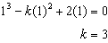

REF: 061812aii

7 ANS: 1
2 | 1 | 0 | -4 | -4 | 8
 |  | 2 | 4 | 0 | -8
 | 1 | 2 | 0 | -4 | 0
Since there is no remainder when the quartic is divided by , this binomial is a factor.

REF: 061711aii

8 ANS: 3 REF: 012508aii

9 ANS: 4 REF: 061907aii

10 ANS: 2
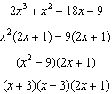

REF: 082206aii

11 ANS: 2 REF: 062206aii

12 ANS: 2 REF: 011720aii

13 ANS: 2
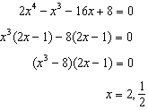

REF: 012307aii

14 ANS: 3
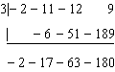 is not a factor since there is a remainder. 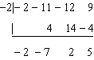

REF: 062414aii

15 ANS:
Since , there is no remainder when is divided by , and so is a factor.

REF: 012026aii

16 ANS:
Any method that demonstrates 4 is a zero of confirms that is a factor, as suggested by the Remainder Theorem. 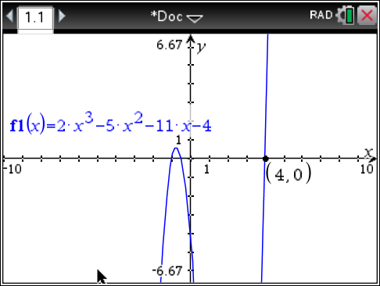

REF: spr1507aii

17 ANS:
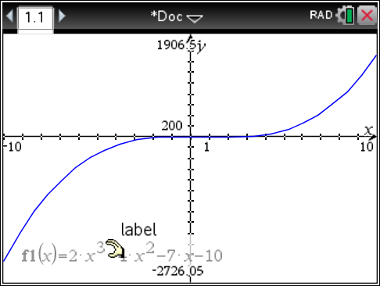 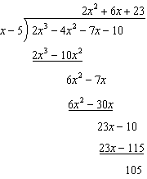 Since there is a remainder, is not a factor.

REF: 061627aii

18 ANS:
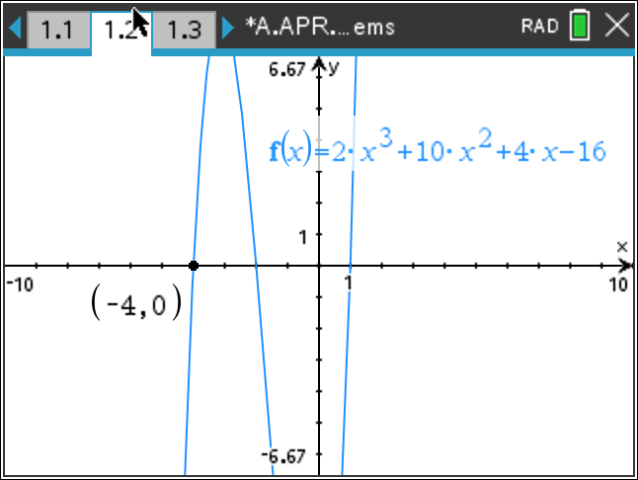 Since is a zero, is a factor.

REF: 012426aii

19 ANS:
Since there is no remainder when the cubic is divided by , this binomial is a factor.
-3 | 7 | 27 | 9 | -27
 |  | -21 | -18 | 27
 | 7 | 6 | -9 | 0

REF: 082426aii

20 ANS:
. Since there is a remainder when the cubic is divided by , this binomial is not a factor.
2 | 1 | -4 | 4 | 6
 |  | 2 | -4 | 0
 | 1 | -2 | 0 | -6

REF: 061725aii

21 ANS:
is a factor of since .

REF: 081929aii

22 ANS:
; 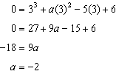

REF: 062328aii

23 ANS:
; is a factor of ; 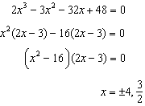

REF: 081834aii

