1 Emmeline is working on one side of a polynomial identity proof used to form Pythagorean triples. Her work is shown below:
Step 1:
Step 2:
Step 3:
Step 4:
What statement is true regarding Emmeline's work?
1) | Emmeline's work is entirely correct. | 3) | There are mistakes in step 2 and step 4.
2) | There is a mistake in step 2, only. | 4) | There is a mistake in step 4, only.

2 The expression can not be written as
1) |  | 3)
2) |  | 4)

3 Which equation does not represent an identity?
1) |  | 3)
2) |  | 4)

4 Which statement(s) are true for all real numbers?
I
II
1) | I, only | 3) | I and II
2) | II, only | 4) | neither I nor II

5 For which equations will the value make the statement an identity?
I
II
1) | I, only | 3) | I and II
2) | II, only | 4) | neither I nor II

6 Mr. Farison gave his class the three mathematical rules shown below to either prove or disprove. Which rules can be proved for all real numbers?
I
II
III
1) | I, only | 3) | II and III
2) | I and II | 4) | I and III

7 Which equation represents a polynomial identity?
1) |  | 3)
2) |  | 4)

8 The expression 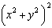 is not equivalent to
1) | 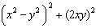 | 3)
2) |  | 4) | 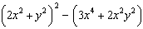

9 Which equation is true for all real values of x?
1) |  | 3)
2) |  | 4)

10 How many equations below are identities?
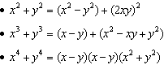
1) | 1 | 3) | 3
2) | 2 | 4) | 0

11 Given the following polynomials
Which identity is true?
1) |  | 3)
2) |  | 4)

12 Given the polynomial identity , which equation must also be true for all values of x and y?
1)
2)
3)
4)

13 Algebraically prove that the difference of the squares of any two consecutive integers is an odd integer.

14 Verify the following Pythagorean identity for all values of x and y:

15 Erin and Christa were working on cubing binomials for math homework. Erin believed they could save time with a shortcut. She wrote down the rule below for Christa to follow.
Does Erin's shortcut always work? Justify your result algebraically.

16 Algebraically determine the values of h and k to correctly complete the identity stated below.
1 ANS: 3 REF: 012003aii

2 ANS: 2 REF: 011806aii

3 ANS: 4

REF: 012417aii

4 ANS: 4

REF: 061902aii

5 ANS: 1
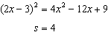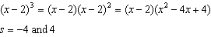

REF: 062405aii

6 ANS: 4

REF: 081620aii

7 ANS: 2 REF: 012311aii

8 ANS: 2
1) ; 3) ; 4)

REF: 012522aii

9 ANS: 1
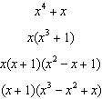

REF: 082404aii

10 ANS: 4
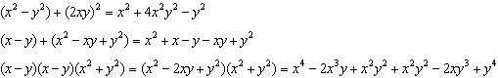

REF: 062322aii

11 ANS: 4
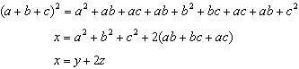

REF: 061822aii

12 ANS: 1
2) ; 3) ; 4) 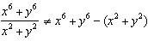

REF: 082219aii

13 ANS:
Let x equal the first integer and equal the next. . is an odd integer.

REF: fall1511aii

14 ANS:
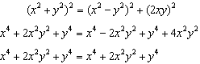

REF: 081727aii

15 ANS:
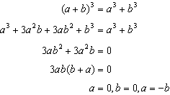No. Erin’s shortcut only works if , or .

REF: 011927aii

16 ANS:
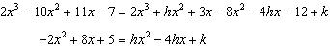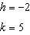

REF: 011733aii

