1 What is the least common denominator of , , and ?
1) 2) 3) 4)

2 The sum of 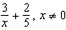, is
1) 2) 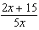 3) 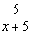 4) 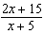

3 What is the sum of and ?
1) 1 2) 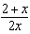 3) 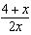 4) 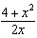

4 Which expression is equivalent to 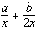?
1) 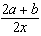 2) 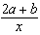 3) 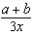 4) 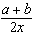

5 What is the sum of and ?
1) 2) 3) 4)

6 The expression 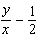 is equivalent to
1) 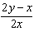 2) 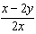 3) 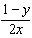 4) 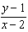

7 Expressed as a single fraction, 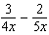 is equal to
1) 2) 3) 4)

8 Expressed as a single fraction, what is 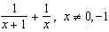?
1) 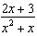 2) 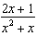 3) 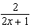 4)

9 What is the sum of 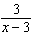 and 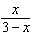?
1) 1 2) 3) 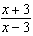 4) 0

10 What is the sum of 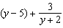?
1) 2) 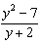 3) 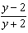 4) 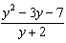

11 The expression 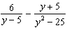 is equivalent to
1) 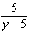 2) 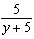 3) 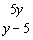 4) 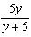

12 The expression 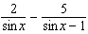 is equivalent to
1) 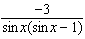 2) 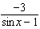 3) 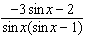 4) 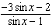

13 Express in simplest form: 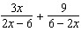

14 Express in simplest form: 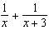
1 ANS: 3
The LCM of 2 and 7 is 14. The LCM of x and x is x. The LCD is 14x.

REF: 060412a

2 ANS: 2
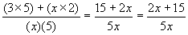

REF: 080207a

3 ANS: 4
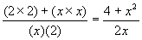

REF: 010423a

4 ANS: 1
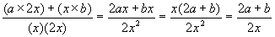

REF: 089911a

5 ANS: 4
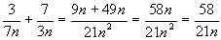

REF: 060727a

6 ANS: 1
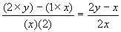

REF: 010016a

7 ANS: 4
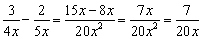

REF: 010921a

8 ANS: 2
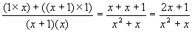

REF: 069906a

9 ANS: 2
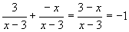

REF: 010315b

10 ANS: 4
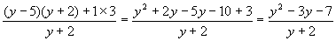

REF: 080505b

11 ANS: 1
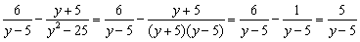

REF: 080805b

12 ANS: 3

REF: 060816b

13 ANS:
. 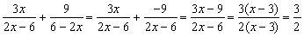

REF: 060929b

14 ANS:
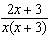. 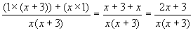

REF: 060524b

