1 Boyle's Law involves the pressure and volume of gas in a container. It can be represented by the formula . When the formula is solved for , the result is
1)
2) | 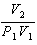
3) | 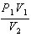
4) | 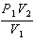

2 Michael borrows money from his uncle, who is charging him simple interest using the formula . To figure out what the interest rate, r, is, Michael rearranges the formula to find r. His new formula is r equals
1) | 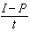
2) | 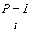
3)
4)

3 The formula represents the equation of a line in standard form. Which expression represents y in terms of A, B, C, and x?
1) | 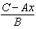
2) | 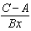
3) | 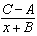
4) | 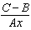

4 When the formula is solved for w, the result is
1) | 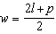
2) | 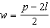
3) | 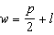
4) | 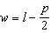

5 An equation used to find the velocity of an object is given as , where u is the initial velocity, v is the final velocity, a is the acceleration of the object, and s is the distance traveled. When this equation is solved for a, the result is
1) | 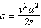
2) | 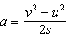
3)
4)

6 The formula for the area of a trapezoid is 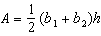. The height, h, of the trapezoid may be expressed as
1)
2) | 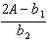
3) | 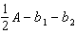
4) | 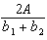

7 The volume of a trapezoidal prism can be found using the formula 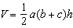. Which equation is correctly solved for b?
1) | 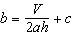
2) | 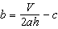
3) | 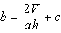
4) | 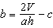

8 The amount of energy, Q, in joules, needed to raise the temperature of m grams of a substance is given by the formula , where C is the specific heat capacity of the substance. If its initial temperature is , an equation to find its final temperature, , is
1) | 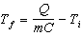
2) | 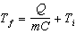
3) | 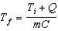
4) | 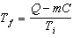

9 The equation for the volume of a cylinder is . The positive value of r, in terms of h and V, is
1) | 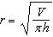
2)
3)
4) | 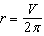

10 The formula for electrical power, P, is , where I is current and R is resistance. The formula for I in terms of P and R is
1) | 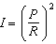
2) | 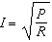
3)
4)

11 The formula for the volume of a cone is 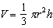. The radius, r, of the cone may be expressed as
1) | 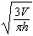
2) | 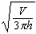
3) | 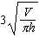
4) | 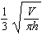

12 The distance a free falling object has traveled can be modeled by the equation 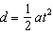, where a is acceleration due to gravity and t is the amount of time the object has fallen. What is t in terms of a and d?
1) | 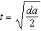
2) | 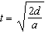
3) | 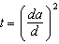
4) | 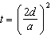

13 The formula for blood flow rate is given by 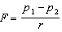, where F is the flow rate, the initial pressure, the final pressure, and r the resistance created by blood vessel size. Which formula can not be derived from the given formula?
1)
2)
3)
4) | 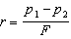

14 Students were asked to write a formula for the length of a rectangle by using the formula for its perimeter, . Three of their responses are shown below.
I. 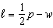
II. 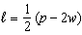
III. 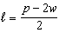
Which responses are correct?
1) | I and II, only
2) | II and III, only
3) | I and III, only
4) | I, II, and III

15 The formula for the sum of the degree measures of the interior angles of a polygon is . Solve for n, the number of sides of the polygon, in terms of S.

16 The formula 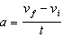 is used to calculate acceleration as the change in velocity over the period of time. Solve the formula for the final velocity, , in terms of initial velocity, , acceleration, a, and time, t.

17 The formula 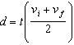 is used to calculate the distance, d, covered by an object in a given period of time, t. Solve the formula for , the final velocity, in terms of d, t, and , the initial velocity.

18 The temperature inside a cooling unit is measured in degrees Celsius, C. Josh wants to find out how cold it is in degrees Fahrenheit, F. Solve the formula 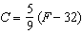 for F so that Josh can convert Celsius to Fahrenheit.

19 The formula for converting degrees Fahrenheit (F) to degrees Kelvin (K) is:
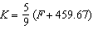
Solve for F, in terms of K.

20 A formula for determining the finite sum, S, of an arithmetic sequence of numbers is 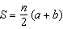, where n is the number of terms, a is the first term, and b is the last term. Express b in terms of a, S, and n.

21 The formula for the area of a trapezoid is 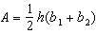. Express in terms of A, h, and . The area of a trapezoid is 60 square feet, its height is 6 ft, and one base is 12 ft. Find the number of feet in the other base.

22 The formula 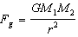 calculates the gravitational force between two objects where G is the gravitational constant, is the mass of one object, is the mass of the other object, and r is the distance between them. Solve for the positive value of r in terms of , G, , and .

23 The volume of a large can of tuna fish can be calculated using the formula . Write an equation to find the radius, r, in terms of V and h. Determine the diameter, to the nearest inch, of a large can of tuna fish that has a volume of 66 cubic inches and a height of 3.3 inches.

24 The formula for the volume of a cone is . Solve the equation for h in terms of V, r, and .

25 Using the formula for the volume of a cone, express r in terms of V, h, and .
1 ANS: 3 REF: 011704ai

2 ANS: 3 REF: 011606ai

3 ANS: 1
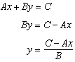

REF: 062211ai

4 ANS: 2
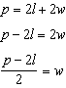

REF: 012509ai

5 ANS: 2
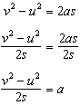

REF: 012408ai

6 ANS: 4
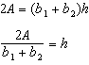

REF: 062315ai

7 ANS: 4
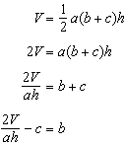

REF: 082224ai

8 ANS: 2
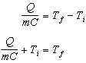

REF: 012318ai

9 ANS: 1 REF: 011516ai

10 ANS: 2
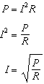

REF: 011920ai

11 ANS: 1
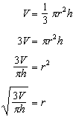

REF: 061423ai

12 ANS: 2
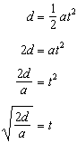

REF: 061519ai

13 ANS: 3 REF: 061723ai

14 ANS: 4 REF: 061823ai

15 ANS:
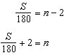

REF: 061631ai

16 ANS:
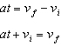

REF: 081928ai

17 ANS:
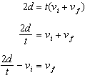

REF: 082328ai

18 ANS:
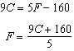

REF: 062131ai

19 ANS:
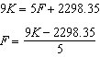

REF: 081829ai

20 ANS:
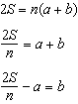

REF: 012032ai

21 ANS:
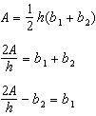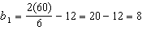

REF: 081434ai

22 ANS:
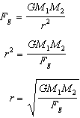

REF: 011830ai

23 ANS:
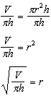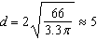

REF: 081535ai

24 ANS:
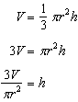

REF: 061930ai

25 ANS:

REF: 081727ai

