1 The solution to is
1)
2) | 28
3)
4)

2 The solution to is
1)
2) | 2
3)
4)

3 What is the solution to ?
1)
2)
3)
4)

4 An equation is given below.
The solution to the equation is
1) | 8.3
2) | 8.7
3) | 3
4) | -3

5 The value of x that satisfies the equation 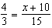 is
1)
2) | 5
3) | 10
4) | 30

6 The solution to 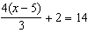 is
1) | 15
2) | 14
3) | 6
4) | 4

7 What is the value of x in the equation 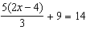?
1) | 1.9
2) | 3.5
3) | 5.3
4) | 8.9

8 What is the value of x in the equation 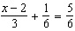?
1) | 4
2) | 6
3) | 8
4) | 11

9 Which value of x makes 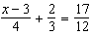 true?
1) | 8
2) | 6
3) | 0
4) | 4

10 Which value of x satisfies the equation 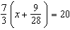?
1) | 8.25
2) | 8.89
3) | 19.25
4) | 44.92

11 Which value of x satisfies the equation 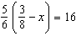?
1)
2)
3)
4)

12 The solution to 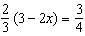 is
1)
2)
3)
4)

13 When solving 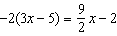 for x, the solution is
1)
2)
3)
4)

14 The value of x which makes 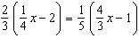 true is
1)
2)
3)
4)

15 What is the solution to the equation 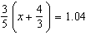?
1)
2) | 0.4
3)
4)

16 Which of the equations below have the same solution?
I.
II.
III. 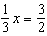
1) | I and II, only
2) | I and III, only
3) | II and III, only
4) | I, II, and III

17 Solve algebraically for x:

18 Solve the equation algebraically for x:

19 Solve the equation below algebraically for the exact value of x.
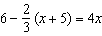

20 Solve algebraically for x:
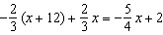
1 ANS: 4
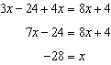

REF: 062106ai

2 ANS: 2
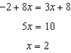

REF: 081804ai

3 ANS: 2
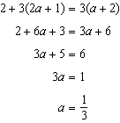

REF: 012307ai

4 ANS: 1
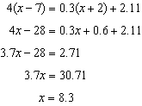

REF: 061719ai

5 ANS: 3
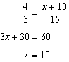

REF: 081904ai

6 ANS: 2
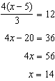

REF: 062406ai

7 ANS: 2
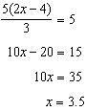

REF: 082304ai

8 ANS: 1
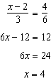

REF: 081420ai

9 ANS: 2
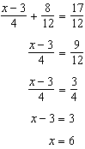

REF: 012005ai

10 ANS: 1
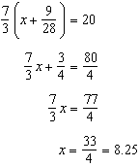

REF: 061405ai

11 ANS: 2
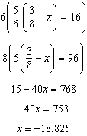

REF: 081713ai

12 ANS: 4
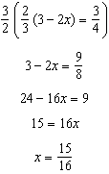

REF: 012416ai

13 ANS: 1
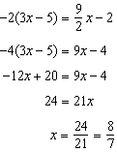

REF: 012511ai

14 ANS: 4
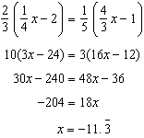

REF: 011822ai

15 ANS: 2
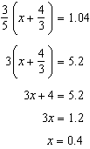

REF: 011905ai

16 ANS: 3
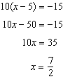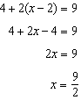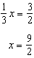

REF: 082217ai

17 ANS:
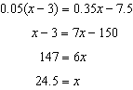

REF: 082428ai

18 ANS:
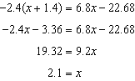

REF: 062325ai

19 ANS:
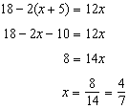

REF: 061830ai

20 ANS:
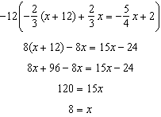

REF: 061925ai

