1 What is the solution to ?
1) |  | 3)
2) | 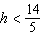 | 4) | 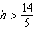

2 When is solved for x, the solution is
1) |  | 3)
2) |  | 4)

3 The solution to is
1) |  | 3)
2) |  | 4)

4 What is the solution to ?
1) |  | 3)
2) |  | 4)

5 What is the solution to the inequality ?
1) |  | 3)
2) |  | 4)

6 What is the solution to the inequality ?
1) |  | 3)
2) |  | 4)

7 What is the solution to 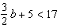?
1) |  | 3)
2) |  | 4)

8 The inequality 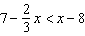 is equivalent to
1) |  | 3)
2) | 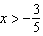 | 4) | 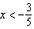

9 What is the solution to the inequality 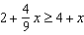?
1) | 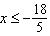 | 3) | 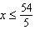
2) | 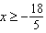 | 4) | 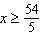

10 What is the solution to the inequality below?
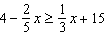
1) |  | 3)
2) |  | 4)

11 Which graph is the solution to the inequality ?
1) | 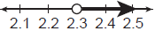 | 3) | 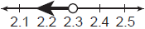
2) | 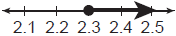 | 4) | 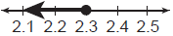

12 Solve algebraically.

13 Solve algebraically for y:

14 Solve the inequality 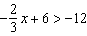 algebraically for x.

15 Solve the inequality below:

16 Solve algebraically for x:

17 Solve 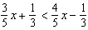 for x.
1 ANS: 1
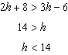

REF: 081607ai

2 ANS: 4
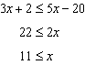

REF: 061609ai

3 ANS: 4
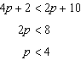

REF: 061801ai

4 ANS: 2
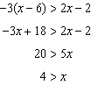

REF: 082310ai

5 ANS: 4
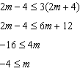

REF: 082413ai

6 ANS: 4
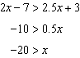

REF: 012418ai

7 ANS: 1
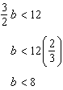

REF: 062207ai

8 ANS: 1
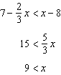

REF: 011507ai

9 ANS: 1
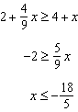

REF: 081711ai

10 ANS: 3
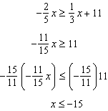

REF: 062322ai

11 ANS: 4
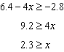

REF: 012522ai

12 ANS:
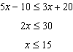

REF: 062425ai

13 ANS:
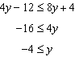

REF: 062125ai

14 ANS:
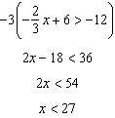

REF: 012327ai

15 ANS:
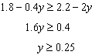

REF: 011727ai

16 ANS:
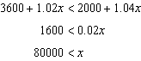

REF: 011925ai

17 ANS:
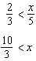

REF: 081929ai

