1 The quadratic equation is rewritten in the form , where q is a constant. What is the value of p?
1)
2)
3)
4) | 9

2 Which equation has the same solution as ?
1)
2)
3)
4)

3 Which equation is equivalent to ?
1)
2)
3)
4)

4 When solving the equation by completing the square, which equation is a step in the process?
1)
2)
3)
4)

5 When solving by completing the square, which equation is a step in the process?
1)
2)
3)
4)

6 Which step can be used when solving by completing the square?
1)
2)
3)
4)

7 Which equation has the same solutions as ?
1)
2)
3)
4)

8 Which equation has the same solutions as ?
1)
2)
3)
4)

9 Which equation has the same solution as ?
1)
2)
3)
4)

10 When using the method of completing the square, which equation is equivalent to ?
1)
2)
3)
4)

11 When completing the square for , which equation is a correct step in this process?
1)
2)
3)
4)

12 If is solved by completing the square, one of the steps in the process is
1)
2)
3)
4)

13 If is solved by completing the square, an intermediate step would be
1)
2)
3)
4)

14 The method of completing the square was used to solve the equation . Which equation is a correct step when using this method?
1)
2)
3)
4)

15 What are the roots of the equation ?
1)
2)
3)
4)

16 What are the solutions to the equation ?
1)
2)
3)
4)

17 What are the solutions to the equation ?
1)
2)
3)
4)

18 Which value of k will make 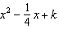 a perfect square trinomial?
1)
2)
3)
4)

19 Brian correctly used a method of completing the square to solve the equation . Brian’s first step was to rewrite the equation as . He then added a number to both sides of the equation. Which number did he add?
1)
2)
3)
4) | 49

20 When directed to solve a quadratic equation by completing the square, Sam arrived at the equation 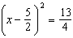. Which equation could have been the original equation given to Sam?
1)
2)
3)
4)

1 ANS: 3
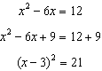

REF: 061812ai

2 ANS: 2

REF: 061408ai

3 ANS: 2
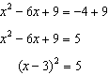

REF: 082320ai

4 ANS: 2
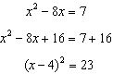

REF: 011614ai

5 ANS: 1
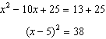

REF: 082215ai

6 ANS: 1 REF: 061408a2

7 ANS: 4
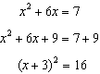

REF: 011517ai

8 ANS: 2
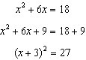

REF: 082408ai

9 ANS: 1
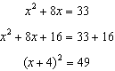

REF: 011915ai

10 ANS: 4
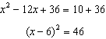

REF: 012319ai

11 ANS: 1
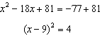
REF: 062306ai

12 ANS: 3
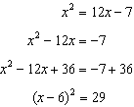
REF: 061505a2

13 ANS: 2
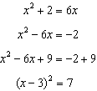
REF: 011116a2

14 ANS: 1
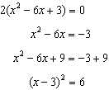
REF: 011722ai

15 ANS: 2
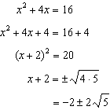
REF: 061410ai

16 ANS: 2
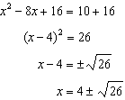
REF: 061722ai

17 ANS: 1
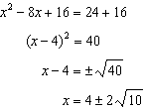
REF: 061523ai

18 ANS: 1
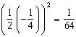
REF: 081527a2

19 ANS: 2 REF: 061122a2

20 ANS: 4
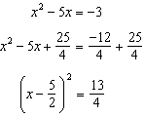
REF: 061518ai

