1 The solution to the equation is
1) |  | 3) | 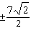
2) |  | 4) | 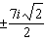

2 What is the solution when the equation is solved for x, where w is a positive integer?
1) |  | 3) | 6
2) | 0 | 4)

3 The roots of the equation are
1) |  | 3)
2) |  | 4)

4 The roots of the equation in simplest form are
1) |  | 3)
2) |  | 4)

5 The roots of the equation are
1) |  | 3)
2) |  | 4)

6 The solutions to the equation 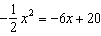 are
1) |  | 3)
2) |  | 4)

7 A solution of the equation is
1) | 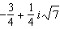 | 3) | 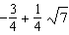
2) | 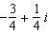 | 4)

8 The roots of the equation are
1) | 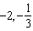 | 3) | 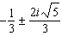
2) | 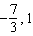 | 4) | 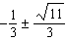

9 What are the solutions to
1) | 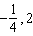 | 3) | 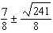
2) | 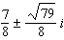 | 4) | 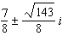

10 The solutions to the equation are
1) | 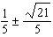 | 3) | 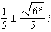
2) | 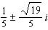 | 4) | 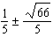

11 The solution to the equation is
1) | 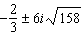 | 3) | 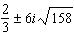
2) | 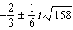 | 4) | 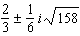

12 The solutions to the equation are
1) | 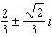 | 3) | 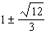
2) | 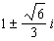 | 4)

13 If a solution of is expressed in simplest form, the value of b is
1) | 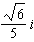 | 3)
2) |  | 4)

14 Solve the equation algebraically. Express the answer in form.

15 Solve the equation . Express the answer in form.

16 Solve the equation . Write your solution in form.

17 a) Algebraically determine the roots, in simplest form, to the equation below.
b) Consider the system of equations below.
The graph of this system confirms the solution from part a is imaginary. Explain why.
1 ANS: 4
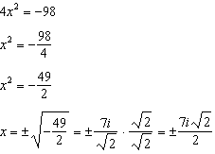

REF: 061707aii

2 ANS: 4
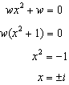

REF: 061912aii

3 ANS: 3
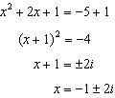

REF: 081703aii

4 ANS: 3
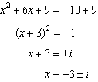

REF: 012416aii

5 ANS: 1
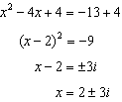

REF: 062312aii

6 ANS: 3
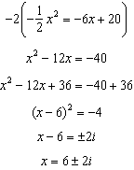

REF: fall1504aii

7 ANS: 1
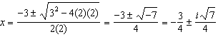

REF: 061612aii

8 ANS: 3
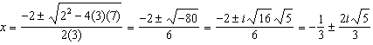

REF: 081809aii

9 ANS: 2
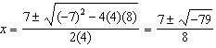

REF: 012507aii

10 ANS: 2
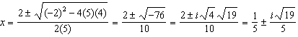

REF: 011905aii

11 ANS: 4
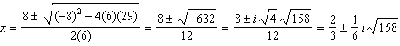

REF: 011711aii

12 ANS: 2
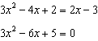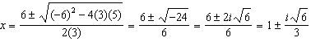

REF: 062410aii

13 ANS: 2
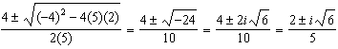

REF: 012020aii

14 ANS:
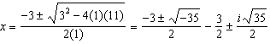

REF: 082432aii

15 ANS:
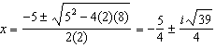

REF: 061827aii

16 ANS:
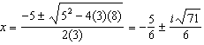

REF: 082327aii

17 ANS:
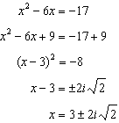The solution is imaginary because the parabola and line do not intersect.

REF: 081936aii

