1 Which graph represents the solution of and ?
1) | 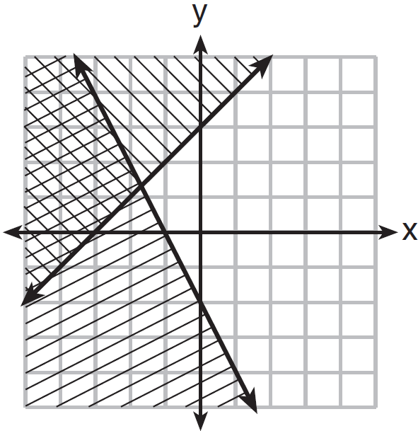 | 3) | 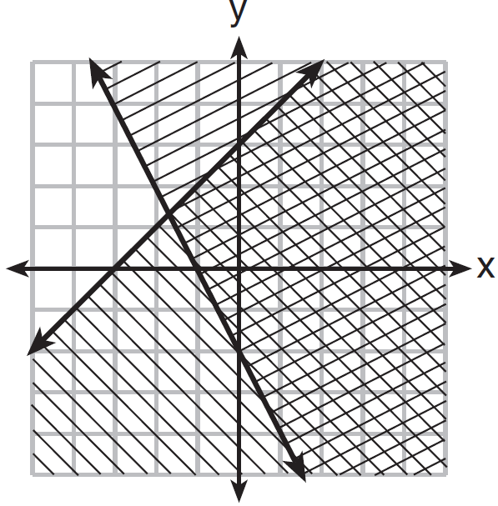
2) | 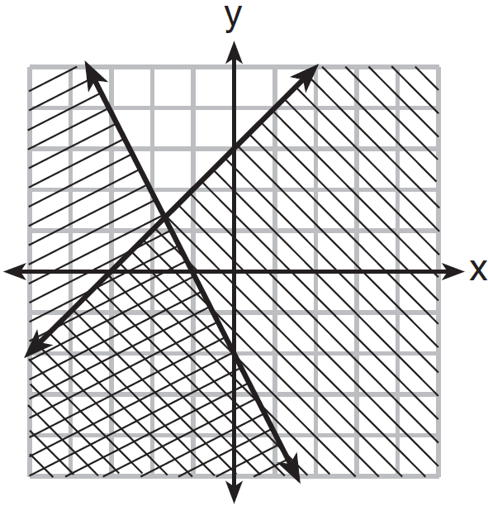 | 4) | 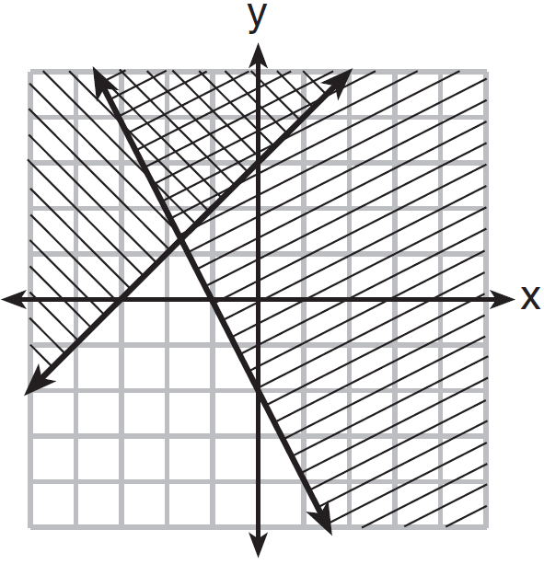

2 Given: 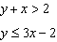
Which graph shows the solution of the given set of inequalities?
1) | 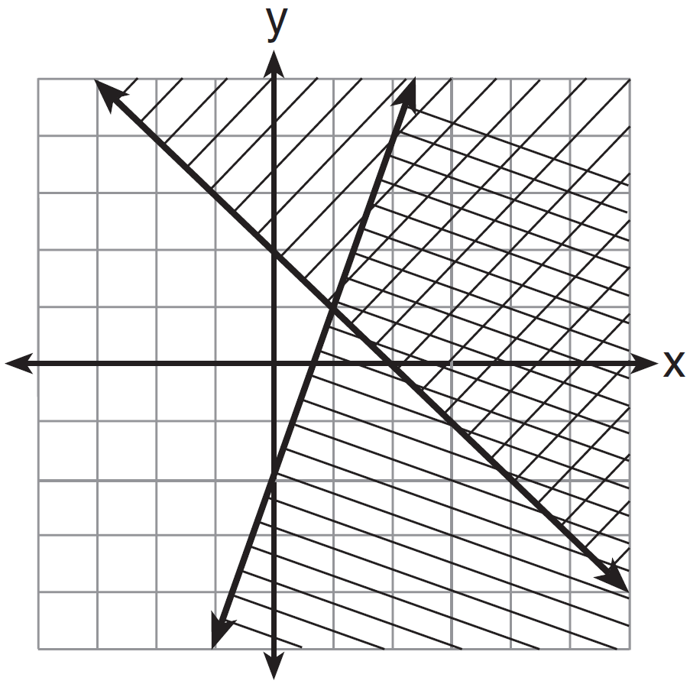 | 3) | 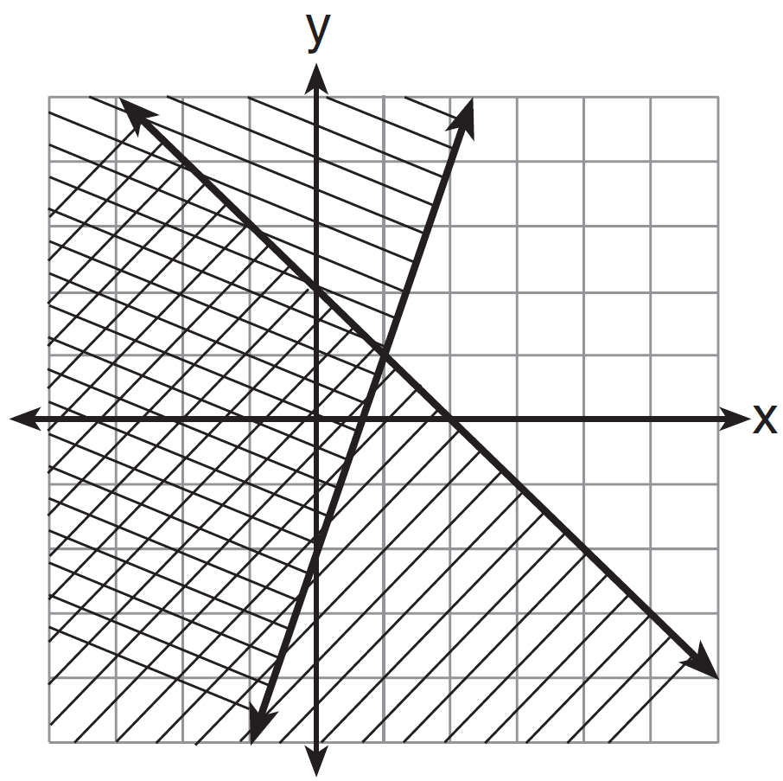
2) | 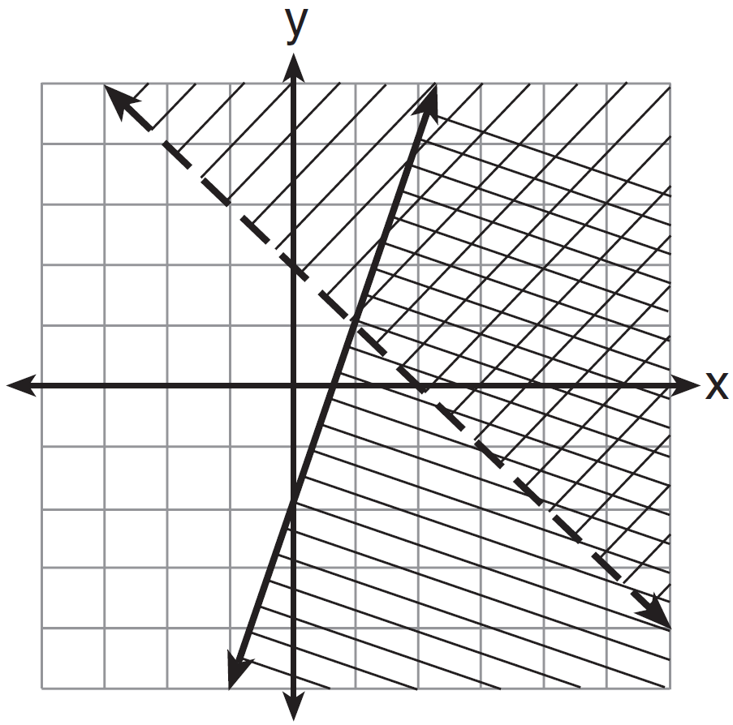 | 4) | 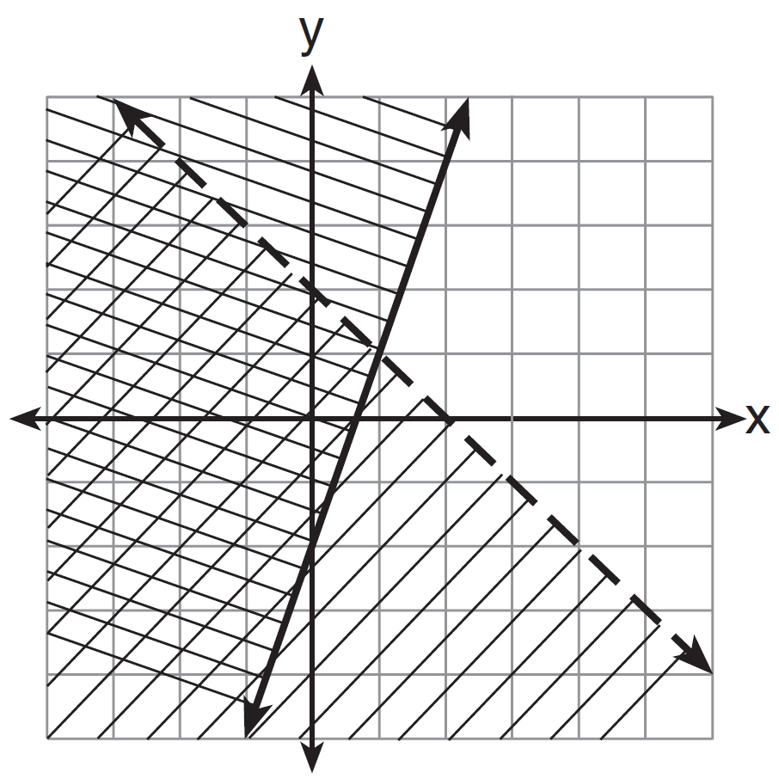

3 A system of inequalities is graphed on the set of axes below.

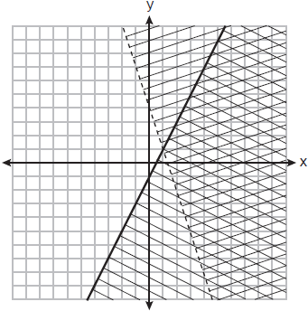

Which point is a solution to this system?
1) |  | 3)
2) |  | 4)

4 What is one point that lies in the solution set of the system of inequalities graphed below?

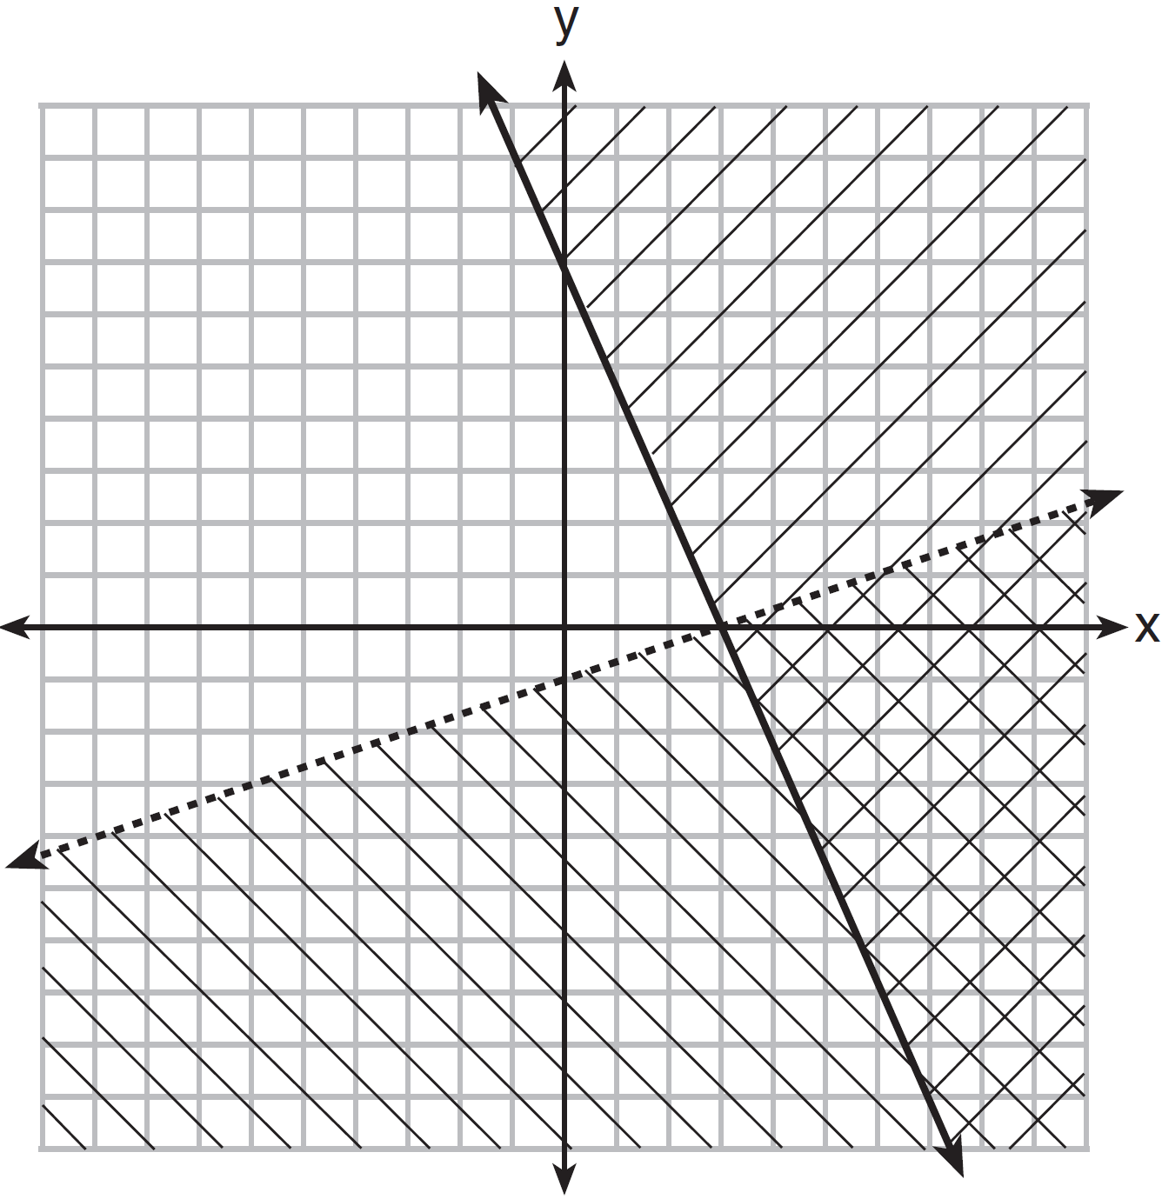
1) |  | 3)
2) |  | 4)

5 Which ordered pair is not in the solution set of 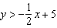 and ?
1) |  | 3)
2) |  | 4)

6 Which point is a solution to the system below?
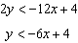
1) | 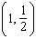 | 3) | 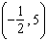
2) |  | 4)

7 First consider the system of equations 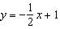 and . Then consider the system of inequalities 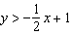 and . When comparing the number of solutions in each of these systems, which statement is true?
1) | Both systems have an infinite number of solutions. | 3) | The system of inequalities has more solutions.
2) | The system of equations has more solutions. | 4) | Both systems have only one solution.

8 Determine if the point is a solution to the system of inequalities graphed below. Justify your answer.

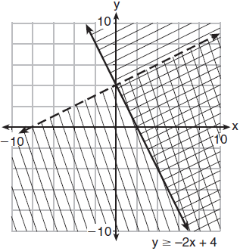

9 Graph the following system of inequalities on the set of axes below:
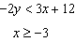
Label the solution set S.
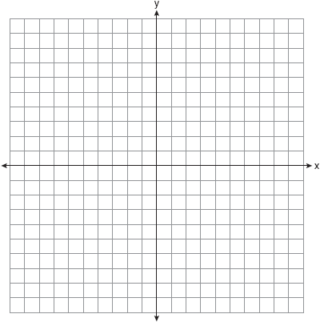
Allison thinks that is a solution to this system. Determine if Allison is correct. Justify your answer.

10 Given: 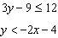
Graph the system of inequalities on the set of axes below.
State the coordinates of a point that satisfies both inequalities. Justify your answer.

11 Graph the system of inequalities on the set of axes below:
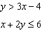
Label the solution set S..

Is the point a solution to the system? Justify your answer.

12 Graph the system of inequalities on the set of axes below.
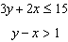

State the coordinates of a point in the solution to this system. Justify your answer.

13 Graph the system of inequalities on the set of axes below:
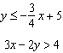
Is a solution to the system of inequalities? Explain your answer.

14 On the set of axes below, graph the following system of inequalities:
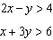
Label the solution set S.
Is a solution to this system? Justify your answer.

15 On the set of axes below, graph the following system of inequalities:
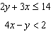
Determine if the point is in the solution set. Explain your answer.

16 Graph the following systems of inequalities on the set of axes below:
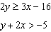
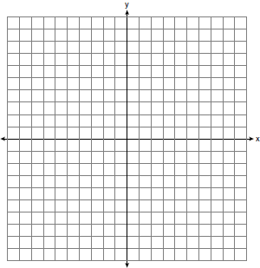
Based upon your graph, explain why is a solution to this system and why is not a solution to this system.

17 Solve the system of inequalities graphically on the set of axes below. Label the solution set S.
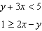

Is the point in the solution set? Explain your answer.

18 Solve the system of inequalities graphically on the set of axes below. Label the solution set S.
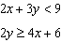

Determine if the point is a solution to this system of inequalities. Justify your answer.

19 On the set of axes below, graph the following system of inequalities: 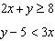

Determine if the point is in the solution set. Explain your answer.

20 Graph the system of inequalities: 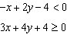

Stephen says the point is a solution to this system. Determine if he is correct, and explain your reasoning.

21 Solve the following system of inequalities graphically on the set of axes below.
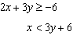
Label the solution set S..

Is the point in the solution set? Explain your answer.

22 Solve the following system of inequalities graphically on the grid below and label the solution S.
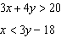



Is the point in the solution set? Explain your answer.

23 The graph of an inequality is shown below.

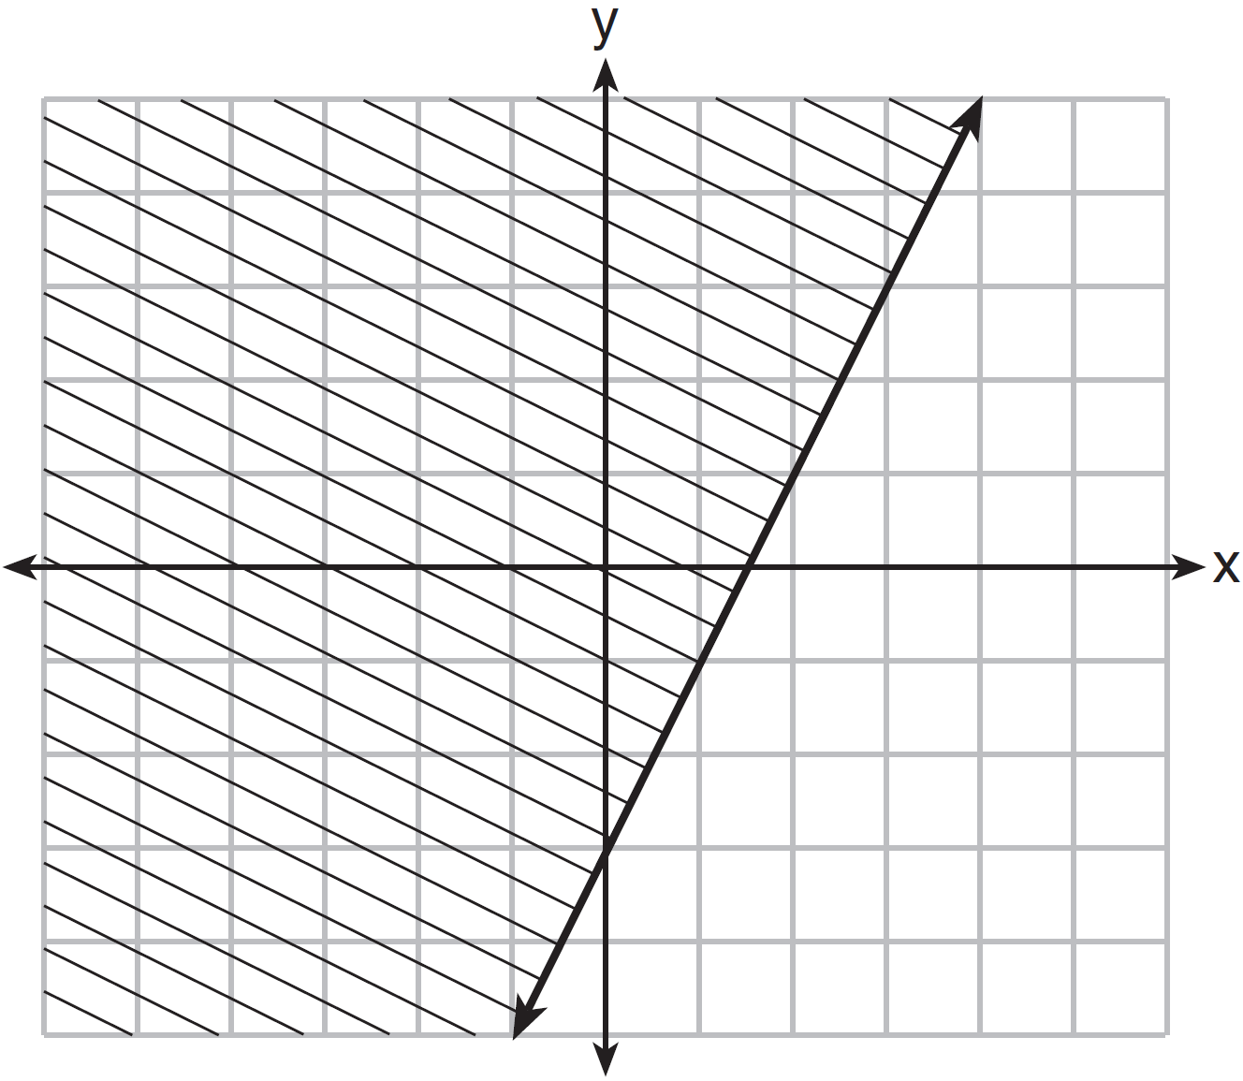

a) Write the inequality represented by the graph.
b) On the same set of axes, graph the inequality .
c) The two inequalities graphed on the set of axes form a system. Oscar thinks that the point is in the solution set for this system of inequalities. Determine and state whether you agree with Oscar. Explain your reasoning.

24 The sum of two numbers, x and y, is more than 8. When you double x and add it to y, the sum is less than 14. Graph the inequalities that represent this scenario on the set of axes below.

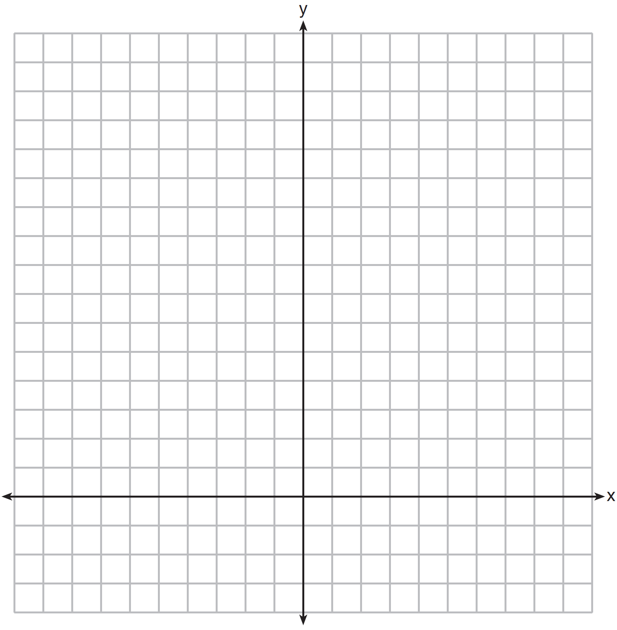

Kai says that the point is a solution to this system. Determine if he is correct and explain your reasoning.

25 The Reel Good Cinema is conducting a mathematical study. In its theater, there are 200 seats. Adult tickets cost $12.50 and child tickets cost $6.25. The cinema's goal is to sell at least $1500 worth of tickets for the theater. Write a system of linear inequalities that can be used to find the possible combinations of adult tickets, x, and child tickets, y, that would satisfy the cinema's goal. Graph the solution to this system of inequalities on the set of axes below. Label the solution with an S. Marta claims that selling 30 adult tickets and 80 child tickets will result in meeting the cinema's goal. Explain whether she is correct or incorrect, based on the graph drawn.

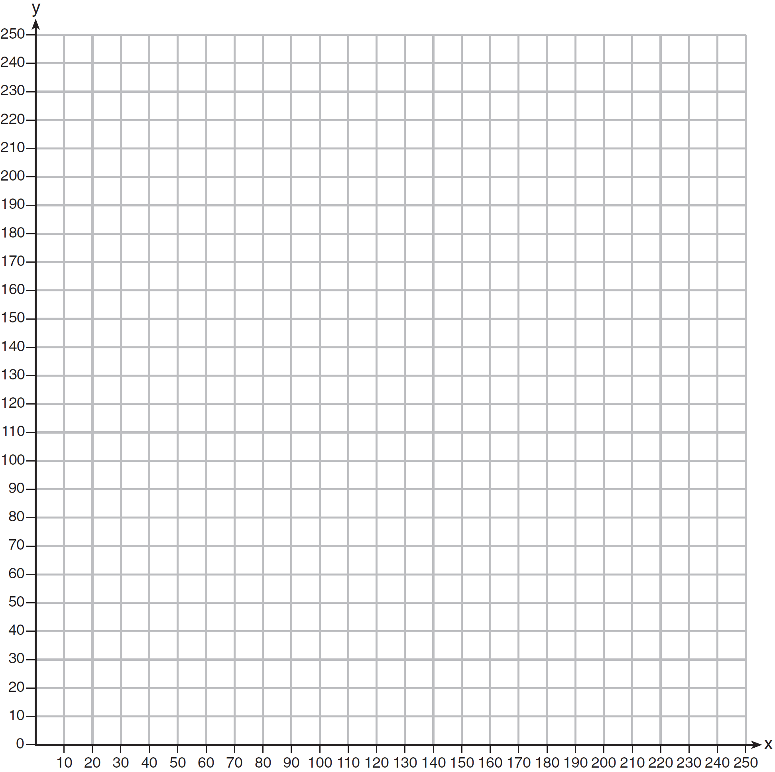
1

