1 When the expression is rewritten as the product of two binomials, the result is
1)
2)
3)
4)

2 Which expression is equivalent to ?
1)
2)
3)
4)

3 Which expression is equivalent to ?
1)
2)
3)
4)

4 The expression is equivalent to
1)
2)
3)
4)

5 Which expression is equivalent to ?
1)
2)
3)
4)

6 The expression is equivalent to
1)
2)
3)
4)

7 If , then m equals
1)
2)
3) | 3
4) | 6

8 When factored completely, is equivalent to
1)
2)
3)
4)

9 Which expression is equivalent to ?
1)
2)
3)
4)

10 Which expression is not equivalent to ?
1)
2)
3)
4)

11 Which expression is equivalent to ?
1)
2)
3)
4)

12 Factored completely, is equivalent to
1)
2)
3)
4)

13 The completely factored form of is
1)
2)
3)
4)

14 What is the completely factored form of ?
1)
2)
3)
4)

15 The completely factored form of is
1)
2)
3)
4)

16 Which factorization is incorrect?
1)
2)
3)
4)

17 Which expression has been rewritten correctly to form a true statement?
1)
2)
3)
4)

18 Over the set of integers, factor the expression .

19 Over the set of integers, completely factor .

20 Factor the expression completely.

21 Factor completely.

22 Factor the expression completely.

23 Over the set of integers, factor the expression completely.

24 Over the set of integers, factor the expression completely.

25 Factor completely over the set of integers:

26 Completely factor the following expression:

27 Rewrite the expression 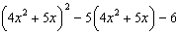 as a product of four linear factors.
1 ANS: 2
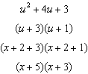

REF: 081901aii

2 ANS: 1
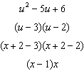

REF: 012301aii

3 ANS: 2
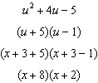

REF: 062401aii

4 ANS: 3
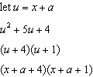

REF: 012006aii

5 ANS: 2
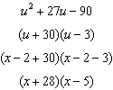

REF: 012503aii
6 ANS: 2
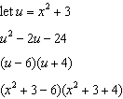

REF: 062310aii

7 ANS: 2 REF: 081904aii

8 ANS: 4

REF: 011703aii

9 ANS: 4
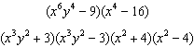

REF: 081814aii

10 ANS: 3 REF: 062302aii

11 ANS: 3

REF: 082423aii

12 ANS: 2
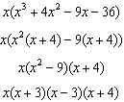

REF: 062407aii

13 ANS: 3
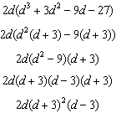

REF: 081615aii

14 ANS: 4
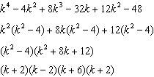

REF: fall1505aii

15 ANS: 2
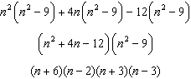

REF: 061911aii

16 ANS: 3

REF: 081605aii

17 ANS: 1
1) let , then 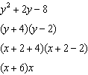

REF: 081715aii

18 ANS:

REF: 081825aii

19 ANS:
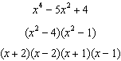

REF: 012331aii

20 ANS:

REF: 082226aii

21 ANS:

REF: 012425aii

22 ANS:
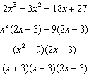

REF: 082325aii

23 ANS:

REF: 061727aii

24 ANS:

REF: 082427aii

25 ANS:
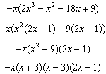

REF: 062228aii

26 ANS:

REF: 011828aii

27 ANS:
The expression is of the form or . Let :
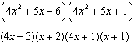

REF: fall1512aii

