1 A radioactive substance has an initial mass of 100 grams and its mass halves every 4 years. Which expression shows the number of grams remaining after t years?
1) | 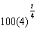
2)
3) | 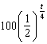
4) | 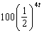

2 The element Americium has a half-life of 25 minutes. Given an initial amount, , which expression could be used to determine the amount of Americium remaining after t minutes?
1) | 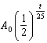
2) | 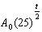
3) | 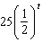
4) | 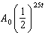

3 A culture of 1000 bacteria triples every 10 hours. Which expression models the number of bacteria in the sample after t hours?
1)
2)
3)
4) | 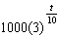

4 Susan won $2,000 and invested it into an account with an annual interest rate of 3.2%. If her investment were compounded monthly, which expression best represents the value of her investment after t years?
1)
2) | 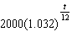
3) | 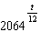
4) | 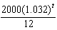

5 A payday loan company makes loans between $100 and $1000 available to customers. Every 14 days, customers are charged 30% interest with compounding. In 2013, Remi took out a $300 payday loan. Which expression can be used to calculate the amount she would owe, in dollars, after one year if she did not make payments?
1) | 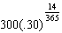
2) | 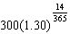
3) | 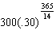
4) | 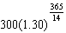

6 According to a pricing website, Indroid phones lose 58% of their cash value over 1.5 years. Which expression can be used to estimate the value of a $300 Indroid phone in 1.5 years?
1)
2)
3)
4)

7 Audra is interested in studying the number of students entering kindergarten in the Ahlville Central School District over the next several years. Using data dating back to 2015, she determines that the number of kindergarteners is decreasing at an exponential rate. She creates a formula to model this situation , where x is the number of years since 2015 and y is the number of students entering kindergarten. If there were 105 students entering kindergarten in Ahlville in 2015, which statement about Audra’s formula is true?
1) | a is positive and b is negative.
2) | a is negative and b is positive.
3) | Both a and b are positive.
4) | Both a and b are negative.

8 Biologists are studying a new bacterium. They create a culture with 100 of the bacteria and anticipate that the number of bacteria will double every 30 hours. Write an equation for the number of bacteria, B, in terms of the number of hours, t, since the experiment began.

9 A brewed cup of coffee contains 130 mg of caffeine. The half-life of caffeine in the bloodstream is 5.5 hours. Write a function, to represent the amount of caffeine in the bloodstream t hours after drinking one cup of coffee.

1 ANS: 3 REF: 010813b

2 ANS: 1 REF: 082309aii

3 ANS: 4 REF: 062411aii

4 ANS: 1
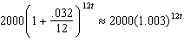

REF: 012004aii

5 ANS: 4 REF: 081622aii

6 ANS: 1
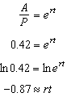

REF: 011723aii

7 ANS: 3

REF: 082314aii

8 ANS:
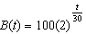

REF: 012031aii

9 ANS:
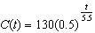

REF: 082430aii

