1 Which representation yields the same outcome as the sequence defined recursively below?
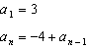
1) |  | 3)
2) |  | 4)

2 A pattern of blocks is shown below.

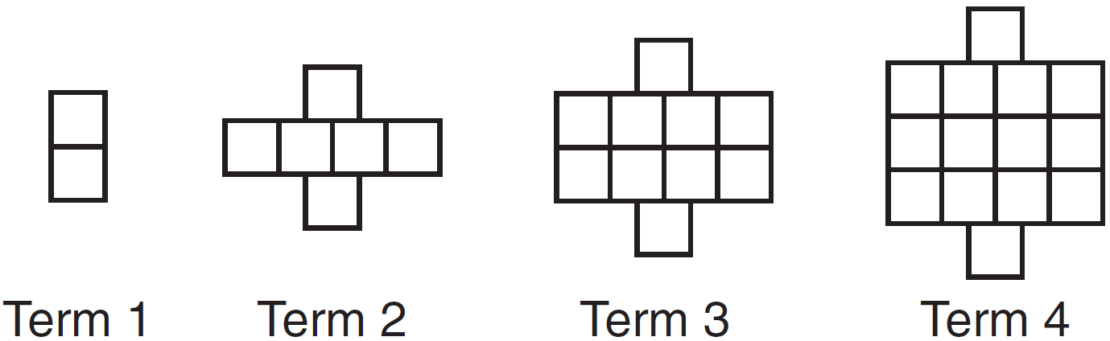

If the pattern of blocks continues, which formula(s) could be used to determine the number of blocks in the nth term?

I | II | III
 | 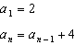

1) | I and II | 3) | II and III
2) | I and III | 4) | III, only

3 In 2014, the cost to mail a letter was 49¢ for up to one ounce. Every additional ounce cost 21¢. Which recursive function could be used to determine the cost of a 3-ounce letter, in cents?
1) |  | 3)
2) |  | 4)

4 At her job, Pat earns $25,000 the first year and receives a raise of $1000 each year. The explicit formula for the nth term of this sequence is . Which rule best represents the equivalent recursive formula?
1) |  | 3) | ,
2) |  | 4) | ,

5 Savannah just got contact lenses. Her doctor said she can wear them 2 hours the first day, and can then increase the length of time by 30 minutes each day. If this pattern continues, which formula would not be appropriate to determine the length of time, in either minutes or hours, she could wear her contact lenses on the nth day?
1) | 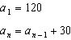 | 3) | 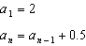
2) |  | 4)

6 The sequence can also be written as
1) |  | 3)
2) |  | 4)

7 Which function could be used to represent the sequence , given that ?
1) |  | 3)
2) |  | 4)

8 A recursive formula for the sequence is
1) | 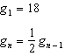 | 3) | 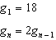
2) | 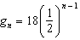 | 4)

9 A recursive formula for the sequence is
1) | 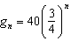 | 3) | 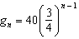
2) | 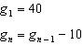 | 4) | 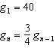

10 A recursive formula for the sequence is
1) |  | 3)
2) | 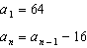 | 4) | 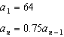

11 An initial investment of $5000 in an account earns 3.5% annual interest. Which function correctly represents a recursive model of the investment after n years?
1) |  | 3)
2) | 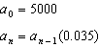 | 4) | 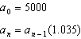

12 The population of Jamesburg for the years 2010-2013, respectively, was reported as follows:
250,000 250,937 251,878 252,822
How can this sequence be recursively modeled?
1) |  | 3) | 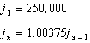
2) |  | 4) | 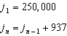

13 In 2010, the population of New York State was approximately 19,378,000 with an annual growth rate of 1.5%. Assuming the growth rate is maintained for a large number of years, which equation can be used to predict the population of New York State t years after 2010?
1) |  | 3)
2) | 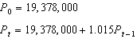 | 4) | 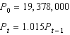

14 Jack started a new fitness program. The first day he did 10 push-ups. The program required him to increase the number of push-ups each day by doing 9 less than twice the number from the previous day. Which recursive formula correctly models Jack’s new program, where n is the number of days and is the number of push-ups on the nth day?
1) | 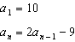 | 3) | 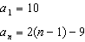
2) | 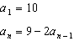 | 4) | 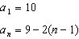

15 A father makes a deal with his son regarding his weekly allowance. The first year, he agrees to pay his son a weekly allowance of $10. Every subsequent year, the allowance is recalculated by doubling the previous year's weekly allowance and then subtracting 8. Which recursive formula could be used to calculate the son's weekly allowance in future years?
1) |  | 3) | 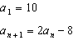
2) |  | 4) | 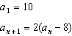

16 The average depreciation rate of a new boat is approximately 8% per year. If a new boat is purchased at a price of $75,000, which model is a recursive formula representing the value of the boat n years after it was purchased?
1) |  | 3)
2) | 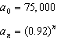 | 4) | 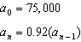

17 After Roger’s surgery, his doctor administered pain medication in the following amounts in milligrams over four days.

Day (n) | 1 | 2 | 3 | 4
Dosage (m) | 2000 | 1680 | 1411.2 | 1185.4

How can this sequence best be modeled recursively?
1) | 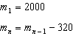 | 3) | 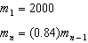
2) |  | 4)

18 A tree farm initially has 150 trees. Each year, 20% of the trees are cut down and 80 seedlings are planted. Which recursive formula models the number of trees, , after n years?
1) | 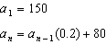 | 3)
2) | 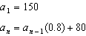 | 4)

19 The Rickerts decided to set up an account for their daughter to pay for her college education. The day their daughter was born, they deposited $1000 in an account that pays 1.8% compounded annually. Beginning with her first birthday, they deposit an additional $750 into the account on each of her birthdays. Which expression correctly represents the amount of money in the account n years after their daughter was born?
1) |  | 3) | 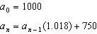
2) |  | 4) | 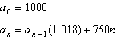

20 The formula below can be used to model which scenario?
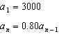
1) | The first row of a stadium has 3000 seats, and each row thereafter has 80 more seats than the row in front of it. | 3) | A bank account starts with a deposit of $3000, and each year it grows by 80%.
2) | The last row of a stadium has 3000 seats, and each row before it has 80 fewer seats than the row behind it. | 4) | The initial value of a specialty toy is $3000, and its value each of the following years is 20% less.

21 Write a recursive formula, , to describe the sequence graphed below.

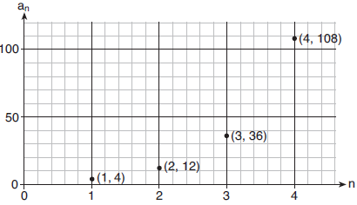

22 Write a recursive formula for the sequence

23 Write a recursive formula for the sequence

24 Write a recursive formula for the sequence

25 While experimenting with her calculator, Candy creates the sequence 4, 9, 19, 39, 79, .... Write a recursive formula for Candy's sequence. Determine the eighth term in Candy's sequence.

26 The explicit formula represents the number of seats in each row in a movie theater, where n represents the row number. Rewrite this formula in recursive form.

27 The population, in millions of people, of the United States can be represented by the recursive formula below, where represents the population in 1910 and n represents the number of years since 1910.
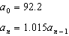
Identify the percentage of the annual rate of growth from the equation . Write an exponential function, P, where represents the United States population in millions of people, and t is the number of years since 1910. According to this model, determine algebraically the number of years it takes for the population of the United States to be approximately 300 million people. Round your answer to the nearest year.

28 Write an explicit formula for , the nth term of the recursively defined sequence below.
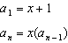
For what values of x would when ?

29 Elaina has decided to run the Buffalo half-marathon in May. She researched training plans on the Internet and is looking at two possible plans: Jillian’s 12-week plan and Josh’s 14-week plan. The number of miles run per week for each plan is plotted below.

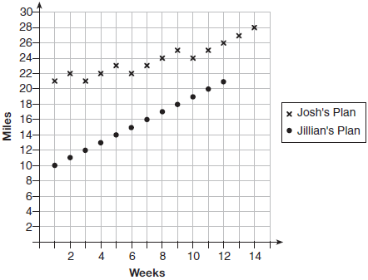

Which one of the plans follows an arithmetic pattern? Explain how you arrived at your answer. Write a recursive definition to represent the number of miles run each week for the duration of the plan you chose. Jillian’s plan has an alternative if Elaina wanted to train instead for a full 26-mile marathon. Week one would start at 13 miles and follow the same pattern for the half-marathon, but it would continue for 14 weeks. Write an explicit formula, in simplest form, to represent the number of miles run each week for the full-marathon training plan.

1 ANS: 2

REF: 012321ai

2 ANS: 3 REF: 061522ai

3 ANS: 1 REF: 011708ai

4 ANS: 3 REF: 011824aii

5 ANS: 4

REF: 011916aii

6 ANS: 3 REF: 081618aii

7 ANS: 2 REF: 011919ai

8 ANS: 1
(2) is not recursive

REF: 081608aii

9 ANS: 4
(1) and (3) are not recursive

REF: 012013aii

10 ANS: 4
1) is a correct formula, but not recursive

REF: 082216aii

11 ANS: 4 REF: 062412aii

12 ANS: 3 REF: 061623aii

13 ANS: 4 REF: 081624aii

14 ANS: 1 REF: 082319ai

15 ANS: 3 REF: 062321ai

16 ANS: 4 REF: 081810aii

17 ANS: 3 REF: 081909aii

18 ANS: 2 REF: 012321aii

19 ANS: 3 REF: 081724aii

20 ANS: 4
The scenario represents a decreasing geometric sequence with a common ratio of 0.80.

REF: 061610aii

21 ANS:
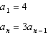

REF: 081931aii

22 ANS:
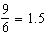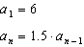

REF: 061931aii

23 ANS:
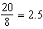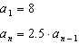
REF: 012531aii

24 ANS:
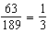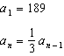
REF: 062329aii

25 ANS:
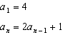
REF: 081729aii

26 ANS:
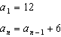
REF: 012430aii

27 ANS:
1.5%; ; 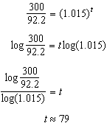
REF: 062237aii

28 ANS:
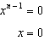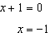
REF: spr1511aii

29 ANS:
Jillian’s plan, because distance increases by one mile each week. 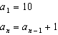
REF: 011734aii

