1 The graph below represents .

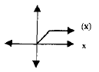

Which of the following is the graph of ?
1) | 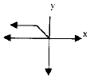
2) | 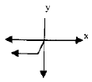
3) | 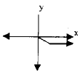
4) | 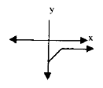

2 The accompanying graph represents the equation .

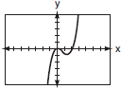

Which graph represents if ?
1) | 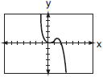
2) | 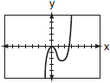
3) | 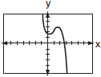
4) | 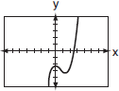

3 The graph below represents .

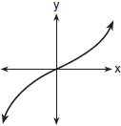

Which graph best represents ?
1) | 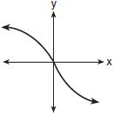
2) | 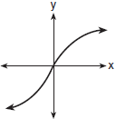
3) | 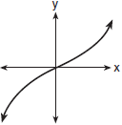
4) | 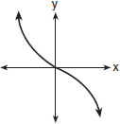

4 Given the parent function , the function is the result of a shift of
1) | 1 unit left and 2 units down
2) | 1 unit left and 2 units up
3) | 1 unit right and 2 units down
4) | 1 unit right and 2 units up

5 Consider the function , defined by the graph below.

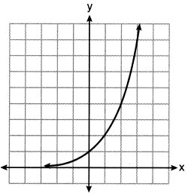

Which equation could be used to represent the graph shown below?

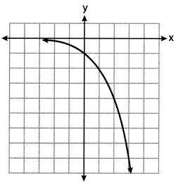
1)
2)
3)
4)

6 The graph below represents national and New York State average gas prices.
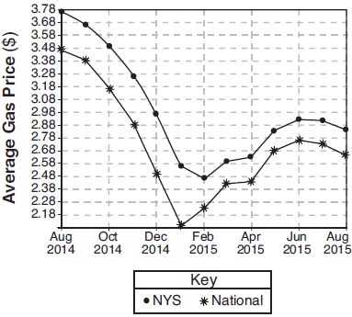
If New York State's gas prices are modeled by and , which expression best approximates the national average x months from August 2014?
1)
2)
3)
4)

7 The height of a running trail is modeled by the quartic function shown below, where x is the distance in miles from the start of the trail and y is the height in feet relative to sea level.
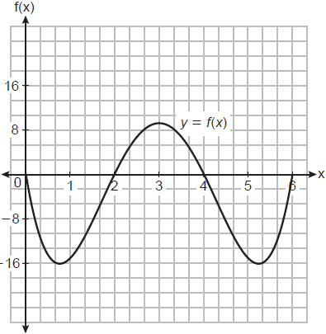
If this trail has a minimum height of 16 feet below sea level, which function(s) could represent a running trail whose minimum height is half of the minimum height of the original trail?
I. 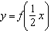 II. III. 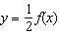
1) | I, only
2) | II, only
3) | I and III
4) | II and III

8 Richard is asked to transform the graph of below.

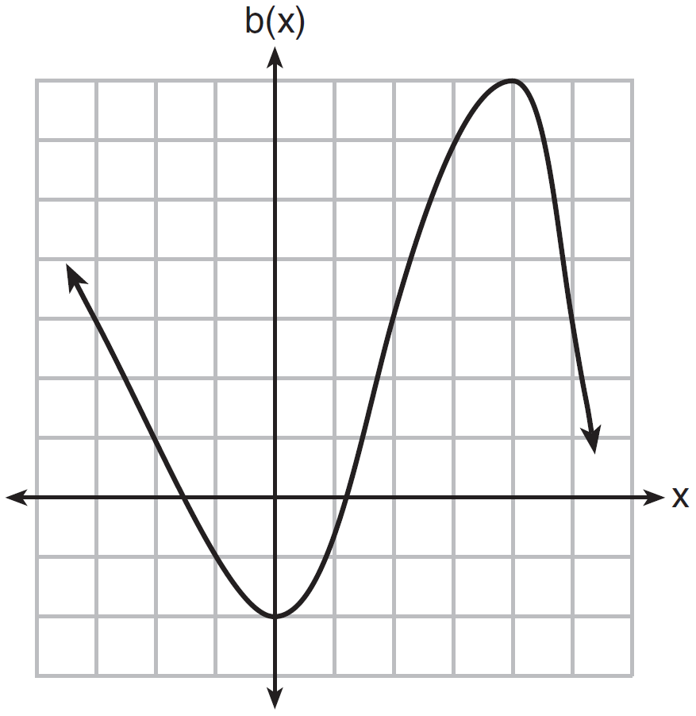

The graph of is transformed using the equation . Describe how the graph of changed to form the graph of .

9 In the diagram below, is graphed. Also graphed is , the result of a translation of .

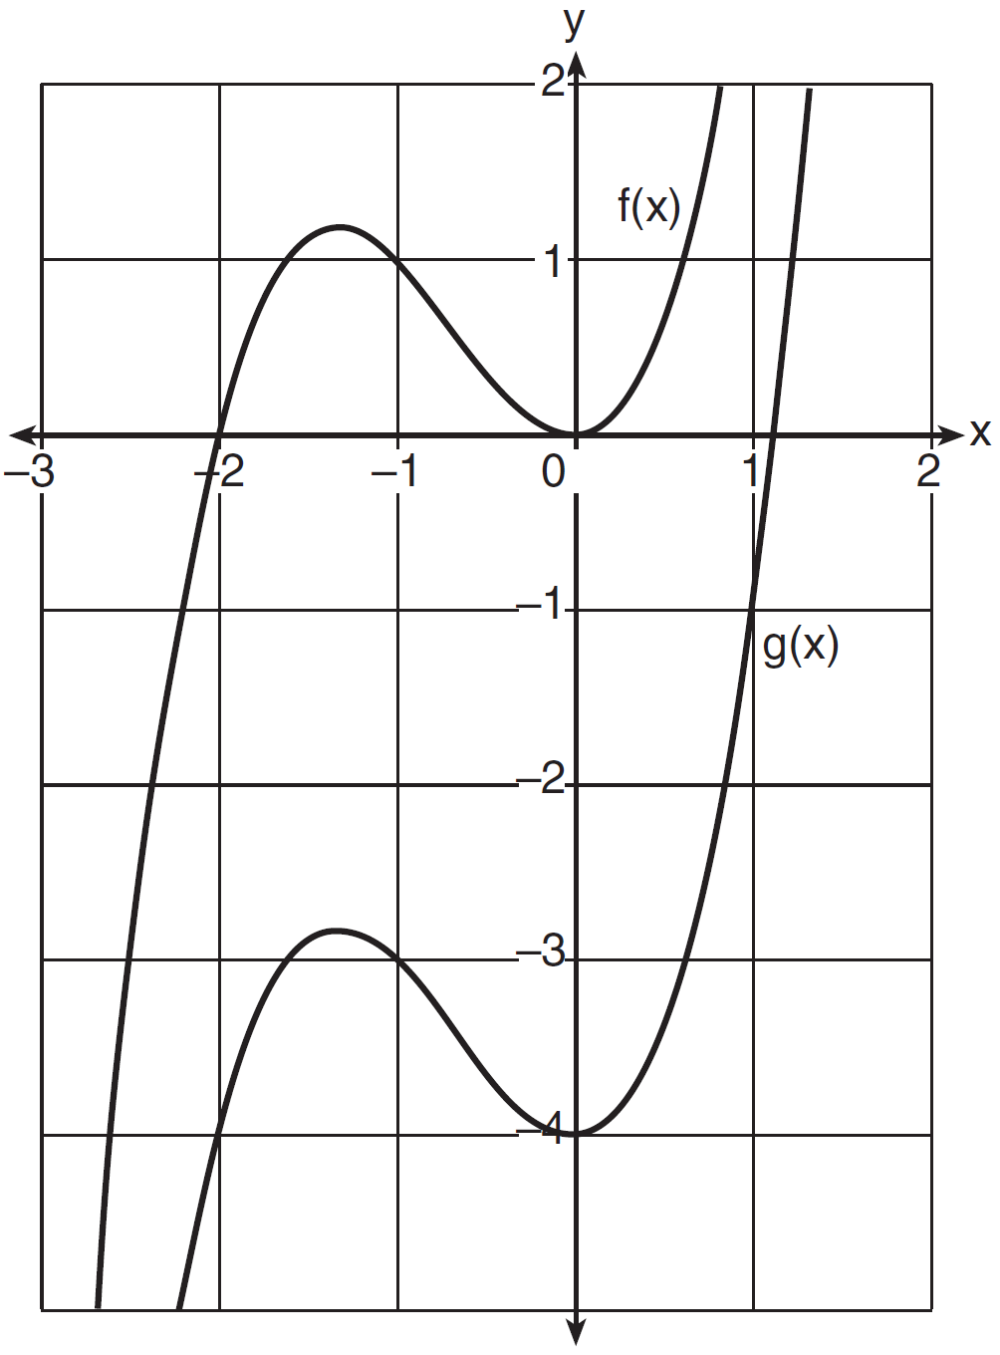

Determine an equation of . Explain your reasoning.

10 The graph of is shown below. The function has a leading coefficient of 1.

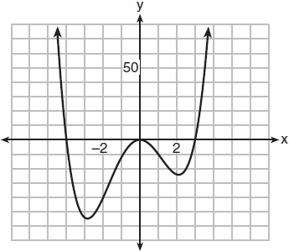

Write an equation for . The function g is formed by translating function f left 2 units. Write an equation for .

1 ANS: 3 REF: fall9903b

2 ANS: 1 REF: 060701b

3 ANS: 4 REF: 080406b

4 ANS: 3 REF: 011910ai

5 ANS: 3 REF: 062205aii

6 ANS: 4 REF: 081817aii

7 ANS: 4
I. Minimum does not change, only period; II. ; III. 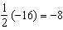

REF: 012523aii

8 ANS:
2 units right and 3 units down.

REF: 081626ai

9 ANS:
, because is a translation down 4 units.

REF: 061632ai

10 ANS:
;

REF: 011836aii

