1 The image of function is found by mapping each point on the function to the point . This image is a reflection of in
1) | the x-axis
2) | the y-axis
3) | the line whose equation is
4) | the line whose equation is

2 By what transformation can the set representing the inverse of a function be found?
1) | reflection in the origin
2) | reflection in the line
3) | rotation of 90º about the origin
4) | reflection in the y-axis

3 If the point lies on the graph , the graph of must contain point
1)
2)
3)
4)

4 The inverse function of is
1)
2)
3)
4)

5 If , which statement is true?
1) | m and its inverse are both functions.
2) | m is a function and its inverse is not a function.
3) | m is not a function and its inverse is a function.
4) | Neither m nor its inverse is a function.

6 Given the relation
Which statement is true?
1) | Both A and are functions.
2) | Neither A nor is a function.
3) | Only A is a function.
4) | Only is a function.

7 Given:
If the inverse of the set is , which statement is true?
1) | A and are functions.
2) | A nor are not functions.
3) | A is a function and is not a function.
4) | A is not a function and is a function.

8 Write the inverse of the given function:

9 The accompanying diagram represents the graph of .

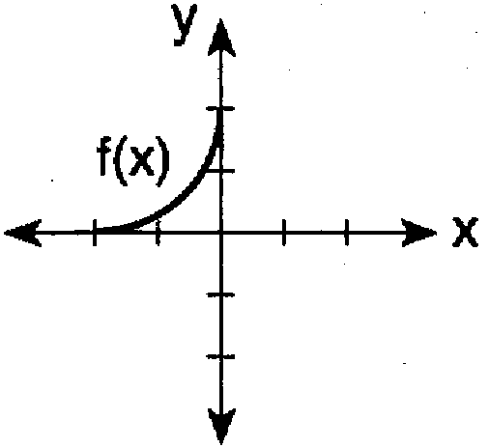

Which graph represents ?
1) | 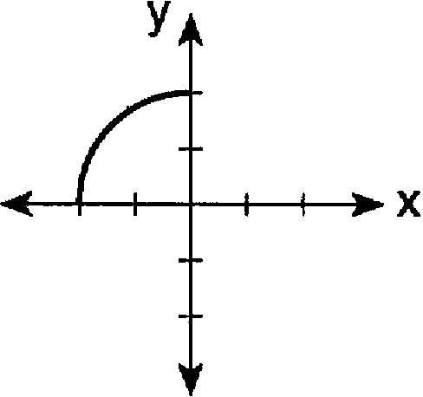
2) | 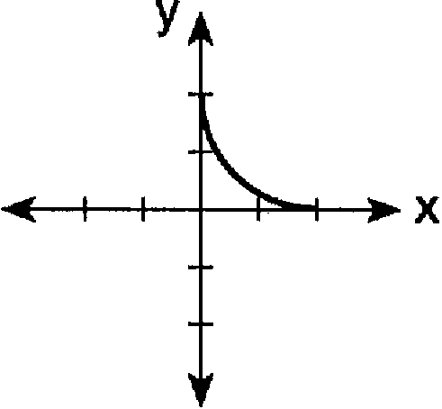
3) | 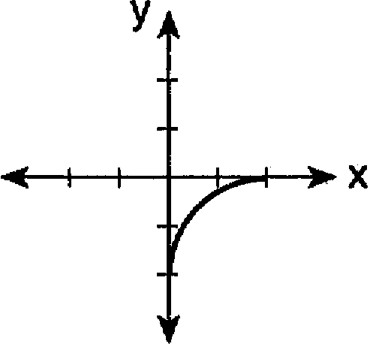
4) | 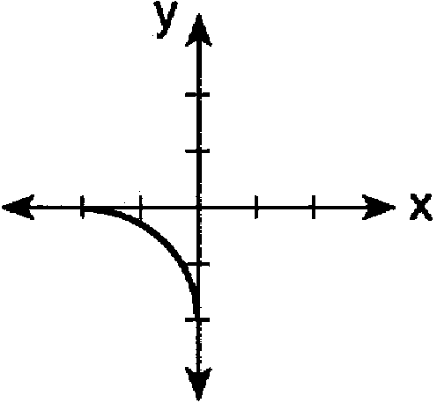

10 The accompanying graph shows the relationship between kinetic energy, y, and velocity, x.

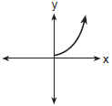

The reflection of this graph in the line is
1) | 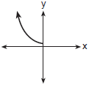
2) | 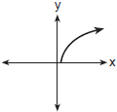
3) | 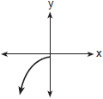
4) | 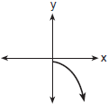

11 Which graph represents the inverse of ?
1) | 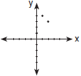
2) | 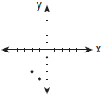
3) | 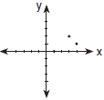
4) | 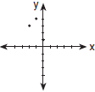

12 Which graph has an inverse that is a function?
1) | 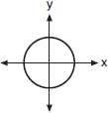
2) | 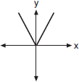
3) | 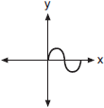
4) | 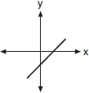

13 The function, f, is drawn on the accompanying set of axes. On the same set of axes, sketch the graph of , the inverse of f.

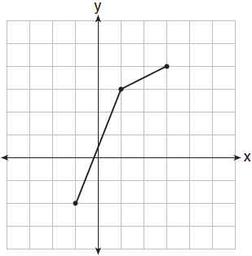

14 The accompanying graph shows the relationship between the cooling time of magma and the size of the crystals produced after a volcanic eruption. On the same graph, sketch the inverse of this function.

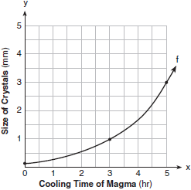

15 Draw and in the interval on the accompanying set of axes. State the coordinates of the points of intersection.



16 If , find .

17 If and 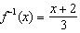, then equals
1) | x
2)
3) | 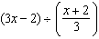
4) | 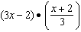

18 When 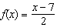, what is the value of ?
1)
2)
3) | 3
4)

19 Given: and .
Find: , , , ,

1 ANS: 3 REF: 011010b

2 ANS: 2 REF: 018730siii

3 ANS: 1 REF: 080216b

4 ANS: 3 REF: 019024siii

5 ANS: 2 REF: 081523a2

6 ANS: 3
A is a function because for every x, there is a unique y. is not a function. For the element “2” in the domain, there are two elements in the range, “3” and “6”.

REF: 010914b

7 ANS: 1 REF: 069424siii

8 ANS:

REF: 069009siii

9 ANS: 3 REF: 069623siii

10 ANS: 2 REF: 080820b

11 ANS: 3

REF: 060220b

12 ANS: 4
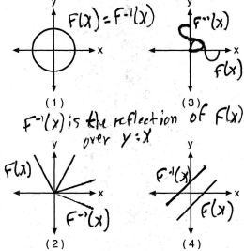

REF: 080712b

13 ANS:
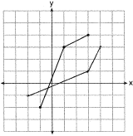

REF: 011024b

14 ANS:
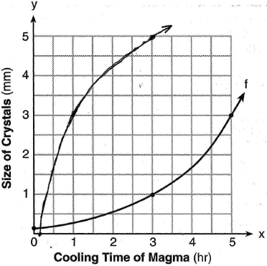

REF: 060926b

15 ANS:
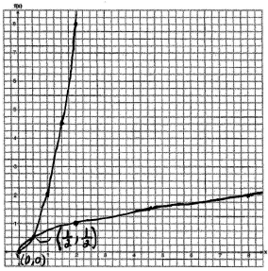. 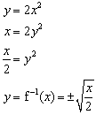

REF: 060130b

16 ANS:
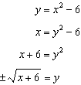

REF: 061132a2

17 ANS: 1
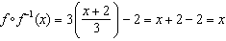

REF: 011726a2

18 ANS: 3
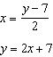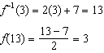

REF: 061619a2

19 ANS:
25, 5, 10, 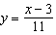, 9

REF: 019641siii

