1 What is the common difference of the arithmetic sequence ?
1)
2)
3) | 3
4) | 9

2 In an arithmetic sequence, the first term is 4 and the third term is . What is the common difference?
1)
2)
3)
4)

3 The first term in a sequence is 5 and the fifth term is 17. What is the common difference?
1) | 2.4
2) | 12
3) | 3
4) | 4

4 Determine the common difference of the arithmetic sequence in which and .

5 Find the common difference in the arithmetic sequence, , in which and .

6 What is the common difference of the arithmetic sequence below?
1)
2)
3) | 3
4)

7 What is the common difference in the sequence , , , ?
1)
2)
3)
4)

8 Given the sequence:
Which expression can be used to determine the common difference of this sequence?
1)
2)
3) | 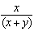
4) | 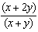

9 Given the following three sequences:
I.
II.
III.
Which ones are arithmetic sequences?
1) | I and II, only
2) | I and III, only
3) | II and III, only
4) | I, II, and III

10 Which arithmetic sequence has a common difference of 4?
1)
2)
3)
4)

11 A geometric sequence with a common ratio of is
1)
2)
3)
4)

12 Consider the following patterns:
I.
II.
III.
IV. 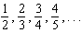
Which pattern is geometric?
1) | I
2) | II
3) | III
4) | IV

13 Which situation could be modeled using a geometric sequence?
1) | A cell phone company charges $30.00 per month for 2 gigabytes of data and $12.50 for each additional gigabyte of data.
2) | The temperature in your car is 79°. You lower the temperature of your air conditioning by 2° every 3 minutes in order to find a comfortable temperature.
3) | David’s parents have set a limit of 50 minutes per week that he may play online games during the school year. However, they will increase his time by 5% per week for the next ten weeks.
4) | Sarah has $100.00 in her piggy bank and saves an additional $15.00 each week.

14 Determine and state whether the sequence displays exponential behavior. Explain how you arrived at your decision.

15 A geometric sequence is shown below.
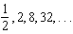
What is the common ratio?
1)
2) | 2
3)
4) | 4

16 What is the common ratio of the geometric sequence shown below?
1)
2) | 2
3)
4)

17 The common ratio of the sequence 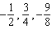 is
1)
2)
3)
4)

18 If then the common ratio of the sequence is
1)
2) | 2
3)
4)

19 What is the common ratio of the sequence 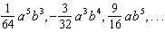?
1) | 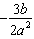
2)
3) | 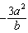
4) | 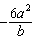

20 What is a common ratio of the geometric sequence whose first term is 5 and third term is 245?
1) | 7
2) | 49
3) | 120
4) | 240

21 The third term in a sequence is 25 and the fifth term is 625. Which number could be the common ratio of the sequence?
1)
2) | 5
3)
4) | 25

22 What is the common ratio of the geometric sequence whose first term is 27 and fourth term is 64?
1)
2)
3)
4)

1 ANS: 3 REF: 061001a2

2 ANS: 3
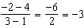

REF: 062223ai

3 ANS: 3
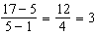

REF: 062215ai

4 ANS:
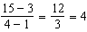

REF: 012328ai

5 ANS:
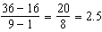

REF: 081630a2

6 ANS: 4 REF: 061411a2

7 ANS: 1

REF: 011401a2

8 ANS: 2 REF: 011610a2

9 ANS: 2 REF: 061919ai

10 ANS: 3 REF: 011110a2

11 ANS: 4 REF: 082419ai

12 ANS: 1
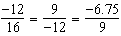

REF: 012017aii

13 ANS: 3 REF: 061910aii

14 ANS:
Yes, because the sequence has a common ratio, 3.

REF: 081726ai

15 ANS: 4
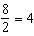

REF: 012503ai

16 ANS: 3
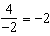

REF: 011304a2

17 ANS: 1
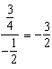

REF: 011508a2

18 ANS: 1
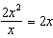

REF: 082202ai

19 ANS: 2
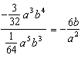

REF: 061326a2

20 ANS: 1
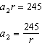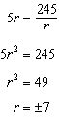

REF: 081924ai

21 ANS: 2
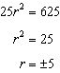

REF: 062412ai

22 ANS: 3
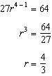

REF: 081025a2

