1 The first four terms of the sequence defined by 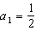 and are
1) | 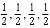
2) | 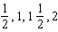
3) | 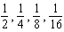
4) | 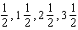

2 The first four terms of the sequence with and 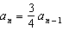 are
1)
2) | 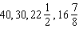
3)
4) | 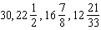

3 A recursively defined sequence is shown below.
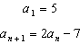
The value of is
1)
2)
3) | 8
4) | 15

4 A sequence is defined recursively by
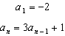
What is the value of ?
1)
2)
3) | 22
4) | 67

5 If a sequence is defined recursively as and , then is
1)
2)
3) | 55
4) | 67

6 If and , then equals
1) | 75
2) | 147
3) | 180
4) | 900

7 A sequence of blocks is shown in the diagram below.

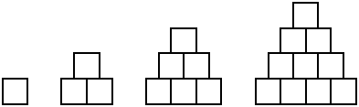

This sequence can be defined by the recursive function and . Assuming the pattern continues, how many blocks will there be when ?
1) | 13
2) | 21
3) | 28
4) | 36

8 If and , what is the value of ?
1) | 5
2) | 20
3) | 120
4) | 720

9 What is the third term of the recursive sequence below?
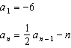
1)
2)
3)
4)

10 A function is defined as , where . What is the value of ?
1) | 8
2) | 8.5
3) | 9.2
4) | 10

11 What is the fourth term of the sequence defined by
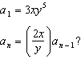
1)
2)
3)
4)

12 Find the third term in the recursive sequence , where .

13 Given the recursive formula:

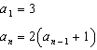

State the values of , , and for the given recursive formula.

14 The recursive formula to describe a sequence is shown below.
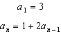
State the first four terms of this sequence. Can this sequence be represented using an explicit geometric formula? Justify your answer.

15 Write the first five terms of the recursive sequence defined below.
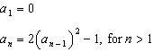

16 Use the recursive sequence defined below to express the next three terms as fractions reduced to lowest terms.
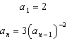

17 Find the first four terms of the recursive sequence defined below.
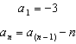
1 ANS: 1 REF: 081520a2

2 ANS: 2
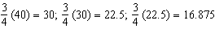

REF: 081608a2

3 ANS: 1

REF: 012023ai

4 ANS: 1

REF: 082220ai

5 ANS: 4

REF: 062224ai

6 ANS: 1

REF: 081919ai

7 ANS: 3
1, 3, 6, 10, 15, 21, 28, ...

REF: 081715ai

8 ANS: 3
, , ,

REF: 061824ai

9 ANS: 1
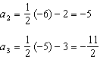

REF: 011623a2

10 ANS: 2
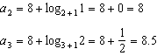

REF: 062221aii

11 ANS: 3
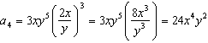

REF: 061512a2

12 ANS:
. . .

REF: 061233a2

13 ANS:

REF: 061931ai

14 ANS:
; No, because there is no common ratio: 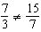

REF: 061830aii

15 ANS:

REF: 081832ai

16 ANS:
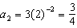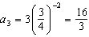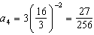

REF: 011537a2

17 ANS:

REF: fall0934a2

