1 If the function represents exponential growth, which statement about is false?
1) | and
2) | The y-intercept is .
3) | The asymptote is .
4) | The x-intercept is .

2 Which statement about the graph of the equation is not true?
1) | It is asymptotic to the x-axis.
2) | The domain is the set of all real numbers.
3) | It lies in Quadrants I and II.
4) | It passes through the point .

3 The graph of is positive on which interval?
1)
2)
3)
4)

4 Given , as
1)
2)
3)
4)

5 If and 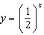 are graphed on the same set of coordinate axes, which transformation would map one of these curves onto the other?
1) | reflection in the y-axis
2) | reflection in the x-axis
3) | reflection in the line
4) | reflection in the origin

6 If , which function represents the reflection of in the y-axis?
1)
2) | 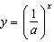
3) | 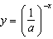
4)

7 Describe the transformation applied to the graph of that forms the new function .

8 The graph of is shown in the accompanying diagram.

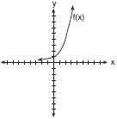

Which graph represents ?
1) | 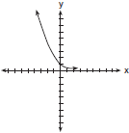
2) | 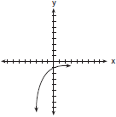
3) | 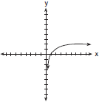
4) | 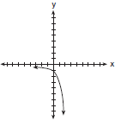

9 The strength of a medication over time is represented by the equation , where x represents the number of hours since the medication was taken and y represents the number of micrograms per millimeter left in the blood. Which graph best represents this relationship?
1) | 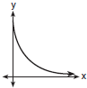
2) | 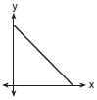
3) | 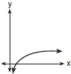
4) | 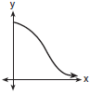

10 The graph of the equation has an asymptote. On the grid below, sketch the graph of and write the equation of this asymptote.

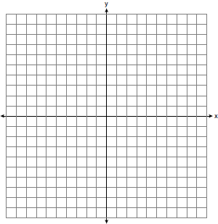

11 On the axes below, for , graph .

12 Graph on the axes below.

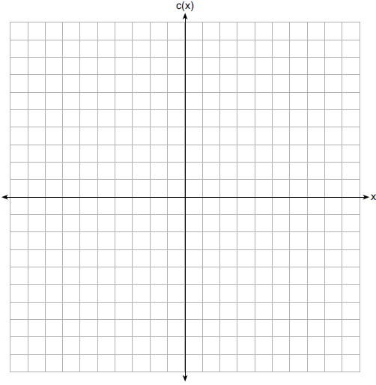

Describe the end behavior of as x approaches positive infinity. Describe the end behavior of as x approaches negative infinity.

13 On the axes below, graph .

14 Graph on the set of axes below.

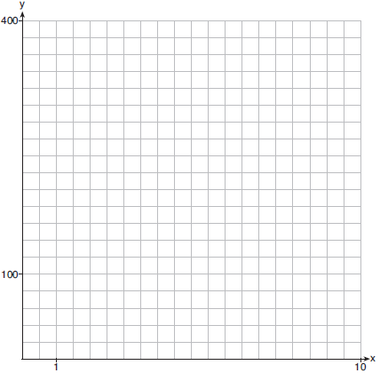

1 ANS: 4
There is no x-intercept.

REF: 011823aii

2 ANS: 4 REF: 011219a2

3 ANS: 2
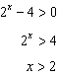

REF: 082402aii

4 ANS: 3 REF: 082214aii

5 ANS: 1
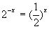 and 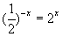

REF: fall9908b

6 ANS: 2 REF: 080919b

7 ANS:
Translation 3 units right and 4 units up

REF: 012027aii

8 ANS: 2 REF: 080115b

9 ANS: 1 REF: 080304b

10 ANS:
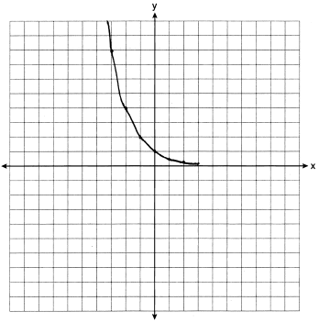

REF: 061031a2

11 ANS:
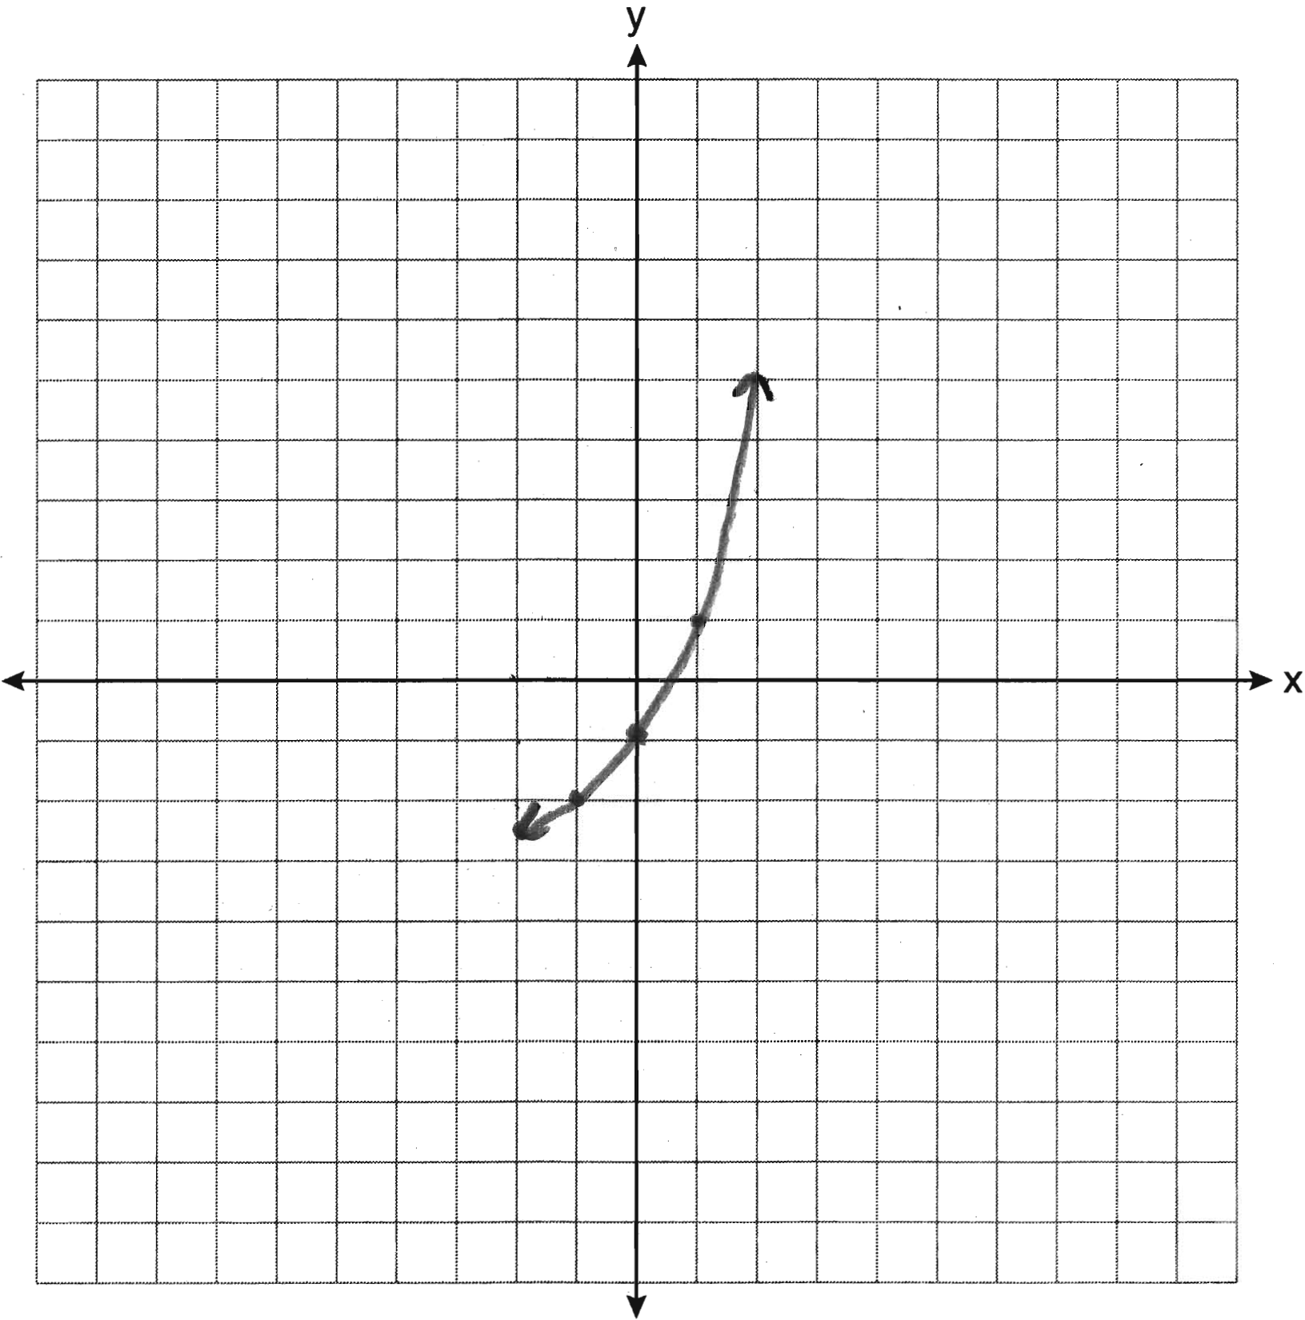

REF: 011233a2

12 ANS:
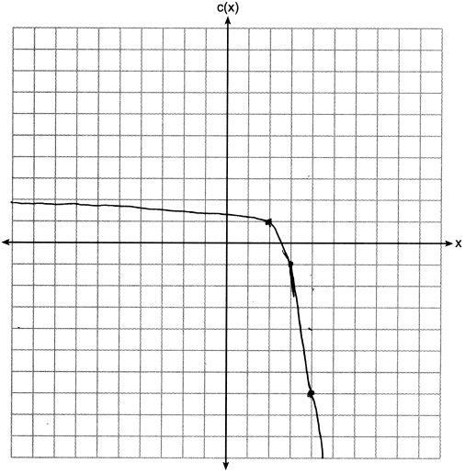 . .

REF: 012335aii

13 ANS:
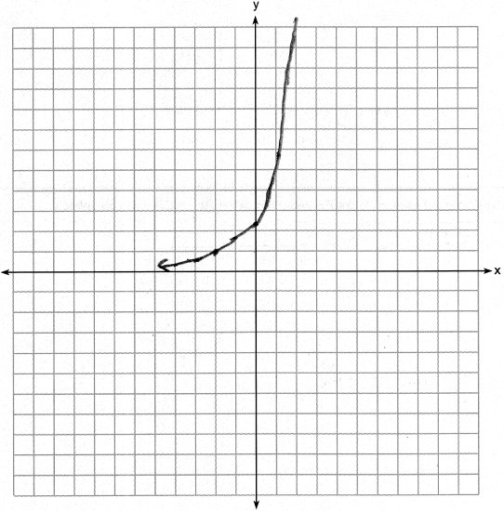

REF: 082425aii

14 ANS:
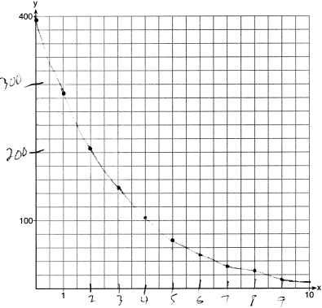

REF: 061729aii

