1 The formula is used to determine the speed of sound, S, in meters per second, near Earth’s surface, where t is the surface temperature, in degrees Celsius. Which graph best represents this function?
1) | 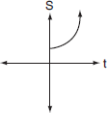
2) | 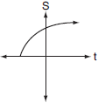
3) | 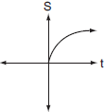
4) | 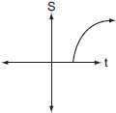

2 If , what are its domain and range?
1) | domain: ; range:
2) | domain: ; range:
3) | domain: ; range:
4) | domain: ; range:

3 What is the domain of ?
1)
2)
3)
4)

4 The equation relates speed of sound, V, in meters per second, to air temperature, C, in degrees Celsius. What is the temperature, in degrees Celsius, when the speed of sound is 320 meters per second? [The use of the accompanying grid is optional.]



5 The number of people, y, involved in recycling in a community is modeled by the function , where x is the number of months the recycling plant has been open. Construct a table of values, sketch the function on the grid, and find the number of people involved in recycling exactly 3 months after the plant opened. After how many months will 940 people be involved in recycling?



6 On the set of axes below, graph the function represented by for the domain .

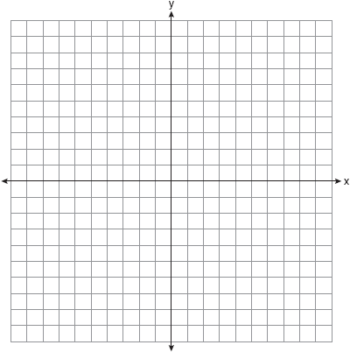
1 ANS: 2 REF: 060718b

2 ANS: 1 REF: 011313a2

3 ANS: 2
For real solutions, the expression under the radical must be greater than or equal to zero. 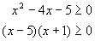. For the product of these two binomials to be positive, both binomials must be either positive or negative. 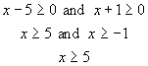 or 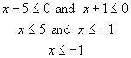. 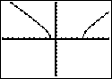

REF: 010218b

4 ANS:
. 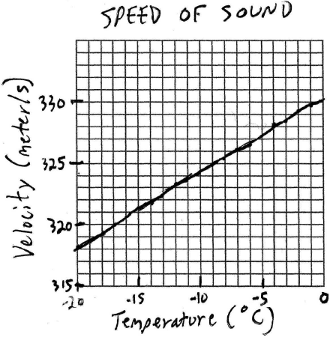. 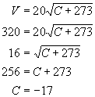

REF: 060426b

5 ANS:
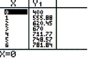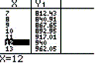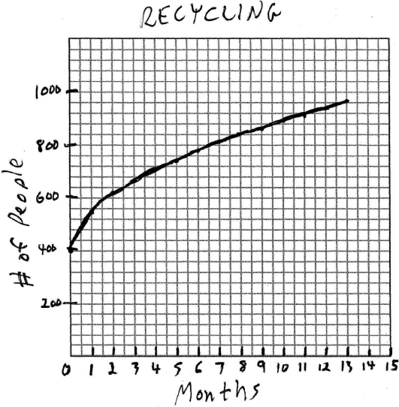 670, 12. . 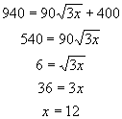

REF: 010532b

6 ANS:
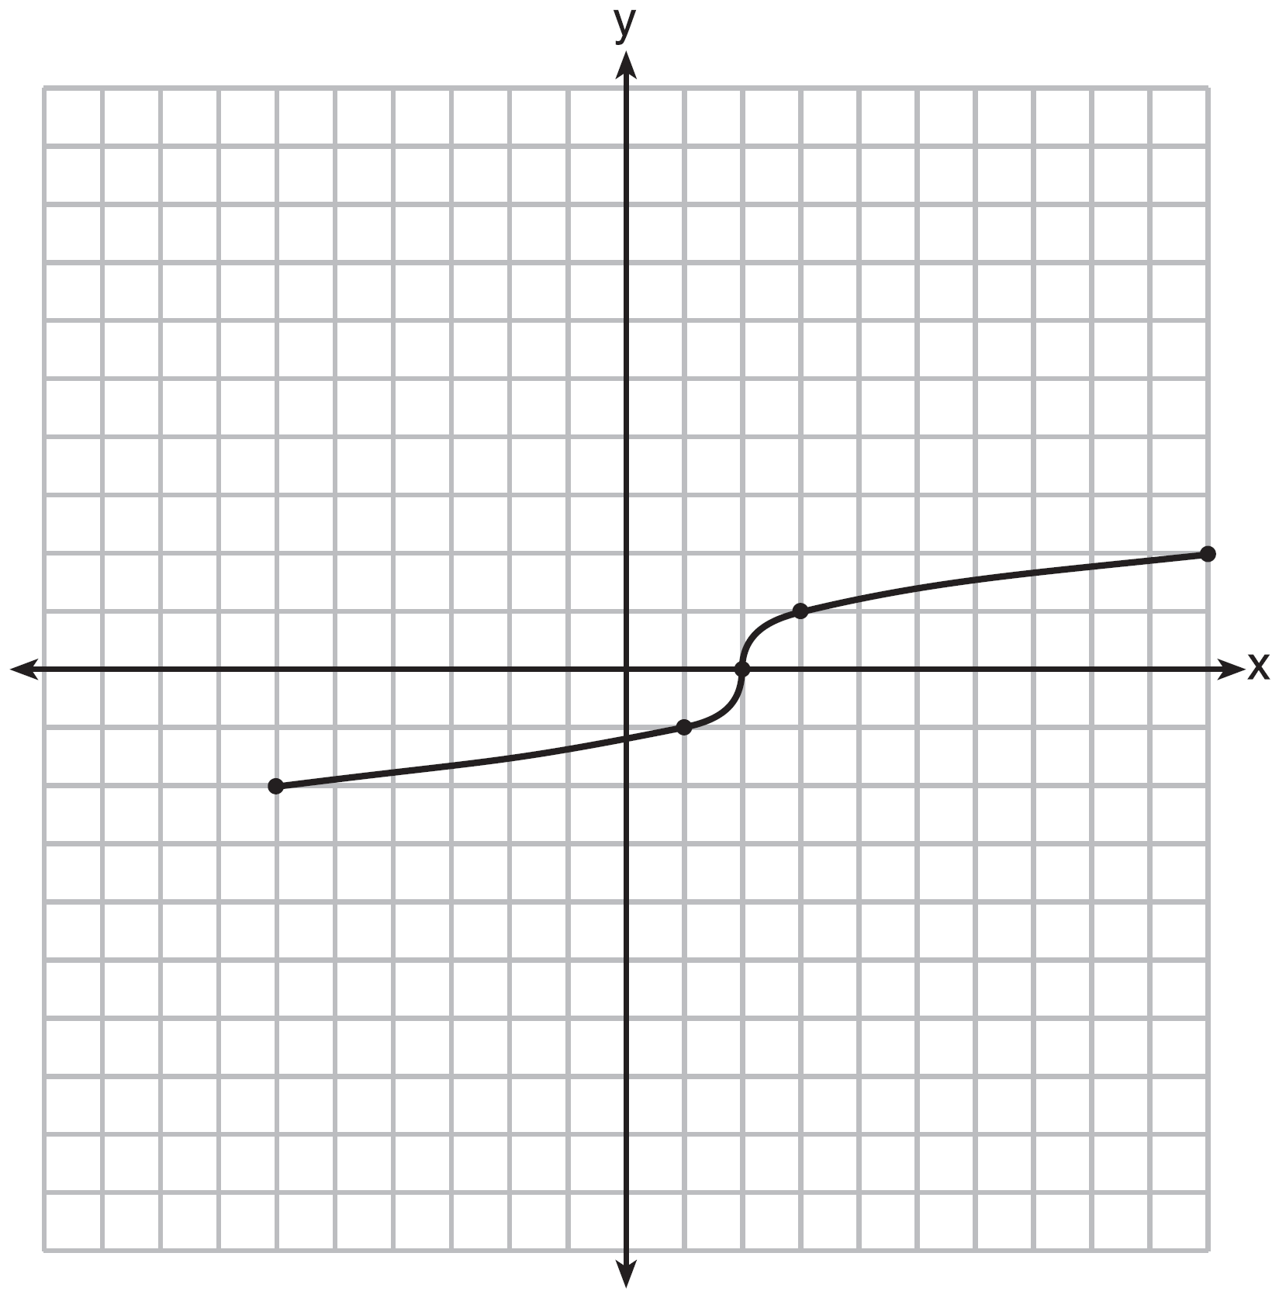

REF: fall1304ai

