1 What is the solution of ?
1)
2)
3)
4) | 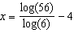

2 If then x equals
1)
2) | 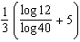
3) | 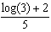
4) | 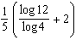

3 If , where a, b, and c are positive, then t equals
1) | 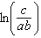
2) | 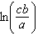
3) | 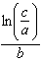
4) | 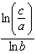

4 The solution to the equation is
1)
2) | 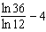
3)
4) | 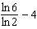

5 What is the solution to ?
1) | 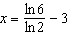
2)
3) | 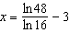
4)

6 The solution to the equation is
1) | 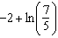
2) | 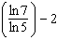
3)
4)

7 The solution of , to the nearest thousandth, is
1) | 0.583
2) | 1.945
3) | 4.220
4) | 14.066

8 To the nearest tenth, the solution to the equation is
1) | 1.1
2) | 2.5
3) | 6.3
4) | 68.5

9 Which expression is not a solution to the equation ?
1) | 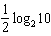
2)
3)
4)

10 Given , solve the equation for x algebraically.

11 Solve algebraically for x to the nearest thousandth:

12 Solve algebraically for t to the nearest hundredth.
1 ANS: 1
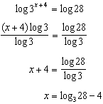

REF: 082306aii

2 ANS: 3
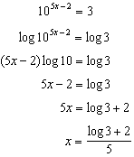

REF: 012517aii

3 ANS: 3
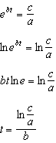

REF: 011813aii

4 ANS: 4
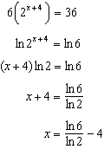

REF: 082408aii

5 ANS: 1
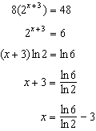

REF: 061702aii

6 ANS: 1
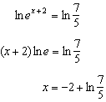

REF: 062207aii

7 ANS: 4
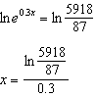

REF: 081801aii

8 ANS: 2
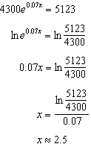

REF: 012302aii

9 ANS: 4
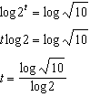 2) 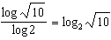, 1) 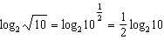, 3) 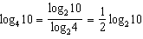

REF: 012009aii

10 ANS:
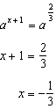

REF: 012326aii

11 ANS:
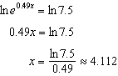

REF: 062330aii

12 ANS:
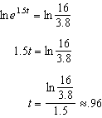

REF: 062426aii

