1 If , then x equals
1)
2)
3)
4)

2 The equation where and is equivalent to
1)
2)
3)
4)

3 The function is equivalent to
1)
2)
3)
4)

4 Given 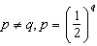, expressed in logarithmic form, is equivalent to
1) | 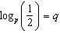
2) | 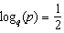
3)
4)

1 ANS: 4 REF: 060409b

2 ANS: 3 REF: 011503a2

3 ANS: 2 REF: 080607b

4 ANS: 3 REF: 012404aii

