1 If 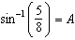, then
1) | 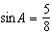
2) | 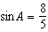
3) | 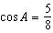
4) | 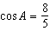

2 If 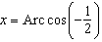, then x is equal to
1)
2)
3)
4)

3 What is the principal value of 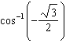?
1)
2)
3)
4)

4 What is a value of 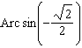?
1)
2)
3)
4)

5 If 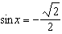 and 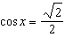, the measure of angle x is
1) | 45º
2) | 135º
3) | 225º
4) | 315º

6 What is the value of x in the equation 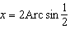?
1)
2)
3)
4)

7 The value of is
1) | 0
2)
3)
4)

8 The value of 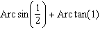 is
1) | 120°
2) | 105°
3) | 90°
4) | 75°

9 The ratio 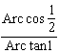 is equal to
1)
2)
3)
4)

10 If 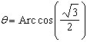, what is the measure of angle ?

11 What is the smallest positive value of x that satisfies 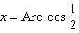?

12 Find the value of 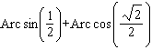.

13 Find the value of .

14 If , what is the value of angle A to the nearest minute?
1)
2)
3)
4)

15 If , find the value of positive acute angle x to the nearest minute.

16 If , find the value of positive acute angle to the nearest minute.

17 If , find the measure of positive acute angle to the nearest minute.

18 If , find the value of A to the nearest minute.

1 ANS: 1 REF: 011112a2

2 ANS: 1 REF: 089528siii

3 ANS: 3 REF: 081007a2

4 ANS: 2 REF: 010911b

5 ANS: 4 REF: 089932siii

6 ANS: 3 REF: 080224siii

7 ANS: 3 REF: 018626siii

8 ANS: 4 REF: 019021siii

9 ANS: 3
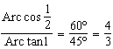

REF: 011708a2

10 ANS:
30

REF: 068010siii

11 ANS:
60º

REF: 068903siii

12 ANS:

REF: 088908siii

13 ANS:
60º

REF: 018713siii

14 ANS: 3 REF: 068722siii

15 ANS:

REF: 088413siii

16 ANS:

REF: 018613siii

17 ANS:

REF: 018914siii

18 ANS:
REF: 068011siii

