1 In the diagram below of circle O, chords and intersect at E, , and .

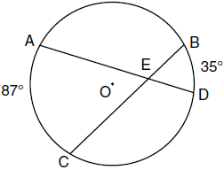

What is the degree measure of ?
1) | 87
2) | 61
3) | 43.5
4) | 26

2 In the diagram below of circle O, chords and intersect at point B, such that and .

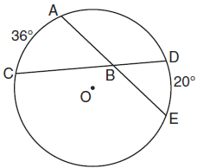

What is ?
1) | 56
2) | 36
3) | 28
4) | 8

3 In circle O, chord intersects diameter at S.

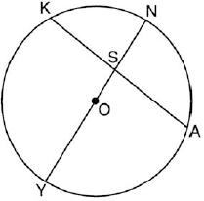

If and , what is ?
1) | 22.5º
2) | 75º
3) | 97.5º
4) | 120º

4 In the accompanying diagram of circle O, chords and intersect at E and .

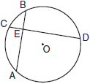

What is ?
1) | 36
2) | 90
3) | 100
4) | 126

5 The accompanying diagram shows a child’s spin toy that is constructed from two chords intersecting in a circle. The curved edge of the larger shaded section is one-quarter of the circumference of the circle, and the curved edge of the smaller shaded section is one-fifth of the circumference of the circle.

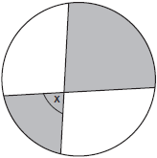

What is the measure of angle x?
1) | 40°
2) | 72°
3) | 81°
4) | 108°

6 In circle A below, chord and diameter intersect at F.

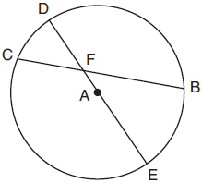

If and , what is ?

7 In the accompanying diagram, and are chords of circle O and intersect at E. If and , find .
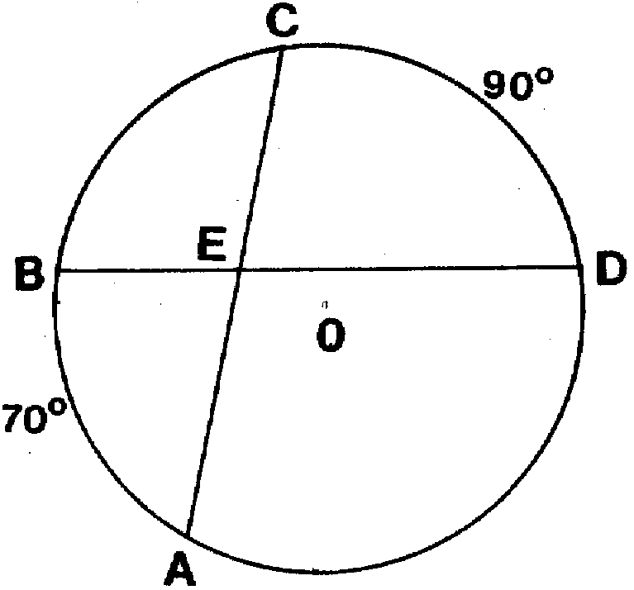

8 In the accompanying diagram, chords and intersect at E. If and , find .
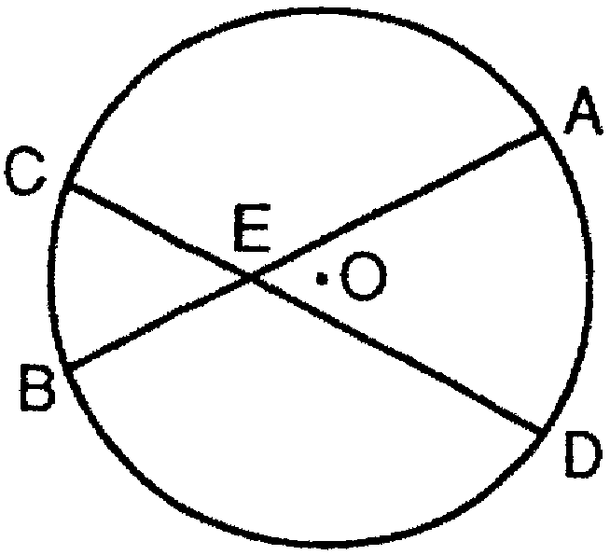

9 In the accompanying diagram of circle O, chords and intersect at E, , and . Find .
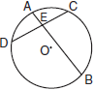

10 In the accompanying diagram, is a diameter of circle O and chord intersects diameter at E. If and , find .

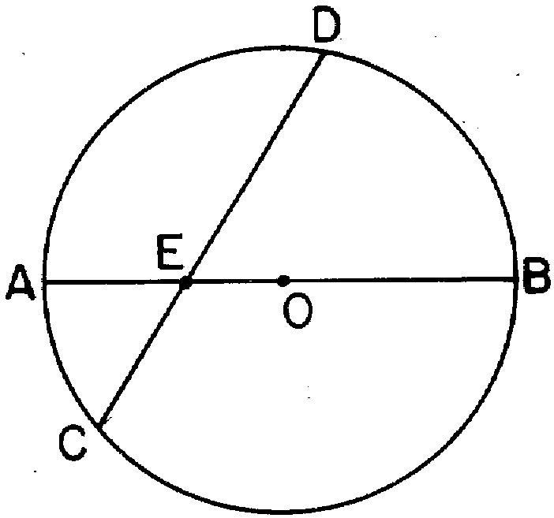

11 In the accompanying diagram, chords and intersect at E. If and , find .
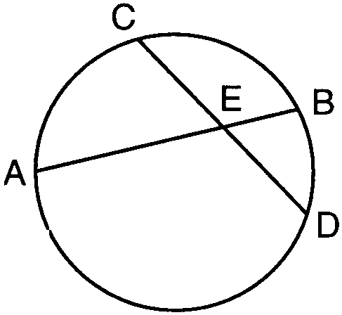

12 In the accompanying figure of circle O, chords and intersect at E and is a diameter. If , find .
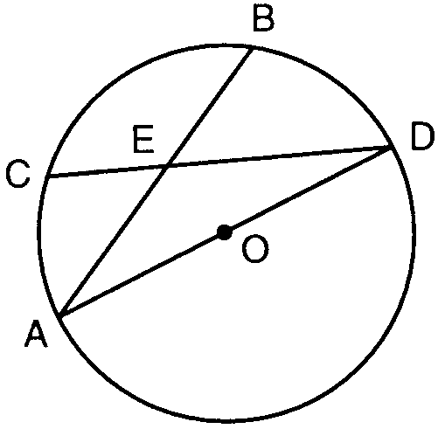

13 In the diagram below of circle P, diameter and chord intersect at Q, , and .
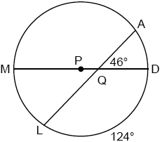

What is ?
1) | 36º
2) | 46º
3) | 51º
4) | 92º

14 In the diagram below, chords and intersect at E. If , , and , what is the value of x?
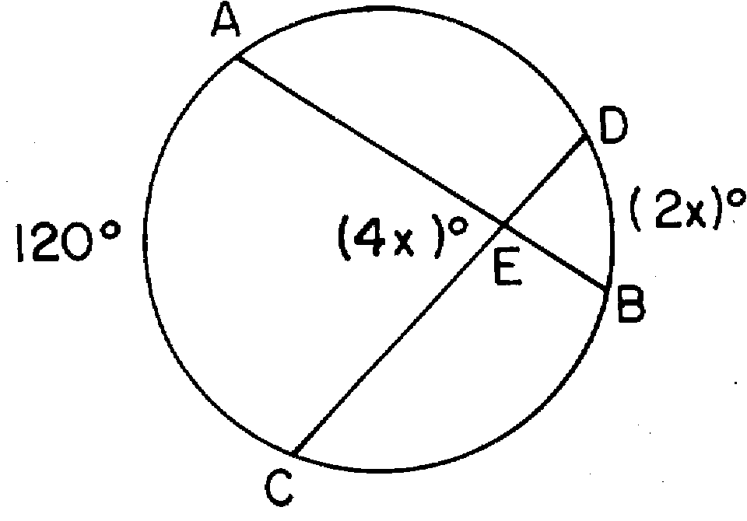
1) | 12
2) | 20
3) | 30
4) | 60

15 In the diagram below of circle O, chords and intersect at E.
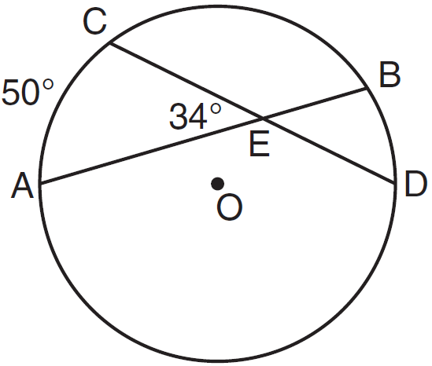

If and , what is ?
1) | 16
2) | 18
3) | 68
4) | 118

16 In the accompanying diagram of circle O, and .
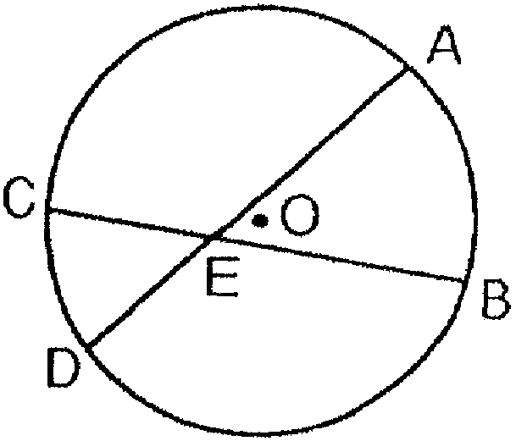

What is the measure of ?
1) | 104º
2) | 80º
3) | 52º
4) | 40º

17 In the diagram below of circle O, chords and intersect at E.

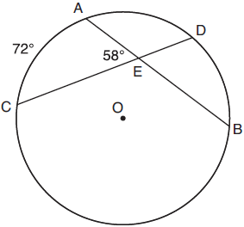

If and , how many degrees are in ?
1) | 108º
2) | 65º
3) | 44º
4) | 14º

1 ANS: 2
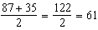

REF: 011015ge

2 ANS: 3
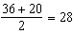

REF: 061019ge

3 ANS: 3
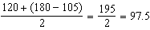

REF: 012510geo

4 ANS: 2 REF: 060221siii

5 ANS: 3
Because the curved edge of the larger shaded section is one-quarter of the circumference of the circle, that arc measures 90°. Because the curved edge of the smaller shaded section is one-fifth of the circumference of the circle, that arc measures 72°. The angle formed by the intersection of two chords is equal to half the sum of the intercepted arcs. 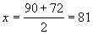. 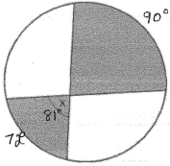

REF: 080408b

6 ANS:
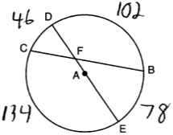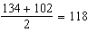

REF: 081827geo

7 ANS:
80

REF: 018410siii

8 ANS:
55

REF: 069411siii

9 ANS:
80

REF: 060111siii

10 ANS:
60

REF: 088709siii

11 ANS:
120

REF: 089811siii

12 ANS:
131

REF: 089915siii

13 ANS: 1
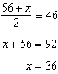

REF: 082421geo

14 ANS: 2 REF: 018931siii

15 ANS: 2
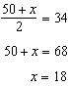

REF: 011214ge

16 ANS: 4 REF: 019429siii

17 ANS: 3
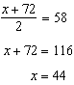

REF: 061817geo

